Supplementary Information for
A novel stable QTL in chromosome A04 for salt tolerance at the seed germination stage of upland cotton via a resequencing-based high-density genetic map

This PDF file includes:

Table of Contents
Fig. S1-5, Table S1-4. (Table S1-4 are provided in the separate Excel files)

Table of Contents:
Supplementary item | Title | Page
Fig. S1 | The salt-tolerance phenotypes parts of RIL lines obtained in the field condition | 2
Fig. S2 | Phenotypic diversity of RGR for the RIL population based on 0.3% salt treatment | 2
Fig. S3 | The relative expression of 21 genes in germination between two parents | 3
Fig. S4 | The transcript-level of GA-related genes between both parents in germination under salt stress | 4
Fig. S5 | DAB staining of H₂O₂ in GhADC2-overexpressing Arabidopsis after salt stress | 5
Fig. S6 | The expression levels of genes related to GAs biosynthesis in TRV:GASA1 after salt stress | 5
Table S1 | Correlation coefficients for RGR among five environments | -
Table S2 | The detailed information of all the RGR-related QTLs in five environments and BLUP | -
Table S3 | A list of all the primers for gene cloning, vector construction and qRT-PCR. | -

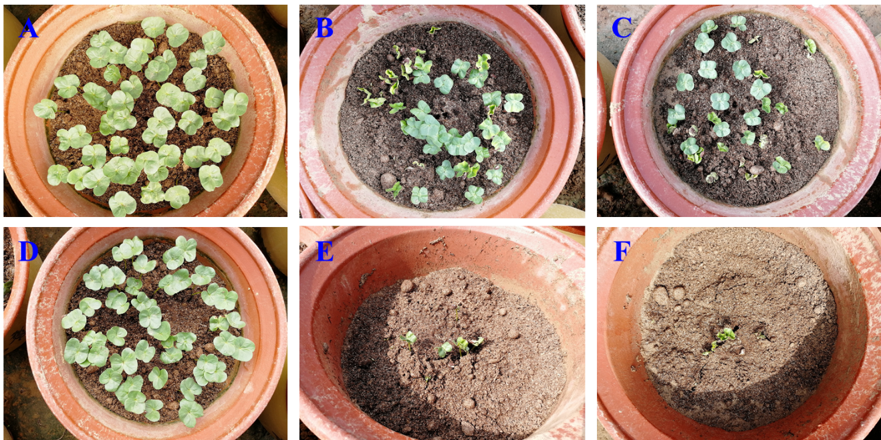
Fig. S1 The salt-tolerance phenotypes parts of RIL lines obtained in the field condition.
(A, D) lines under water treatment; (B-C, E-F) lines under salt treatment

Fig. S2 Phenotypic diversity of RGR for the RIL population based on 0.3% salt treatment.
(A-F) indicated the RGR obtained in E1-E5 and the BLUP value, respectively.

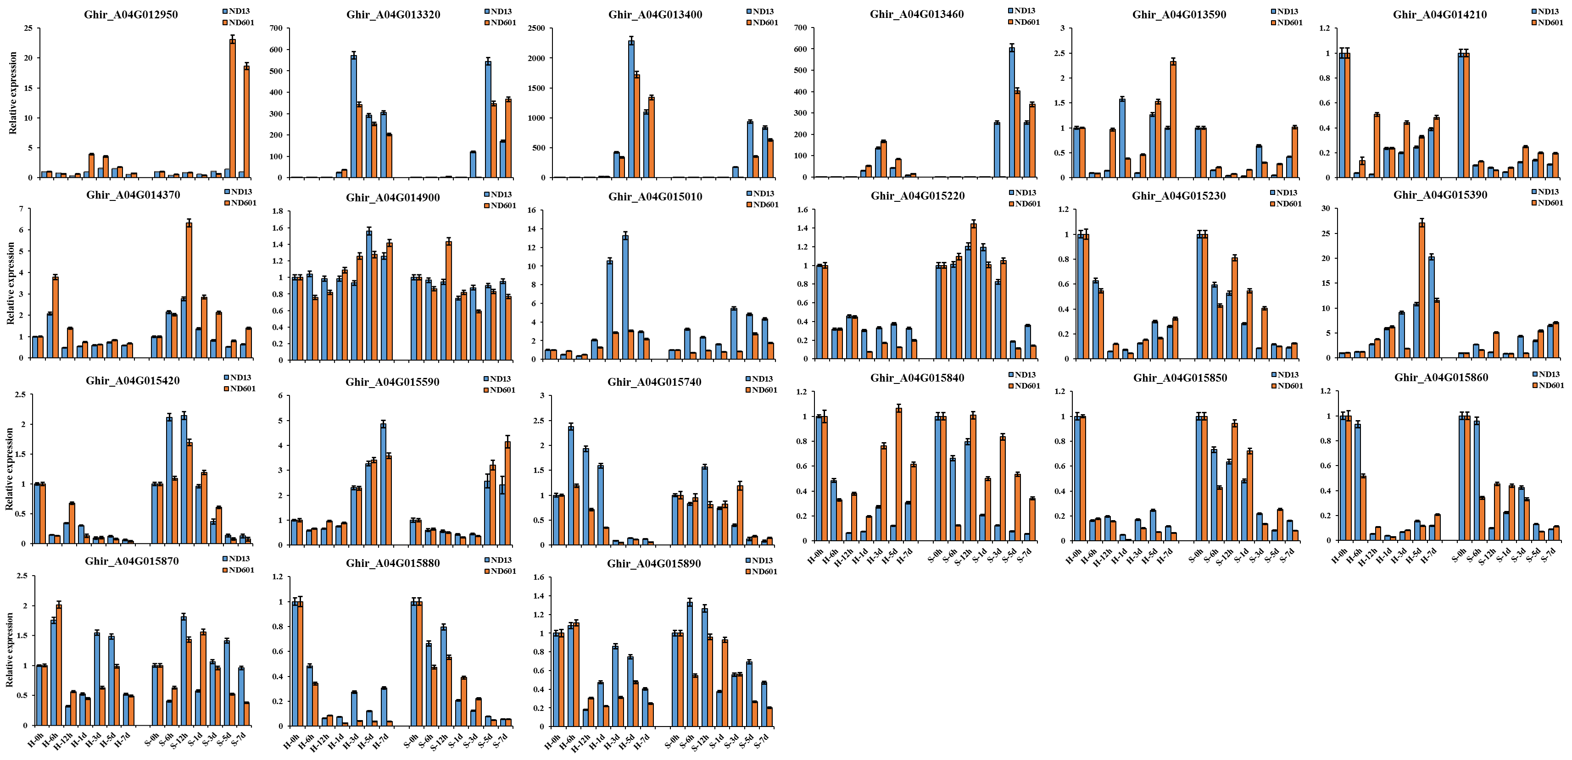

Fig. S3 The relative expression of 21 genes in germination between two parents.
Note: Quantification of genes in QTL qRGR-A04-1 by qRT-PCR at 0 h, 6 h, 12 h, 1 d, 3 d, 5 d and 7 d in germination between two parents. H and S indicating the seeds under the water and salt treatment, respectively. Values are means with SD (n = 3 biological replicates).

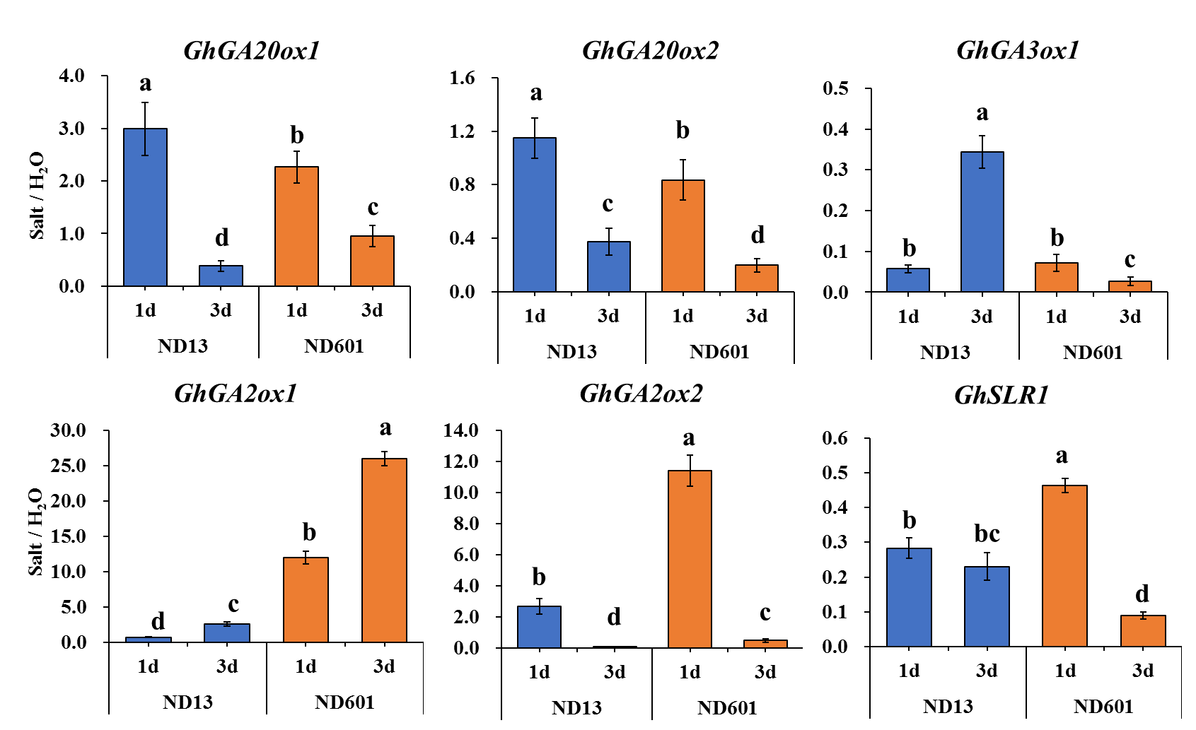
Fig. S4 The transcript-level of GA-related genes between both parents in germination under salt stress.
GhGA20ox1, GhGA20ox2, GhGA3ox1, were GA-related genes encoding active GAs. GhGA2ox1 and GhGA2ox2 were GA-related genes encoding inactive GAs. GhSLR1 was a DELLA protein. The seeds were treated with 0.3% NaCl and sampled at 0 h, 6 h, 12 h, 1 d, 3 d, 5 d and 7 d and the water treatment as the control to calculate the relative value. Different letters at the top of each column indicate significant differences, as determined by ANOVA (p < 0.05). The data are presented as the means ± SEs.

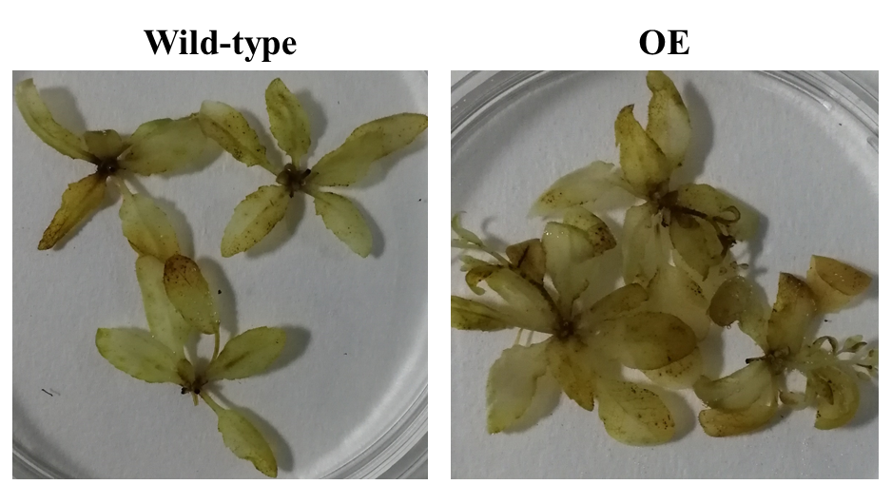

Fig. S5 DAB staining of H₂O₂ in GhADC2-overexpressing Arabidopsis after salt stress.

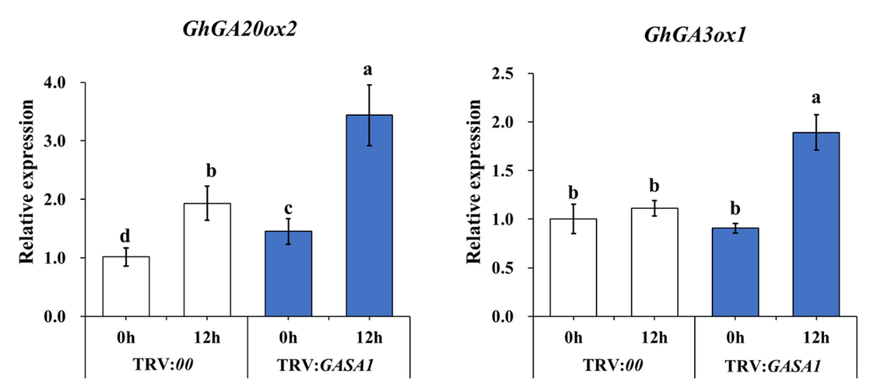
Fig. S6 The expression levels of genes related to GAs biosynthesis in TRV:GASA1 after salt stress.
Different letters at the top of each column indicate significant differences at P < 0.05 (n = 3 biological replicates) by the Student’s t-test. Error bars indicate s.e.m.

