Additional file 1 Sequences for real-time PCR primers
Genes¹ | Primer sequence²(5′-3′) | Accession no.
β-Actin | F: GAGAAATTGTGCGTGACATCA | L08165
 | R: CCTGAACCTCTCATTGCCA
GYS2 | F: ATCGCCTTCTGTCTCTCAGC | XM_015291547.1
 | R: TTTTGCCTATCCCTTTCAGC
INSR | F: CTCCCTTCTGTAACCGTGGT | XM_001233398.4
 | R: TCTGTAGTGACGAGGATGCC
Claudin-2 | F: CCTGCTCACCCTCATTGGAG | NM_001277622.1
 | R: GCTGAACTCACTCTTGGGCT
SOD3 | F: TTGTGATCCATGAGCAGGAA | XM_015285700.2
 | R: TTGTTGCAGATCCCAATCAC
FABP1 | F: GGGGAAGAGTGTGAGATGGA | NM_204192
 | R: GTTGAGTTCGGTCACGGATT
FABP2 | F: TGGCATTTAACGGTACTTGGA | NM_001007923
 | R: TCAGATTATCGTGGGCTCCT
LPL | F: ACTTGAAGACCCGTGCTCAG | NM_205282
 | R: GGCTGGTCTACCTTGGTCAC
APOA1 | F: GTGACCCTCGCTGTGCTCTT | NM 205525
 | R: CACTCAGCGTGTCCAGGTTGT
TXN | F: GATTTCTCTGCCACATGGTGT | NM_205453.1
 | R: ATCTTGGGCATCATCCACAT
NDUFS6 | F: ACGGCAAAAGGAGGTGAACA | XM 419061
 | R: CAACCTCACTCACAGGCTGC
GSTM2 | F: GGCAACCTGAGCCAATTCCT | NM_205090.1
 | R: CCACCCCCCTCACTCTTTCT
GSTA3 | F: TTGGATAAGGCCGCAAACAGATA | NM_001001777.1
 | R: TTTCCAGTAAATGCACGTCTGCTC
¹ GYS2, glycogen synthase 2; INSR, insulin receptor; SOD3, extracellular superoxide dismutase; FABP, fatty acid-binding protein; LPL, lipoprotein lipase; APOA1, apolipoprotein A1; TXN, thioredoxin; NDUFS6, NADH dehydrogenase (ubiquinone) iron-sulfur protein 6; GST, glutathione S-transferase.
² F, forward; R, reverse.
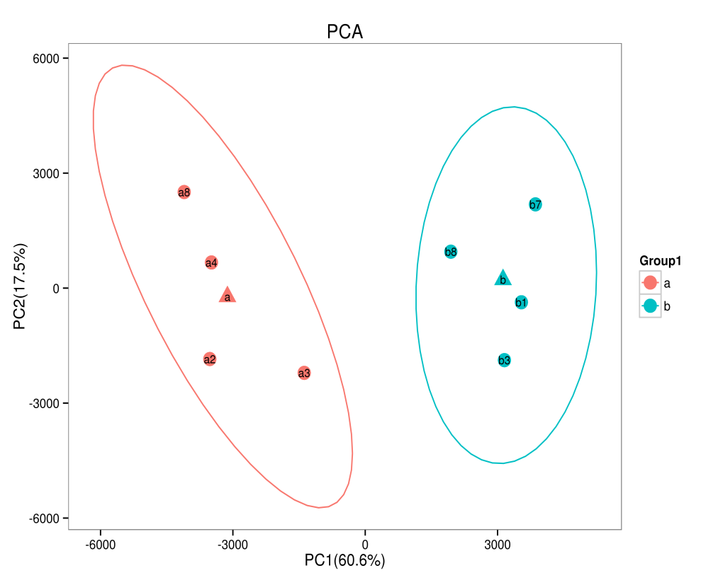
Additional file 2 Principal component analysis (PCA) plot of gene expression profile of the layer intestine between groups.
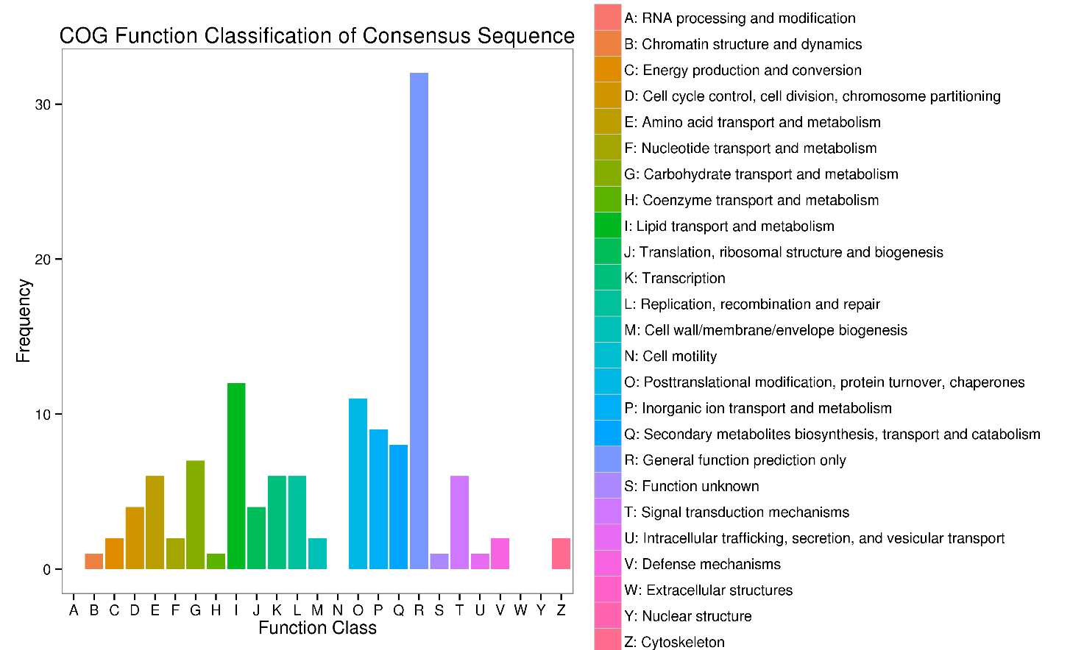
Additional file 3 Clusters of Orthologous Genes (COG) classification of differentially expressed genes of the layer intestine between groups.
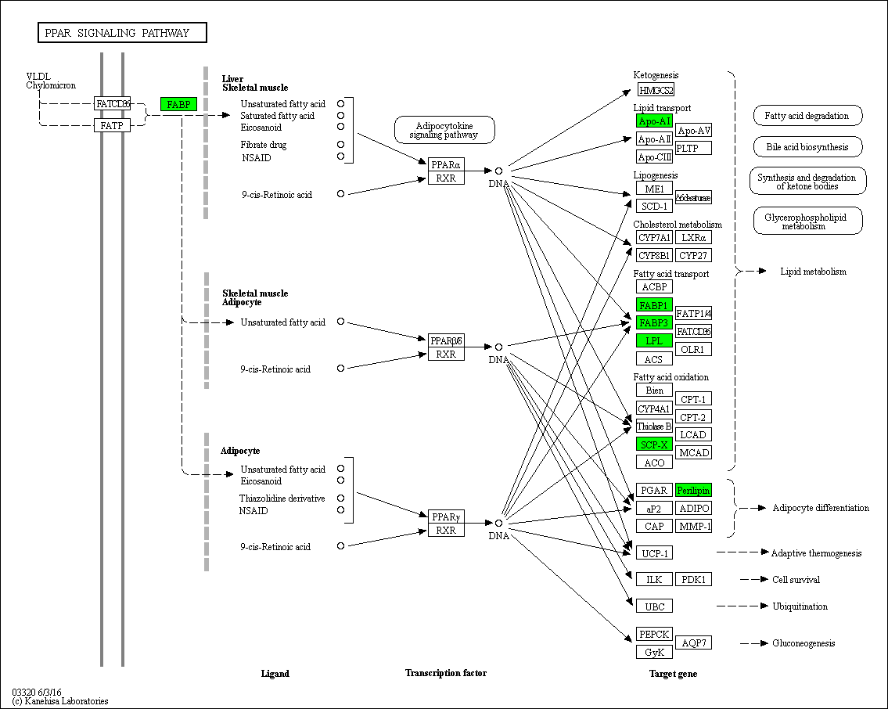
Additional file 4 Sketch map of peroxisome proliferators-activated receptors (PPAR) signaling pathway.
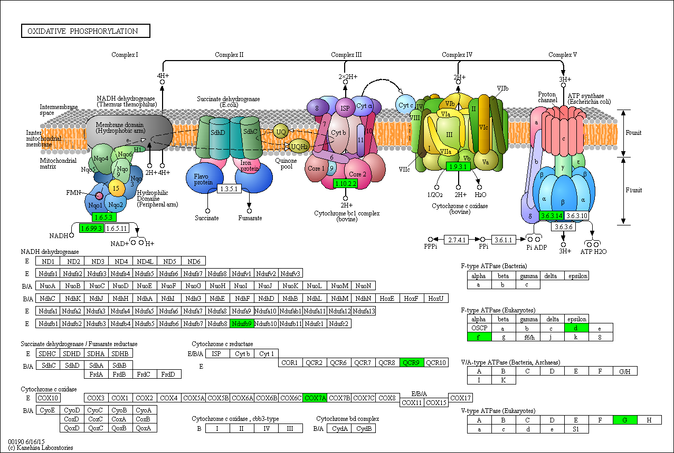
Additional file 5 Sketch map of oxidative phosphorylation pathway.
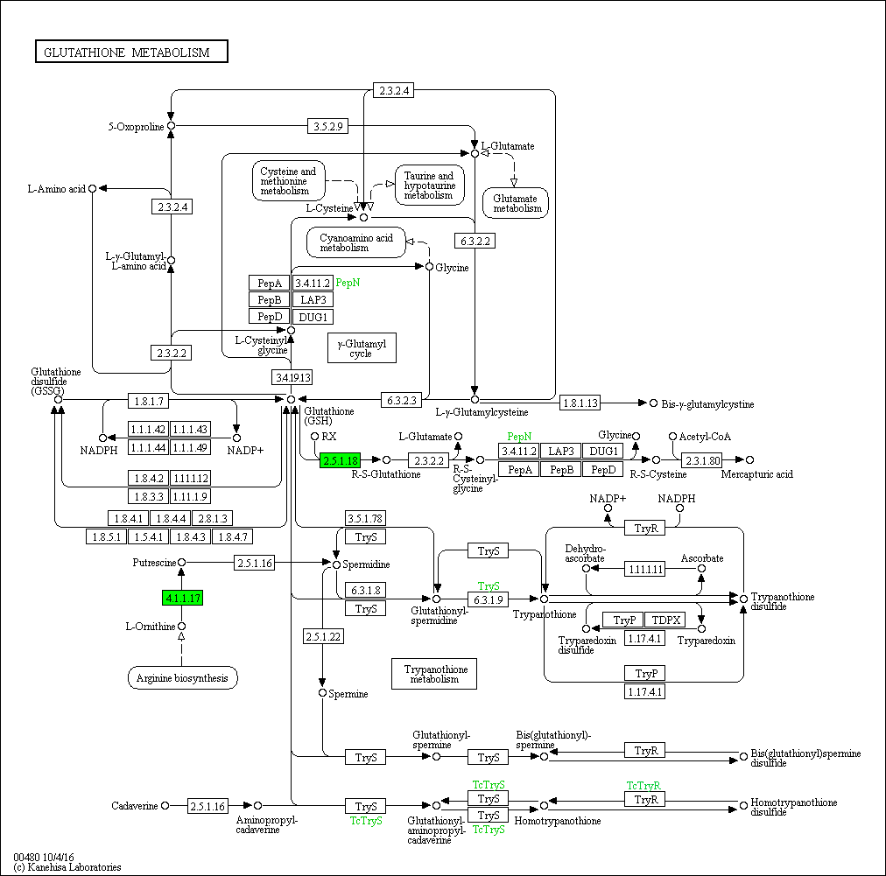
Additional file 6 Sketch map of glutathione metabolism pathway.
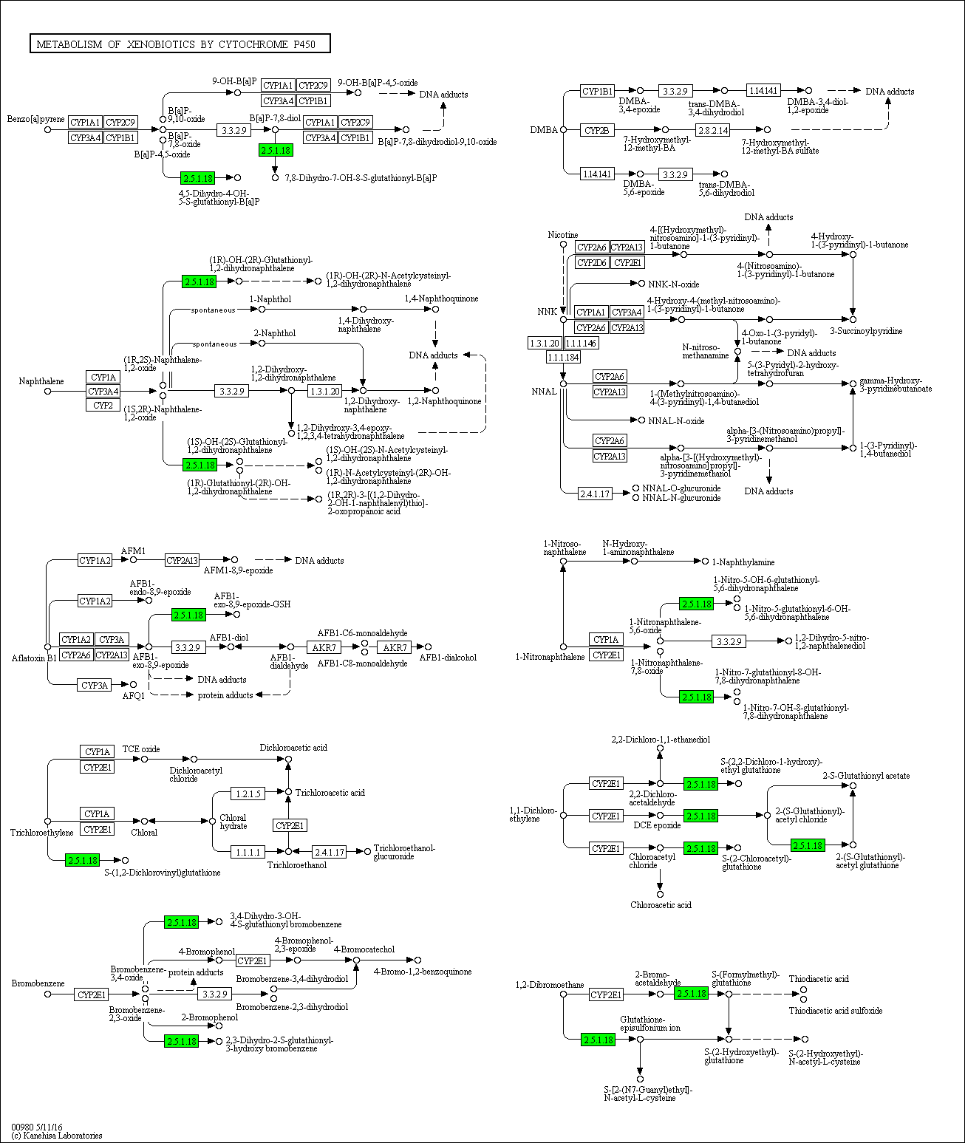
Additional file 7 Sketch map of metabolism of xenobiotics by cytochrome P450.

