**

Table S1. Polymorphisms in the predicted genes between *LG1_116453465* and *LG1_117977450*.

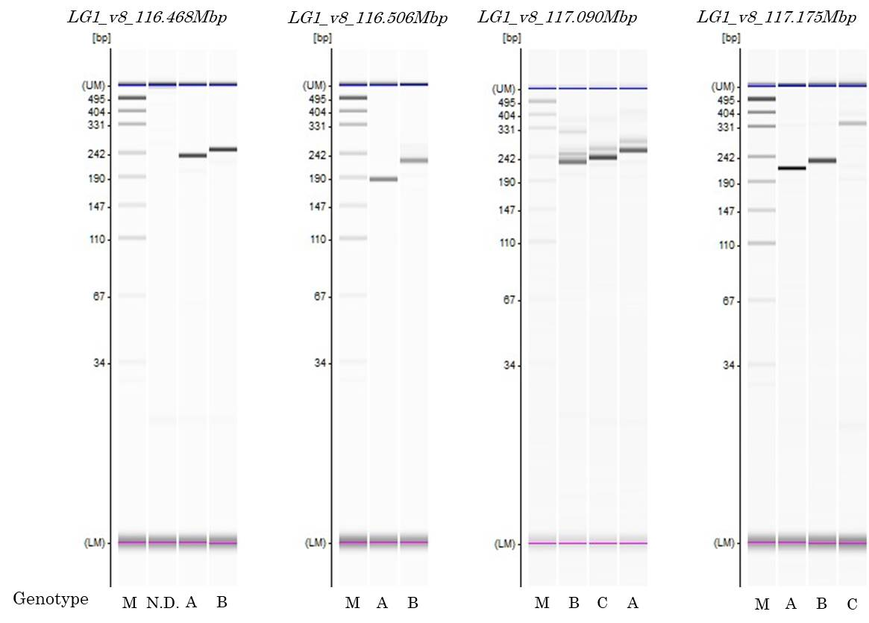

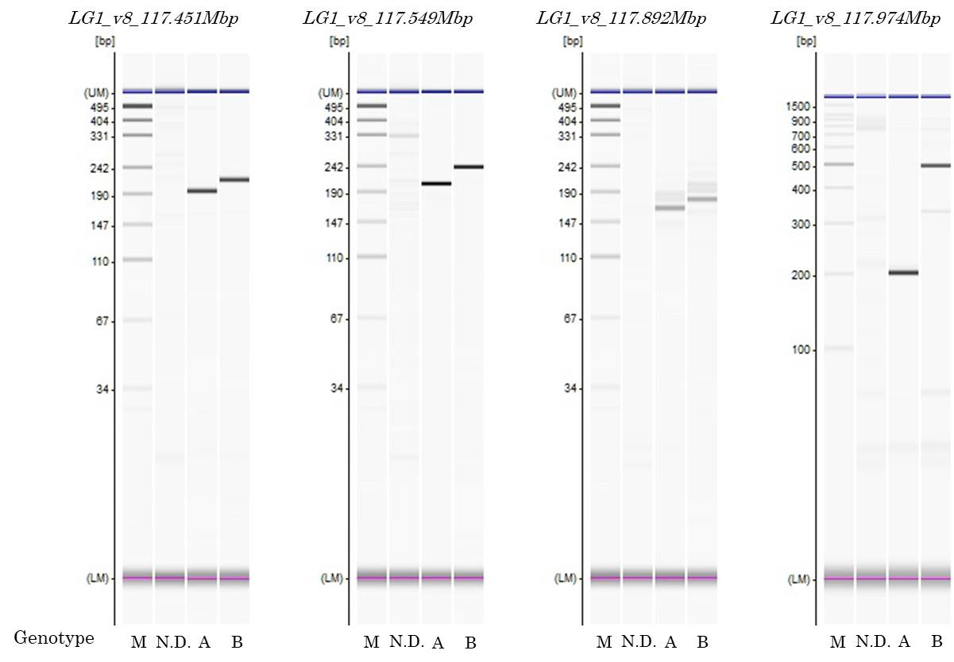

Fig. S1.

**The genotype profiles of amplification products of PCR-based markers in *qFOL1.2* by capillary electrophoresis on a MCE202 MultiNA.**

“A” indicates the genotype of ‘VI185’. “B” indicates the genotype of ‘ShinanoGreen’. “C” indicates the genotype other than “A” or “B”. “N. D.” indicates No Band. “M” indicates ladder marker.