*Supporting Information for*

**Bottom-up Fabrication and Atomic-scale Characterization of**

Triply-linked, Laterally π-Extended Porphyrin Nanotapes

Qiang Sun,⊥,*ǂ,*¶ Luis M. Mateo,†,‡,¶ Roberto Robles,‖,¶ Nicolas Lorente,‖,º,* Pascal Ruffieux,⊥ Giovanni Bottari,*,†,‡,§ Tomás Torres*,†,‡,§ and Roman Fasel*,⊥,+

⊥ nanotech@surfaces Laboratory, Empa-Swiss Federal Laboratories for Materials Science and Technology, 8600 Dübendorf, Switzerland.

† Departamento de Química Orgánica, Universidad Autónoma de Madrid, 28049 Madrid, Spain

‡ IMDEA-Nanociencia, Campus de Cantoblanco, 28049 Madrid, Spain.

‖ Centro de Física de Materiales CFM/MPC (CSIC-UPV/EHU), Paseo de Manuel de Lardizabal 5, 20018 Donostia-San Sebastián.

º Donostia International Physics Center (DIPC), 20018 Donostia-San Sebastián, Spain.

§ Institute for Advanced Research in Chemical Sciences (IAdChem), Universidad Autónoma de Madrid, 28049 Madrid, Spain.

ǂ Materials Genome Institute, Shanghai University, 200444 Shanghai, China.

+ Department of Chemistry and Biochemistry, University of Bern, 3012 Bern, Switzerland.

¶ These authors contributed equally to the paper

E-mail: roman.fasel@empa.ch (R.F.); tomas.torres@uam.es (T.T); giovanni.bottari@uam.es (G.B.); nicolas.lorente@ehu.eus (N.L.)

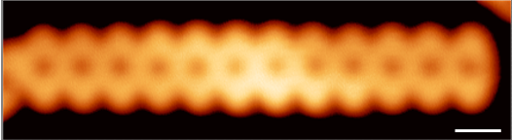

**Fig. S1.0** STM image of **Por12 NT** comprising 12 triply-fused Por units (*V*s = ‒0.05 V, *I*t = 300 pA, Scale bar: 1 nm). Note that the NT is fused to another NT at its left end.

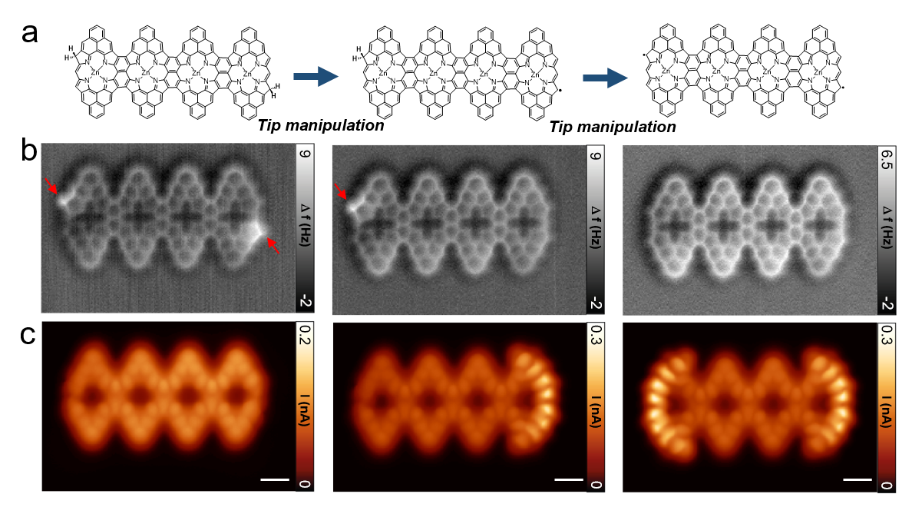

**Fig. S1.1** **a**, Chemical scheme of the tip-induced dehydrogenation of the CH2 sites at the ends of **Por4 NT**. **b**, Constant-height nc-AFM images of **Por4 NT** before (left) and after consecutive tip-induced dehydrogenations (center and right). The arrows indicate the CH2 structures at the *β* positions of the Por core. **c**, Constant-height STM images of the corresponding structures at – 5 mV, revealing the Kondo resonance spatially localized at the ends without CH2 structures. Scale bars: 5 Å. The removal of the hydrogens was carried out by positioning the tip above the CH2 site at a typical set point of V = ‒0.1 V and I = 10 pA, followed by a tip retraction of 4 Å. Thereafter, the bias voltage was ramped up to 3.4 eV until an abrupt change of the tunneling current occurred.

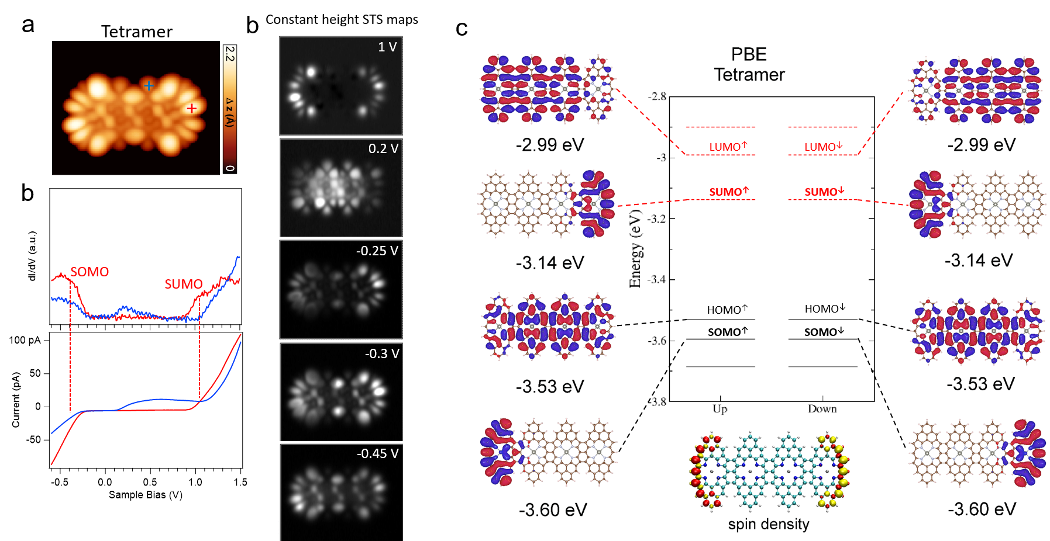

**Fig. S1.2** **a**, STM image of a decoupled **Por4 NT** (on NaCl/Au(111), *V*s = ‒0.3 V, *I*t =30 pA). **b**, d*I*/d*V* and simultaneously acquired current spectra recorded over the tape (spectra positions indicated by crosses in **a**). **c**, Constant-height STS maps at different bias voltages. **d**, Spin-polarized DFT calculated molecular orbitals and energy levels of **Por4 NT** in gas phase. There are two degenerate states for both SOMO and SUMO located at the ends of the tape.

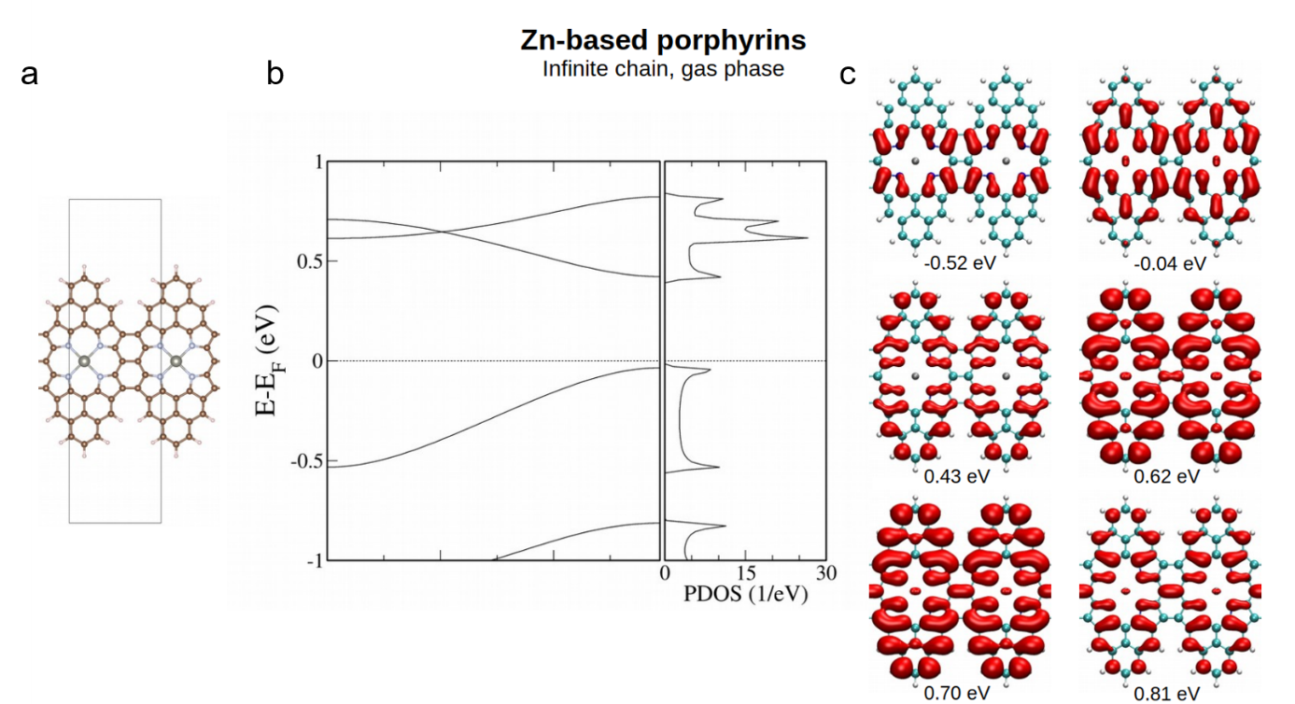

**Fig. S1.3** **a**, Model structure of an infinite Por NT in gas phase with its unit cell indicated by a rectangle. **b**, DFT calculated band structure of the infinite Por NT and its corresponding projected density of states. The band gap of the Por NT is determined to be 0.46 eV. **c**, Plots of the square of the wave functions at indicated energies.



**Fig. S1.4** Some of the possible resonance structures of **Por2 NT**.

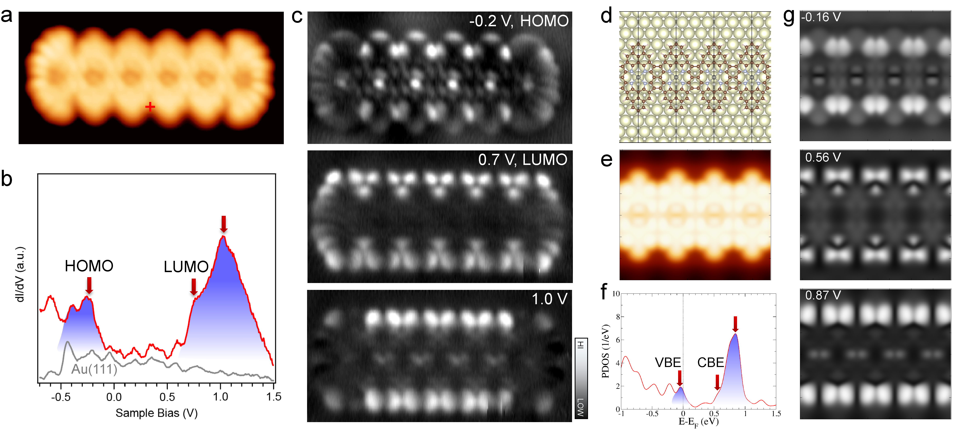

**Fig. S1.5** **Frontier orbital gap of Por NT on Au(111). a** STM image of **Por6 NT** on Au(111) (*V*s = ‒0.4 V, *I*t = 220 pA). **b**, Differential conductance d*I*/d*V* spectrum revealing the gap of the Por NT (*V*mod = 20 mV) (spectrum acquisition position indicated by red cross in **a**). The frontier orbitalsare indicated by red arrows. **c**, Constant-current d*I*/d*V* maps of **Por6 NT** at different bias voltages, with -0.2 V and 0.7 V corresponding to HOMO and LUMO, respectively. **d**, DFT optimized structural model of an infinite Por NT. The periodic unit cell is marked by black lines. **e**, DFT simulated topographic STM image of Por NT in **d**. **f**, Projected density of states (PDOS) of Por NT on Au(111) computed by DFT. The red arrows indicate the energy positions of the valence band edge (VBE) and conduction band edge (CBE). **g**, DFT simulated d*I*/d*V* maps of the surface supported Por NT at different energies including the VBE (-0.16 V) and CBE (0.56 V), corresponding to the maps in the central parts of the finite Por NT in **c**.

Experimentally, d*I*/d*V* spectra were recorded on the central part of a finite-length Por NT, namely **Por6 NT**, to access its "bulk" electronic properties on Au(111) (Figs. S1.5a and S1.5b). Two broad peaks in the negative and positive bias range are discerned. By recording d*I*/d*V* maps at the characteristic bias voltages, we could clearly see the density of states distributing along the NT (Fig. S1.5c). The DFT calculated projected density of states (PDOS) of an infinite Por NT on Au(111) nicely reproduces the two broad peaks at negative and positive energies, respectively (Fig. S1.5f). Moreover, the simulated d*I*/d*V* maps at the corresponding energies with respect to their experimental counterparts show remarkable agreement with the "bulk" parts of the experimental d*I*/d*V* maps (Fig. S1.5g). These observations suggest that the frontier orbitals of the Por NT on Au(111) are at ‒0.2 V and 0.7 V, respectively, and therefore a frontier orbital gap of 0.9 eV on Au(111). We note that the experimentally determined gaps of longer Por NTs are nearly the same, namely 0.9 eV for the **Por12 NT**. We have also calculated the length evolution of the gap with DFT (Supplementary Fig. S1.6). Excluding the spin-polarized SOMO and SUMO states localized at the tape ends, the bulk gap decreases from 0.71 eV for **Por2 NT** to 0.50 eV for **Por6 NT**, converging towards the value of the infinite Por NT (0.46 eV). If we also consider the SOMO and SUMO end states, the frontier gap decreases from 0.46 eV to 0.36 eV for **Por2 NT** to **Por6 NT**, respectively. We note that a qualitative comparison of these values with the experimental ones would need to take the band gap underestimation of DFT and the screening by the underlying metal substrate into account1.

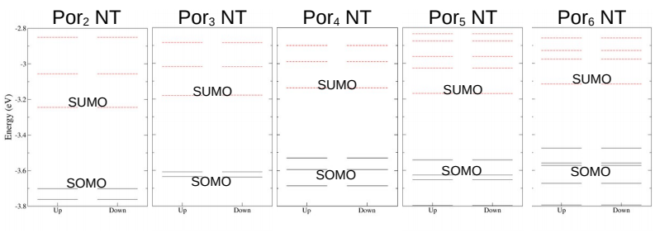**Fig. S1.6** Spin-polarized DFT calculated energy levels for Por NTs in the gas phase. The spin-polarized SUMO and SOMO states are labeled. Here the spin-polarized states at the ends are all antiferromagnetically coupled. We find that the SOMO-SUMO energy gap is constant (0.46 eV) for all tape lengths investigated, reflecting the localized nature of the spin-polarized end states. As the length of the NT increases the bulk HOMO-LUMO gap shrinks, and from **Por3 NT** onwards the HOMO moves energetically beyond the SOMO which is no longer the most frontier orbital.

**References**

[1] J. B. Neaton, M. S. Hybertsen, and S. G. Louie, *Phys. Rev. Lett.* **2006**, *97*, 216405.