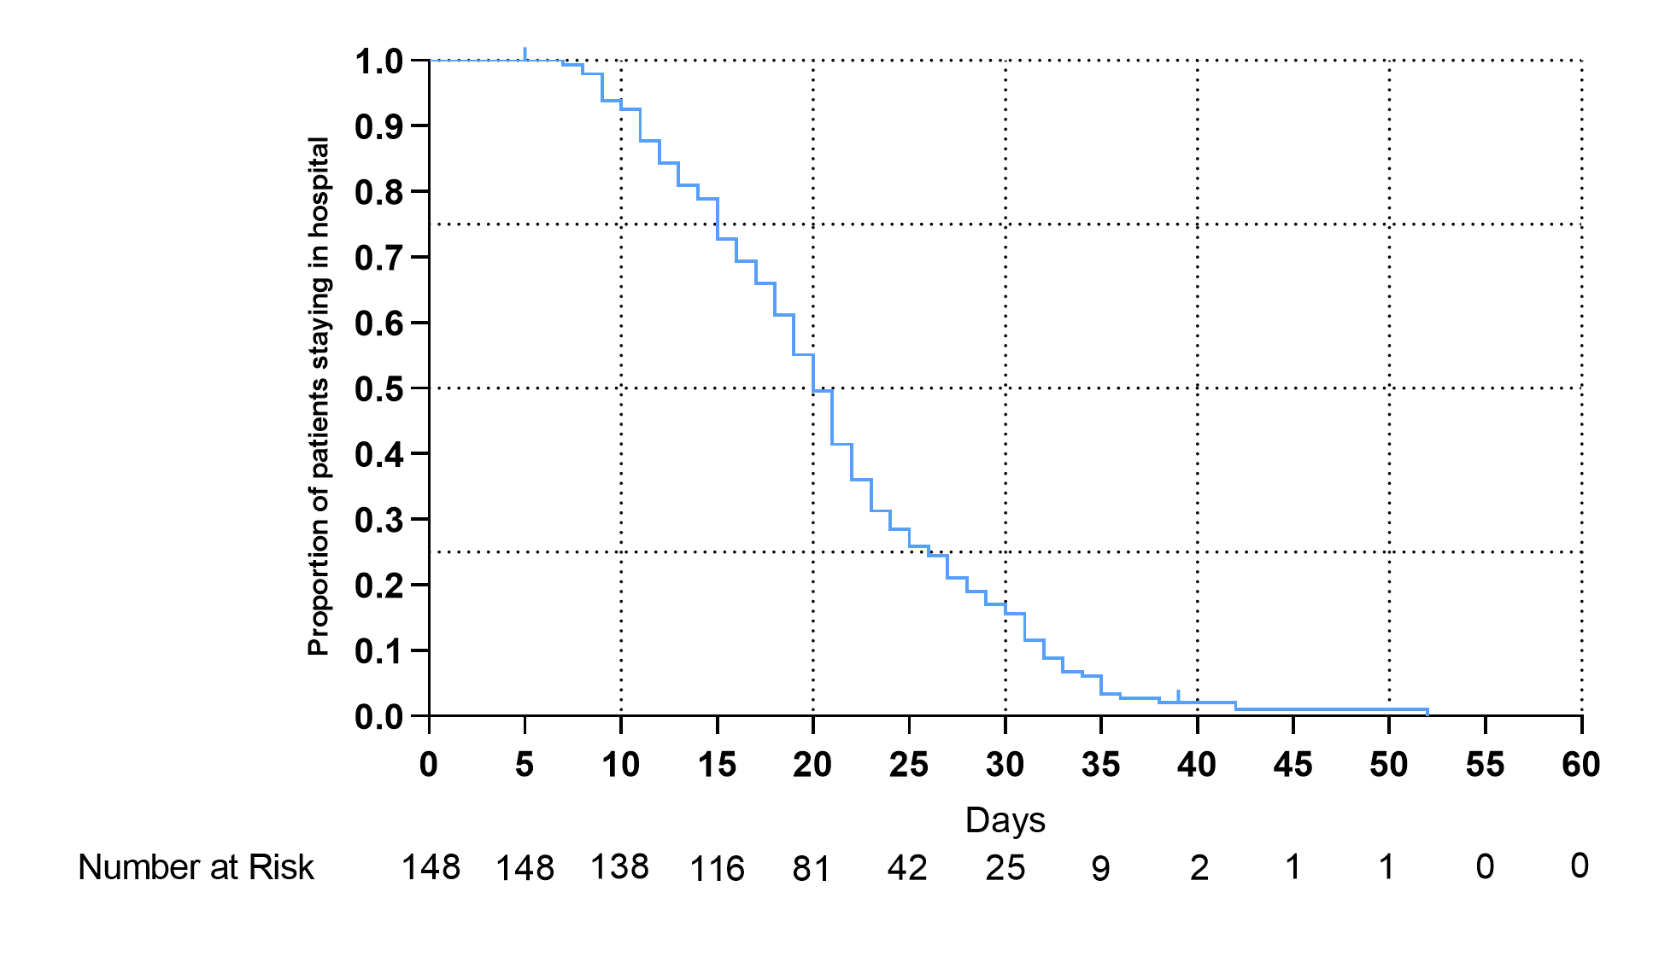
sFigure 1 The process of discharge among patients with confirmed COVID-19 in Wenzhou

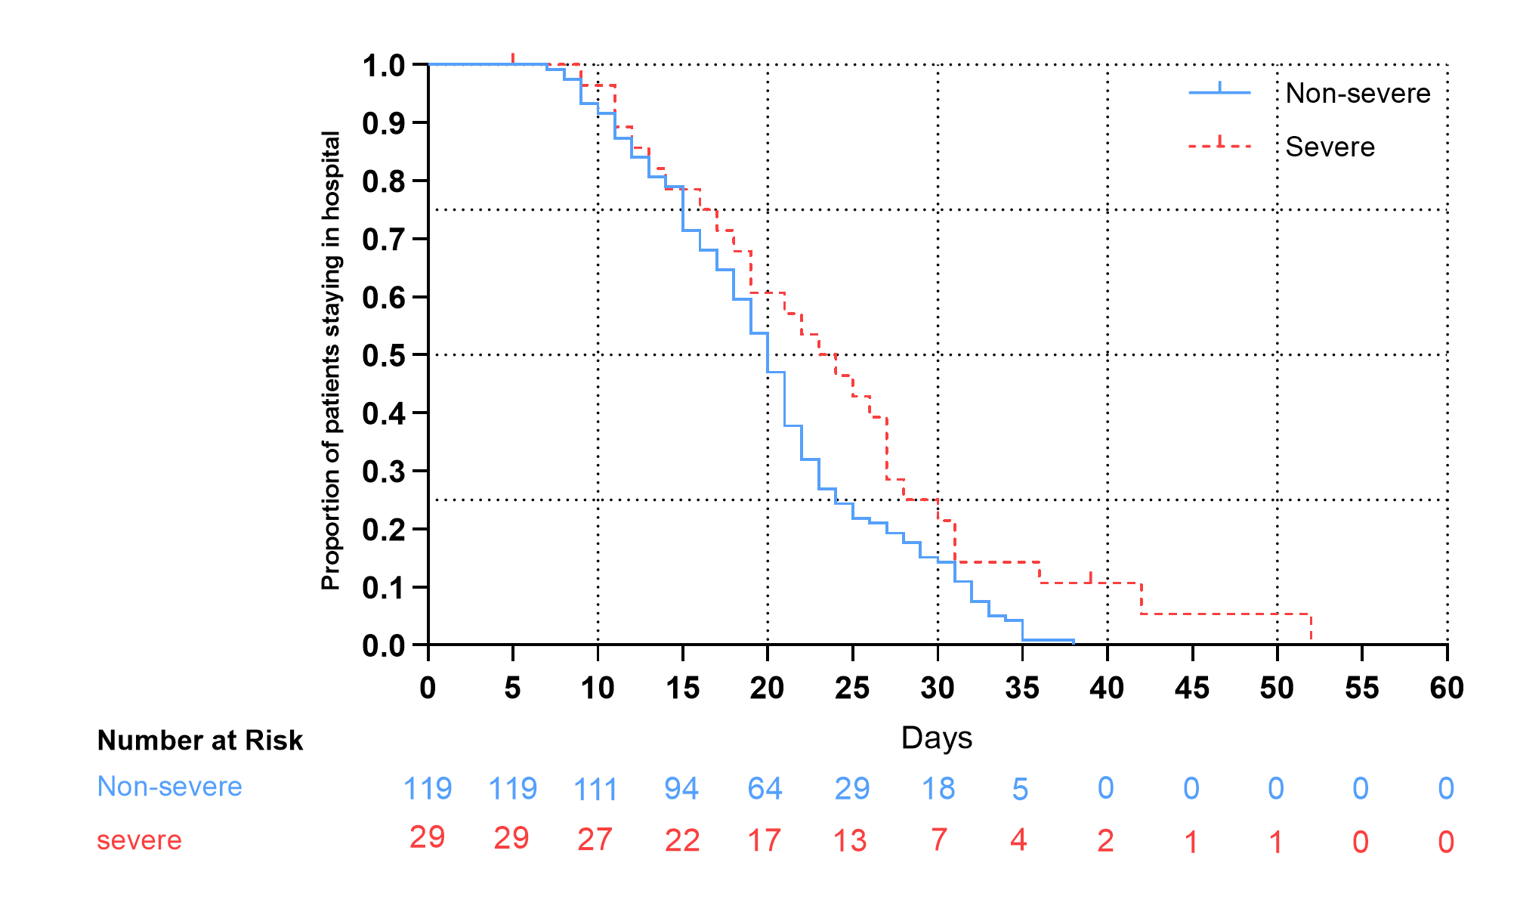
sFigure 2 Comparison of the discharge proportion between the non-severe and severe patients

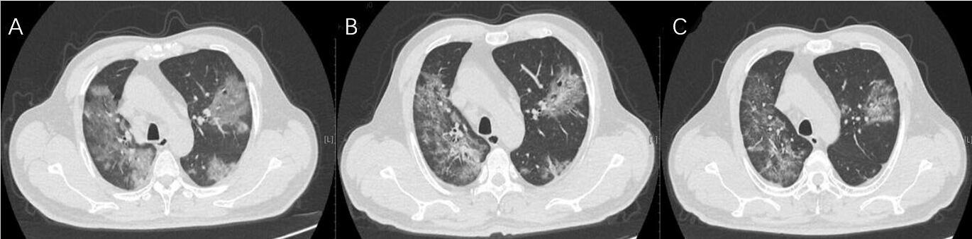
sFigure 3 | Transverse chest computed tomograms of an elderly patient. Imaging at admission(A), showing ground glass opacity and air bronchogram sign, and on fourth (B) and eighth (C) days after admission, showing reduced lesion size and density.

