Supplemental materials

Supplementary 1: Lecture videos
Supplementary 2: Emotional videos
Supplementary 3: Emotional stimuli result in first pilot study

Table A1 Climate change lecture syllabus
Lecture | Main contents
Lecture 1 Climate change science | - Concepts of weather, climate, climate change, and global warming  - Greenhouse effect
Lecture 2 Global climate change impact | - Observed trends in climate change, surface temperatures rising, polar glaciers melting, and sea levels rising  - Global climate change impact, sea levels rising, extreme weather, food security, ecosystems, and human health
Lecture 3 Causes of climate change | - Enhanced greenhouse effect  - Greenhouse gases and human activity  - The global carbon cycle  - Major human activities affecting climate change
Lecture 4 Climate change mitigation action | - The Paris Climate Agreement  - The carbon footprint  - Individual actions to mitigate climate change

Table A2 Emotion survey
How did the video make you feel? | 1 (not at all) | 2 | 3 | 4 | 5 (extremely)
Anxious
Afraid
Worried
Hopeful
Encouraged
Optimistic
Sad
Upset
Disappointed
Careless
Calm
Relaxed
Happy
Excited
Energetic

Table A3 Survey questions included in the analysis
Measure | Questions
Climate change concern (0.81) | - How worried are you about climate change?
 | - How much do you think climate change will negatively affect you personally?
 | - When do you think climate change will start to negatively affect people in China?
 | - How much do you think climate change will negatively affect future generations?
Climate change involvement (0.78) | - I have thought about climate change before.
 | - Climate change is important to me.
 | - I want to learn more about climate change.
 | - My family members have shared climate change information with me.
 | - The city I reside in is affected by climate change.
Self-efficiency (0.85) | - I feel I know what I can do for climate change mitigation at home.  - I think my low-carbon lifestyle (walking, biking to school) can motivate other kids to take action.
- I know what energy-saving actions (such as saving water, electricity, etc.) can do to mitigate climate change.
- I think the recycling of waste (such as paper, cans, plastic, etc.) can effectively reduce the carbon emissions of households.
- Climate change can be controlled if everyone participates in reducing our carbon footprints.
Mitigation behavior (0.84) | - In the last 2 weeks, I searched for information about climate change.
 | - In the last 2 weeks, I paid attention to climate change information in other courses.
 | - In the last 2 weeks, I talked about climate change information with a friend.
 | - In the last 2 weeks, I advised my family to conserve water.
 | - In the last 2 weeks, I reduced plastic bag use when shopping.
 | - In the last 2 weeks, I chose to walk or bike when going to nearby places.
Mitigation behavior intention (0.85) | - In the next year, I will acquire more knowledge about climate change.
 | - In the next year, I will reduce my use of disposable products.
 | - In the next year, I will reduce energy use (such as electricity, water, etc.) in my home to mitigate climate change.
 | - In the next year, I will recycle my unused items.
Climate science knowledge (0.76) | - Burning oil, among other things, produces carbon dioxide (CO₂).
 | - Holes in the ozone layer are the main cause of the greenhouse effect.
 | - Weather and climate are different names for the same thing.
 | - At the same quantity, CO₂ is more harmful to the climate than methane.
- Greenhouse gases such as CO₂ are emitted entirely by mineral extraction and industrial and agricultural production, not by individuals.
- Global warming is essentially an enhanced greenhouse effect caused by human activities.
- The melting of Arctic ice and snow caused by global warming will cause sea levels to rise.
- Temperatures around the world will rise evenly over the next few decades.
 | - Over the next several decades, we can expect some places to get wetter, while others get drier.
- Which of the following gases is not a greenhouse gas? CO₂, CH₄, N₂, H₂O
- Which of the following observations cannot be used to illustrate warming trends? surface temperature, eruption frequency, polar ice cover, sea level rise.
- Carbon circulates most slowly in which of the following circles? atmospheric sphere, hydrosphere, biosphere, lithosphere.
- Which is a false description of low carbon life?
Select and purchase local food whenever possible.
Use clean energy at home, such as solar energy.
Eat more meat and fewer vegetables.
Make one less family driving trip each week.
- The long-term goal of the Paris Climate Accord is to limit the rise in average global temperatures this century to ___ degree/s above pre-industrial levels. 4℃, 3℃, 2℃, 1℃.
 | - Global warming threatens to some extent the survival of living organisms. Which of the following organisms or communities will have an extinction rate of up to 99% at 2℃? Polar bear, coral reef, taiga, mangrove forest.
Big Five Personality  Agreeableness  Conscientiousness  Extroversion  Neuroticism  Openness | I see myself as someone who…  …is reserved (E1R)  …is generally trusting (A1)  …tends to be lazy (C1R)  …is relaxed, handles stress well (N1R)  …has few artistic interests (O1R)  …is outgoing, sociable (E2)  …is considerate and kind to almost everyone (A2)  …is easily distracted in study (C2R)  …gets nervous easily (N2)  …has an active imagination (O2)
Demographics | name; age; gender; nation
α = Cronbach’s alpha. Cronbach’s alpha is a measure of scale reliability, where scores higher than 0.7, are considered reliable. The first nine questions were true or false items, and the last six questions were single choice items. Scoring the BFI-10 scales: Extraversion: E1R, E2; Agreeableness: A1, A2; Conscientiousness: C1R, C2; Neuroticism: N1R, N2; Openness: O1R, O2; R = item is reversed scored.

Table A4 Principal component analysis of “Big Five Personality”
Component | Items | Factor loadings | BFI-10
Agreeableness | …is considerate and kind to almost everyone (A2)  …is generally trusting (A1)  …has an active imagination (O2)  …is relaxed, handles stress well (N1R) | 0.737  0.695  0.644  -0.615 | A  A  O  N
Conscientiousness | …is easily distracted in study (C2R)  …tends to be lazy (C1R)  …gets nervous easily (N2) | 0.807  0.703  -0.700 | C  C  N
Extraversion | …is reserved (E1R)  …is outgoing, sociable (E2) | 0.866  0.590 | E  E
Openness | …has few artistic interests (O1R) | 0.783 | O
The capital letter of the items represents the personality dimensions on the BFI-10 scale; R represents the reverse design; and the numbers represent the order of the items on the scale. For example, A2 refers to Question 2 in agreeableness.

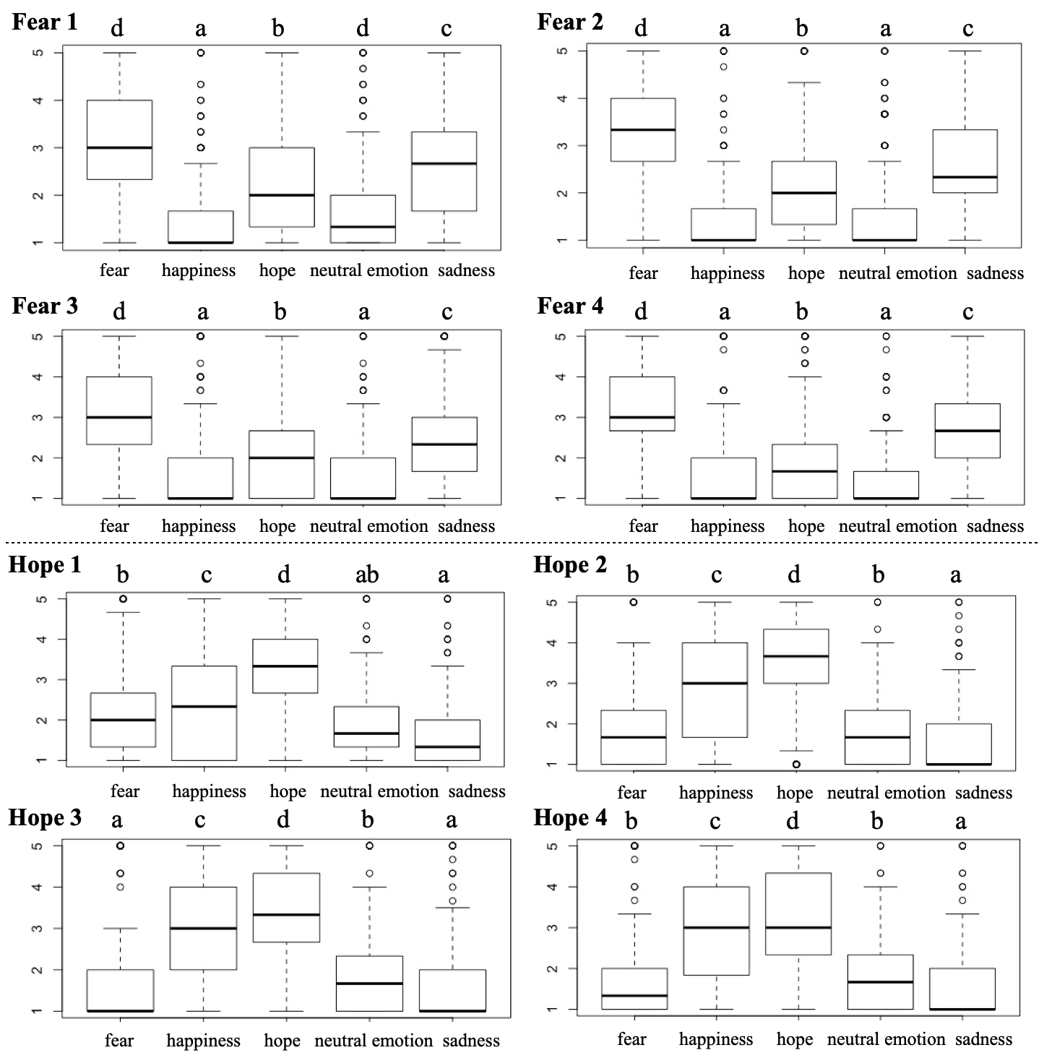
Fig.A1 Turkey HSD analysis of students' self-reported emotions induced by fear and hope videos. Figures 1–4 are a comparison of the arousal of the students' self-reported five emotions (fear, happiness, hope, neutral emotions, and sadness) induced by four fear videos, Figures 5–8 are a comparison of students' self-reported five emotions induced by four hope videos. The themes of the videos are: fear 1—“The Super Typhoon Saomai”; fear 2—“Sea level rising”; fear 3—“Extreme weather”; fear 4—“The Super Typhoon Haiyan”; hope 1—“Carbon sequestration technology”; hope 2—“New clean energy”; hope 3— “Technical leapfrog in developing countries”; and hope 4—“The Paris Agreement.”

Supplementary 3 emotional stimuli result in first pilot study
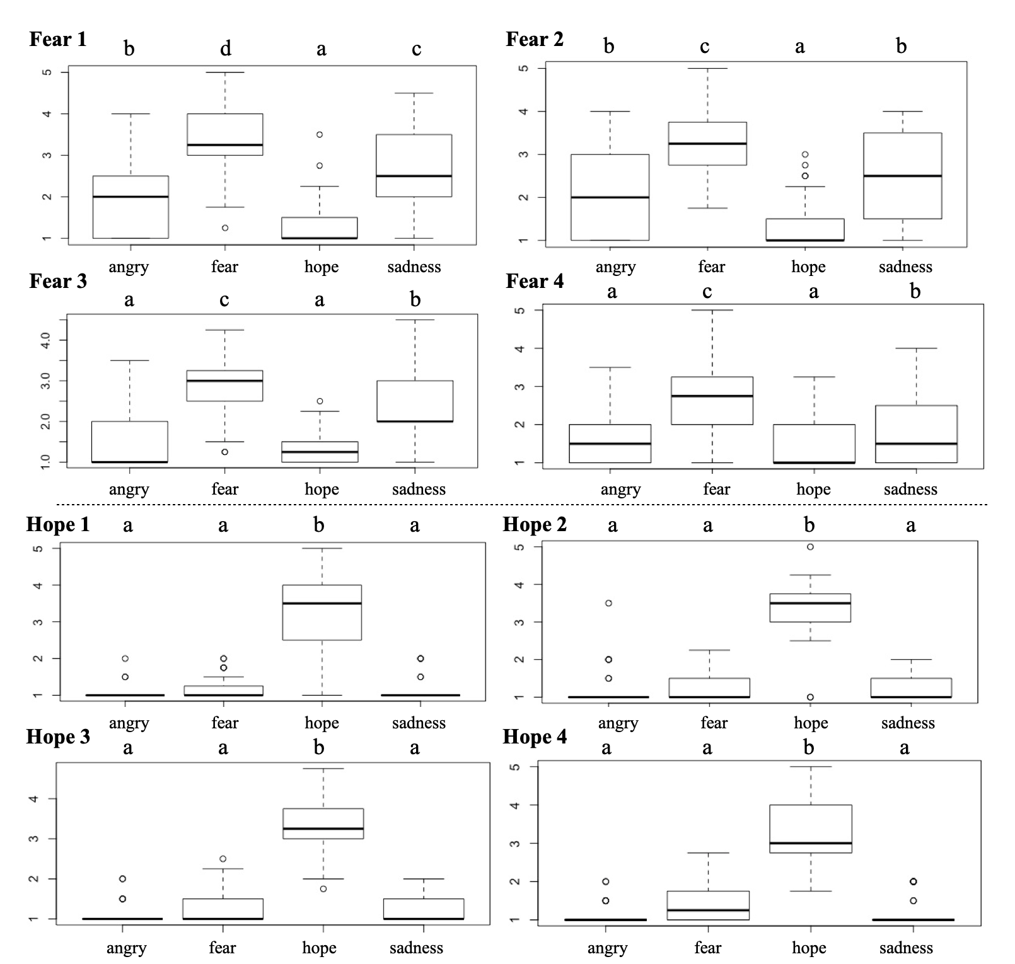
Fig.A2 Turkey HSD analysis of students' self-reported emotions induced by fear and hope videos. Figures 1–4 are a comparison of the arousal of the students' self-reported four emotions (fear, anger, hope, and sadness) induced by four fear videos, Figures 5–8 are a comparison of students' self-reported four emotions induced by four hope videos. The themes of the videos are: fear 1—“The Super Typhoon Saomai”; fear 2—“Sea level rising”; fear 3—“Extreme weather”; fear 4—“Mosquito-borne virus”; hope 1—“Carbon sequestration technology”; hope 2—“New clean energy”; hope 3— “Technical leapfrog in developing countries”; and hope 4—“The Pairs Agreement.”

