Size-dependent growth tactics of a partially migratory fish before migration

Ryo Futamura, Kentaro Morita, Yoichiro Kanno, Shoji Kumikawa, Yuichi Matsuoka, Atsushi Okuda, Hiroshi Sugiyama, Hiroyuki Takahashi, Jiro Uchida, Osamu Kishida*
* Corresponding author: kishida@fsc.hokudai.ac.jp

Statistical analyses on growth rate
Table S1. Formulae of eight models used to test the first prediction.
Model | Response variable | Fixed factor | Random factor
A | GR of FL in winter period | FL at autumn, Life history, Year, Habitat section and their interaction
B | GR of BM in winter period | BM at autumn, Life history, Year, Habitat section and their interaction
C | GR of FL in winter period | FL at autumn, Life history, Year and their interaction | Habitat section
D | GR of BM in winter period | BM at autumn, Life history, Year and their interaction | Habitat section
E | GR of FL in spring period | FL at early spring, Life history, Habitat section and their interaction
F | GR of BM in spring period | BM at early spring, Life history, Habitat section and their interaction
G | GR of FL in spring period | FL at early spring, Life history and their interaction | Habitat section
H | GR of BM in spring period | BM at early spring, Life history and their interaction | Habitat section
Abbreviations: GR (growth rate), FL (fork length), BM (body mass).

Table S2. Results of eight models predicting growth rate.
Model | Fixed factor | Estimate |  | SE | t value | p-value
A | Intercept | 0.33 |  | 0.04 | 8.20 | <0.001
 | FL at autumn |  | 2.4 × 10⁻⁶ | 4.1 × 10⁻⁴ | -5.85 | <0.001
 | Life history |  | -0.21 | 0.06 | -3.59 | <0.001
 | Habitat section |  | 1.3 × 10⁻⁵ | 1.4 × 10⁻⁵ | -0.93 | 0.353
 | Year |  | -0.09 | 0.07 | -1.27 | 0.205
 | FL at autumn × Life history |  | 1.8 × 10⁻³ | 5.9 × 10⁻⁴ | 3.00 | 0.003
 | FL at autumn × Habitat section |  | 7.9 × 10⁻⁸ | 1.5 × 10⁻⁷ | 0.52 | 0.608
 | Life history × Habitat section |  | 9.5 × 10⁻⁶ | 1.9 × 10⁻⁵ | 0.50 | 0.616
 | FL at autumn × Year |  | 5.4 × 10⁻⁴ | 6.5 × 10⁻⁴ | 0.81 | 0.420
 | Life history × Year |  | -0.03 | 0.09 | -0.44 | 0.662
 | Habitat section × Year |  | 9.3 × 10⁻⁶ | 2.4 × 10⁻⁵ | -0.38 | 0.705
 | FL at autumn × Life history × Habitat section |  | -8.1 × 10⁻⁸ | 2.0 × 10⁻⁷ | -0.4 | 0.687
 | FL at autumn × Life history × Year |  | 3.1 × 10⁻⁴ | 9.3 × 10⁻⁴ | 0.34 | 0.622
 | FL at autumn × Habitat section × Year | 1.2 × 10⁻⁷ |  | 2.5 × 10⁻⁷ | 0.49 | 0.621
 | Life history × Habitat section × Year | 2.5 × 10⁻⁵ |  | 3.1 × 10⁻⁵ | 0.80 | 0.427
 | FL at autumn × Life history × Habitat section × Year | 2.5 × 10⁻⁷ |  | 3.2 × 10⁻⁷ | -0.77 | 0.443
Model | Fixed factor | Estimate |  | SE | t value | p-value
B | Intercept | 6.11 |  | 0.55 | 11.20 | <0.001
 | BM at autumn | 3.0 × 10⁻³ |  | 4.3 × 10⁻⁴ | -6.91 | <0.001
 | Life history | -3.27 |  | 0.79 | -4.17 | <0.001
 | Habitat section | 7.4 × 10⁻⁴ |  | 1.9 × 10⁻⁴ | -3.92 | <0.001
 | Year | -2.57 |  | 0.94 | -2.75 | 0.007
 | BM at autumn × Life history | 1.4 × 10⁻³ |  | 5.6 × 10⁻⁴ | 2.58 | 0.011
 | BM at autumn × Habitat section | 4.8 × 10⁻⁷ |  | 1.8 × 10⁻⁷ | 2.61 | 0.010
 | Life history × Habitat section | 4.1 × 10⁻³ |  | 2.5 × 10⁻⁴ | 1.60 | 0.111
 | BM at autumn × Year | 1.6 × 10⁻³ |  | 7.2 × 10⁻⁴ | 2.26 | 0.025
 | Life history × Year | 2.52 |  | 1.24 | -0.02 | 0.840
 | Habitat section × Year | 5.3 × 10⁻³ |  | 3.2 × 10⁻⁴ | 1.63 | 0.105
 | BM at autumn × Life history × Habitat section | 2.4 × 10⁻⁷ |  | 2.2 × 10⁻⁷ | -1.10 | 0.273
 | BM at autumn × Life history × Year | 4.8 × 10⁻⁵ |  | 1.0 × 10⁻⁴ | 0.05 | 0.962
 | BM at autumn × Habitat section × Year | 6.1 × 10⁻⁷ |  | 2.7 × 10⁻⁷ | -2.28 | 0.024
 | Life history × Habitat section × Year | 2.1 × 10⁻⁴ |  | 4.1 × 10⁻⁴ | -0.05 | 0.96
 | BM at autumn × Life history × Habitat section × Year | 6.9 × 10⁻⁸ |  | 3.6 × 10⁻⁷ | -0.02 | 0.85
Model | Fixed factor | Estimate |  | SE | t value | p-value
C | Intercept | 0.28 |  | 0.02 | 11.56 | <0.001
 | FL at autumn | 2.0 × 10⁻³ |  | 2.5 × 10⁻⁴ | -7.88 | <0.001
 | Life history | -0.17 |  | 0.03 | -5.42 | <0.001
 | Year | -0.09 |  | 0.03 | -2.65 | 0.009
 | FL at autumn × Life history | 1.4 × 10⁻³ |  | 3.3 × 10⁻⁴ | 4.15 | <0.001
 | FL at autumn × Year | 6.4 × 10⁻⁴ |  | 3.5 × 10⁻⁴ | 1.86 | 0.064
 | Life history × Year | 0.02 |  | 0.04 | 0.65 | 0.518
 | FL at autumn × Life history × Year | -1.2 × 10⁻³ |  | 4.5 × 10⁻⁴ | -0.47 | 0.638
Model | Fixed factor | Estimate |  | SE | t value | p-value
D | Intercept | 4.21 |  | 0.32 | 13.12 | <0.001
 | BM at autumn | -1.8 × 10⁻³ |  | 2.8 × 10⁻⁴ | -6.30 | <0.001
 | Life history | -2.35 |  | 0.41 | -5.75 | <0.001
 | Year | -1.12 |  | 0.47 | -2.40 | 0.017
 | BM at autumn × Life history | 7.8 × 10⁻⁴ |  | 3.6 × 10⁻⁴ | 2.17 | 0.031
 | BM at autumn × Year | 1.0 × 10⁻⁴ |  | 3.8 × 10⁻⁴ | 0.27 | 0.79
 | Life history × Year | 3.1 |  | 0.60 | 0.52 | 0.603
 | BM at autumn × Life history × Year | 1.5 × 10⁻⁴ |  | 5.3 × 10⁻⁴ | 0.28 | 0.781
Model | Fixed factor | Estimate |  | SE | t value | p-value
E | Intercept | 0.71 |  | 0.14 | 5.11 | <0.001
 | FL at early spring | 3.2 × 10⁻³ |  | 1.3 × 10⁻³ | -2.47 | 0.014
 | Life history | -0.43 |  | 0.20 | -2.13 | 0.035
 | Habitat | 2.3 × 10⁻⁵ |  | 5.7 × 10⁻⁵ | 0.40 | 0.687
 | FL at early spring × Life history | 2.5 × 10⁻³ |  | 2.0 × 10⁻³ | 1.25 | 0.215
 | Habitat × FL at early spring | 5.3 × 10⁻⁷ |  | 5.2 × 10⁻⁷ | -0.60 | 0.548
 | Habitat × Life history | 4.0 × 10⁻⁵ |  | 7.3 × 10⁻⁵ | -0.55 | 0.558
 | FL at early spring × Life history × Habitat | 5.3 × 10⁻⁷ |  | 7.2 × 10⁻⁷ | 0.74 | 0.463
Model | Fixed factor | Estimate |  | SE | t value | p-value
F | Intercept | 2.1 × 10² |  | 2.66 | 7.78 | <0.001
 | BM at early spring | -5.7 × 10⁻³ |  | 1.9 × 10⁻³ | -2.97 | 0.003
 | Life history | -1.5 × 10² |  | 3.78 | -3.97 | <0.001
 | Habitat | 1.3 × 10⁻² |  | 1.0 × 10⁻² | -1.22 | 0.223
 | BM at early spring × Life history | 1.1 × 10⁻² |  | 3.4 × 10⁻³ | 3.33 | 0.001
 | Habitat × BM at early spring | 8.4 × 10⁻⁷ |  | 7.7 × 10⁻⁷ | 1.10 | 0.273
 | Habitat × Life history | 7.5 × 10⁻⁴ |  | 1.4 × 10⁻² | 0.56 | 0.577
 | BM at early spring × Life history × Habitat | 3.3 × 10⁻⁷ |  | 1.2 × 10⁻⁶ | 0.27 | 0.790
Model | Fixed factor | Estimate |  | SE | t value | p-value
G | Intercept | 0.77 |  | 0.07 | 10.49 | <0.001
 | FL at early spring | 3.9 × 10⁻³ |  | 6.7 × 10⁻⁴ | -5.88 | <0.001
 | Life history | -0.53 |  | 0.10 | -5.46 | <0.001
 | FL at early spring × Life history | 3.8 × 10⁻³ |  | 9.5 × 10⁻⁴ | 4.06 | <0.001
Model |  | Estimate |  | SE | t value | p-value
H | Intercept | 1.8 × 10² |  | 1.35 | 13.23 | <0.001
 | BM at early spring | 3.9 × 10⁻³ |  | 9.8 × 10⁻⁴ | -3.94 | <0.001
 | Life history | -1.3 × 10² |  | 1.83 | -7.22 | <0.001
 | BM at early spring × Life history | 1.2 × 10⁻² |  | 1.6 × 10⁻³ | 7.76 | <0.001
Abbreviations: FL (fork length), BM (body mass).

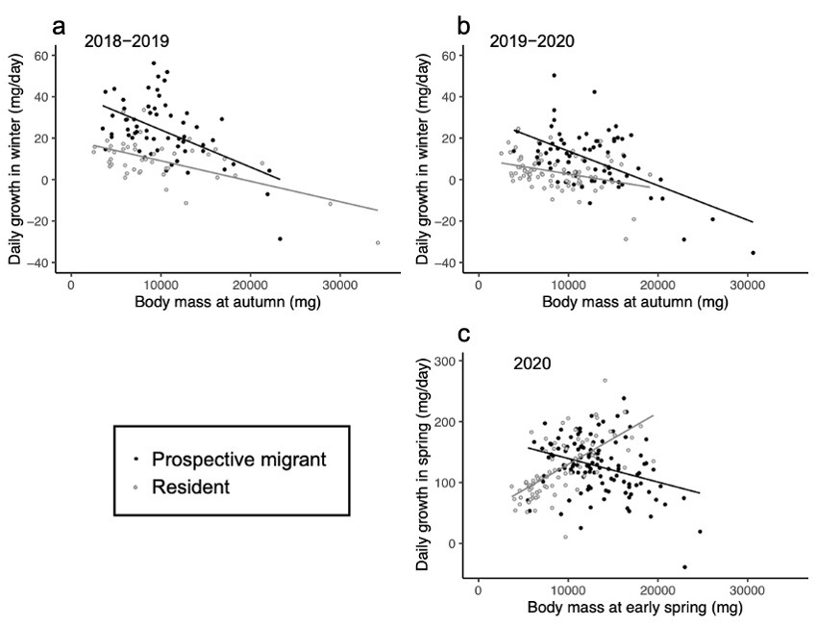
Figure S1. Relationship between size (body mass) and the subsequent growth rate of prospective migrants (black) and residents (grey) of masu salmon juveniles. (a) daily growth of body mass in winter period (2018−2019); (b) daily growth of body mass in winter period (2019−2020); (c) daily growth of body mass in spring period (2020). Regression lines: (a) Y = -1.7 × 10⁻³X + 41.99, p < 0.001, Adjusted R² = 0.28, for prospective migrants; Y = -9.9 × 10⁻⁴X + 18.95, p < 0.001, Adjusted R² = 0.34, for residents; (b) Y = -1.6 × 10⁻³X + 30.40, p < 0.001, Adjusted R² = 0.31, for prospective migrants; Y = -7.1 × 10⁻⁴X + 9.80, p = 0.002, Adjusted R² = 0.10, for residents; (c) Y = -3.9 × 10⁻³X + 178.22, p < 0.001, Adjusted R² = 0.10, for prospective migrants; Y = 8.5 × 10⁻³X + 45.34, p < 0.001, Adjusted R² = 0.43, for residents.
As we predicted, while the prospective migrants with smaller size exhibited higher growth rate in the pre-migration period, such trend was not found in the residents and, rather, the opposite trend was found in one case (c). The heavier residents at the capture survey in early spring grew better in the subsequent spring period than lighter residents. This result might be explained by specific life history of the residents. Among the residents, a part of individuals participates in the reproduction in the next autumn (Tamate and Maekawa 2002). If the residents with larger size are destined to be the reproductive members, they should invest more resource to development of reproductive organs rather than somatic growth and, thus, better growth in body mass of the larger residents in spring period is reasonable.

REFERENCE
Tamate, T., & Maekawa, K. (2002). Individual growth and phase differentiation of lacustrine masu salmon, Oncorhynchus masou, under artificial rearing conditions. Ichthyological Research, 49(4), 397–400. https://doi.org/10.1007/s102280200061

