Supplementary Information

Preprocessing of the resting-state dataset of 1000 subjects from the HCP
The HCP minimal preprocessing pipeline (HCP Functional Pipeline v2.0) was applied to resting-state fMRI images (Glasser et al., 2013). It includes gradient distortion correction, motion correction, EPI distortion correction, registration to the Montreal Neurological Institute (MNI) space, intensity normalization to a global mean of 10000, and masking out non-brain voxels. To remove non-neural spatiotemporal components and structured noise, all resting-state fMRI scans were further denoised through a process that paired independent component analysis (ICA) with the FIX (FMRIB's ICA-based X-noisifier). For a detailed description, please refer to S. M. Smith et al. (2013). Several procedures were further performed on the pre-processed fMRI scans using the GRETNA toolbox (Wang et al., 2015). Briefly, all resting-state fMRI scans were linearly detrended to minimize the effects of low-frequency drift. Then, several nuisance variables, including 6 head motion parameters, white matter, cerebrospinal fluid, and global signals, were regressed out. Finally, all images were temporally bandpass filtered (0.01-0.1 Hz) and smoothed spatially at 6 mm FWHM.

Preprocessing of the resting-state dataset of 1000 subjects from the GSP
The rs-fMRI data of 1000 healthy subjects were obtained from the publicly available genome superstructure project (http://neuroinformatics.harvard.edu/gsp/) (Holmes et al., 2015; Yeo et al., 2011). The preprocessing procedure was similar to that of other studies from our lab (Xie et al., 2017). In brief, the first 4 volumes were discarded for magnetic field stabilization and the participants’ adaption to the scanning environment. The remaining volumes were then slice-timing corrected, realigned to correct head motion, and normalized to MNI space by DARTEL (Ashburner, 2007). Several procedures were further performed on the preprocessed fMRI scans using the GRETNA toolbox (Wang et al., 2015). The normalized rs-fMRI scans were spatially smoothed with a 6 mm FWHM Gaussian kernel and linearly detrended to minimize the effects of low-frequency drift. Then, several nuisance variables, including 6 head motion parameters, white matter, cerebrospinal fluid, and global signals, were regressed out. Finally, all images were temporally bandpass filtered (0.01-0.1 Hz).

Supplementary Tables
Table S1. Selected TMS studies that disrupt facial emotion processing
Study | Disruption | Sample Size
(Pitcher, Garrido, Walsh, & Duchaine, 2008) | Reduced accuracy | 28
(Mattavelli, Cattaneo, & Papagno, 2011) | Prolonged reaction time | 20
(Rochas et al., 2013) | Reduced accuracy | 20
(Pitcher, 2014) | Reduced accuracy | 14
(Ferrari et al., 2016) | Reduced accuracy | 20
(Sliwinska & Pitcher, 2018) | Reduced accuracy | 30
(Sliwinska, Elson, & Pitcher, 2020) | Reduced accuracy | 22
(Korb et al., 2015) | Prolonged reaction time | 30
(Ferrari et al., 2016) | Prolonged reaction time | 12

Table S2. Peaks of clusters of activation network overlap map of each emotion category. The minimum cluster size is 100 mm³, corresponding to a minimum of 13 voxels.
Emotion | Voxels | Overlap | X | Y | Z | Region
combined | 2485 | 169/230 | -48 | 14 | -14 | Temporal Pole
combined | 2390 | 168/230 | 52 | 16 | -16 | Temporal Pole / Frontal Orbital Cortex
combined | 1379 | 159/230 | 44 | -42 | -18 | Temporal Occipital Fusiform Cortex / Temporal Fusiform Cortex
combined | 826 | 161/230 | -40 | -50 | -20 | Temporal Occipital Fusiform Cortex / Temporal Fusiform Cortex
combined | 441 | 154/230 | 52 | -2 | 44 | Precentral Gyrus / Postcentral Gyrus
combined | 348 | 161/230 | -48 | -4 | 50 | Precentral Gyrus / Middle Frontal Gyrus
anger | 8650 | 34/ 39 | -48 | 14 | -14 | Temporal Pole
anger | 6601 | 36/ 39 | 48 | 18 | -18 | Temporal Pole / Frontal Orbital Cortex
anger | 959 | 28/ 39 | 48 | -6 | 48 | Precentral Gyrus / Postcentral Gyrus
anger | 493 | 28/ 39 | 0 | 4 | 64 | Superior Frontal Gyrus / Juxtapositional Lobule Cortex
anger | 334 | 28/ 39 | -42 | -40 | -16 | Temporal Occipital Fusiform Cortex / Temporal Fusiform Cortex
anger | 312 | 26/ 39 | 44 | -40 | -24 | Temporal Occipital Fusiform Cortex / Temporal Fusiform Cortex
anger | 189 | 24/ 39 | 48 | -56 | 0 | Middle Temporal Gyrus / Lateral Occipital Cortex
anger | 108 | 26/ 39 | 38 | -6 | 14 | Insular Cortex / Central Opercular Cortex
anger | 73 | 26/ 39 | -34 | -8 | 14 | Insular Cortex / Central Opercular Cortex
anger | 36 | 25/ 39 | -60 | -14 | 20 | Postcentral Gyrus / Parietal Operculum Cortex
anger | 28 | 23/ 39 | -56 | 30 | 6 | Middle Frontal Gyrus / Inferior Frontal Gyrus
anger | 17 | 24/ 39 | 6 | -4 | 58 | Precentral Gyrus / Juxtapositional Lobule Cortex
disgust | 18982 | 21/ 24 | -52 | 10 | -12 | Temporal Pole
disgust | 6803 | 21/ 24 | 52 | 16 | -16 | Temporal Pole / Frontal Orbital Cortex
disgust | 555 | 18/ 24 | -4 | 6 | 60 | Superior Frontal Gyrus / Juxtapositional Lobule Cortex
disgust | 142 | 15/ 24 | 26 | -94 | -10 | Occipital Pole / Occipital Fusiform Gyrus
disgust | 129 | 15/ 24 | -38 | -4 | 4 | Insular Cortex
disgust | 110 | 15/ 24 | 38 | 0 | 10 | Insular Cortex / Central Opercular Cortex
disgust | 79 | 15/ 24 | -28 | -50 | 56 | Superior Parietal Lobule / Postcentral Gyrus
disgust | 79 | 16/ 24 | 42 | 0 | -48 | Temporal Pole / Temporal Fusiform Cortex
disgust | 65 | 14/ 24 | -22 | -100 | -18 | Occipital Pole / Lateral Occipital Cortex
disgust | 58 | 15/ 24 | 66 | -14 | 22 | Supramarginal Gyrus / Postcentral Gyrus
disgust | 46 | 14/ 24 | -40 | -38 | 14 | Supramarginal Gyrus / Superior Temporal Gyrus
disgust | 20 | 14/ 24 | -34 | -26 | 2 | Planum Polare / Left Putamen
disgust | 17 | 14/ 24 | 12 | -30 | 68 | Precentral Gyrus / Postcentral Gyrus
disgust | 14 | 14/ 24 | -64 | -14 | 20 | Supramarginal Gyrus / Postcentral Gyrus
disgust | 14 | 14/ 24 | 28 | -34 | 72 | Superior Parietal Lobule / Precentral Gyrus
fear | 8499 | 62/ 78 | 46 | -42 | -22 | Temporal Occipital Fusiform Cortex / Temporal Fusiform Cortex
fear | 7892 | 63/ 78 | -50 | 14 | -14 | Temporal Pole
fear | 1015 | 57/ 78 | 52 | -2 | 48 | Precentral Gyrus / Postcentral Gyrus
fear | 498 | 59/ 78 | -52 | -2 | 48 | Precentral Gyrus / Middle Frontal Gyrus
fear | 40 | 48/ 78 | 26 | -54 | 56 | Superior Parietal Lobule / Lateral Occipital Cortex
fear | 22 | 49/ 78 | -24 | -78 | 30 | Precuneous Cortex / Lateral Occipital Cortex
fear | 16 | 48/ 78 | 38 | -4 | 14 | Insular Cortex / Central Opercular Cortex
happiness | 244 | 28/ 44 | -52 | 0 | -16 | Temporal Pole / Superior Temporal Gyrus
happiness | 83 | 29/ 44 | -30 | 6 | -28 | Temporal Pole / Parahippocampal Gyrus
happiness | 52 | 27/ 44 | -42 | -14 | 40 | Precentral Gyrus / Postcentral Gyrus
happiness | 43 | 28/ 44 | 62 | 4 | -10 | Temporal Pole / Superior Temporal Gyrus
happiness | 40 | 28/ 44 | -32 | -10 | -20 | Parahippocampal Gyrus / Left Hippocampus
happiness | 39 | 29/ 44 | 32 | 8 | -24 | Temporal Pole / Right Amygdala
happiness | 37 | 26/ 44 | 46 | -16 | 40 | Precentral Gyrus / Postcentral Gyrus
happiness | 32 | 29/ 44 | 12 | -2 | -24 | Right Hippocampus / Right Amygdala
happiness | 26 | 27/ 44 | -38 | -36 | 18 | Supramarginal Gyrus / Superior Temporal Gyrus
happiness | 26 | 27/ 44 | 60 | -38 | 12 | Supramarginal Gyrus / Superior Temporal Gyrus
happiness | 24 | 27/ 44 | 44 | -12 | 18 | Parietal Operculum Cortex / Central Opercular Cortex
happiness | 24 | 26/ 44 | 44 | -52 | -20 | Temporal Occipital Fusiform Cortex / Inferior Temporal Gyrus
happiness | 23 | 27/ 44 | -46 | 18 | -22 | Temporal Pole / Frontal Orbital Cortex
happiness | 16 | 26/ 44 | 28 | -6 | -26 | Right Hippocampus / Right Amygdala
sadness | 6086 | 18/ 23 | 50 | 6 | -18 | Temporal Pole / Superior Temporal Gyrus
sadness | 3234 | 18/ 23 | -54 | 2 | -12 | Temporal Pole / Superior Temporal Gyrus
sadness | 560 | 17/ 23 | 46 | 0 | 44 | Precentral Gyrus / Middle Frontal Gyrus
sadness | 555 | 17/ 23 | 44 | -42 | -24 | Temporal Occipital Fusiform Cortex / Temporal Fusiform Cortex
sadness | 433 | 15/ 23 | 8 | 10 | 48 | Superior Frontal Gyrus / Paracingulate Gyrus
sadness | 354 | 16/ 23 | -40 | -42 | -26 | Temporal Occipital Fusiform Cortex / Temporal Fusiform Cortex
sadness | 282 | 15/ 23 | -62 | -34 | 18 | Supramarginal Gyrus / Supramarginal Gyrus
sadness | 101 | 14/ 23 | -22 | -30 | 54 | Precentral Gyrus / Postcentral Gyrus
sadness | 99 | 14/ 23 | 40 | -24 | 48 | Precentral Gyrus / Postcentral Gyrus
sadness | 86 | 15/ 23 | 16 | -40 | 46 | Precuneous Cortex / Precentral Gyrus
sadness | 77 | 15/ 23 | 12 | -36 | 70 | Precentral Gyrus / Postcentral Gyrus
sadness | 77 | 15/ 23 | 44 | -18 | 34 | Supramarginal Gyrus / Precentral Gyrus
sadness | 57 | 15/ 23 | -40 | -22 | 34 | Precentral Gyrus / Postcentral Gyrus
sadness | 31 | 14/ 23 | -16 | -32 | 36 | Precuneous Cortex / Precentral Gyrus
sadness | 31 | 14/ 23 | -10 | -16 | 36 | Cingulate Gyrus / Cingulate Gyrus
sadness | 27 | 14/ 23 | -26 | -8 | 46 | Superior Frontal Gyrus / Precentral Gyrus
sadness | 27 | 15/ 23 | -40 | -6 | 46 | Precentral Gyrus / Middle Frontal Gyrus
sadness | 26 | 14/ 23 | 20 | -56 | 8 | Supracalcarine Cortex / Precuneous Cortex
sadness | 26 | 14/ 23 | -50 | 2 | 30 | Precentral Gyrus / Middle Frontal Gyrus
sadness | 17 | 14/ 23 | 42 | 18 | 4 | Insular Cortex / Inferior Frontal Gyrus
sadness | 16 | 15/ 23 | 8 | -48 | 56 | Precuneous Cortex / Precentral Gyrus
sadness | 15 | 15/ 23 | 8 | -22 | 60 | Precentral Gyrus / Juxtapositional Lobule Cortex

Table S3. Peaks of clusters of activation network t map of each emotion category. The minimum cluster size is 100 mm³, corresponding to minimum of 13 voxels.
Emotion | Voxels | Max | X | Y | Z | Region
combined | 20263 | 13.4 | 12 | 8 | -32 | Temporal Pole / Temporal Occipital Fusiform Cortex
combined | 18603 | 13.7 | -52 | 16 | -14 | Temporal Pole
combined | 399 | 8.45 | 36 | 16 | 24 | Precentral Gyrus / Middle Frontal Gyrus
combined | 347 | 7.53 | -4 | 4 | 64 | Superior Frontal Gyrus / Juxtapositional Lobule Cortex
combined | 233 | 6.51 | 34 | -4 | 16 | Insular Cortex / Central Opercular Cortex
combined | 125 | 6.29 | 26 | -52 | 52 | Supramarginal Gyrus / Superior Parietal Lobule
combined | 122 | 7.24 | -16 | -30 | -2 | Left Thalamus / Left Hippocampus
combined | 91 | 7.06 | -2 | 42 | -32 | Frontal Medial Cortex
combined | 71 | 6.09 | -10 | -18 | 44 | Precentral Gyrus / Juxtapositional Lobule Cortex
combined | 26 | 7.77 | 0 | 6 | 12 | Right Lateral Ventricle / Left Lateral Ventricle
anger | 8207 | 6.54 | -50 | 14 | -14 | Temporal Pole
anger | 7843 | 6.5 | 50 | 16 | -16 | Temporal Pole / Frontal Orbital Cortex
anger | 650 | 5.6 | -54 | -2 | 50 | Precentral Gyrus / Middle Frontal Gyrus
anger | 487 | 4.53 | -4 | 2 | 64 | Juxtapositional Lobule Cortex
anger | 403 | 4.36 | 50 | -4 | 40 | Precentral Gyrus / Postcentral Gyrus
anger | 234 | 5.83 | 24 | 8 | 30 | Right Lateral Ventricle / Right Caudate
disgust | 597 | 4.01 | -46 | -36 | -20 | Temporal Fusiform Cortex / Inferior Temporal Gyrus
disgust | 528 | 3.95 | 46 | -40 | 14 | Supramarginal Gyrus / Superior Temporal Gyrus
disgust | 471 | 4.39 | -18 | 0 | -42 | Temporal Pole / Temporal Fusiform Cortex
disgust | 404 | 3.99 | -50 | -46 | 12 | Supramarginal Gyrus / Superior Temporal Gyrus
disgust | 292 | 4.13 | -50 | 14 | -12 | Temporal Pole / Frontal Orbital Cortex
fear | 38697 | 7.69 | 16 | 10 | -30 | Temporal Pole / Frontal Orbital Cortex
fear | 2764 | 6.29 | 26 | 16 | 26 | Supramarginal Gyrus, posterior division / Supramarginal Gyrus, anterior division
fear | 1297 | 5.68 | -54 | 0 | 50 | Precentral Gyrus / Middle Frontal Gyrus
fear | 283 | 4.78 | 0 | 44 | -34 | Frontal Medial Cortex
fear | 279 | 4.31 | 26 | -52 | 50 | Supramarginal Gyrus / Superior Parietal Lobule
happiness | 385 | 3.68 | -52 | 18 | -16 | Temporal Pole

Supplementary figures

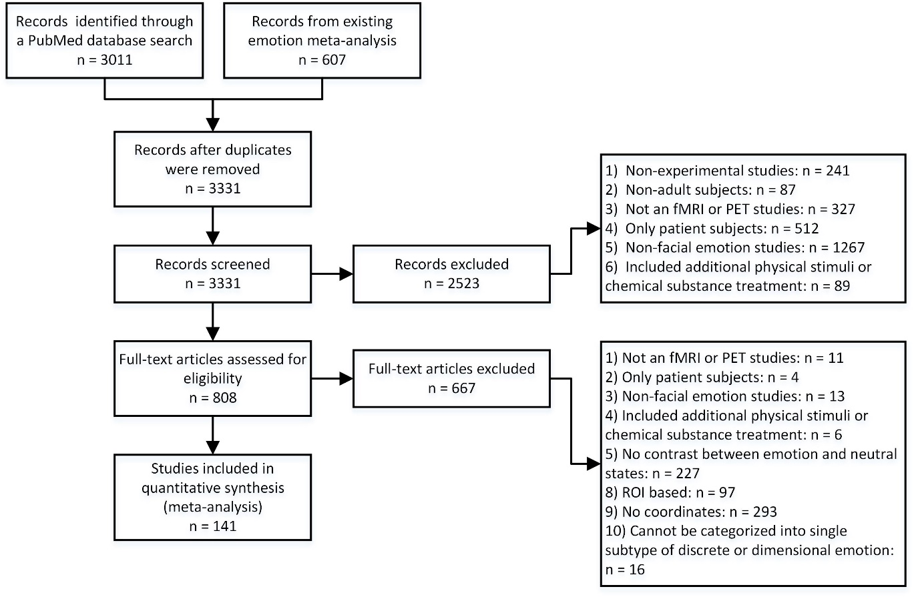
Figure S1. PRISMA flowchart reporting the search strategy and the functional neuroimaging studies of facial emotion processing retrieved.
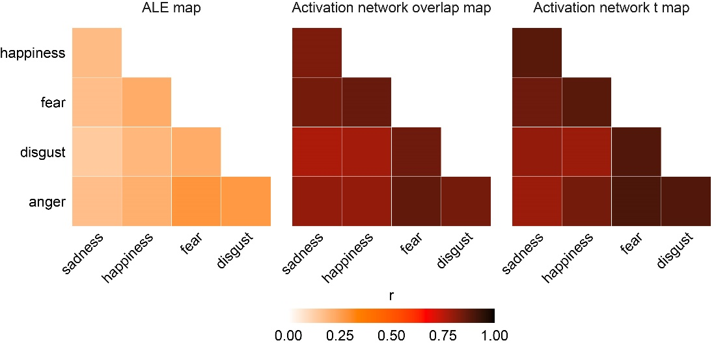
Figure S2. The similarity of network patterns between each pair of basic emotions is far higher than that of activation patterns. Unthresholded maps from both ALE and ANM meta-analyses were used to compute the pairwise spatial correlation between pairs of basic emotions.

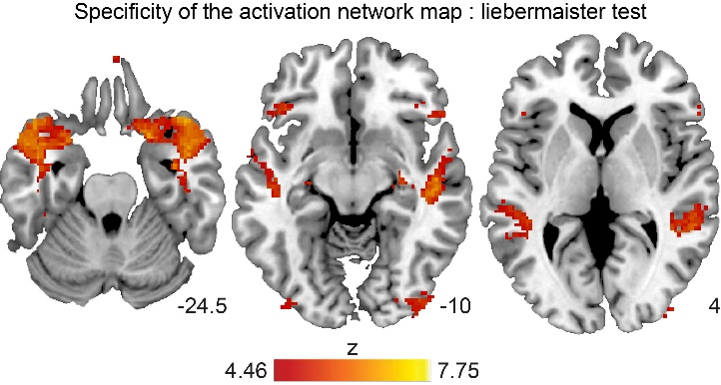
Figure S3. The specificity of the facial emotion processing network using the Liebermaister test implemented in NiiStat. Activation network maps from facial emotion processing (n = 230) were statistically contrasted with activation network maps from non-emotional cognitive processing (n = 145) using binarized maps.
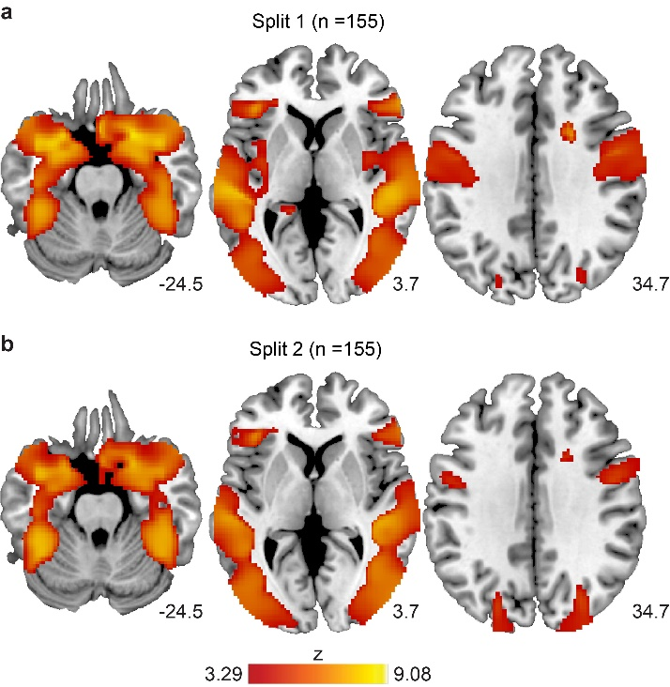
Figure S4. The split-half replication test indicated high reliability of network localization of facial emotion processing. First, all experiments were split randomly into two equal subsets, and then sensitivity analysis was conducted separately using the one-sample t-test approach. The high similarity between the two resulting activation network t maps indicated the high reliability of the ANM results.
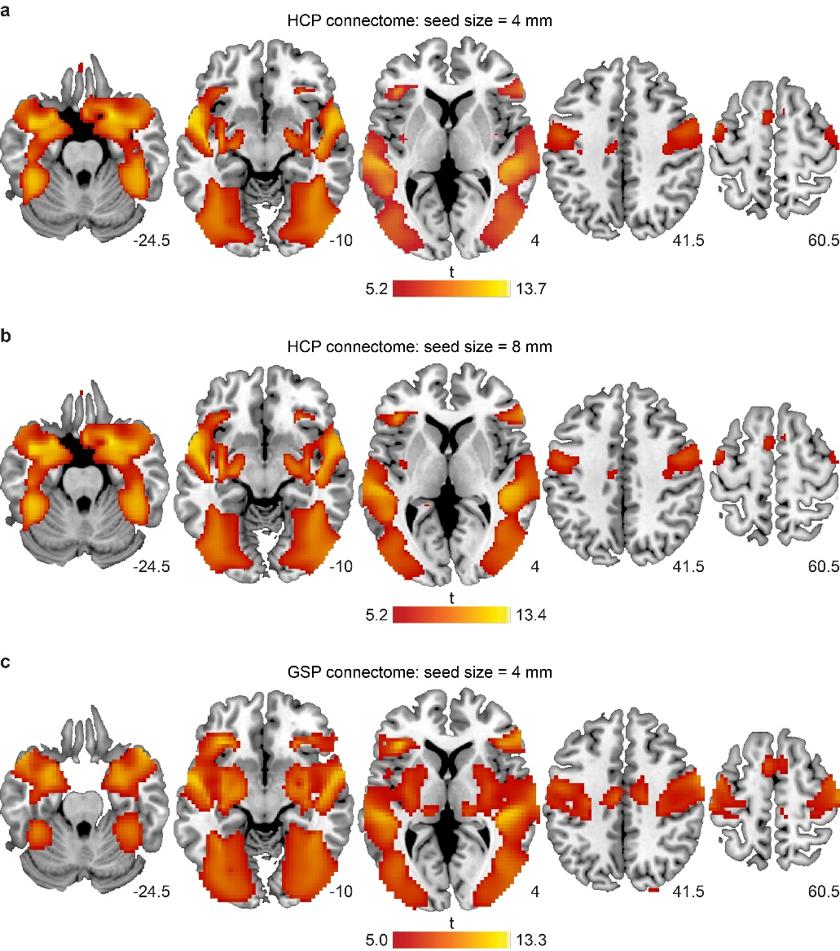
Figure S5. Using a different seed size (8 mm) and human connectome database (GSP) identified a highly consistent functional connectivity map (activation network t map).
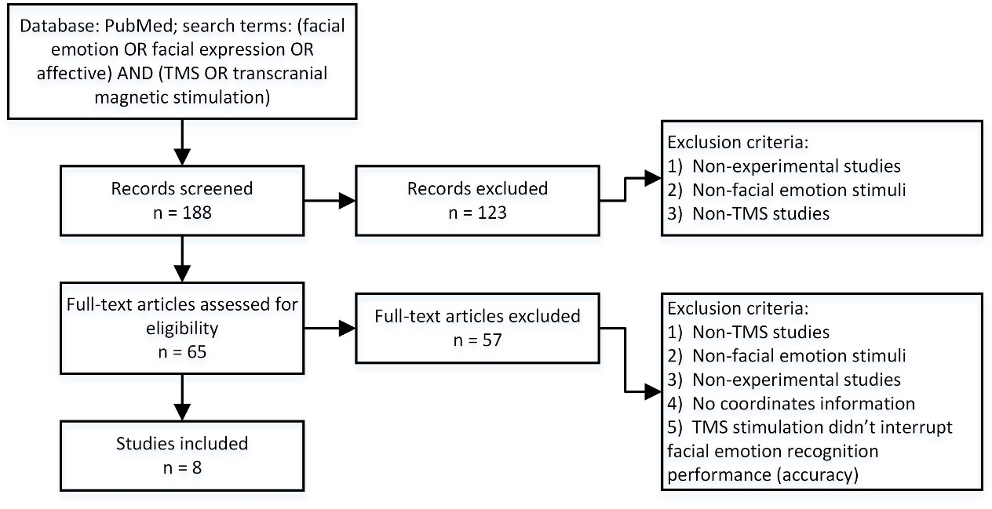
Figure S6. PRISMA flowchart reporting the search strategy and the TMS studies retrieved.

