Supplementary materials
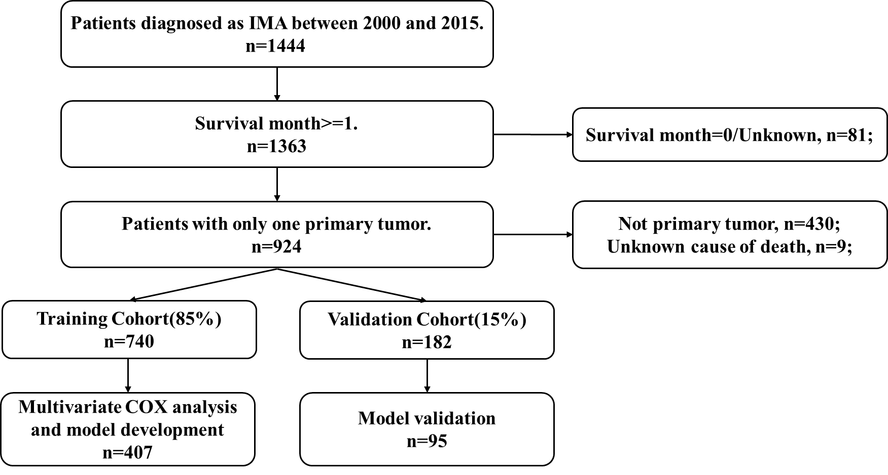
Figure S1. Flow sheet of eligible patients included in the study.

Figure S2. OS for IMA patients stratified by (A) Race, p=0.772; (B) Marital status, p=0.226.

Figure S3. LCSS for IMA patients stratified by (A) Race, p=0.959; (B) Marital status, p=0.267.

Figure S4. (A. B) ROC curves for 3- and 5-year OS based on the validation cohort data. The AUC was 0.813 and 0.840, respectively; (C. D) ROC curves for 3- and 5-year LCSS. The AUC was 0.836 and 0.857, respectively.

Figure S5. (A. B) Calibration plots for 3- and 5-year OS in the validation cohort; (C. D) Calibration plots for 3- and 5-year LCSS in the validation cohort.

