Table S1. non-CNS infection patients with mNGS positive

case | Organism and unique reads | Organism number | Additional Testing | Diagnosis | Possible explanation
Case 6 | Epstein-Barr Virus (EBV), 3 | 1 | anti-MOG antibody positive | Autoimmune encephalitis | Prodromic inflammation
Case 10 | Mycobacterium tuberculosis complex, 1 | 1 | anti-MOG antibody positive | Autoimmune encephalitis | Prodromic inflammation
Case 11 | Epstein-Barr Virus (EBV), 7; human herpesvirus 6B (HHV-6B), 3 | 2 | anti-MOG antibody positive | Autoimmune encephalitis | Prodromic inflammation
Case 13 | Epstein-Barr Virus (EBV), 3; Streptococcus pneumoniae, 2 | 2 | anti-NMDAR antibody positive | Autoimmune encephalitis | Prodromic inflammation
Case 20 | Human herpesvirus 1 (HSV1), 1; Pseudomonas aeruginosa, 5 | 2 | anti-MOG antibody positive | Autoimmune encephalitis | Prodromic inflammation
Case 21 | Acinetobacter baumannii, 3 | 1 | anti-MOG antibody positive | Autoimmune encephalitis | Prodromic inflammation
Case 56 | Human cytomegalovirus-human herpesvirus 5 (CMV), 3; human herpesvirus 7 (HHV 7), 3; Lactobacillus rhamnosus GG, 246; Actinomyces viscosus, 28; Actinomyces naeslundii 10 | 4 | anti-MOG antibody positive | Autoimmune encephalitis | Prodromic inflammation

Table S2. CNS Infection case with only clinically irrelevant organism

case | Organism and unique reads | Organism number | Diagnosis | Possible explanation
Case 28 | varicella zoster virus (VZV), 6 | 1 | Suspected CNS infections (bacteria) | CSF herpes simplex virus and varicella zoster PCR were negative.  Anti-bacterial treatment had an effect.

Table S3. CNS infection cases with clinical irrelevant organisms (by each organism assessed)

Patients | Organisms and unique reads | Diagnosis | Possible explanation
Case 18 | Human herpesvirus 1 (HSV1), 3 | Hemophilus influenzae meningitis | Hemophilus was co-detected. Anti-bacterial treatment had an effect.
Case 28 | varicella zoster virus (VZV), 6 | Suspected CNS infections | CSF herpes simplex virus and varicella zoster PCR were negative.  Anti-bacterial treatment had an effect.
Case 32 | Epstein-Barr Virus (EBV), 6 | Bacterial meningitis | Mycobacteroides abscessus was co-detected. Anti-bacterial treatment had an effect.
Case 38 | Epstein-Barr Virus (EBV),2 | Cryptococcal meningitis | Cryptococcus was co-detected. Anti-bacterial treatment had an effect.

Table S4. Cases with clinically relevant and irrelevant organism in an mNGS test

Patients | Organisms | Diagnosis
Case 18 | Human herpesvirus 1 (HSV1),  Haemophiles | Hemophilus influenzae meningitis
Case 32 | Epstein-Barr Virus (EBV), Mycobacteroides abscessus | Bacterial meningitis
Case 38 | Epstein-Barr Virus (EBV), Cryptococcus | Cryptococcal meningitis

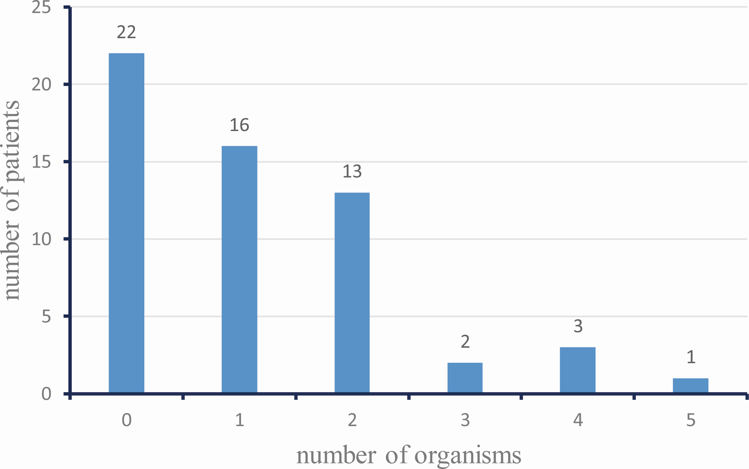

Fig. S1 The number of patients with a combination of different pathogens identified by mNGS
Patients were categorized based on the total number of organisms identified by each mNGS test. Each column represents a total number of patients: 22 patients with no organisms, 16 patients with one organism, 19 patients with multiple organisms.

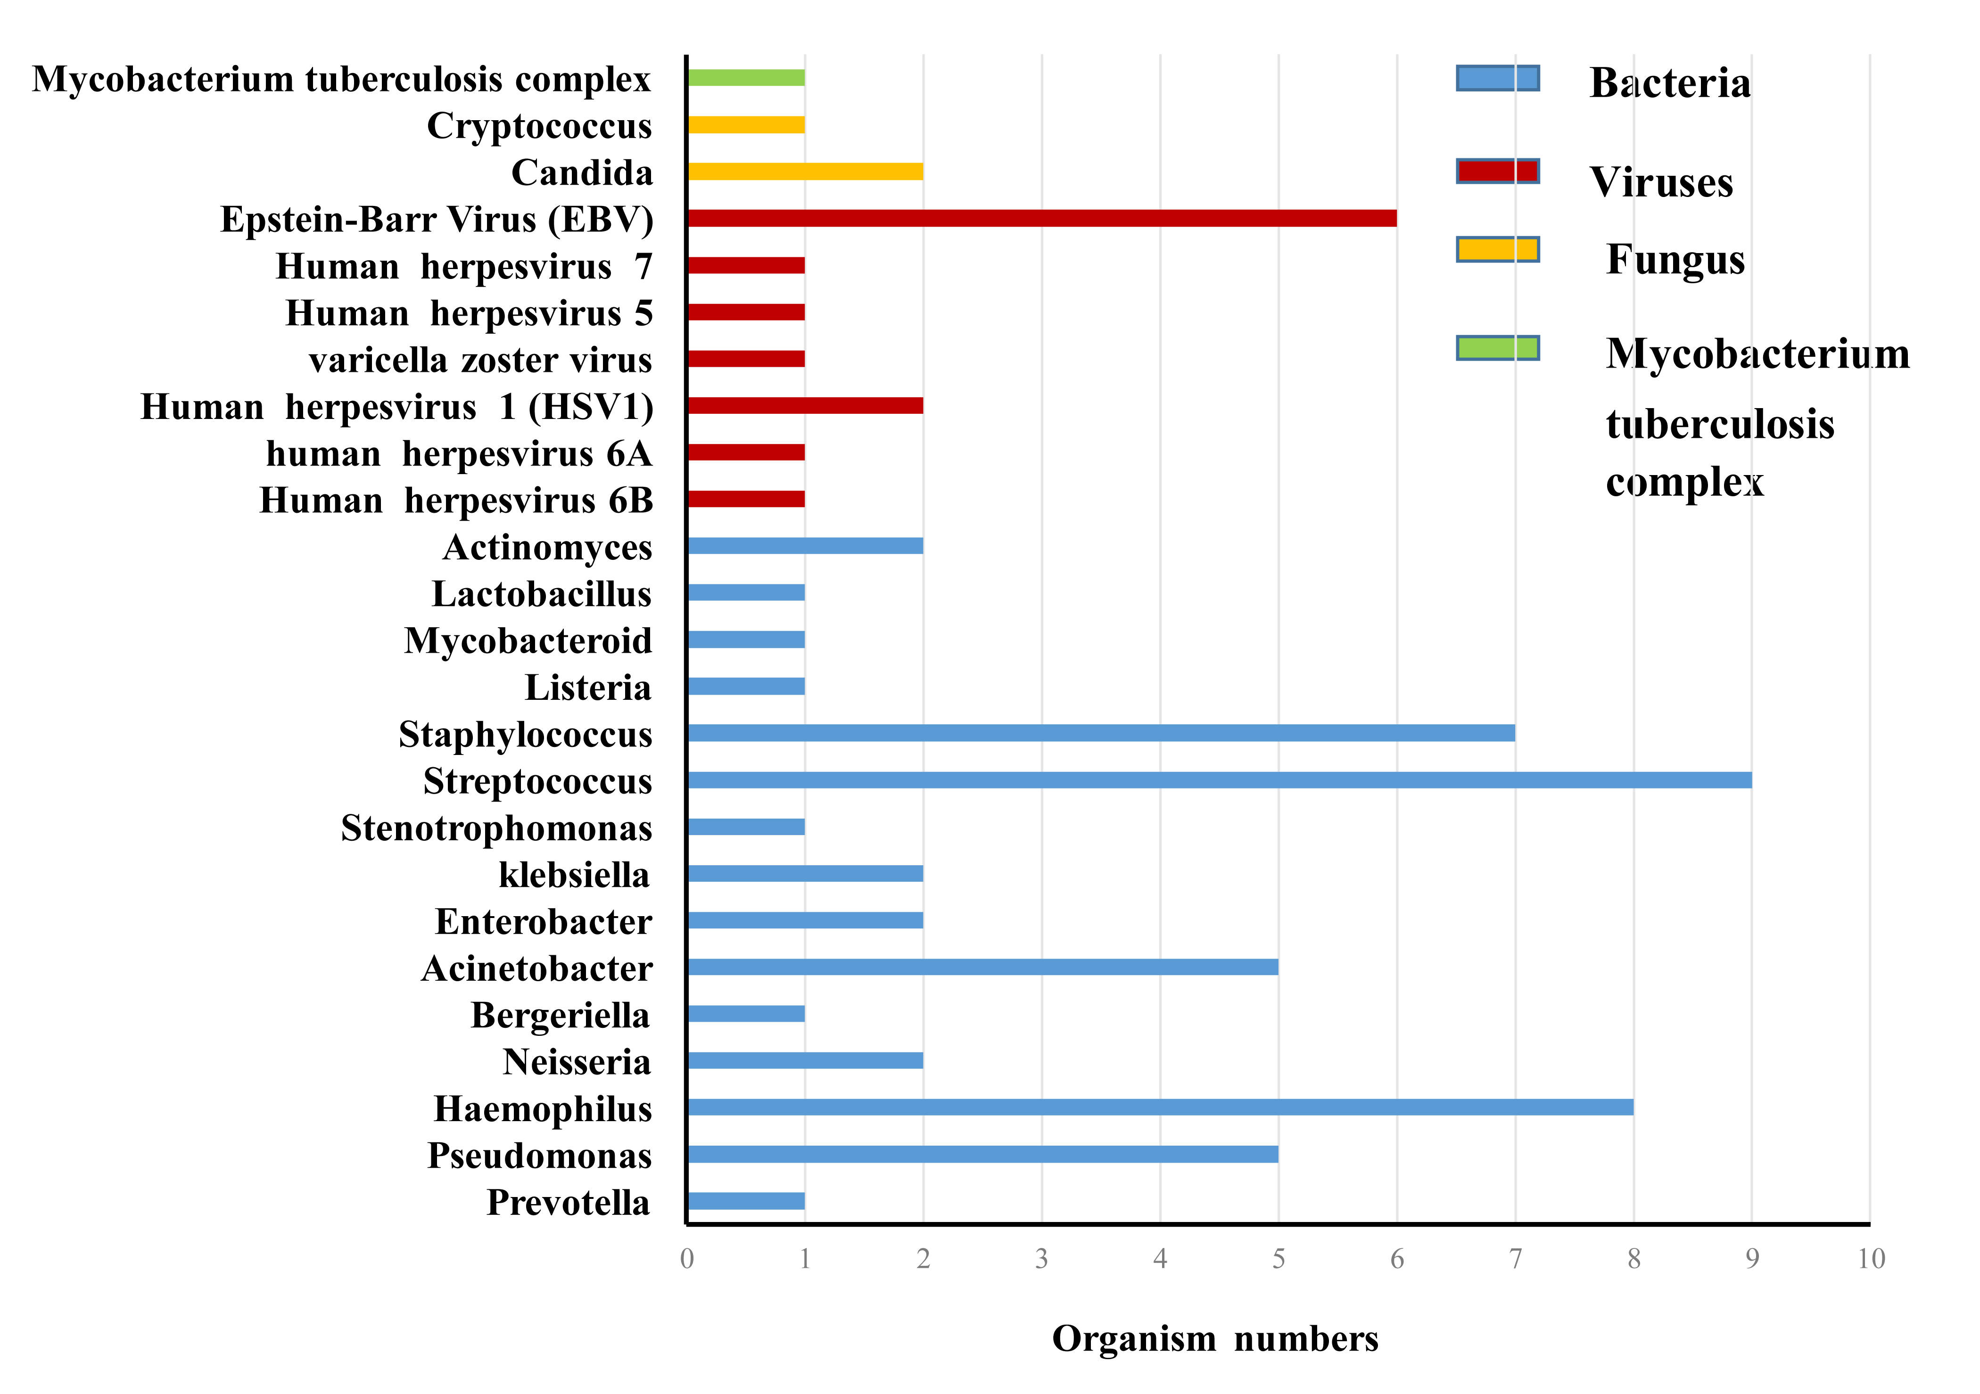
Fig. S2 Distribution of organism genus and species numbers identified by mNGS
Organisms were categorized under different genera. Each column depicts the total number of the organism under each genus.

