Supplementary Material 1 for
Variations in forest biomass ratio along three environmental gradients are dominated by interspecific differences
Samples characteristics
54,700 increment cores were collected by the NFI in 2016 and 2017. 32% of the cores were taken from the bark to the pith for the measurement of the tree age and for the measurement of the increments of the last five rings. 68% of the cores were extracted for the measurement of the increments of the last five rings only. Their length is on average 57% of the tree radius. Half of the sample measures more than 80% of the radius. The most represented species have ratio between 60-75% of the tree radius covered by the samples.
Samples processing and calculation of oven dry wood density
Tree cores were dried at 103°C during 24 hours (Williamson and Wiemann 2010) and scanned with an X-ray medical scanner (Freyburger et al. 2009). Basic data consist in wood density profiles at a 0.625 mm resolution, obtained by the mean of the CARDEN software (Jacquin et al. 2019). Arithmetic means of wood density over each core were computed.
Calculation of basic wood density and Biomass Ratio
Oven-dried wood density ($ρ_{0}$, kg.m⁻³) estimates were then converted into basic specific gravity (named for convenience WD) (Glass and Zelinka 2010) and calculated with the following equation
$WD= ρ_{0}.(1-R_{VT})$
With R_{VT} the total volumetric shrinkage rate, and $ρ_{0}$ the oven-dried wood density (anhydrous mass divided by anhydrous volume, kg.m⁻³).
Biomass ratio defined as the total biomass divided by the total volume, takes also into account the statistical weight of the tree, which is the number of tree per hectare represented by an inventoried tree, BR formula takes the form of:
$$BR= \frac{\sum_{i}{{WD}_{i}.V_{i}.w_{i}}}{\sum_{i}{V_{i}.w_{i}}}$$
With $WD$ (kg.m⁻³) being the measured or imputed basic wood density of the tree i, V (m³) being the stem volume of the tree i, w (ha⁻¹) the statistical weight of the tree i in a plot.

References
As, Nusret & Korkut, Suleyman & Büyüksarı, Ümit. (2016). Some Physical and Mechanical Properties of Turkish Hazelnut (Corylus colurna L.) Wood.
Bhat, K. M., & Kärkkäinen, M. (1980). Distinguishing between Betula pendula Roth. and Betula pubescens Ehrh. on the basis of wood anatomy.
Cáceres, C. B., Hernández, R. E., & Fortin, Y. (2018). Shrinkage variation in Japanese larch (Larix kaempferi,[Lamb.] Carr.) progenies/provenances trials in Eastern Canada. Wood Material Science & Engineering, 13(2), 97-103.
Elaieb, M. T., Khaldi, A., & Candelier, K. (2015). Impact of location and forestry conditions on some physical and mechanical properties of northern Tunisian# Pinus pinea# L. wood. Bois et forêts des tropiques, (324), 65-74.
Elaieb, M. T., Shel, F., Elouellani, S., Rahouti, M., Thévenon, M. F., & Candelier, K. (2017). Physical, mechanical and natural durability properties of wood from reforestation# Pinus halepensis# Mill. in the Mediterranean Basin. Bois et Forêts des Tropiques, (331), 19-31.
De la Fuente-Leon, J., Lafuente-Jimenez, E., Hermosilla, D., Broto-Cartagena, M., & Gasco, A. (2014). Physico-mechanical properties of Spanish juniper wood considering the effect of heartwood formation and the presence of defects and imperfections. Forest Systems, 23(1), 64-71.
Freyburger, C., Longuetaud, F., Mothe, F., Constant, T., & Leban, J. M. (2009). Measuring wood density by means of X-ray computer tomography. Annals of forest science, 66(8), 804.
Glass, S. V., and S. L. Zelinka. 2010. Moisture relations and physical properties of wood. In Wood handbook: wood as an engineering material, 4-1–19. General Technical Report FPL-GTR-190. U.S. Dept. of Agriculture, Forest Service, Forest Products Laboratory, Madison, WI, USA.
Govorčin, S., Sinković, T., Sedlar, T., Ištok, I., & Vukadin, M. (2012). Some Physical and Mechanical Properties of Plum Tree (Prunus Domestica L.). Drvna industrija: Znanstveni časopis za pitanja drvne tehnologije, 63(4), 291-295.
Hashemi, S. K. H., & Kord, B. (2011). Variation of within-stem biometrical and physical property indices of wood from Cupressus sempervirens L. BioResources, 6(2), 1843-1857.
Jacquin, P., Mothe, F., Longuetaud, F., Billard, A., Kerfriden, B., & Leban, J. M. (2019). CarDen: A software for fast measurement of wood density on increment cores by CT scanning. Computers and Electronics in Agriculture, 156, 606-617.
Kiaei, M., & Samariha, A. (2011). Wood density and shrinkage of Ulmus glabra in northwestern of Iran. American-Eurasian Journal of Agriculture and Environment Science, 11(2), 57-260.
Kiaei, M., Bakhshi, R., & Ahangar, M. (2016). Physical and biometric properties of euonymus latifolia wood (case study: chamesttan--nour).
Korkut, S., & Guller, B. (2008). Physical and mechanical properties of European Hophornbeam (Ostrya carpinifolia Scop.) wood. Bioresource technology, 99(11), 4780-4785.
Korkut, S., Guller, B., Aytin, A., & Kök, M. S. (2009). Turkey’s native wood species: Physical and mechanical characterization and surface roughness of Rowan (Sorbus aucuparia L.). Wood Research, 54(2), 19-30.
Kozakiewicz, P., & Zyczkowski, W. (2015). Physical and mechanical properties and anatomy of common juniper (Juniperus commis L.) wood. Sylwan, 159(2), 151-159.
Lavisci, P., Janin, G., & Uzielli, L. (1989). Qualité du bois de six essences du maquis méditerranéen. Forêt Méditerr. X, 69-77.
Leal, S., Sousa, V. B., & Pereira, H. (2012). Cork oak (Quercus suber L.) wood hygroscopic properties and dimensional stability. Forest systems, 21(3), 355-363.
Lorenzo, J. Á. P., & Muñoz, G. R. (2018). Inter-tree and intra-tree variation in the physical properties of wood of laurel (Laurus nobilis). European journal of forest research, 137(4), 507-515.
Markwardt, L. J., & Wilson, T. R. C. (1935). Strength and related properties of woods grown in the United States (No. 479). US Government Printing Office.
Schrammel, L., Weiss, G., & Wolf, S. (2016). Wert-Holz: Das Sorptionsverhalten ausgesuchter, selten genutzter Holzarten.
Usta, I. (2004). The effect of moisture content and wood density on the preservative uptake of Caucasian fir (Abies nordmanniana (Link.) Spach.) treated with CCA. Turkish Journal of Agriculture and Forestry, 28(1), 1-7.
Vieilledent, G., Fischer, F. J., Chave, J., Guibal, D., Langbour, P., & Gérard, J. (2018). New formula and conversion factor to compute basic wood density of tree species using a global wood technology database. American journal of botany, 105(10), 1653-1661.
Voulgaridis, E. V., & Passialis, C. N. (1995). Characteristics and technological properties of the wood of mediterranean evergreen hardwoods. Forêt méditerranéenne.
Williamson, G. B., & Wiemann, M. C. (2010). Measuring wood specific gravity… correctly. American Journal of Botany, 97(3), 519-524.

Supplementary Materials 2 for
Variations in forest biomass ratio along three environmental gradients are dominated by interspecific differences
Relationship between elevation and mean annual temperature
The Aurhely gridded climate normals (Canellas et al. 2014) come from a dataset of spatial climate normals, at kilometer resolution on metropolitan France, for the time period 1981-2010 calculated by Météo-France. As the NFI plots coordinates are not public each NFI plot measured during the 2016 and 2017 campaigns was located in the center of the 1 km square it belongs. It was then possible to analyze the relationship between elevation gradient and mean annual temperature.
We found a decrease of mean annual temperature with increasing elevation (Fig. 1), with a loss of 1.6°C every 500 meters. Elevation explained 49% of mean annual temperature variability. The relationship between elevation and mean annual temperature was found highly significant (p < 10⁻¹⁶).

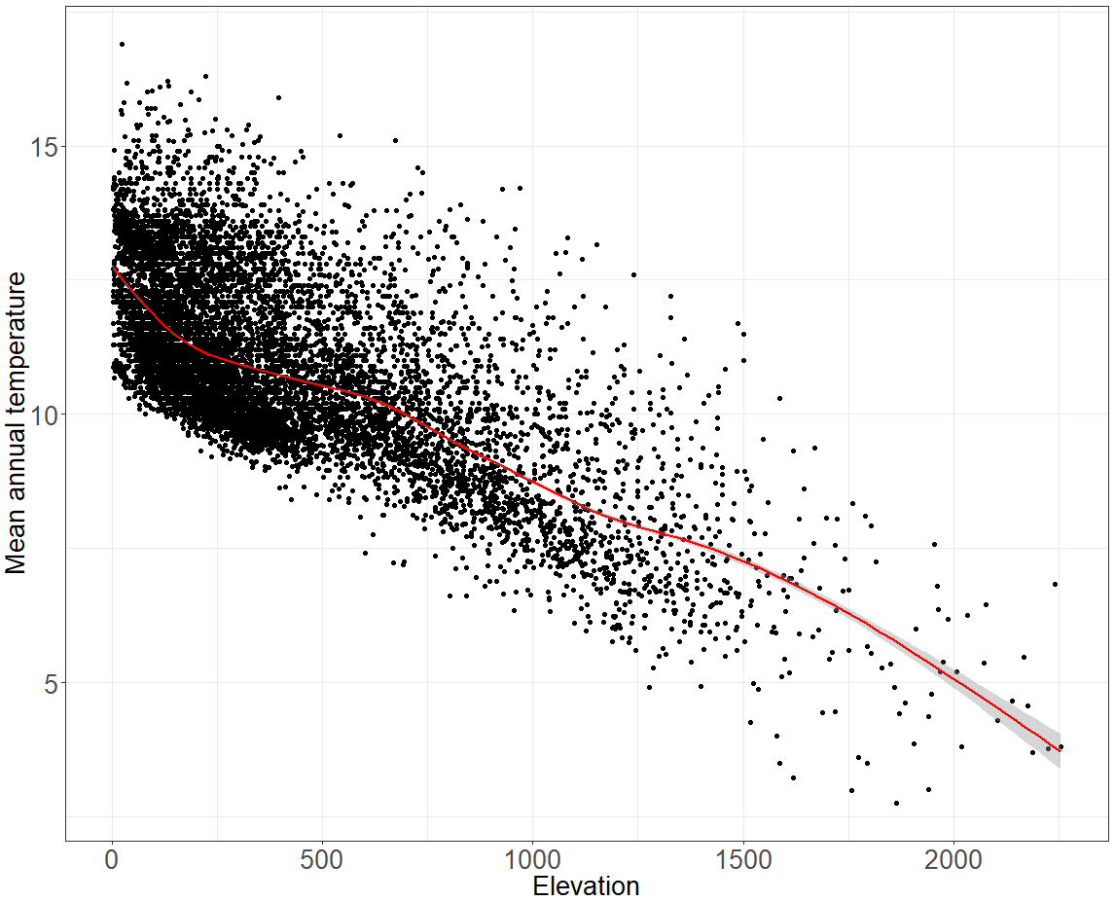
Fig. 1 Relationship between mean annul temperature and elevation
References
Canellas, C., Gibelin, A. L., Lassègues, P., Kerdoncuff, M., Dandin, P., & Simon, P. (2014). Les normales climatiques spatialisées Aurelhy 1981-2010: températures et précipitations. La météorologie.

Supplementary Materials 3 for
Variations in forest biomass ratio along three environmental gradients are dominated by interspecific differences
Variables used for the analysis
To assess the different components affecting plant development, we selected three environmental gradients i) a plant bioindication of the soil basicity index (SBI) based on a vegetation survey as a proxy for soil richness (Rameau et al. 1989), ii) soil water holding capacity in mm (SWHC) at 1m depth based on soil depth, texture and stoniness (Baize and Jabiol 1995; Baize 1988) as a proxy for soil water availability, and the measure of elevation a.s.l in meters as a proxy for temperature. All three are continuous variables, used as such to obtain species mean values, but for the purpose of the study they are also divided in classes defined by the NFI where we aggregate BR calculation: SBI scale ranging from 1 to 11, increasing with soil basicity, SWHC was divided in 11 levels of 20 mm width from below 10 mm up to over 190 mm and elevation split in 9 levels associated to 200m-width classes from 200 m up to 1200 m, 400m-width classes over this level, and one open class beyond 2000 m, owing to the number of NFI plots.

References
Baize, D., & Jabiol, B. (1995). Guide pour la description des sols. Quae.
Baize, D. (1988). Guide des analyses courantes en pédologie. Institut national de la recherche agronomique.
Rameau, J. C., Mansion, D., Dumé, G., Timbal, J., Lecointe, A., Dupont, P., & Keller, R. (1989). Flore forestière française. Guide écologique illustré, 1, 1785.

