The photoprotective properties of α-tocopherol phosphate against long-wave UVA1 (385 nm) radiation in keratinocytes in vitro

M M Saleh ª, K P Lawrence ^{b}, S A Jones ^{*c} and A R Young ^{b}
ª Department of Pharmaceutics and Pharmaceutical Technology, School of Pharmacy, The University of Jordan, Amman 11942, Jordan
^{b} King’s College London, St John’s Institute of Dermatology, Guy’s Hospital, London, SE1 9RT, UK
^{c} Institute of Pharmaceutical Science, Faculty of Health Sciences & Medicine, Franklin-Wilkins Building, King's College London, 150 Stamford Street, London SE1 9NH, UK
*Corresponding author: Dr. S. A. Jones. King’s College London. School of Cancer and Pharmaceutical Sciences, Faculty of Life Sciences & Medicine, Franklin-Wilkins Building, 150 Stamford Street, London SE1 9NH. Tel: +44 (0)207 848 4843. Fax: +44 (0)207 848 4800. Email: stuart.jones@kcl.ac.uk

Supporting Information
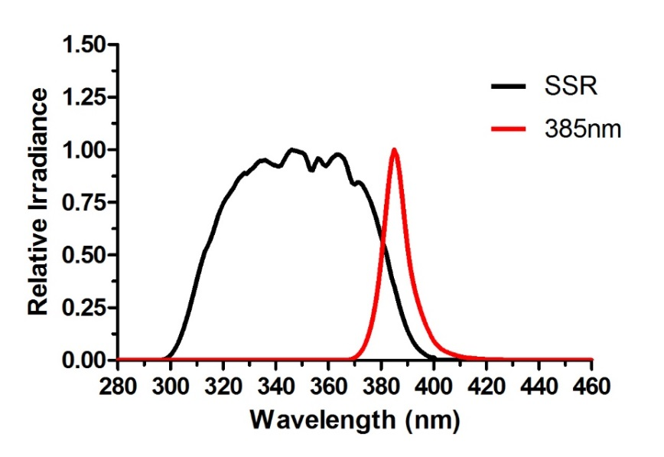
Fig.S1: The spectral outputs of the radiation sources. The spectral output of the sources used in all the studies as measured with a Bentham spectroradiometer (details below in dosimetry section) from 280-460 nm.
Table S1: Spectral waveband analyses of the radiation sources. The spectral breakdown of each of the sources used in all the studies as measured.
Source | Region | Wavelength (nm) | % of total irradiance
SSR | UVC | 250-280 | 0
 | UVB | 280-320 | 12
 | UVA | 320-400 | 88
 | Visible | 400-500 | 0
 | Total | 280-500 | 100
385 nm | UVC | 250-280 | 0
 | UVB | 280-320 | 0
 | UVA | 320-400 | 94.82
 | Visible | 400-500 | 5.18
 | Total | 280-500 | 100

Table S2: The doses of SSR used and percentage reduction in absorbance for α-TP and α-T photostability study. The equivalent doses (J/cm²) for each dose (SED) used to test the photostability of 0.5 mg/mL (1 mM) α-TP or 0.43 mg/mL (1 mM) of α-T. The percentage degradation compared to 0 SED as measured by UV spectrometry between 278-320 nm (n=3).
Dose (SED) | Exposure time | Dose (J/cm²) | Abs. at 288 nm | % degradation of α-TP | Abs. at 291 nm | % degradation of α-T
0 | 0 s | 0 | 0.92 ± 0.02 | 0 | 0.78 ± 0.08 | 0
10 | 70 s | 17.8 | 0.92 ± 0.02 | 0.03 | 0.81 ± 0.04 | 3.22
20 | 140 s | 35.6 | 0.93 ± 0.03 | 1.41 | 0.77 ± 0.82 | -1.61
30 | 210 s | 53.3 | 0.93 ± 0.02 | 1.92 | 0.73 ± 0.04 | -6.65
40 | 280 s | 71.1 | 1.01 ± 0.03 | 10.18 | 0.73 ± 0.11 | -6.95
50 | 350 s | 88.9 | 1.02 ± 0.05 | 11.34 | 0.67 ± 0.06 | -14.61

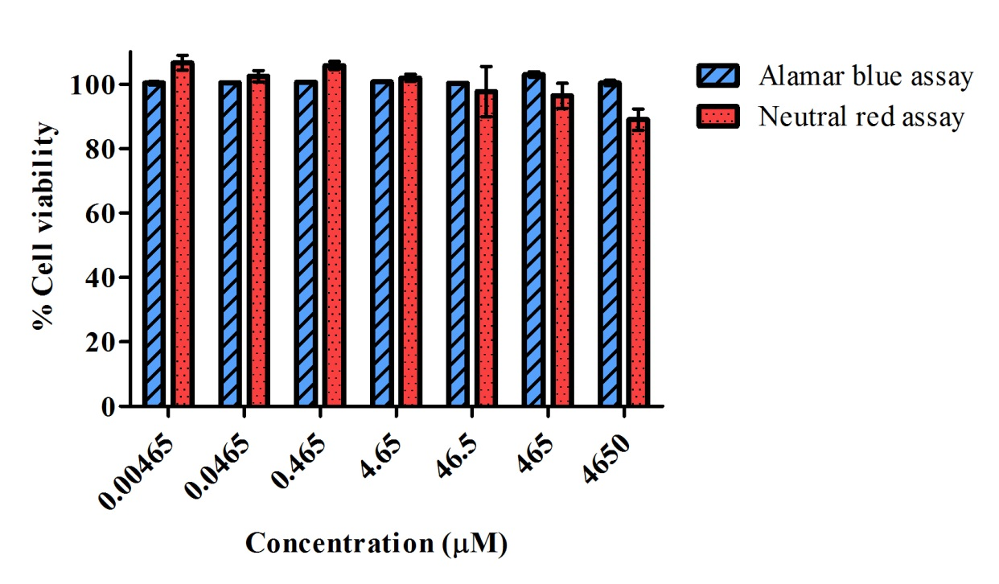
Fig.S2: Tolerability of HaCaT keratinocytes when treated with (0.005-4,650 μM) of α-T diluted in 0.5% ethanol, 95% Dulbecco's modified eagle's cell culture medium (with FBS) at 37°C for 24 hours. The α-T was well tolerated by the HaCaT keratinocytes when assessed using both the Alamar blue® (blue columns) and neutral red (red columns) cell viability assays. All the concentrations show viability ≥ 90%. Data represents mean ± standard deviation, (n=3).

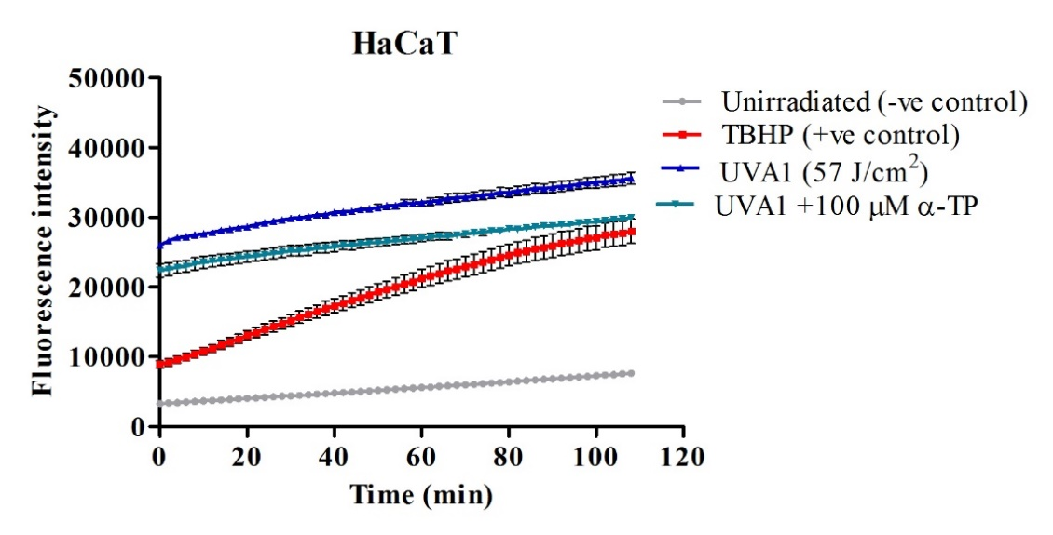
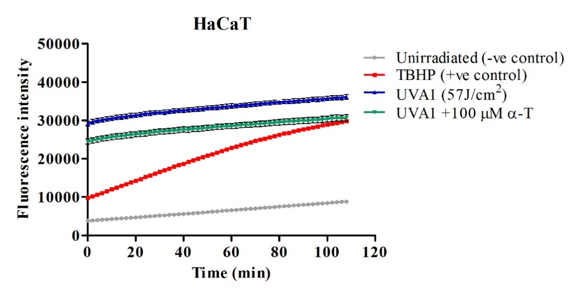
Fig.S3: Pre-treatment studies on HaCaT keratinocytes. The generation of ROS in HaCaT keratinocytes at 2 min intervals after UVA1 irradiation over 1.8-2 h. HaCaT were pretreated with 100 µM of α-TP and α-T for 24 h and subsequently re-incubated with 20 µM DCFDA for 45 min and then immediately washed with PBS and exposed to a UVA1 dose of 57 J/cm². The TBHP was added into the reserved positive control wells at at concentration of 250 µM. Data represent mean ± SD (n=3).
Table S3: The generation of ROS in HaCaT keratinocytes pre-treated with antioxidants
Condition | Mean (n=3) difference (a.u.) over 2 h  compared to unirradiated control
 | Positive control (TBHP) | 385 nm UVA1 (57 J/cm²) | 385 nm UVA1 (57 J/cm²) + pre-treatment (100 µM)
HaCaT + pre-αTP | -8,414,000 | -14,220,000 | -10,800,000
HaCaT + pre-α-T | -7,685,000 | -13,020,000 | -9,908,000

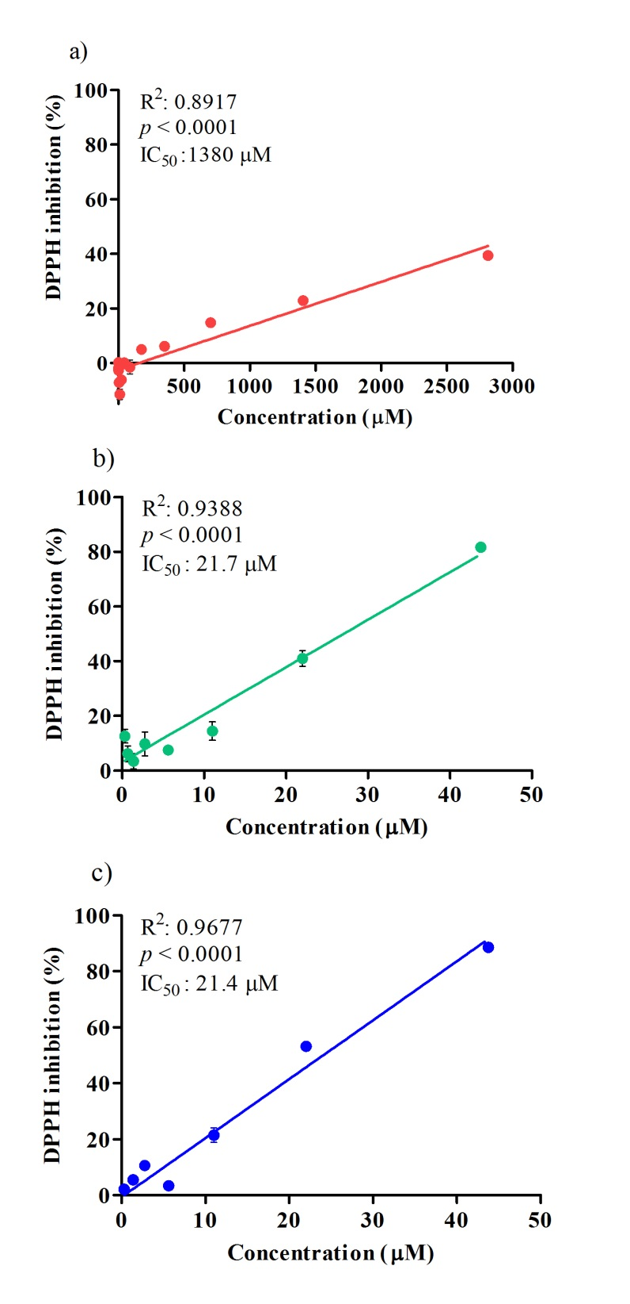

Fig.S4: The DPPH radical scavenging/inhibition activity of α-TP (a), L-ascorbic acid (b), and α-T (c). All tested antioxidants show an ability to quench the DPPH radical as a measure of radical scavenging activity in a concentration-dependant manner. All compounds demonstrated significant activity (p < 0.0001, linear regression analysis). The standard deviation was too small to be seen (n=3).

