The ARRIVE Guidelines Checklist
Animal Research: Reporting In Vivo Experiments
Carol Kilkenny¹, William J Browne², Innes C Cuthill³, Michael Emerson⁴ and Douglas G Altman⁵
¹The National Centre for the Replacement, Refinement and Reduction of Animals in Research, London, UK, ²School of Veterinary Science, University of Bristol, Bristol, UK, ³School of Biological Sciences, University of Bristol, Bristol, UK, ⁴National Heart and Lung Institute, Imperial College London, UK, ⁵Centre for Statistics in Medicine, University of Oxford, Oxford, UK.

 |  | ITEM | RECOMMENDATION | Section/  Paragraph
 |  |  |  | Title page/1
31-72
(Title page)
 | INTRODUCTION
 | 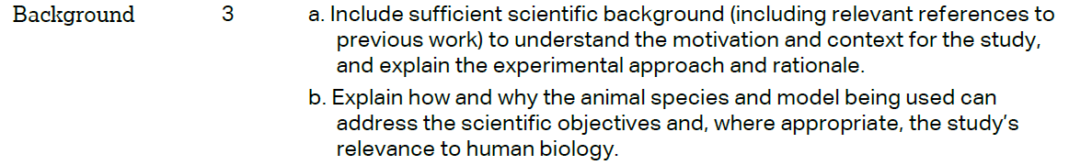 |  |  | 76-136
 |  |  |  | 128-136
 | METHODS
 |  |  |  | 139-144
 | 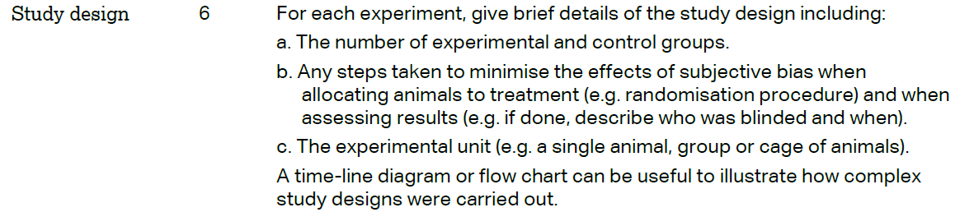 |  |  | 139-144
 | 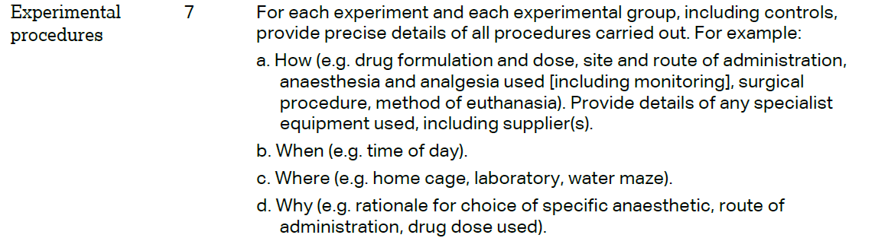 |  |  | 146-222
 | 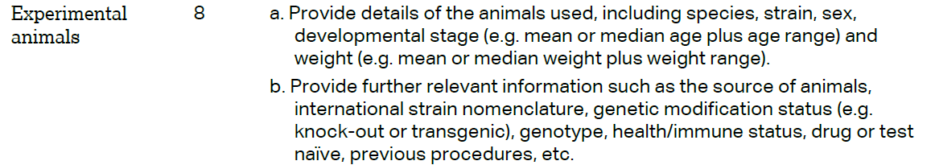 |  |  | 224-240
The ARRIVE guidelines. Originally published in PLoS Biology, June 2010¹
 | 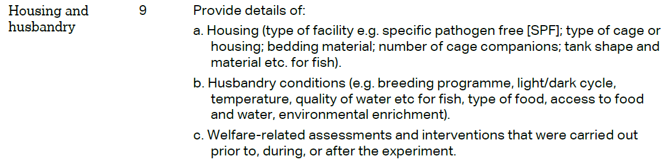 | 224-229
 | 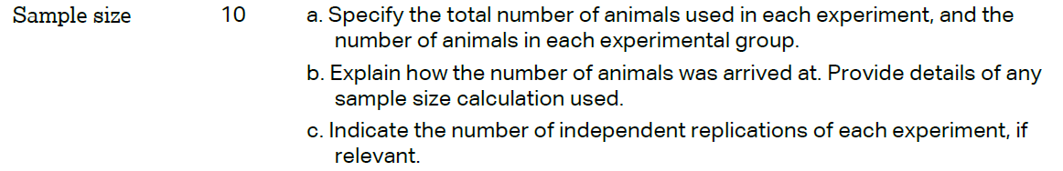 | 262
 | 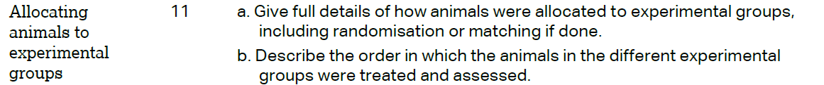 | 261-266
 |  | 272-282
 | 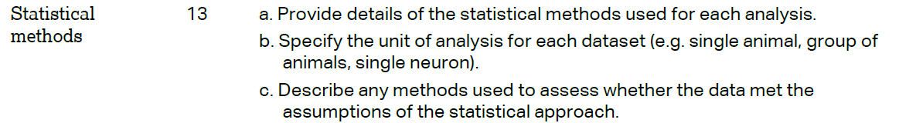 | 284-294
 | RESULTS
 |  | 328-329
 |  | 331-335
 |  | 331-343
 |  | NA
 | DISCUSSION
 | 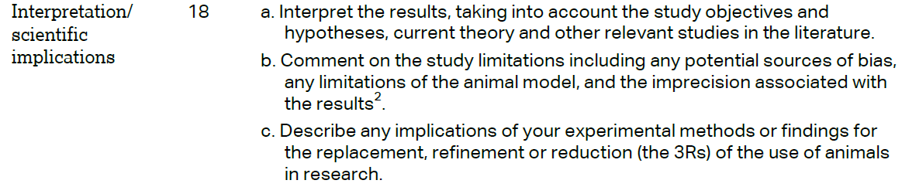 | a.357-385  b.441-448  c.NA
 |  | 454-457
 |  | 476-480
