# *Supplementary material: 10 most important features by models.*

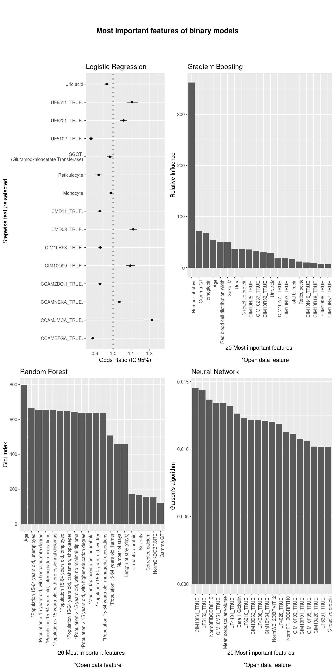

**, in Rennes.**

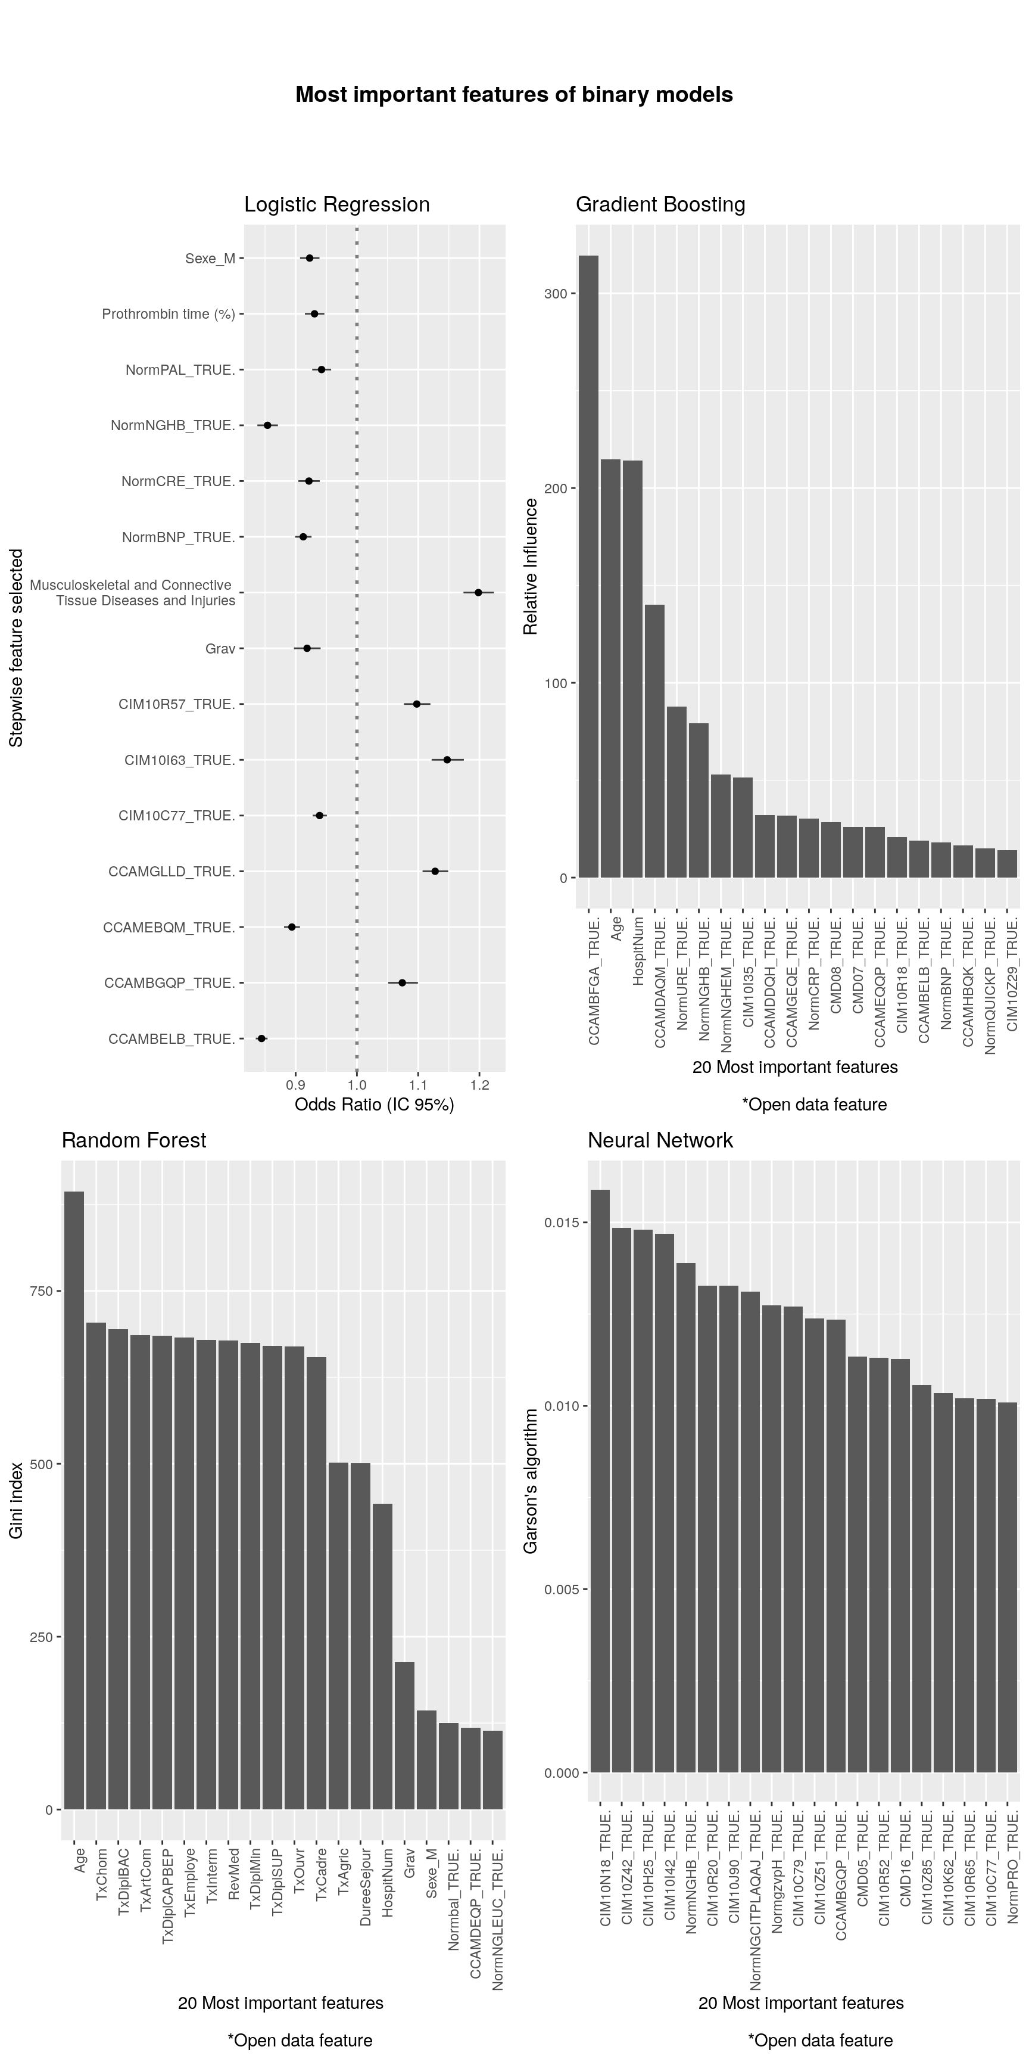

**, in Tours.**