**Supplementary method**

*Development of prediction model*

The k-nearest neighbor algorithm (K-NN)1 is one of the simplest and popular way in supervised learning method for classification and regression. K-NN determines the output value by the number of closest training data from input data with out. There are two important parameters in K-NN algorithm, k and distance. The k in K-NN means the number of closest training data of input data and the most frequent value is decided by output. Below figure x show one example of KNN, 1-NN and 5 – NN.

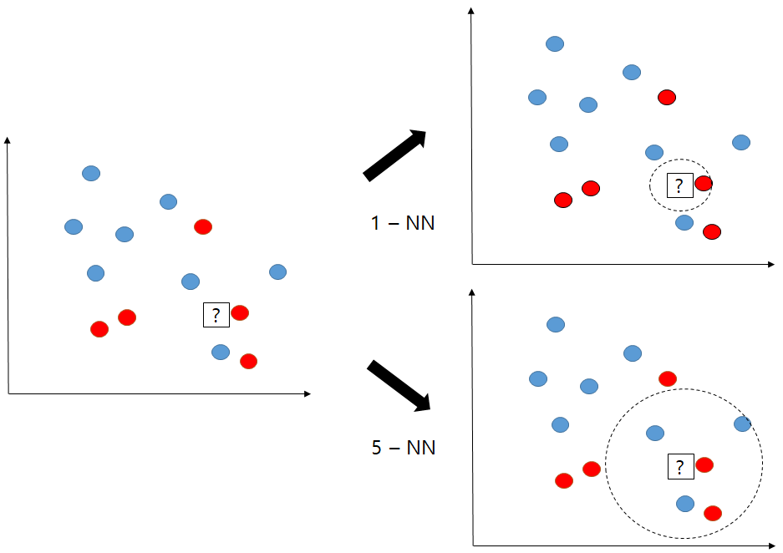

Figure (E1) Example of K-NN: 1-NN and 5-NN case

As you can see in figure E1, in 1-NN case, test data is predicted as red circle class because the nearest one data is the red circle, however 5-NN case test data is classified blue circle class because more than half of the five closest are blue circles. Another important parameter in K-NN is distance that it decides which data are closet data. The most popular distance measures between two data  and  where  are feature of data are as follows.

Euclidean :



Malanobis



Manhattan



In this paper, we use 5-NN with Euclidean distance for choice closet data to predict insufficient hepatic enhancement.

**Supplementary Table 1. Diagnostic performance of prediction model for classification of visual assessment of hepatic enhancement during hepatobiliary phase.**

|  |  |  |  |  |  |  |  |  |  |
| --- | --- | --- | --- | --- | --- | --- | --- | --- | --- |
| Grade | CPS | | | MELD-Na | | | combination of various parameters | | |
| sensitivity | specificity | accuracy | sensitivity | specificity | accuracy | sensitivity | specificity | accuracy |
| 1 | 49.6 ± 0.07 | 50.6 ± 0.11 | 65.5 ± 0.07 | 85.7 ± 0.14 | 44.2 ± 0.12 | 58.1 ± 0.07 | 75.6 ± 0.11 | 65.1 ± 0.08 | 68.9 ± 0.05 |
| 2 | NaN | 81.8 ± 0.16 | 56.4 ± 0.08 | 10.2 ± 0.16 | 90.9 ± 0.09 | 60.0 ± 0.05 | 37.1 ± 0.11 | 76.9 ± 0.09 | 63.9 ± 0.05 |
| 3 | 64. 7± 0.07 | 90.4 ± 0.07 | 78.4 ± 0.05 | 61.4 ± 0.09 | 87.6 ± 0.05 | 81.1 ± 0.04 | 58.0 ± 0.10 | 90.7 ± 0.05 | 81.4 ± 0.04 |
| 4 | NaN | 100.0 ± 0.00 | 96.9 ± 0.01 | 0.0 ± 0.00 | 100.0 ± 0.00 | 96.1 ± 0.02 | 0.0 ± 0.00 | 100.0 ± 0.00 | 96.7 ± 0.01 |

Note. — Data are presented as a mean (%) ± standard deviation.

**Reference**

1 Murphy, K. P. *Machine learning: a probabilistic perspective*. (MIT press, 2012).