Supplementary information

Supplementary Note 1. Single-ion state of Fe²⁺ in Ba₂FeSi₂O₇
Recent terahertz spectroscopy and X-ray absorption spectroscopy (XAS) on A₂FeSi₂O₇ (A=Sr and Ba) revealed that the considerable tetragonal distortion of FeO₄-tetrahedra (Sr: 17% and Ba: 26% $z$-compression from cubic) with large spin-orbit coupling of Fe²⁺ ($λ∼$20 meV) induces significant easy-plane single-ion anisotropy in the system (1, 2). Following the description for the spin-orbital states of Fe²⁺ in a tetrahedral environment, in Ba₂FeSi₂O₇ the large single-ion anisotropy determines the ground state from the multiplet of Fe²⁺ ion. Starting with the free ion, $^{5}D$ ($L=2$, $S=2$), the tetrahedral crystal field ($Δ_{Td}$) and tetragonal distortion ($δ_{Tetra}$) leave an A-manifold with 5 levels (see Supplementary Figure 1) with hybridized $L^{z}$ and $S^{z}$ states. When $Δ_{Td},δ_{Tetra}≫λ$, it leads to a pure spin $S=2$ quintet (see Supplementary Figure 1A). Introducing a single-ion term $D(S^{z})^{2}$ with easy-plane anisotropy, lifts the degeneracy of the quintet into levels with $S^{z}$=0 (singlet), $S^{z}=±1$ (doublet), and $S^{z}=±2$ (doublet) where the energy-splitting between the states is given $D$ and 3$D$. Supplementary Figure 1B shows the inelastic neutron scattering measured at $T$=90 K, $∼7*Θ_{CW}$ (powder averaged Curie-Weiss temperature $Θ_{CW}\sim -12.8$ K) where the single-ion physics dominates (1). In the spectra, two flat excitations are visible at d$E∼$1.32 meV and 3.9 meV which indicate transitions between levels as follows $|S^{z}=0〉→$ $|S^{z}=±1〉$ and $|S^{z}=±1〉→$ $|S^{z}=±2〉$. Note that the transitions between $|S^{z}=0〉$ and $|S^{z}=±2〉$ are forbidden by dipole selection rules. At finite temperature, the thermal population of the spin states determines the effective spin of the system. In the low temperature region where $T≪3*D$ ($∼$45 K), the $|S^{z}=±2〉$ states are depopulated and the system can then be treated as an effective $S=1$.

Supplementary Note 2. Analysis of a possible gap at magnetic zone center
To check for evidence of a gap in the spin wave dispersion near the ZC, the low energy inelastic neutron scattering was investigated using CTAX at HFIR with $E_{f}$=3 meV. The energy resolution of the instrument (FWHM$∼$0.101 meV for elastic scattering), presents a challenge to directly extract a small gap due to the large scattering near the magnetic Bragg reflection at $Q_{m}$. As an alternative approach, we examine the spin wave dispersions near the ZC and compare the calculated spin wave dispersion with and without a small gap. The measured dispersion was obtained by fitting with a resolution convoluted Gaussian function to constant momentum transfer scans for 0.85$≤H≤$1.15. The extracted magnon dispersion is displayed as the contour plot along with the calculated spin waves with $Δ_{gap}=0$ and 0.2 meV in Supplementary Figure 1A. As shown, a gapless Goldstone mode ($Δ_{gap}$=0) has linear dispersion emanating from the ZC, whereas the gaped spin wave has quadratic dispersion near the ZC providing a possible means of distinguising a gaped spectra from an gapless spectra. To find the best description of the dispersion near the ZC, the deviation between the data and calculated dispersion is defined as ($E_{exp.}-E_{calc.})^{2}$. The sum of this deviation is presented in Supplementary Figure 2B as a function of the gap energy. The deviation has a minimum at $Δ_{gap}∼$0.25 meV, suggesting a gap in spin wave spectrum of Ba₂FeSi₂O₇.

Supplementary Note 3. Spin wave dispersion along $L$-direction
Supplementary Figure 3 shows INS data along the $L$-direction for [$H$, 0, $L$] with $H$=0 and 1, measured using HYSPEC spectrometer. The spin excitations are weakly dispersing along $L$ indicating quasi-two-dimensional behavior due to the relatively weak inter-layer coupling. As shown, the acoustic magnon ($T_{1}$) has a bandwidth of 0.5 meV, and the $T_{2}$ and $L$ modes are almost completely flat along the $L$ direction. The $L$-dependence of the spin excitations is reproduced by the GLSWT and GLSWT + one loop correction calculations with $\tilde{J'}$=$\tilde{J}/10$.

Supplementary Note 4. Generalized spin wave approach
In the local reference frame, the spin and quadrupolar operators can be expanded in $1/M$ as:
$$S_{r}^{μ}=M{\tilde{S}}_{00}^{μ}+\sqrt{M}\sum_{α=±1}{‍}\left({\tilde{S}}_{α0}^{μ}b_{r,α}^{†}+h.c.\right)$$  $$+\sum_{α,β=±1}{‍}\left({\tilde{S}}_{αβ}^{μ}-{\tilde{S}}_{00}^{μ}δ_{αβ}\right){\tilde{b}}_{r,α}^{†}{\tilde{b}}_{r,β}$$  $$-\frac{1}{2\sqrt{M}}\sum_{α=±1}{‍}\sum_{β=±1}{‍}({\tilde{S}}_{α0}^{μ}{\tilde{b}}_{r,α}^{†}{\tilde{b}}_{r,β}^{†}{\tilde{b}}_{r,β}+h.c.)+O(\frac{1}{M^{3/2}}),$$ | (S1)

$$(S_{r}^{z})^{2}=1-M{\tilde{A}}_{00}-\sqrt{M}\sum_{α=±1}{‍}({\tilde{A}}_{α0}{\tilde{b}}_{r,α}^{†}+h.c.)$$  $$-\sum_{α,β=±1}{‍}({\tilde{A}}_{αβ}-{\tilde{A}}_{00}δ_{αβ}){\tilde{b}}_{r,α}^{†}{\tilde{b}}_{r,β}$$  $$+\frac{1}{2\sqrt{M}}\sum_{α=±1}{‍}\sum_{β=±1}{‍}({\tilde{A}}_{α0}{\tilde{b}}_{r,α}^{†}{\tilde{b}}_{r,β}^{†}{\tilde{b}}_{r,β}+h.c.)+O(\frac{1}{M^{3/2}}).$$ | (S2)
The expressions for the coefficients $A_{k,α}$ and $B_{k,α}$ of the quadratic Hamiltonian $H^{(2)}$ Eq. (17) are:
$$A_{k,+1}=-8\left(x-1\right)x\left(2\tilde{J}+{\tilde{J}}^{'}\right)-\left(x-1\right)\tilde{D}$$  $$+2\left(x\left(1+\tilde{Δ}\right)-1\right)\tilde{J}γ_{k}^{xy}$$  $$+2\left(x\left(1+{\tilde{Δ}}^{'}\right)-1\right){\tilde{J}}^{'}γ_{k}^{z},$$  $$B_{k,+1}=-2\left(x\left(\tilde{Δ}-1\right)+1\right)\tilde{J}γ_{k}^{xy}$$  $$-2\left(x\left({\tilde{Δ}}^{'}-1\right)+1\right){\tilde{J}}^{'}γ_{k}^{z},$$  $$A_{k,-1}=-16\left(x-1\right)x\left(2\tilde{J}+{\tilde{J}}^{'}\right)-\left(2x-1\right)D$$  $$-2(1-2x)^{2}(\tilde{J}γ_{k}^{xy}+\tilde{J}'γ_{k}^{z}),$$  $$B_{k,-1}=2(1-2x)^{2}(\tilde{J}γ_{k}^{xy}+\tilde{J}'γ_{k}^{z})$$ | (S3)

$$A_{k,+1}=-8\left(x-1\right)x\left(2\tilde{J}+{\tilde{J}}^{'}\right)-\left(x-1\right)\tilde{D}$$  $$+2\left(x\left(1+\tilde{Δ}\right)-1\right)\tilde{J}γ_{k}^{xy}$$  $$+2\left(x\left(1+{\tilde{Δ}}^{'}\right)-1\right){\tilde{J}}^{'}γ_{k}^{z},$$  $$B_{k,+1}=-2\left(x\left(\tilde{Δ}-1\right)+1\right)\tilde{J}γ_{k}^{xy}$$  $$-2\left(x\left({\tilde{Δ}}^{'}-1\right)+1\right){\tilde{J}}^{'}γ_{k}^{z},$$  $$A_{k,-1}=-16\left(x-1\right)x\left(2\tilde{J}+{\tilde{J}}^{'}\right)-\left(2x-1\right)D$$  $$-2(1-2x)^{2}(\tilde{J}γ_{k}^{xy}+\tilde{J}'γ_{k}^{z}),$$  $$B_{k,-1}=2(1-2x)^{2}(\tilde{J}γ_{k}^{xy}+\tilde{J}'γ_{k}^{z})$$ | (S4)

Supplementary Note 5. Cubic and cubic-linear vertices
In this section, we derive the cubic and cubic-linear vertices given in Eq. (24) and Eq. (25). The cubic Hamiltonian has three contributions
$$H^{(3)}=H_{intra}^{(3)}+H_{inter}^{(3)}+H_{D}^{(3)},$$ | (S5)
with
$$H_{intra}^{\left(3\right)}=\tilde{J}\sum_{〈r,r'〉,ν}{‍}\sum_{α,β=±1}{‍}\{\sum_{α^{'}=±1}{‍}a_{ν}[2{\tilde{S}}_{αβ}^{ν}{\tilde{S}}_{0α^{'}}^{ν}{\tilde{b}}_{rα}^{†}{\tilde{b}}_{rβ}{\tilde{b}}_{r'α'}]$$  $$-a_{ν}[{\tilde{S}}_{0α}^{ν}{\tilde{S}}_{00}^{ν}({\tilde{b}}_{rβ}^{†}{\tilde{b}}_{rβ}{\tilde{b}}_{rα}+2{\tilde{b}}_{r'β}^{†}{\tilde{b}}_{r'β}{\tilde{b}}_{rα})]+h.c.\},$$ | (S6)

$$H_{inter}^{(3)}=\tilde{J}'\sum_{〈r,r'〉,ν}{‍}\sum_{α,β=±1}{‍}\{\sum_{α'=±1}{‍}b_{ν}[2{\tilde{S}}_{αβ}^{ν}{\tilde{S}}_{0α'}^{ν}{\tilde{b}}_{rα}^{†}{\tilde{b}}_{rβ}{\tilde{b}}_{r'α'}]$$  $-b_{ν}[{\tilde{S}}_{0α}^{ν}{\tilde{S}}_{00}^{ν}({\tilde{b}}_{rβ}^{†}{\tilde{b}}_{rβ}{\tilde{b}}_{rα}+2{\tilde{b}}_{r'β}^{†}{\tilde{b}}_{r'β}{\tilde{b}}_{rα})]+h.c.\},$ | (S7)

$$H_{D}^{(3)}=\frac{\tilde{D}}{2}\sum_{r}{‍}\sum_{α,β=±1}{‍}[{\tilde{A}}_{0α}{\tilde{b}}_{rβ}^{†}{\tilde{b}}_{rβ}{\tilde{b}}_{rα}+h.c.],$$ | (S8)
To simplify the notation, we will write a particular term of (39) (in momentum space) as $(I)={\tilde{b}}_{{\overline{q}}_{1},α}^{†}{\tilde{b}}_{q_{2},β}{\tilde{b}}_{q_{3},γ}f(q_{i},t)$, with
$$f(q_{1,2,3},t)=\left\{\begin{matrix}1 & t=0 \\ γ_{q_{3}}^{xy} & t=1 \\ γ_{q_{3}}^{z} & t=2\end{matrix}\right..$$ | (S9)
The Nambu spinor of the bosonic operators can be Bogoliubov transformed into the quasi-particle representation ${\vec{b}}_{k}=U(k){\vec{β}}_{k}$, where the matrix elements of $U(k)$ are obtained from the Bogoliubov coefficients given in Eq. (20)
$$U\left(k\right)=\left(\begin{matrix}U_{2×2}^{11}\left(k\right) & U_{2×2}^{12}\left(k\right) \\ U_{2×2}^{21}\left(k\right) & U_{2×2}^{22}\left(k\right)\end{matrix}\right)$$  $$=\left(\begin{matrix}u_{k,+1} & 0 & v_{k,+1} & 0 \\ 0 & u_{k,-1} & 0 & v_{k,-1} \\ v_{k,+1} & 0 & u_{k,+1} & 0 \\ 0 & v_{k,-1} & 0 & u_{k,-1}\end{matrix}\right).$$ | (S10)
After applying the above-mentioned Bogoliubov transformation, we obtain
$$(I)=\sum_{n_{1,2,3}}{‍}\{F^{\left(a\right)}(αβγ,n_{1,2,3};q_{1,2,3},t)β_{q_{1},n_{1}}β_{q_{2},n_{2}}β_{q_{3},n_{3}}$$  $$+F^{\left(b\right)}\left(αβγ,n_{1,2,3};q_{1,2,3},t\right)β_{{\overline{q}}_{1},n_{1}}^{†}β_{{\overline{q}}_{2},n_{2}}^{†}β_{{\overline{q}}_{3},n_{3}}^{†}$$  $$+F^{\left(c\right)}\left(αβγ,n_{1,2,3};q_{1,2,3},t\right)β_{{\overline{q}}_{1},n_{1}}^{†}β_{{\overline{q}}_{2},n_{2}}^{†}β_{q_{3},n_{3}}$$  $$+F^{\left(d\right)}\left(αβγ,n_{1,2,3};q_{1,2,3},t\right)β_{{\overline{q}}_{1},n_{1}}^{†}β_{q_{2},n_{2}}β_{q_{3},n_{3}}$$  $$+L^{\left(c\right)}\left(αβγ,n_{1,2,3};q_{1,2,3},t\right)δ_{q_{3},{\overline{q}}_{2}}δ_{n_{3},n_{2}}β_{{\overline{q}}_{1},n_{1}}^{†}$$  $$+L^{(d)}(αβγ,n_{1,2,3};q_{1,2,3},t)δ_{q_{2},{\overline{q}}_{1}}δ_{n_{2},n_{1}}β_{q_{3},n_{3}}\}.$$ | (S11)
The explicit forms of $F^{(a,b,c,d)}$ and $L^{(c,d)}$ can be obtained by simple algebras, which are not shown here for the sake of brevity.
The “sink” (“source”) function $F^{(a)}$ ($F^{(b)}$) is symmetric under permutations of all three legs (momenta and flavors). Consequently, we introduce the symmetrized functions
$${\tilde{F}}^{(a)}≡\sum_{P(q_{1,2,3};n_{1,2,3})}{‍}F^{(a)}, {\tilde{F}}^{(b)}≡\sum_{P(q_{1,2,3};n_{1,2,3})}{‍}F^{(b)}.$$ | (S12)
Similarly, the “decay” function $F^{(c)}$ and the “fusion” function $F^{(d)}$ are symmetrized for the two outgoing and the two incoming legs, respectively,
$${\tilde{F}}^{(c)}=\sum_{P(q_{1,2};n_{1,2})}{‍}F^{(c)}, {\tilde{F}}^{(d)}=\sum_{P(q_{2,3};n_{2,3})}{‍}F^{(c)}.$$ | (S13)
After inserting the above results into Eq. (39), we obtain the explicit forms of the cubic vertices in $V_{s/d}^{(3)}$ Eq. (24) and $V_{α}^{L}$ in Eq. (25).

Supplementary Note 6. Quartic vertex
The quartic contributions to the expansion (9) are
$$H^{(4)}=H_{intra}^{(4)}+H_{inter}^{(4)},$$ | (S14)
with

$$H_{intra}^{\left(4\right)}=\tilde{J}\sum_{〈r,r'〉,ν}{‍}\sum_{α,β=±1}{‍}\{[a_{ν}{\tilde{S}}_{00}^{ν}{\tilde{S}}_{00}^{ν}{\tilde{b}}_{rα}^{†}{\tilde{b}}_{r'β}^{†}{\tilde{b}}_{rα}{\tilde{b}}_{r'β}]$$  $$+\sum_{α^{'}β^{'}=±1}{‍}\left[a_{ν}{\tilde{S}}_{αβ}^{ν}{\tilde{S}}_{α^{'}β^{'}}^{ν}{\tilde{b}}_{rα}^{†}{\tilde{b}}_{r'α'}^{†}{\tilde{b}}_{rβ}{\tilde{b}}_{r'β'}\right]$$  $$-2\sum_{α^{'}=±1}{‍}\left[a_{ν}{\tilde{S}}_{αβ}^{ν}{\tilde{S}}_{00}^{ν}{\tilde{b}}_{rα}^{†}{\tilde{b}}_{r'α'}^{†}{\tilde{b}}_{rβ}{\tilde{b}}_{r'α'}\right]$$  $$-\sum_{α^{'}=±1}{‍}\left[a_{ν}{\tilde{S}}_{α0}^{ν}{\tilde{S}}_{β0}^{ν}{\tilde{b}}_{rα}^{†}{\tilde{b}}_{r'β}^{†}{\tilde{b}}_{r'α'}^{†}{\tilde{b}}_{r'α'}+h.c.\right]$$  $$-\sum_{α'=±1}{‍}[a_{ν}{\tilde{S}}_{α0}^{ν}{\tilde{S}}_{0β}^{ν}{\tilde{b}}_{rα}^{†}{\tilde{b}}_{r'α'}^{†}{\tilde{b}}_{r'α'}{\tilde{b}}_{r'β}+h.c.]\}.$$ | (S15)
Similarly to the cubic contribution, $H_{inter}^{(4)}$ can be obtained from $H_{intra}^{(4)}$ by substituting $\tilde{J}→\tilde{J}'$, $a_{ν}→b_{ν}$. The matrix elements appear in the normal ordering of the quartic vertex are defined as:
$${\overline{N}}_{rr'}^{αβ}≡\frac{1}{N}\sum_{\left\langle r,r'\right\rangle }{‍}\left\langle b_{rα}^{†}b_{r'β}\right\rangle$$  $$=\frac{1}{N}\sum_{k}{‍}\sum_{n}{‍}U_{α,n}^{21}(k)[U_{β,n}^{21}(k)]^{*}cos⁡[k⋅(r'-r)],$$  $$Δ_{rr'}^{αβ}≡\frac{1}{N}\sum_{\left\langle r,r'\right\rangle }{‍}\left\langle b_{rα}b_{r'β}\right\rangle$$  $$=\frac{1}{N}\sum_{k}{‍}\sum_{n}{‍}U_{α,n}^{11}(k)[U_{β,n}^{21}(k)]^{*}cos⁡[k⋅(r'-r)],$$  $${\overline{Δ}}_{rr'}^{αβ}≡\frac{1}{N}\sum_{\left\langle r,r'\right\rangle }{‍}\left\langle b_{rα}^{†}b_{r'β}^{†}\right\rangle$$  $$=\frac{1}{N}\sum_{k}{‍}\sum_{n}{‍}U_{α,n}^{21}(k)[U_{β,n}^{11}(k)]^{*}cos[k⋅(r'-r)],$$ | (S16)
We note that some of these matrix elements are equal to zero because of the residual U(1) symmetry of the antiferromagnetic order. To obtain the normal-ordered Hamiltonian Eq. (34), we apply a mean-field (Hartree-Fock) decoupling to the quartic Hamiltonian Eq. (42), for example,
$${\tilde{b}}_{rα}^{†}{\tilde{b}}_{r'β}^{†}{\tilde{b}}_{rα}{\tilde{b}}_{r'β}≃Δ_{rr'}^{αβ}{\tilde{b}}_{rα}^{†}{\tilde{b}}_{r'β}^{†}+{\overline{N}}_{r'r'}^{ββ}{\tilde{b}}_{rα}^{†}{\tilde{b}}_{rα}$$  $$+{\overline{N}}_{r'r}^{βα}{\tilde{b}}_{rα}^{†}{\tilde{b}}_{rβ}+{\overline{Δ}}_{rr'}^{αβ}{\tilde{b}}_{rα}{\tilde{b}}_{r'β}$$  $$+{\overline{N}}_{rr}^{αα}{\tilde{b}}_{r'β}^{†}b_{r'β}+{\overline{N}}_{rr'}^{αβ}{\tilde{b}}_{r'β}^{†}{\tilde{b}}_{rα}.$$ | (S17)
The coefficients $V_{αα}^{(4,N)}$ that appear in the normal term of Eq. (34) can be derived after consecutive Fourier and Bogoliubov transformations.

Supplementary Note 7. One-loop diagrams in the long-wavelength limit
Without loss of generality, we consider an isotropic Heisenberg model, i.e. $\tilde{J}=\tilde{J}'$, $\tilde{Δ}=\tilde{Δ}'$ to show the $1/q$ divergence of the one-loop diagrams involving the Goldstone mode. According to Eq. (20),
$$\lim_{q→0}u_{q,+},v_{q,+}=\sqrt{\frac{\tilde{J}d}{v_{0,+}}}\frac{1}{\sqrt{q}},-\sqrt{\frac{\tilde{J}d}{v_{0,+}}}\frac{1}{\sqrt{q}}$$ | (S18)
where $v_{0,+}=2\tilde{J}d\sqrt{\tilde{D}/(4\tilde{J}d^{2})+1/d}$ is the spin wave velocity of the Goldstone mode and $d=3$ is the spatial dimension of the lattice equal to half of the coordination number. Note that the cubic vertices are proportional to a product of the Bogoliubov coefficients of three legs
$$V_{d,s}^{(3)}∝u(v)_{q_{1},α}u(v)_{q_{2},β}u(v)_{q_{3},γ}.$$ | (S19)
For the decay and sink diagrams shown on the second line of Supplementary Figure 5 (a), we can choose, for instance, $q_{3}=q∼0$, $γ=+1$ to contract with the leg of the long-wavelength bosons. Consequently,
$$Σ^{(d,s)}(+)∼|V_{d,s}^{(3)}(q_{1,2},q;αβ+)|^{2}∼(1/\sqrt{q})^{2}∼1/q.$$ | (S20)
As for the cubic-linear diagrams, we need to choose two legs to contract with the long-wavelength boson, implying that
$$Σ^{(cl)}(+)∼V_{d}^{(3)}(0,-qq;-++)∼1/q.$$ | (S21)
Finally, notice that $V_{++}^{(4,N)}∼1/q$ in the long-wavelength limit, because the quadratic forms of the transverse boson in Eq. (43) after the Bogoliubov transformation are proportional to $u(v)_{q,+1}u(v)_{q,+1}$. By adding up all diagrams in $O(M^{0})$, we have verified that the coefficient of the $1/q$-factor vanishes, implying that the Goldstone mode is preserved after the one-loop correction.

Supplementary Note 8. Calculation of the neutron intensity
The imaginary-time dynamical spin susceptibility is defined as:
$$χ^{μν}(q,iω_{n})=-\int_{0}^{β}{‍}dτe^{iω_{n}τ}〈T_{τ}\left[S_{q}^{μ}(τ)S_{\overline{q}}^{ν}(0)\right]〉.$$ | (S22)
The real-time spin-spin correlation function in Eq. (22) is obtained by using the fluctuation-dissipation theorem at $T=0$ after the analytic continuation $iω_{n}→ω+i0^{+}$:
$$S^{μν}(q,ω)=-2I\left[χ^{μν}(q,ω)\right].$$ | (S23)
Up to order $O(1/M)$, $S^{μν}$ acquires two contributions:
$$S^{μν}=S_{qp}^{μν}+S_{tc}^{μν},$$ | (S24)
where $S_{qp}^{μν}$ includes contributions from the quasi-particle channel associated with “transverse fluctuations" of the SU(3) order parameter, while $S_{tc}^{μν}$ includes two-particle contributions associated with “longitudinal fluctuations" of the SU(3) order parameter (3). The latter is not analyzed in this work, as it only contributes to the continuum. After the one-loop corrections, the quasi-particle channel can be written as a linear combination of the dressed bosonic propagators $G$. For details, see (3).

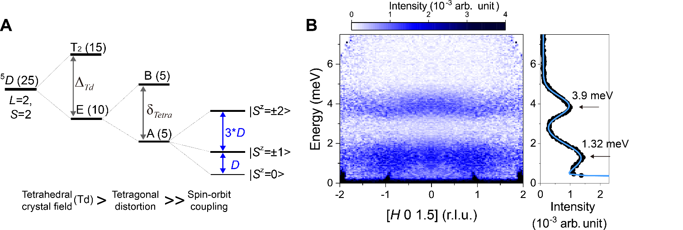
Supplementary Figure 1. Orbital configuration and single-ion excitation of Ba₂FeSi₂O₇
(A) Orbital energy states of Fe²⁺ with a tetrahedral crystal field ($Δ_{Td}$), tetragonal distortion ($δ_{Tetra}$), and spin orbit coupling ($λ$). (B) The left panel shows inelastic neutron scattering data measured at $T$=90 K, symmetrized over negative and positive $H$ and integrated over $L$=[0.9, 2.1] and $K$=[-0.1, 0.1]. The integrated scattering intensity over $H$=[-2, 2] is shown in the right panel. The two peaks were fitted with Gaussian functions (solid blue line). Arrows indicate the peak centers at 1.32 meV and 3.9 meV.

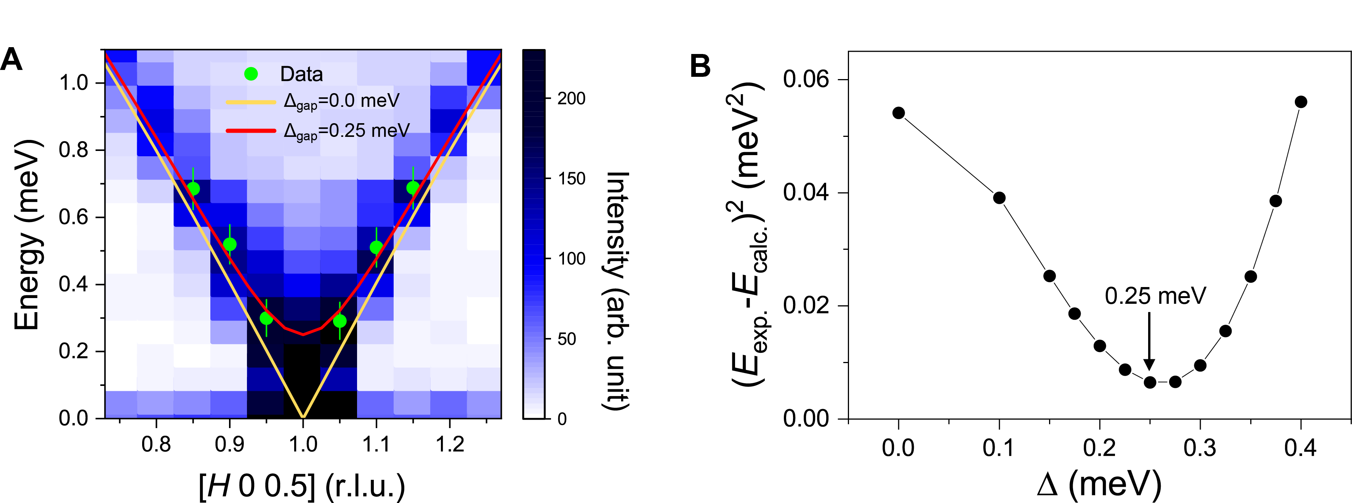Supplementary Figure 2. Gap excitation at magnetic zone center
(A) Contour map for low energy inelastic neutron scattering data near the zone center. The magnon dispersion extracted from the data is indicated by green circles and is compared with the dispersion calculated with the GLSWT with and without a gap ($Δ_{gap}=$0.25 meV) in the spectrum. (B) Sum of the square of the energy difference between the measured and calculated dispersion as a function of gap size. The arrow marks the gap size $Δ_{gap}∼$ 0.25 meV that best fits the data.

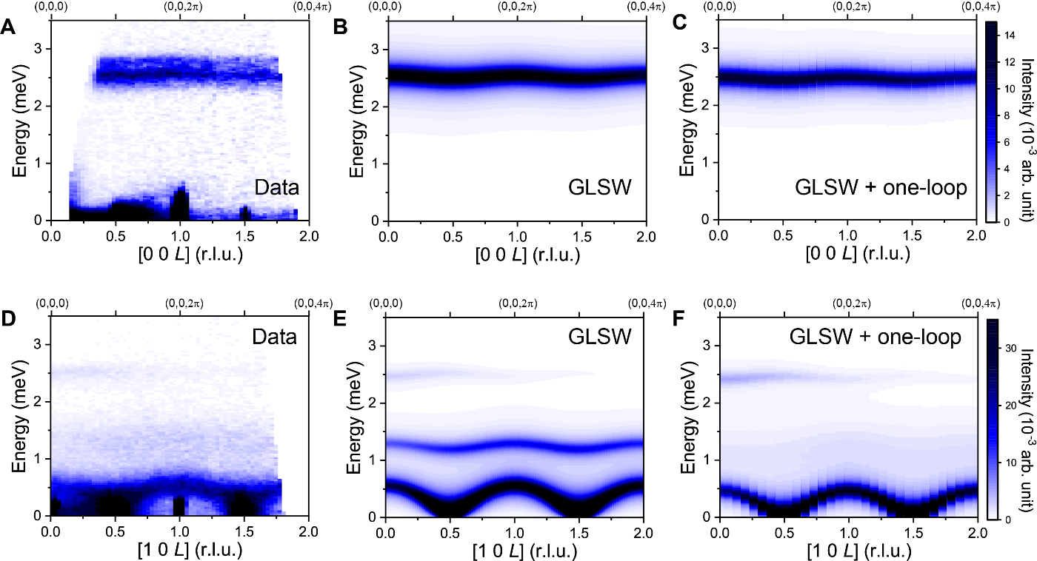Supplementary Figure 3. Spin excitation along L-direction
Inelastic neutron scattering spectra along [$H$, 0, $L$] for $H$=0 (A-C) and 1 (D-F) along with the calculated spectra using the GLSWT and GLSWT+one loop corrections using parameter sets $A$ and $B$ in Table. 1, respectively. All the calculated spectra were convoluted with the instrumental resolution of HYSPEC.

References
1. T.-H. Jang, S. H. Do, M. Lee, V. Zapf, H. Wu, C. M. Brown, A. D. Christianson, S. W. Cheong, J. H. Park, Two-dimensional square-lattice magnet Ba₂FeSi₂O₇: integer spin with large easy-plane single-ion anisotropy (in preparation).
2. T. T. Mai, C. Svoboda, M. T. Warren, T. H. Jang, J. Brangham, Y. H. Jeong, S. W. Cheong, R. Valdés Aguilar, Terahertz spin-orbital excitations in the paramagnetic state of multiferroicSr2FeSi2O7. Physical Review B 94, (2016).
3. M. Mourigal, W. T. Fuhrman, A. L. Chernyshev, M. E. Zhitomirsky, Dynamical structure factor of the triangular-lattice antiferromagnet. Phys. Rev. B 88, 094407 (2013).

