Supplementary data
Summary statistics for AL PROfile Fatigue
Facet | Total References | Interviews Facet Occurred
Fatigue Frequency | 3 | 3
Fatigue Duration | 19 | 13
Fatigue Intensity | 68 | 18
Impact on Physical Activities | 51 | 17
Impact on Mental Activities | 5 | 3
Impact on Social Activities | 14 | 9

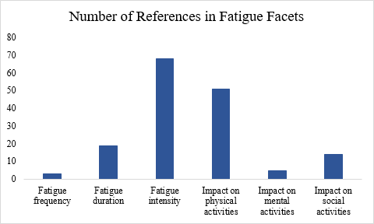

Summary statistics for AL PROfile Physical Function
Facet | Total References | Interviews Facet Occurred
Mobility (lower extremity) | 78 | 18
Upper extremity | 16 | 9
Axial or central (neck and back function) | 7 | 5
Complex activities | 23 | 10
Daily living tasks | 65 | 19

