**Ecological effects on female bill color explain plastic sexual dichromatism in a mutually-ornamented bird**

Rita Freitas, Cristiana Marques, Gonçalo C. Cardoso, Sandra Trigo*

CIBIO/InBIO, Centro de Investigação em Biodiversidade e Recursos Genéticos da Universidade do Porto, Vairão 4485-661, Portugal.

* Correspondence author: strigo@cibio.up.pt

**Supplementary Figures and Supplementary Tables**



**Figure S1** Bill color saturation of (A) females and (B) males (mean ± SE) during each 4-week diet manipulation period.

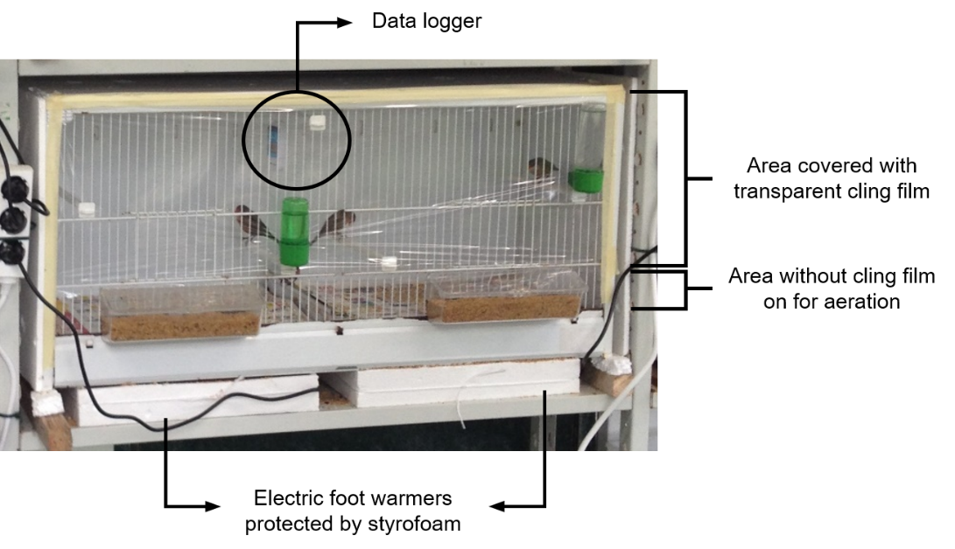

**Figure S2** Setup of the bird cages in the temperature manipulation experiment.



**Figure S3** Fluctuations in measured ambient temperatures along the experiment outside (black line) and inside each bird cage (3 nearly identical red lines, and 3 nearly identical blue lines). Dashed portions of the lines, during one week in December, correspond to the reconstructed temperatures inside the cages (see ‘Materials and methods’). Dates written along the time axis mark the onset of temperature manipulations and each of the bill color measurements.

Table S1. Post-hoc tests for the effects of diet manipulation on bill color saturation for females. Results of a GLMM with bill color saturation as dependent variable, individuals as subjects, treatment and date as factors, and their interaction. N = 12

|  |  |  |  |  |  |  |
| --- | --- | --- | --- | --- | --- | --- |
|  | | **Control vs. Lutein** | | | **Control vs. Vitamin E** | |
| Before vs After | *F* | | *P* | *F* | | *P* |
| Intercept | 14273.30 | | 0.000 | 22338.17 | | 0.000 |
| Treatment | 0.38 | | 0.540 | 0.161 | | 0.161 |
| Date | 3.38 | | 0.073 | 0.013 | | 0.911 |
| Treatment * Date | 4.71 | | **0.035** | 0.768 | | 0.768 |

Table S2. Effects of diet manipulation on bill color saturation for females (N = 12) and males (N = 11). Results of a GLMM with bill color saturation as dependent variable, and different treatments as factor (initial values and after values for control, lutein and vitamin E treatments).

|  |  |  |  |  |  |  |
| --- | --- | --- | --- | --- | --- | --- |
|  | | **Females** | | | **Males** | |
|  | *F* | | *P* | *F* | | *P* |
| Intercept | 22234.68 | | 0.000 | 38400.24 | | 0.000 |
| Treatment | 6.55 | | **0.001** | 1.01 | | 0.398 |