Supplement Figure 1
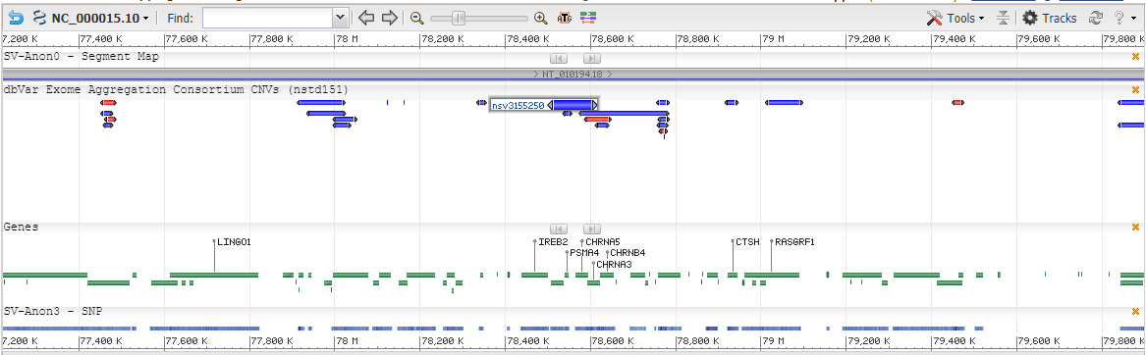

Supplement Figure 2 Kaplan–Meier analysis of the correlation between IREB2, CHRNA3, CHRNB4, HYKK expression level and overall survival (OS) / recurrence free survival (RFS) based on the TCGA database.
