Additional file 1
Supplementary figure
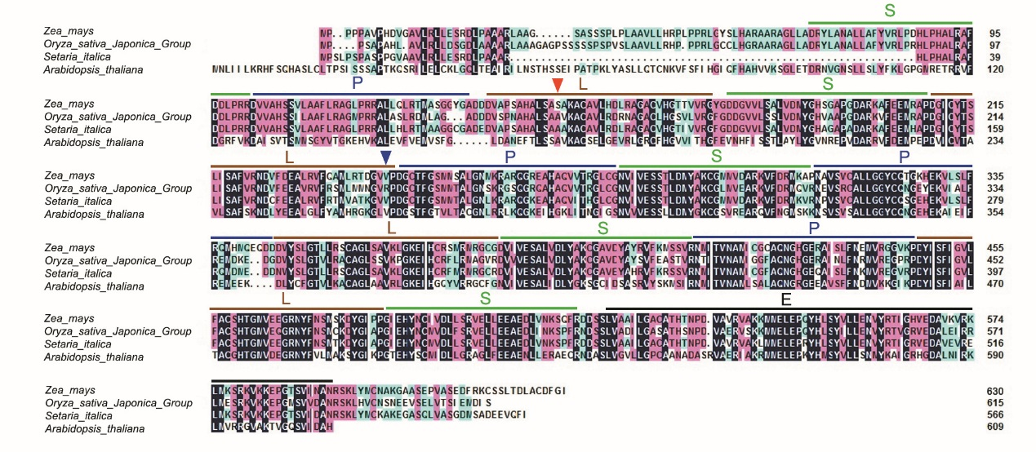
Figure S1. Amino acid alignment of maize DEK55 with homologous PPR proteins of other plant species
PPR elements P, L and S are indicated by a green, blue and red bar, respectively. The mutant sites in dek55-1 and dek55-2 are indicated by red and blue arrow heads, respectively. E domain is indicated by black bar. Arabidopsis thaliana, sequence ID NP_171853.1; Oryza sativa Japonica Group, sequence ID XP_015643919.1; Setaria italica, sequence ID XP_022681874.1. All data obtained from the NCBI (https://www.ncbi.nlm.nih.gov/)
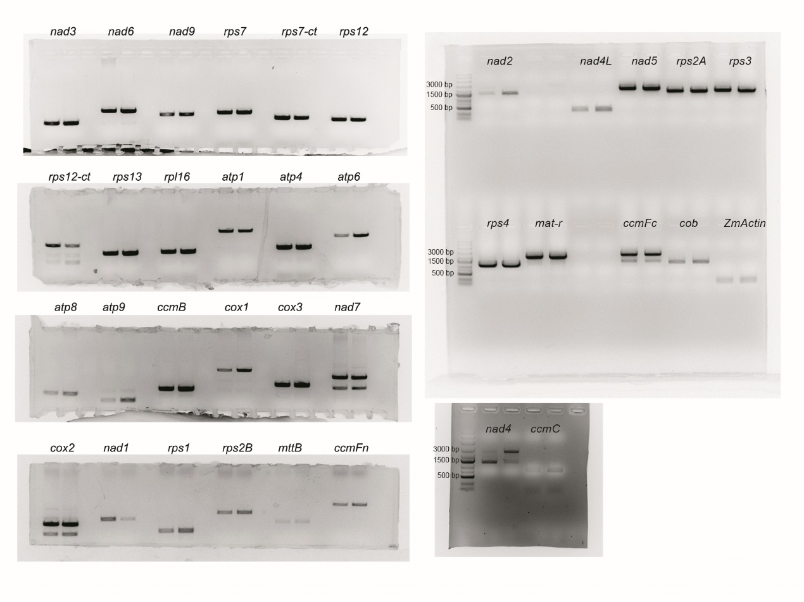
Figure S2. Original gel images for Fig. 5a.
The RT-PCR products were detected by 1.0% agarose gel electrophoresis. The genes name were marked.
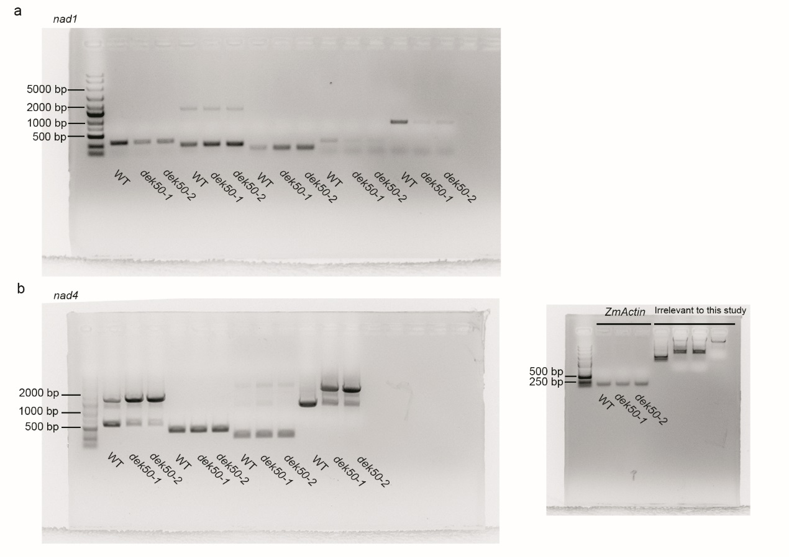
Figure S3. Original gel images for Fig. 5c-d.
(a) Original gel images of RT-PCR analysis of intron-splicing efficiency of nad1 in WT, dek55-1 and dek55-2 mutant kernels.
(b) Original gel images of RT-PCR analysis of intron-splicing efficiency of nad4 in WT, dek55-1 and dek55-2 mutant kernels. ZmActin gene (GRMZM2G126010) was used as an internal control and original gel image was also shown. Results irrelevant to this study were marked with “Irrelevant to this study”.
Figure S4. Original gel images for Fig. 6a-b.
(a) Original gel images of BN-PAGE analysis of mitochondrial complexes.
(b) Original gel images of in-gel NADH dehydrogenase activity analysis of complex I.
Results irrelevant to this study were marked with “Irrelevant to this study”.
Supplementary Table
Table S1. Genetic analysis of the mutant kernels in the segregation ear.
Self-pollinated parents | Number of mutants | Number of WT | Actual ratio | Expected ratio | P
dek55-1/+ | 411 | 1239 | 1:3.01 | 1:3 | 0.93
F₁ (C733×dek55-1/+) | 916 | 2821 | 1:3.07 | 1:3 | 0.49
F₁ (S162×dek55-1/+) | 457 | 1364 | 1:2.98 | 1:3 | 0.92

Table S2. The primers used in this study.

umc1705-F | ATCTCACGTACGGTAATGCAGACA | For fine mapping
umc1705-R | CATGACCTGATAAACCCTCCTCTC
umc2302-F | GCATATGCGAGATCATATCGTTGA
umc2302-R | CTATACAGCCCTCAGCTCTGCTGT
M2-F | GTGCTATGCATGAGGGTAGAGT
M2-R | TGTATTGGGCGATACCGAGC
M3-F | ATCTGTAGTGCTTCCGTGCTCT
M3-R | GGCTCATTTGTAAGGTTGTGC
M4-F | GTTGAGATAACTATGCAAATCGTG
M4-R | CTTCCAACGTGCGTCTCTAC
M5-F | CGTCGTCGAGGTGATTAGGG
M5-R | GAACCCTCCTCCCGACTACT
M6-F | GGTTTCCAGAGCTAGGTGGG
M6-R | CGTCGTTTCCGTCGTCAATC
F148-F | GTTCGGTCGAGTTGGGATGA
F148-R | CAGACCAACCCTTCAGTCCC
DEK55-Full-F | GCCAGGTAGAATAGATGGAACC | Clone DEK55 full length
DEK55-Full-R | CAAGAGCTGCTAAAATTTGTCAGTAC
ZmActin-F | ATGGTCAAGGCCGGTTTCG | qRT-PCR and RT-PCR primer of ZmActin
ZmActin-R | TCAGGATGCCTCTCTTGGCC
DEK55-qRT-F | CGATGACTGGTATAGCTTAGGG | qRT-PCR analysis of DEK55 gene expression
DEK55-qRT-R | CGCATCCTCTCATCCTCATAG
nad1-1F | GCAACGTAGAAAGGGTCCTG | Test nad1 introns splicing efficiency
nad1-2R | TGAGCTGCAGATCGTAATGC
nad1-2F | TCGAAATATGCCTTTCTAGGAG
nad1-3R | ATTCAGCTTCCGCTTCTGG
nad1-3F | GTCATGGCGCAAAAGCAGATATGG
nad1-4R | AGAGCAGACCCCATTGAAGA
nad1-4F | TCTTCAATGGGGTCTGCTCT
nad1-5R | AGGGAGCCATCGAAAGGTGA
nad4-1F | TTGATTGGTCTGTGCGTTTC | Test nad4 introns splicing efficiency
nad4-2R | GGCTTCGGGTAACCAAATA
nad4-2F | TGCCGTCAAAGTGCCTAT
nad4-3R | GGTGCTCACTAAACCTCCATA
nad4-3F | CACTTTAGCCAATATGAGTTTACC
nad4-4R | ATGCAGTCCGGGAACACT
Aox1-qRT-F | AAGGTGCTGCTCGACAAGAT | qRT-PCR analysis of Aox1 gene expression
Aox1-qRT-R | GTAGGCGTTGAAGAAGACGC
Aox2-qRT-F | GACATCTTCTTCCAGAGGCG | qRT-PCR analysis of Aox2 gene expression
Aox2-qRT-R | TGACTACGTCCTTGAGCGTG
Aox3-qRT-F | CCAAGCTCGTGAAGGAAGAC | qRT-PCR analysis of Aox3 gene expression
Aox3-qRT-R | GTAGGCGTTGAAGAAGACGC
DEK55-SC-F | CCGCGAATTCATGCCGCCGCCCCCAGCCG | Construct full length DEK55-EGFP vector
DEK55-SC-R | CCGCGGTACCGATACCAAAATCACAAGC
nad4-F1 | TTGATTGGTCTGTGCGTTTC | RT-PCR
nad4-R1 | ATGCAGTCCGGGAACACT
nad4-F | CAGTCACCCGGAGAAGATTT | Gene sequencing in RNA editing efficiency analysis
nad4-R | TAATTTGGCGCCTGATTGAC
nad2-F | GACGGAGGAGAGGAAATGAA | RT-PCR, Gene sequencing in RNA editing efficiency analysis
nad2-R | GCAGTCCACCCTTTCTTTGA
nad3-F | CTTTCCTATGTCCTTCCCCC
nad3-R | GAGGAGAGCGAGAGAACGAA
nad4L-F | CTGACATTCCATGTTTCCGA
nad4L-R | GAAGAGAACGAAAGGAGAACAGA
nad5-F | CGCTCGAACATTGTCTGATT
nad5-R | GTCCTGGCAAGCTCCTACAG
nad6-F | TGGAAAAACCAAACCCACAT
nad6-R | CAAGTTCCCTTGGCGTAGTC
nad7-F | GTTTTGGCTCGCAATAAAGC
nad7-R | CAGGTGGGACAAGCTCTAGG
nad9-F | AGCAAGAAGCGGAACAAAAA
nad9-R | TATTGATTTGTCCCCTCCCC
cob-F | ATCAAGGCAAGGGGGTAAAT
cob-R | GGTGTGATCAGTCTCATCCG
cox1-F | GGCCCCTCTCTGATAAGGTT
cox1-R | GTTAAGGCAAAGCCCAAACA
cox2-F | GTCCTACTTCTGGTGCTGCC
cox2-R | GAGAATTGCATTTCCGCTTC
cox3-F | TCAATCCACTTATTCGTTCCC
cox3-R | GTTTACATACAACCGGGGCA
atp1-F | CGTTGCTGGTGAAGAAGCAT
atp1-R | AAAAGCGGATTTATCCATCG
atp4-F | AGCCACGTGCTCTAATCCTC
atp4-R | TCCCTTTCTCTTGGAGCAGA
atp6-F | CCAAGTCTCTTTTGGGAGCA
atp6-R | GGCTCCTCGTTTTTATGCAA
atp8-F | GGCAAGGATCCTCAGTCCTA
atp8-R | GAGGGTTGGTTTGATTGGAA
atp9-F | AGGGGCCTCGTCATCTCTAT
atp9-R | TAGTTGCGAAGGAAAAGCGT
ccmB-F | AGCCGTCGAAGTGAATGAAT
ccmB-R | AACGGCTTTTCCATGACTTG
ccmC-F | ACTTGCAAGGCAAGGAAAAA
ccmC-R | CCATGGATGCTTTAGCGAGT
ccmFc-F | GAGAAGCTCAAATCGAACGG
ccmFc-R | CGCAGCCACTATTTTGACTC
ccmFn-F | TGAAGATTGTAAGGCGTTTCC
ccmFn-R | GGATCATCCTGTGGTTACCG
rps1-F | AAGGTGGGCTTCGGATTATT
rps1-R | TCTTCAGTTTTACGCTTACGCT
rps2A-F | CAGGAAAGATATTTGCCCCA
rps2A-R | CCTGTATCTCCGGAAACGAA
rps2B-F | TCCATGGACCCACGTAAAAT
rps2B-R | GGCCCCTCTCTGATAAGGAA
rps3-F | GCAGAAAGGGGCAAAAGTAA
rps3-R | TCGCGACCCCTACTACATCT
rps4-F | AGAGTTGGGTTCGATTCCCT
rps4-R | AGCGACTAGGCCGATCTTTT
rps7-F | TTCGTTGGAAAAACCTACGC
rps7-R | ATGAGGAAGGCCGATTTTCT
rps7-ct-F | TTGAACCTCTTTCACGCTCA
rps7-ct-R | TTCCGATCGAGATGTATGGA
rps12-F | CTAGCTGCTTCCATATCGCC
rps12-R | CGGATCGGGAGTAACCACTA
rps12-ct-F | TGTACGGTTCTGTAGAGGGACA
rps12-ct-R | TCCGTTTTCTTTTTATAAGGGC
rps13-F | TCATGATGATTAAGGGAAGAGTGA
rps13-R | TTGAATTGAACAGTGTGATTGAT
rpl16-F | GGTTTTTCCCCACTAACCAA
rpl16-R | GGGTGCGGAAATAGCTAGAA
mat-r-F | AACGCCTGTTCGCTAAAATC
mat-r-R | AGGCTTTGCTCCCCTTTTT
mttB-F | TTGGTTTAGAATTGCTCGGG
mttB-R | AGGGGGAACCCTACCGAC
AD-Zmd049043F | CGGAATTCATGGCCCTCGCACTGCGCC | Yeast two-hybrid assay
AD-Zmd049043R | CGGGATCCTCATACCTGCCAGTTTCCTTG
AD-Zmd045528F | CGGAATTCATGGCCGCCGCCGCC
AD-Zmd045528R | CGGGATCCTCATCGCTGGTTCTCCCTC
AD-Zmd026307F | CGGAATTCATGGCAGCCGCATCAGCG
AD-Zmd026307R | CGGGATCCTCAGTGCTGCTCCTGATTC
AD-Zmd038760F | CGCATATGATGTATGCTTTTAGTACGAC
AD-Zmd038760R | CGGAATTCCTAGTCGCAGCTCCCAGTG
AD-Zmd026243F | CGGAATTCATGGCCACCGTAGCGCGC
AD-Zmd026243R | CGGGATCCTCATCTCTGGTAAGATTGG
AD-Zmd048291F | CGGAATTCATGGCGTCGGCGTCGCGTG
AD-Zmd048291R | CGGGATCCTCACTGGAAGTTGGAGTTGCC
AD-Zmd024674F | CGGAATTCATGGCCGCCTCCCTCCCGAC
AD-Zmd024674R | CGGGATCCTCACGAAGACGCGGACTCG
DEK55-BD-F | CGGAATTCGACCGCTACCTTGCTAACGCG
DEK55-BD-R | CGGGATCCTCAGATACCAAAATCACAAGC

