Comparison of microbial turnover in the gut and environment
A total of 2,256 OTUs were identified from all feces, feed and water samples. To determine if the gut microbiota differ from that of the environment (water or feed), Bray-Curtis distance matrices were compared and the results indicated no significant differences of the feed and environment microbial assemblages with feces microbiota (F_{1,40=} 1.15 and p>0.05, R²=2.8%). In addition, the microbiota among ARS-FY-H and ARS-FY-L genetic lines, feed, and water were compared based on Bray-Curtis dissimilarity matrices. The nMDS ordination showed that feed and water samples were clustered together with most of the Low-muscle yield genetic line samples. However, a pairwise Adonis test indicates no significant differences between the 2 genetic lines (ran individually) with feed or water samples (p>0.05) (Additional figure. 1). This might be because fish acquire microbiota from feed and, from water in which they are reared. Similarly,

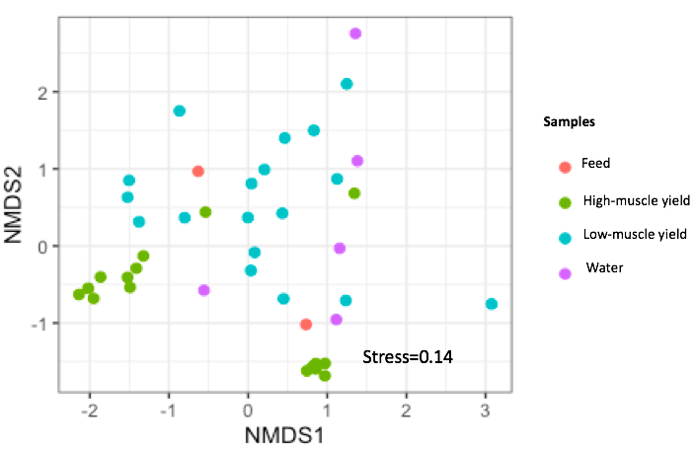

Figure 1. Beta diversity patterns of High-, Low-muscle yield genetic lines microbiota compared to feed and water; data was visualized under nMDS ordination. (stress=0.14)

