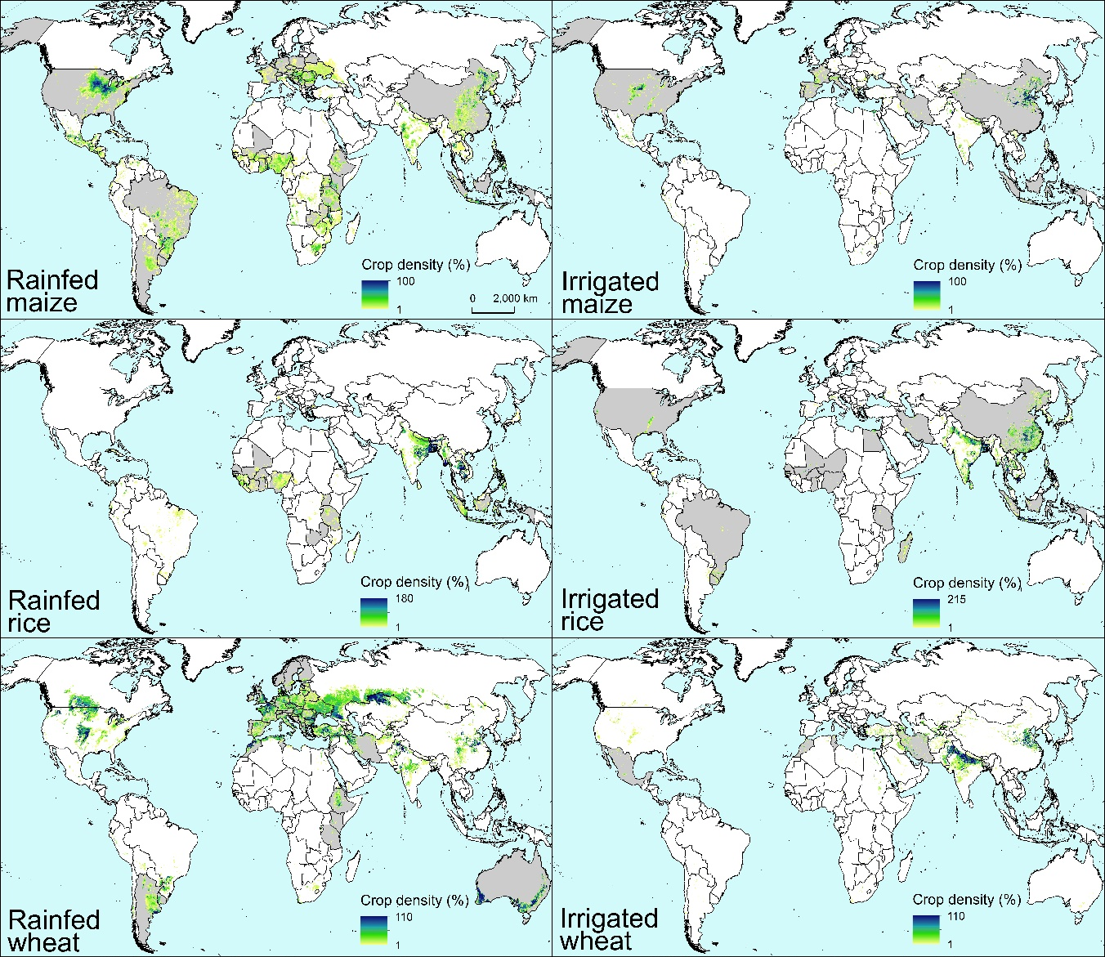
Extended Data Figure 1: Target crops and countries. Crop density of rainfed and irrigated maize, rice, and wheat, and countries included in the comparison shown in the present study (dark gray). Crop harvested area density was retrieved from SPAM 2010 (You et al., 2014).

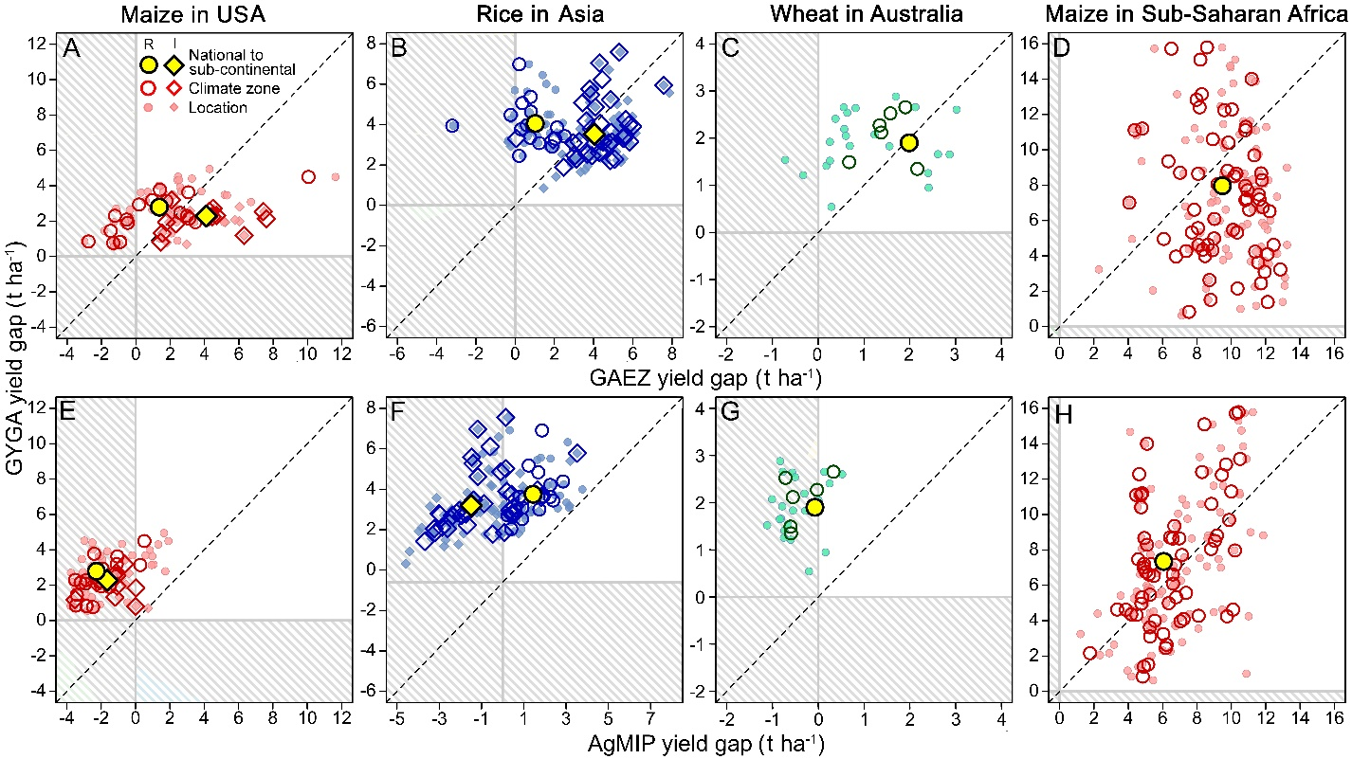
Extended Data Figure 2: Comparison of yield gap derived from top-down and bottom-up approaches. Yield gap estimated following a bottom-up approach (Global Yield Gap Atlas, GYGA) versus those derived from top-down Global Agro-Ecological Zones (GAEZ, upper panels) and Agricultural Model Intercomparison and Improvement Project (AgMIP, bottom panels) for rainfed (R) and irrigated (I) maize, rice, and wheat in important producing regions and at three spatial scales: local , regional (climate zone), and national or sub-continental. Inside each panel, dashed areas indicate negative yield gaps. Each data point represents the average yield gap. The dashed line corresponds to x = y. Comparisons for other cropping systems are shown in the Supplementary Materials.

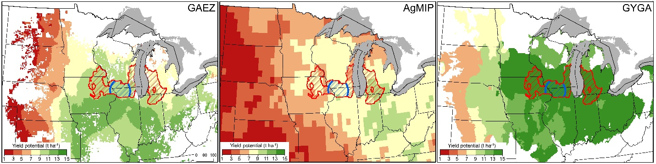
Extended Data Figure 3: Yield potential derived from top-down and bottom-up approaches. Comparison of water limited yield potential estimated for rainfed maize in the US Corn Belt following top-down (GAEZ and AgMIP) and bottom-up (GAEZ) approaches. Figures show three spatial resolution: local (buffer with blue borders), sub-national (climate zone with red borders), and national. For simplicity, only one buffer and one climate zone are shown.

