Supporting Information for
More rapid intensification of flash droughts with shorter onset timescales

Y. Qing¹, S. Wang^{1,2,}*, B. C. Ancell³, and Z. L. Yang⁴
- Department of Land Surveying and Geo-Informatics, The Hong Kong Polytechnic University, Hong Kong, China
- The Hong Kong Polytechnic University Shenzhen Research Institute, Shenzhen, China
- Department of Geosciences, Texas Tech University, Lubbock, TX, USA
- Department of Geological Sciences, The John A. and Katherine G. Jackson School of Geosciences, University of Texas at Austin, Austin, TX, USA
*Corresponding author: Shuo Wang (shuo.s.wang@polyu.edu.hk)

List of Table Captions

Table 1. List of regions used in this study (only land grid points are used in the analysis).

List of Figure Captions

Fig. 1 a-e The proportions of flash droughts that last for different pentads among all flash droughts. f-j The mean intensification rates of flash droughts that last for different pentads.
Fig. 2 The percentage of flash droughts developing at different lead times among all flash droughts over different regions.
Fig. 3 Global distribution of cropland.
Fig. 4 Comparison of the percentages of areas with upward and downward trends across different regions of the world.
Fig. 5 Temporal evolution of the annual percentages of flash droughts developing at different pentads among all flash drought events over different regions of the world (AUS is not shown because the number of flash drought events is too small to carry out statistical significance tests).
Fig. 6 Distributions of the percentages of flash droughts among all drought events across different regions of the world.
Fig. 7 Temporal evolution of the annual percentages of flash droughts among all drought events over different regions of the world (AUS is not shown because the number of flash drought events is too small to carry out statistical significance tests).
Fig. 8 Distributions of the frequencies of flash droughts identified by different thresholds of soil moisture.
Fig. 9 Distributions of the frequencies of flash droughts identified based on different soil layers.
Fig. 10 Spatial distribution of all droughts around the world.
Fig. 11 The percentage of pentads for flash droughts on average per month, derived from each land surface model and the multi-model ensemble mean. The frequency of occurrence (FOC) is defined as the percentage of pentads for flash droughts (N/N_{total}) for each grid point.
Fig. 12 Variations in soil moisture percentiles for flash drought events at 1-, 2-, 3-, 4-, 5-pentad lead times of all grid points. The two red dashed lines represent the wet (high SM percentile of the 40th percentile) and the dry (low SM percentile of the 20th percentile) SM conditions, respectively.

Table 1 List of regions used in this study (only land grid points are used in the analysis).

Name | Acronym | Latitude (°) | Longitude (°)
Australia | AUS | 45S-11S | 110E-155E
Amazon Basin | AMZ | 20S-12N | 82W-34W
Southern South America | SSA | 56S-20S | 76W-40W
Central America | CAM | 10N-30N | 116W-83W
Western North America | WNA | 30N-60N | 130W-103W
Central North America | CNA | 30N-50N | 103W-85W
Eastern North America | ENA | 25N-50N | 85W-60W
Alaska | ALA | 60N-72N | 170W-103W
Greenland | GRL | 50N-85N | 103W-10W
Mediterranean Basin | MED | 30N-48N | 10W-40E
Northern Europe | NEU | 48N-75N | 10W-40E
Western Africa | WAF | 12S-18N | 20W-22E
Eastern Africa | EAF | 12S-18N | 22E-52E
Southern Africa | SAF | 35S-12S | 10W-52E
Sahara | SAH | 18N-30N | 20W-65E
Southeast Asia | SEA | 11S-20N | 95E-155E
East Asia | EAS | 20N-50N | 100E-145E
South Asia | SAS | 5N-30N | 65E-100E
Central Asia | CAS | 30N-50N | 40E-75E
Tibet | TIB | 30N-50N | 75E-100E
North Asia | NAS | 50N-70N | 40E-180E

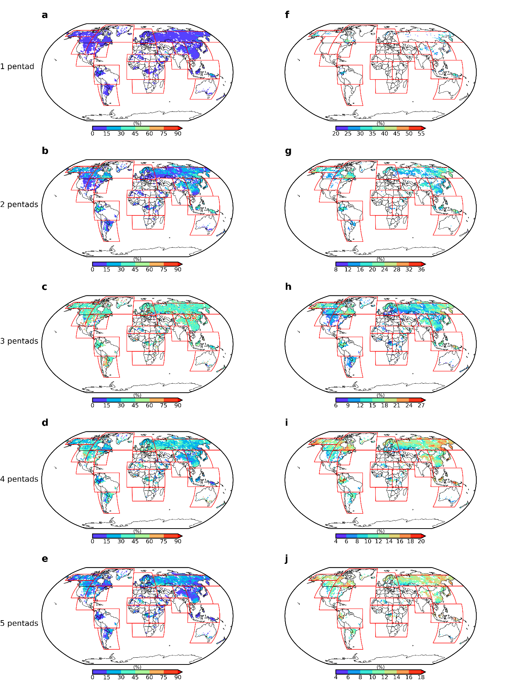
Fig. 1 a-e The proportions of flash droughts that last for different pentads among all flash droughts. f-j The mean intensification rates of flash droughts that last for different pentads.
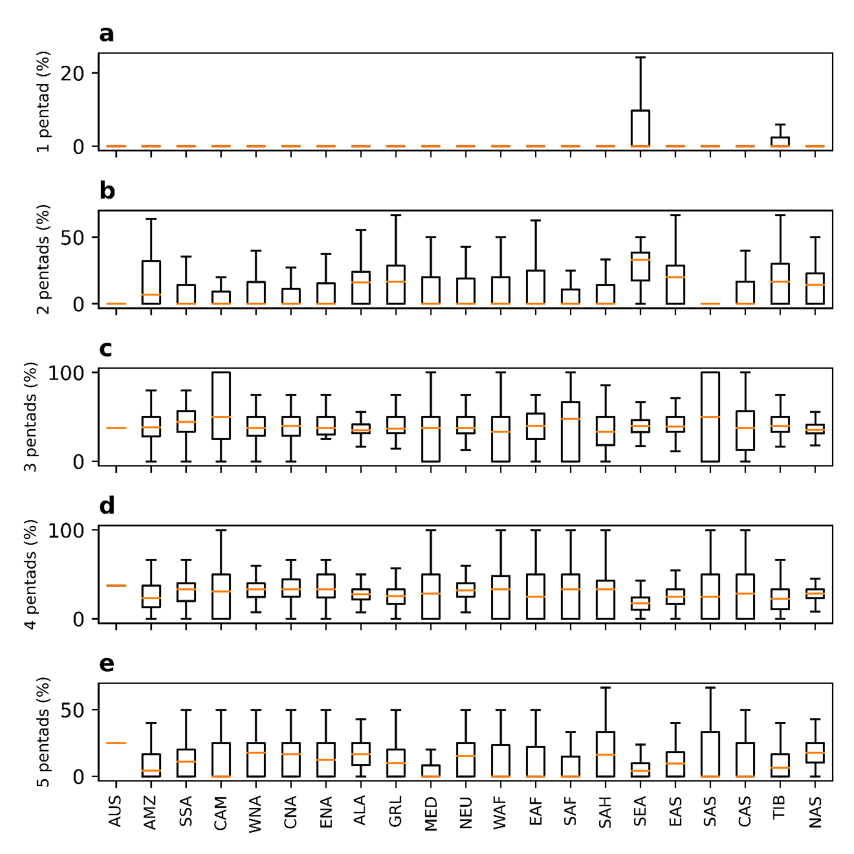
Fig. 2 The percentage of flash droughts developing at different lead times among all flash droughts over different regions.

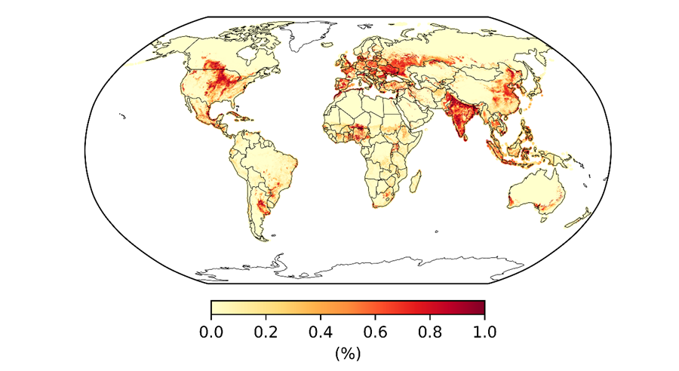
Fig. 3 Global distribution of cropland.

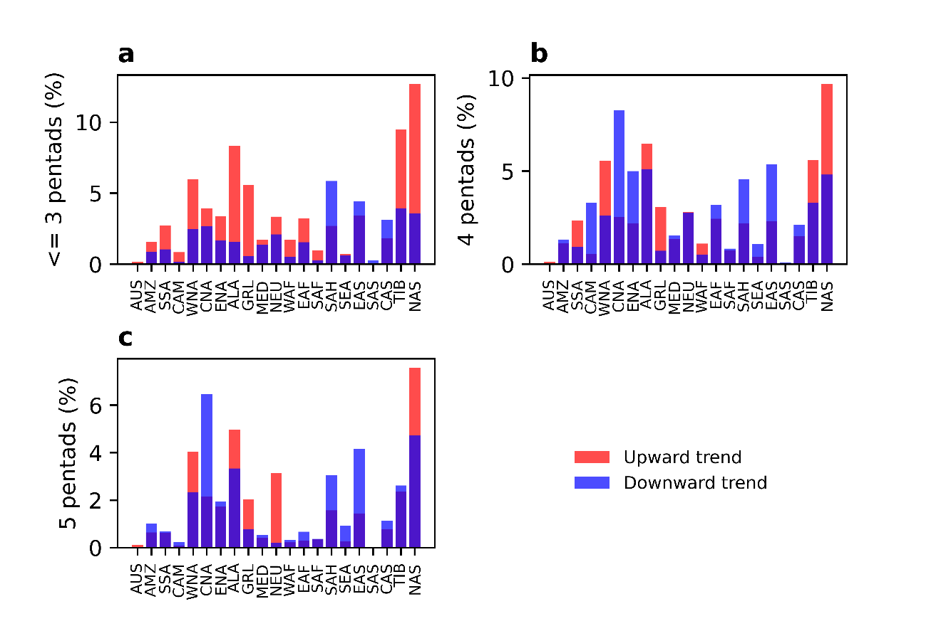
Fig. 4 Comparison of the percentages of areas with upward and downward trends across different regions of the world.
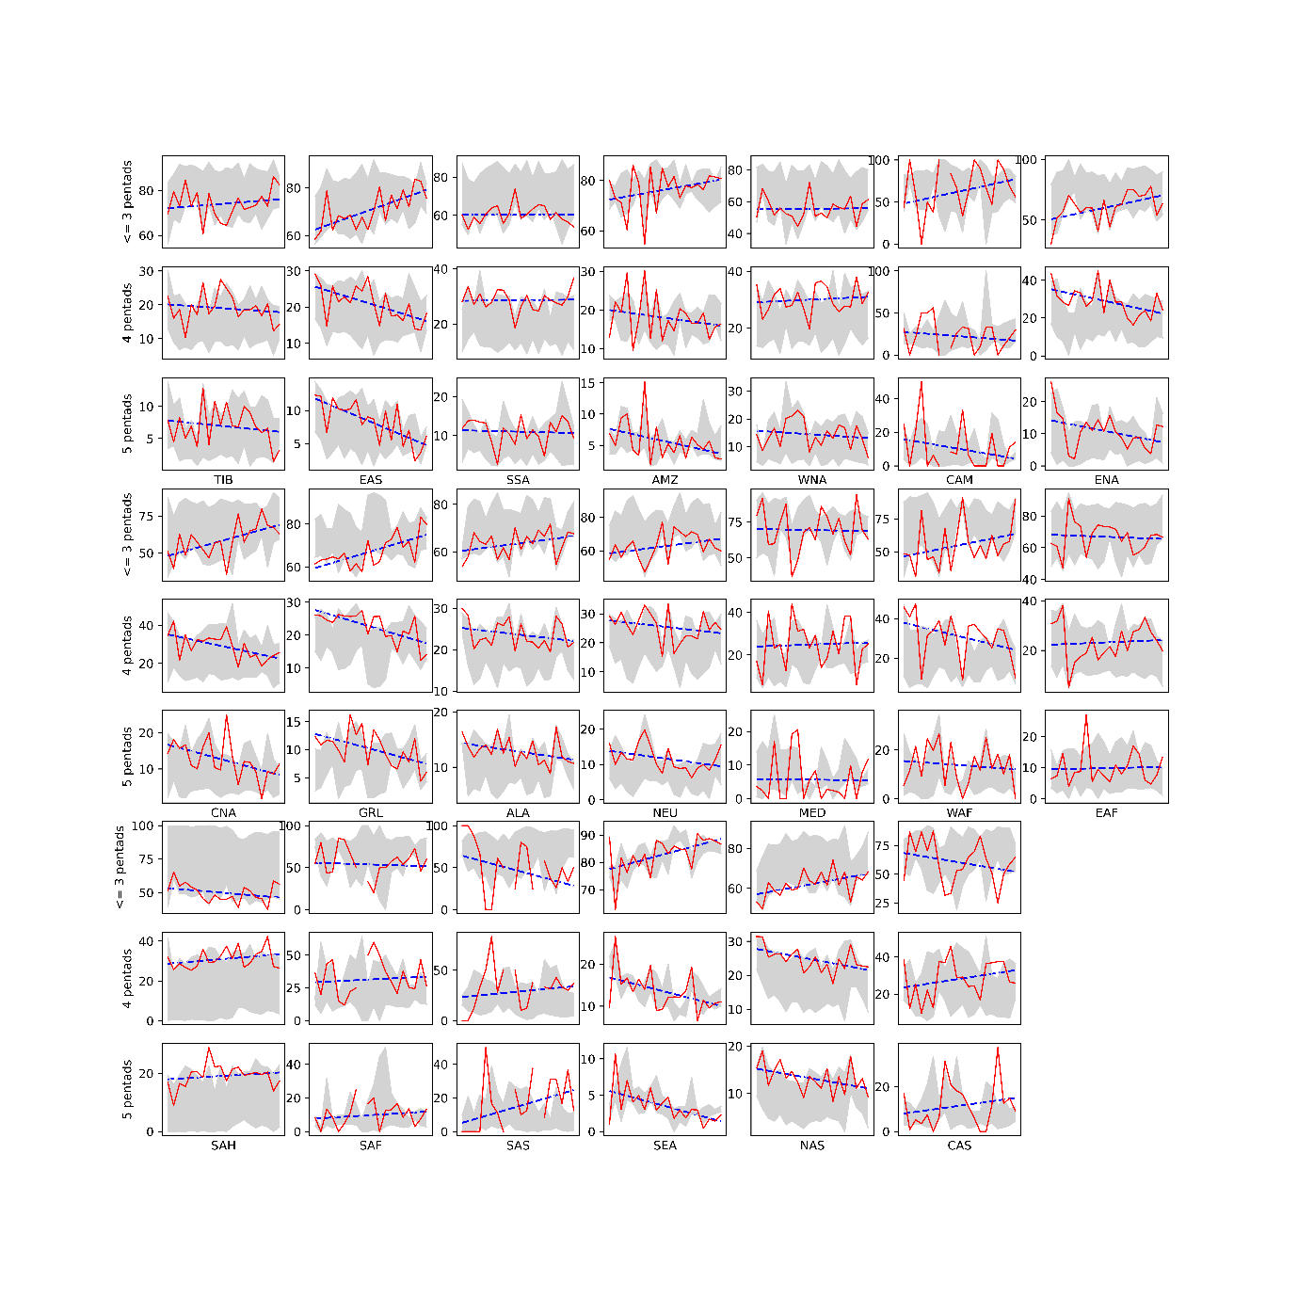
Fig. 5 Temporal evolution of the annual percentages of flash droughts developing at different pentads among all flash drought events over different regions of the world (AUS is not shown because the number of flash drought events is too small to carry out statistical significance tests).

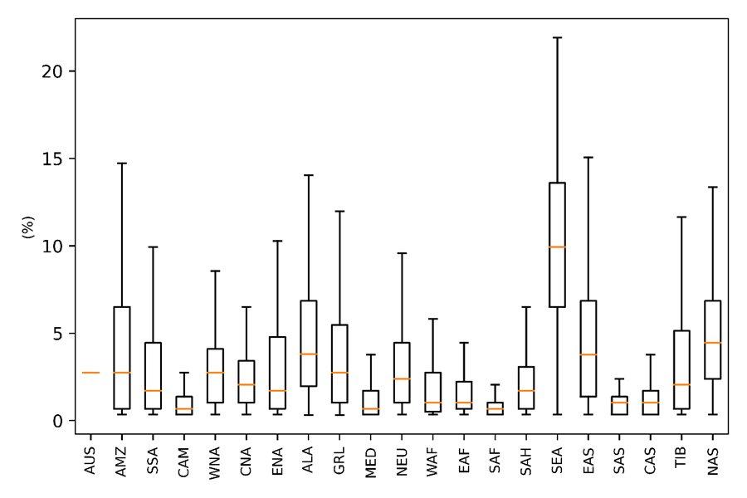
Fig. 6 Distributions of the percentages of flash droughts among all drought events across different regions of the world.

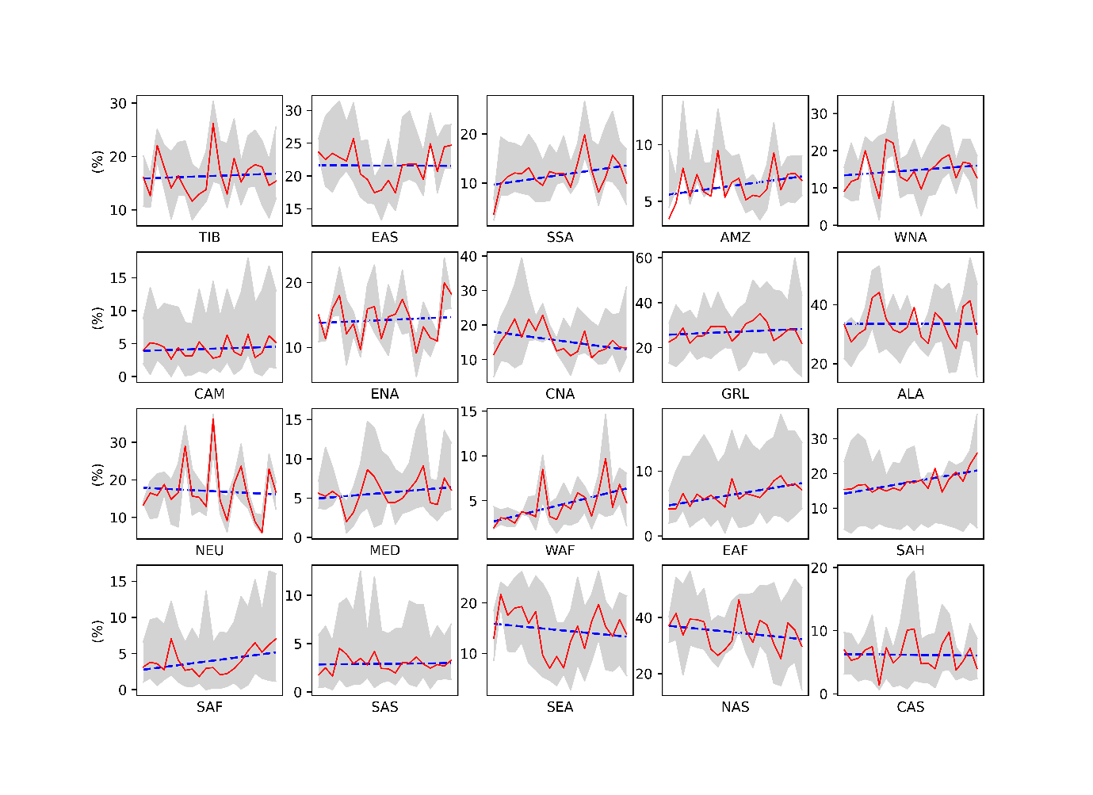
Fig. 7 Temporal evolution of the annual percentages of flash droughts among all drought events over different regions of the world (AUS is not shown because the number of flash drought events is too small to carry out statistical significance tests).
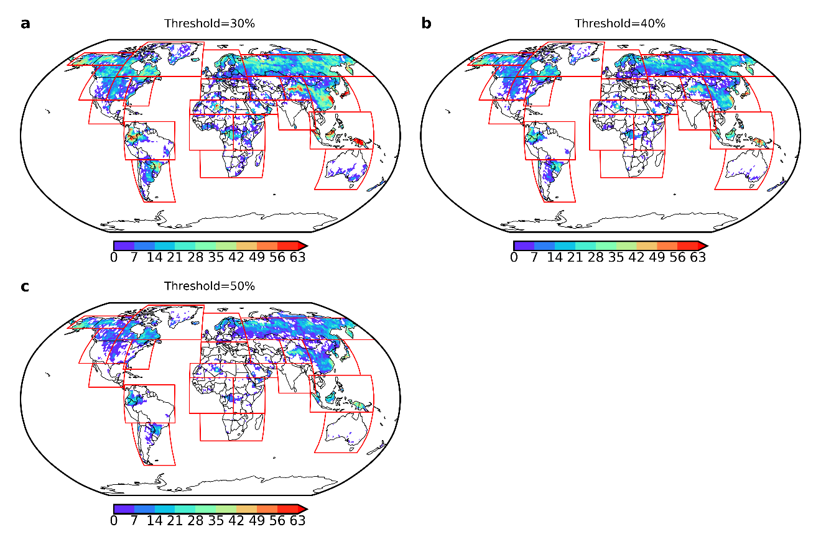
Fig. 8 Distributions of the frequencies of flash droughts identified by different thresholds of soil moisture.

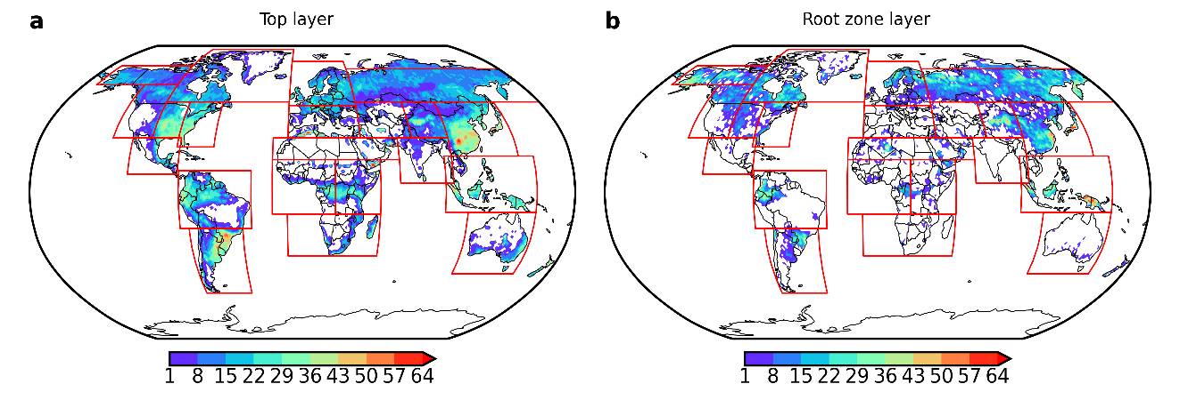
Fig. 9 Distributions of the frequencies of flash droughts identified based on different soil layers.

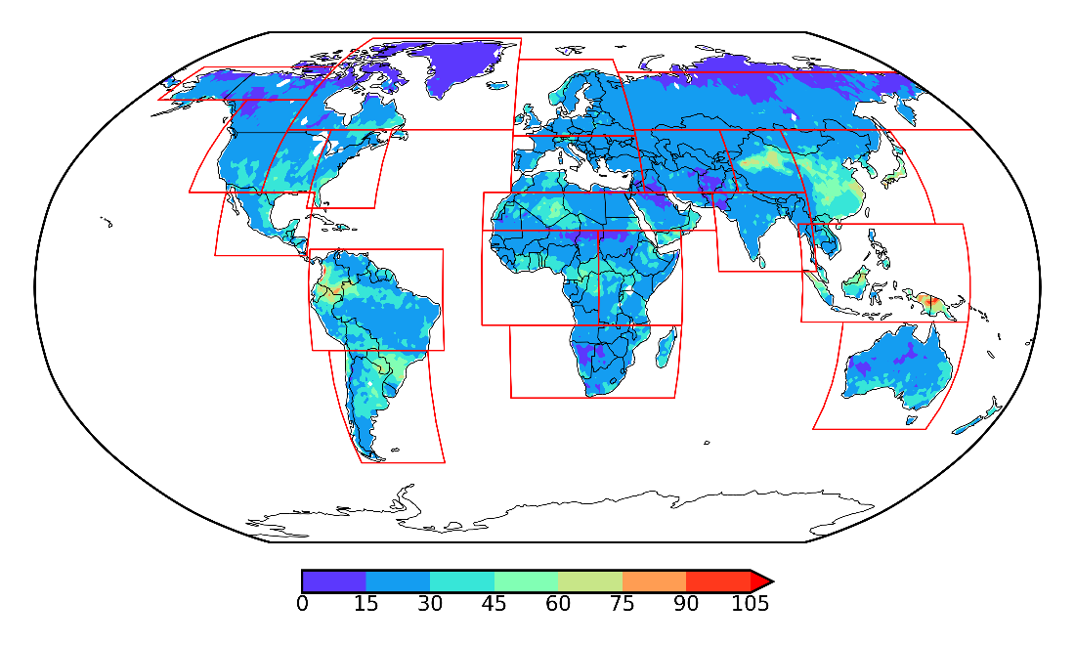
Fig. 10 Spatial distribution of all droughts around the world.

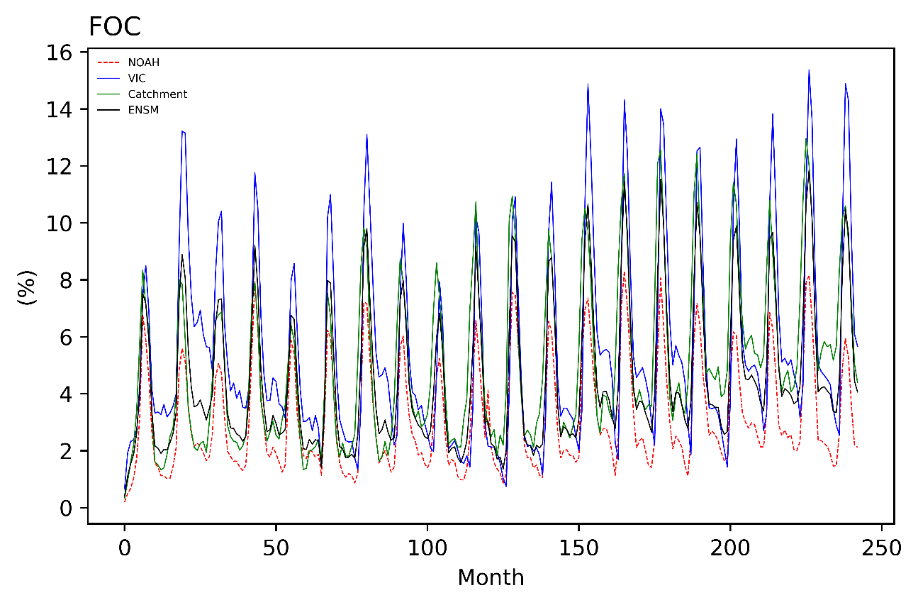
Fig. 11 The percentage of pentads for flash droughts on average per month, derived from each land surface model and the multi-model ensemble mean. The frequency of occurrence (FOC) is defined as the percentage of pentads for flash droughts (N/N_{total}) for each grid point.

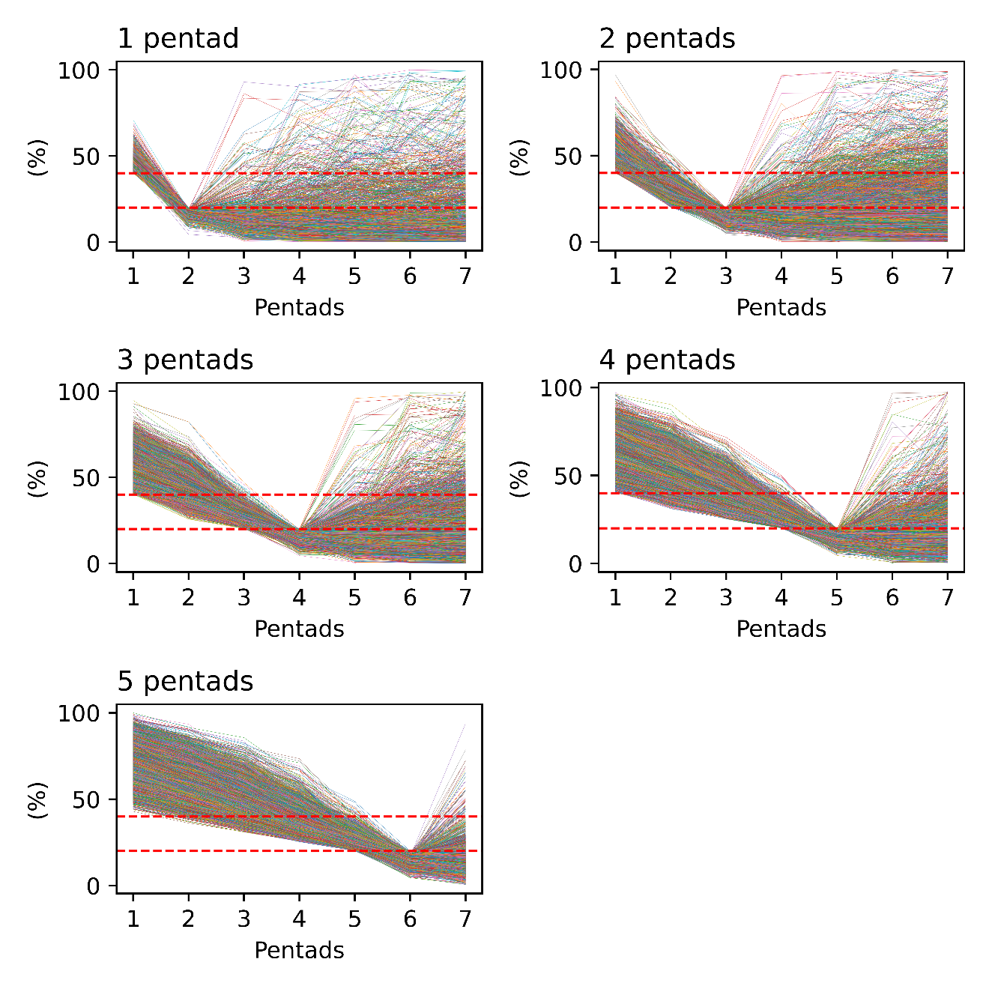
Fig. 12 Variations in soil moisture percentiles for flash drought events at 1-, 2-, 3-, 4-, 5-pentad lead times of all grid points. The two red dashed lines represent the wet (high SM percentile of the 40th percentile) and the dry (low SM percentile of the 20th percentile) SM conditions, respectively.

