Additional file 1. Statistical tests and distribution of 100 cowpea germplasm collections based on qualitative traits
Trait | Description | Frequency (%) | Degrees of freedom | Chi-square | P-value | Genotypes
Growth habit | Determinate | 43.0 | 198 | 469.19 | 0.00 | BB3-9-7-5, BB8-1-5-2, BB10-4-2-5, BB14-16-2-2, BBXSC13, BBSC12, Bubebe, CP1, CP2, CP6, CP11, CP414, CP418, CP732, CP753, CP2232, CP2980, CP3067, CP3422, CP3423, CP3425, Geneb, IT82-16, IT82-16E, Kapita, L10xL7, Local chipata, LT3-8-4-1, LT4-2-4-1, LT11-3-3-12, LT11-3-3-13, LT11-5-2-2, Lutechipata, Lutembwe, MS1-8-1-4,Sundan1, ZM2960, ZM2966, ZM3064, ZM3716, ZM4588, ZM4706, ZM6680.
 | Indeterminate | 39.0 |  |  |  | CP4,CP12, CP102,CP305, CP411, CP421, CP426,CP479,CP601,CP645,CP1769, CP2231,CP2863,CP3420,CP2XSC103, Chawa, Kapita black, Kapita north,L4XL3, L8XL9, Local kapita, LT16-7-2-5, Lute, Makulu, Mount, Namuseba, ZM308, ZM471, ZM1790, ZM2095, ZM2938, ZM2943, ZM2954, ZM2969, ZM2999, ZM3000, ZM3070, ZM4710, ZM5419.
 | Creeping | 18.0 |  |  |  | Bgene, CP399, CP436, CP570, CP633, CP698, CP2223, CP3413, Chiko, Chimponongo, LT4-2-4-14, Msandile, Mtilizi, Muz, ZM2081, ZM2108, ZM2939, ZM3003
Leaf size | Small | 35.0 | 198 | 404.31 | 0.00 | BBXSC13, BB8-1-5-2, CP6, CP12, CP421, CP645, CP698, CP1769, CP2232, CP2863, CP3422, Chiko, IT82-16E, L8XL9, LT4-2-4-14, LT4-2-4-14, LT11-3-3-12, Lutembwe, Lutechipata, MS1-8-1-4, Sundan1, ZM2095, ZM2108, ZM2939, ZM2943, ZM2954, ZM2966, ZM3003, ZM3064, ZM3070, ZM3716, ZM4588, ZM4706, ZM5419.
 | Medium | 26.0 |  |  |  | BB10-4-2-5, BB14-16-2-2, BBSC12, Bgene, Bubebe, CP2, CP4, CP11, CP414, CP418, CP436, CP753, CP2231, Chawa, Geneb, L10Xl7, Local Chipata, LT3-8-4-1, LT11-3-3-13, LT11-5-2-2, Namuseba,Makulu,ZM1790, ZM2960, ZM2969, ZM5419.
 | Big | 39.0 |  |  |  | BB3-9-7-5, CP1,CP102, CP399, CP411, CP426, CP479, CP570, CP601, CP633, CP732, CP2223, CP2980, CP3067, CP3413, CP3420, CP3423, CP3425, CPXSC103, Chimponongo, IT82-16, Kapita, Kapita black, Kapita north, L4XL3, Local kapita, LT16-7-2-5, Lute, Mount, Msandile, Mtilizi, Muz, ZM308, ZM471, ZM2081, ZM2938, ZM3000, ZM6680.
Flower colour | White | 1.0 | 198 | 387.81 | 0.00 | ZM6680.
 | Yellow | 4.0 |  |  |  | CP11, Namuseba, MS1-8-1-4, ZM2095.
 | Violet | 95.0 |  |  |  | BB3-9-7-5, BB8-1-5-2, BB10-4-2-5, BB14-16-2-2, BBXSC13, BBSC12, Bgene, Bubebe, CP1, CP4, CP2, CP6, CP11, CP12, CP102, CP305, CP399, CP411, CP414, CP418, CP421, CP426, CP436, CP479,CP601, CP633, CP645, CP698, CP732, CP753, CP421, CP426, CP479, CP570, CP601, CP645, CP1769, CP2223 CP2231, CP2232, CP2863, CP2980, CP3067, CP3413, CP3420, CP3422, CP3423, CP3425, CP2XSC103, Chawa, Chiko, Chimponongo, Geneb, IT82-16, IT82-16E, Kapita, L10xL7, Local Chipata, LT3-8-4-1, LT4-2-4-14, LT4-2-4-1, LT11-3-3-12, LT11-3-3-13, LT11-5-2-2, Kapita black, Kapita north, L4XL3, L8XL9, Local kapita, LT16-7-2-5, Lute, Lutechipata, Lutembwe, Makulu, Mount, MS1-8-1-4, Msandile, Mtilizi, Muz, Namuseba, Sundan1, ZM300, ZM308, ZM471, ZM1790, ZM2081, ZM2095, ZM2108, ZM2938, ZM2939, ZM2943, ZM2954 ZM2960, ZM2966, ZM2969, ZM2999, ZM3000 ZM3064, ZM3070, ZM3716, ZM4588, ZM4706, ZM4710, ZM5419, ZM6680.

Additional file 1 …. Continued
Trait | Description | Frequency (%) | Degrees of freedom | Chi-square | P-value | Genotypes
Pod colour | Light green | 30.0 | 198 | 445.12 | 0.00 | BB10-4-2-5, BBSC12, BBXSC13, BB3-9-7-5,CP2,CP11, CP414, CP418,CP753, CP2231, CP2232, CP23, CP3425, IT82-16E, Kapita black, L8XL9, LT3-8-4-1, LT4-2-4-1, LT11-3-3-13, LT11-5-2-2, MS1-8-1-4, Namuseba, ZM2095, ZM2938, ZM2999, ZM3716, ZM4706, ZM4710, ZM5419.
 | Dark green | 52.0 |  |  |  | BB8-1-5-2, BB14-16-2-2, Bgene, CP1, CP4, CP6, CP12, CP305, CP426, CP436, CP479,CP570, CP601, CP645, CP732, CP1769, CP2863, CP2980, CP3413, CP2XSC103, Chawa, Chimponongo, Geneb, IT82-16,Kapita, Kapita north, Local chipata, Local kapita, LT4-2-4-14, LT11-3-3-12, Lutechipata, Lutembwe, Msandile, Mtilizi, Muz, Sundan1, ZM308, ZM471, ZM1790, ZM2081, ZM2108, ZM2939, ZM2954, ZM2960, ZM2969, ZM3000, ZM3003, ZM3070, ZM4588, ZM6688.
 | Purple | 18.0 |  |  |  | CP102, CP399, CP411, CP421, CP633, CP698, CP2223, CP3067, CP3420, CP3422, Chiko, L4Xl3, LT16-7-2-5, Lute, Makulu, Mount, ZM2943, ZM3064.
Leaf colour intensity | Light green | 26.0 | 198 | 588.10 | 0.00 | BB10-4-2-5, BB14-16-2-2, BBSC12, Bgene, Bubebe, CP2, CP4, CP11, CP414, CP418, CP436, CP753, CP2231, Chawa, Geneb, L10Xl7, Local Chipata, LT3-8-4-1, LT11-3-3-13, LT11-5-2-2, Namuseba,Makulu,ZM1790, ZM2960, ZM2969, ZM5419.
 | Medium green | 35.0 |  |  |  | BBXSC13, BB8-1-5-2, CP6, CP12, CP421, CP645, CP698, CP1769, CP2232, CP2863, CP3422, Chiko, IT82-16E, L8XL9, LT4-2-4-14, LT4-2-4-14, LT11-3-3-12, Lutembwe, Lutechipata, MS1-8-1-4, Sundan1, ZM2095, ZM2108, ZM2939, ZM2943, ZM2954, ZM2966, ZM3003, ZM3064, ZM3070, ZM3716, ZM4588, ZM4706, ZM5419.
 | Dark green | 39.0 |  |  |  | BB3-9-7-5, CP1,CP102, CP399, CP411, CP426, CP479, CP570, CP601, CP633, CP732, CP2223, CP2980, CP3067, CP3413, CP3420, CP3423, CP3425, CPXSC103, Chimponongo, IT82-16, Kapita, Kapita black, Kapita north, L4XL3, Local kapita, LT16-7-2-5, Lute, Mount, Msandile, Mtilizi, Muz, ZM308, ZM471, ZM2081, ZM2938, ZM3000, ZM6680.
Seed coat colour | Red- brown | 8. 0 | 396 | 557.10 | 0.82 | BBXSC13, CP2, CP570, CP3420, L4XL3, Msandile, MS1-8-1-4, ZM2966.
 | White | 10.0 |  |  |  | BB8-1-5-2, BB8-1-5-2, BB10-4-2-5, BB14-16-2-2, Bubebe, CP2XSC103, L8XL9, L10XL7, Nanuseba, ZM3716.
 | Purple- brown | 12.0 |  |  |  | Bgene, CP102, CP418, CP3435, Chiko, Geneb, Kapita north, LT11-3-3-13, Lute, Mtilizi, Mount, ZM2969
 | Brown | 49.0 |  |  |  | BBSC12, CP1,CP6,CP11,CP305,CP399, CP411, CP414,CP421, CP436, CP466, CP633, CP645, CP668, CP753, CP1769, CP2223, CP2232, CP2863, CP3067, CP3413, CP3422, Chawa, Kapita, Local kapita,LT4-2-4-1, LT4-2-4-14, LT11-3-3-12, LT11-5-2-2, LT16-7-2-5, Lutechipata, Lutembwe, Makulu, Muz, Sundan1, ZM308, ZM471, ZM2095, ZM2938, ZM2943, ZM2954, ZM2960, ZM2999, ZM3064, ZM3067, ZM4706, ZM4710, ZM5419, ZM6680
 | Black | 21.0 |  |  |  | CP4, CP12, CP479, CP601, CP732, CP2231, CP2980, CP3423, Chimponongo, IT82-16, IT82-16E, Kapita black, Local Chipata, ZM1790, ZM2081, ZM2108, ZM2929, ZM3000, ZM3003, ZM3070, ZM4588.

Additional file 2. Correlations among phenotypic, genotypic and joint matrices based on Mantel test with 999 permutations showing the correlations (above diagonal) and p-values (below diagonal)

Matrix | Phenotypic | Genotypic | Joint
Phenotypic | - | -0.025 | -0.125
Genotypic | 0.69 | - | 0.99
Joint | 0.7 | 0.00 | -

Additional file 3. List, source, and description of 90 cowpea genotypes used in the study
No. | Genotype | Source | Description | No. | Genotype | Source | Description
1 | CP 1 | NGB | Elite line | 46 | ZM 2081 | NGB | Elite line
2 | CP 2 | NGB | Elite line | 47 | ZM 2095 | NGB | Elite line
3 | CP 4 | NGB | Elite line | 48 | ZM 2108 | NGB | Elite line
4 | CP 6 | NGB | Elite line | 49 | ZM 2938 | NGB | Elite line
5 | CP 11 | NGB | Elite line | 50 | ZM 2943 | NGB | Elite line
6 | CP 12 | NGB | Elite line | 51 | ZM 2946 | NGB | Elite line
7 | CP 102 | NGB | Elite line | 52 | ZM 2954 | NGB | Elite line
8 | CP 305 | Malawi | Elite line | 53 | ZM 2966 | NGB | Elite line
9 | CP 399 | Malawi | Elite line | 54 | ZM 2969 | NGB | Elite line
10 | CP 411 | Malawi | Elite line | 55 | ZM 2999 | NGB | Elite line
11 | CP 414 | Malawi | Elite line | 56 | ZM 3003 | NGB | Elite line
12 | CP 418 | Malawi | Elite line | 57 | ZM 3064 | NGB | Elite line
13 | CP 421 | Malawi | Elite line | 58 | ZM 3080 | NGB | Elite line
14 | CP 426 | Malawi | Elite line | 59 | ZM 4710 | NGB | Elite line
15 | CP 436 | Malawi | Elite line | 60 | ZM 5419 | NGB | Elite line
16 | CP 479 | Malawi | Elite line | 61 | Mtilizi | UNZA | Elite line
17 | CP 570 | Malawi | Elite line | 62 | Bgene | Farmers | Landrace
18 | CP 601 | Malawi | Elite line | 63 | Chiko | Farmers | Landrace
19 | CP 633 | Malawi | Elite line | 64 | Chimponongo | Farmers | Landrace
20 | CP 645 | Malawi | Elite line | 65 | Geneb | Farmers | Landrace
21 | CP 698 | Malawi | Elite line | 66 | Kapita | Farmers | Landrace
22 | CP 732 | Malawi | Elite line | 67 | Kapita black | Farmers | Landrace
23 | CP 753 | Malawi | Elite line | 68 | Kapita North | Farmers | Landrace
24 | CP 1769 | Malawi | Elite line | 69 | Chiparamba | Farmers | Landrace
25 | CP 2223 | Malawi | Elite line | 70 | Kapita local | Farmers | Landrace
26 | CP 2231 | Malawi | Elite line | 71 | Lute | Farmers | Landrace
27 | CP 2232 | Malawi | Elite line | 72 | Lutechipata | Farmers | Landrace
28 | CP 2863 | Malawi | Elite line | 73 | Lutembwe chipata | Farmers | Landrace
29 | CP 2980 | Malawi | Elite line | 74 | Makulu | Farmers | Landrace
30 | CP 3067 | Malawi | Elite line | 75 | Mount | Farmers | Landrace
31 | CP 3413 | Malawi | Elite line | 76 | Muz | Farmers | Landrace
32 | CP 3420 | Malawi | Elite line | 77 | BB X SC13(1) | UNZA | Mutant line
33 | CP 3422 | Malawi | Elite line | 78 | BB10-4-2-5 | UNZA | Mutant line
34 | CP 3423 | Malawi | Elite line | 79 | BB14-16-2-2 | UNZA | Mutant line
35 | CP 3425 | Malawi | Elite line | 80 | BB3-9-7-5 | UNZA | Mutant line
36 | 82E -16 | IITA | Elite line | 81 | BB8-1-5-2 | UNZA | Mutant line
37 | Bubebe | UNZA | Elite line | 82 | CP2 X SC 103(1) | UNZA | Mutant line
38 | IT82E-16 | IITA | Elite line | 83 | LT11-3-3-12 | UNZA | Mutant line
39 | L4 X L3(1) | NGB | Elite line | 84 | LT16-7-2-5 | UNZA | Mutant line
40 | L8 X L9 | NGB | Elite line | 85 | LT4-2-4-1 | UNZA | Mutant line
41 | LIO X L7(1) | NGB | Elite line | 86 | LT3-8-4-1 | UNZA | Mutant line
42 | Msandile | UNZA | Elite line | 87 | LT4-2-4-14 | UNZA | Mutant line
43 | Namuseba | UNZA | Elite line | 88 | LTII-3-3-13 | UNZA | Mutant line
44 | Sudan 1 | Malawi | Elite line | 89 | LTII-5-2-2 | UNZA | Mutant line
45 | ZM 1790 | NGB | Elite line | 90 | MSI-8-1-4 | UNZA | Mutant line
NGB=The National Gene Bank, UNZA=The University of Zambia, all farmers were from Zambia
Note: All accessions from smallholder farmers were from Zambia.

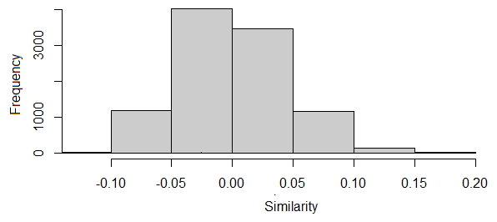
Additional file 4. The Mantel test between phenotypic and genotypic matrices
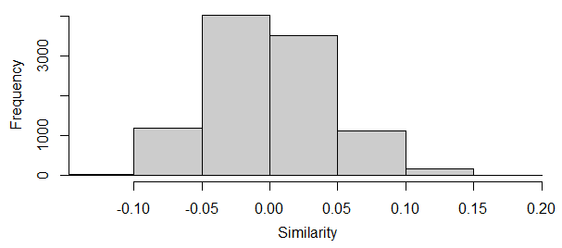
Additional file 5. The Mantel test between phenotypic and joint matrices

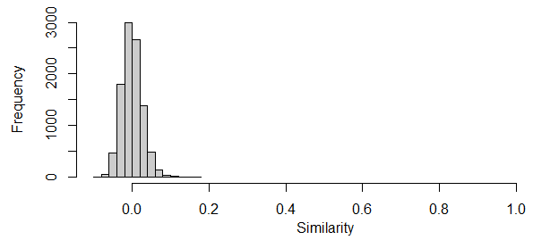
Additional file 6. The Mantel test between genotypic and joint matrices

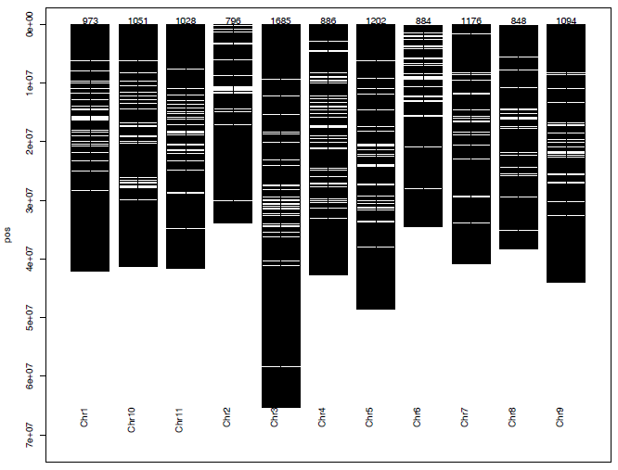
Additional file 7. Chromosomal distribution of the 14,166 SNPs used to evaluate 90 cowpea genotypes

