Appendix 1a – Thrombectomy service organisation survey

The research programme patient and public involvement (PPI) representative (DB) facilitated recruitment of 14 stroke survivors and their relatives/carers from the North East Clinical Research Network (Stroke) PPI Panel (two of the stroke survivors were previous representatives of the National Lay Member Stroke Research Network who participated in the survey development via email) who were engaged in an iterative process with the research team to develop the form and content of the survey (maximising readability and accessibility). Two interactive meetings were convened to obtain feedback on (i) initial draft of the survey; and (ii) an updated version with graphics and textual presentation that adhered to guidance on developing resources for people with aphasia [40] to aid understanding of the questions, particularly for respondents with communication issues and varying health literacy. Subsequent testing was undertaken with 10 stroke survivors/carers and local PPI panels.

In total 147 responses (mean age=49 years/SD=16; 61% female) were received from stroke survivors (n=27/18%); relatives/carers of stroke survivors (n=51/35%) and other members of the public (n=69/47%). Findings are presented in Table 1.

Table 1a. Summary statistics for thrombectomy service organisation survey
Service Organisation Question | Overall | Stroke survivor | Relative/ carer of stroke survivor | Member of public
Thrombectomy can only be delivered at specialist centres, would you agree to be transferred from your local hospital to such a centre to undergo thrombectomy?  - Yes  - No | N=142  138 (97%)  4 (3%) | n=26  26 (100%)  0 (0%) | n=49  47 (96%)  2 (4%) | n=67  65 (97%)  2 (3%)
How long would you be prepared to travel via an emergency (999) ambulance for thrombectomy?  - Up to 20 miles/29 mins  - Up to 30 miles/41 mins  - Up to 40 miles/53 mins  - Up to 50 miles/65 mins | N=145  36 (25%)  46 (32%)  17 (12%)  46 (32%) | n=27  8 (30%)  4 (15%)  6 (22%)  9 (33%) | n=50  14 (28%)  20 (40%)  3 (6%)  13 (26%) | n=68  14 (21%)  22 (32%)  8 (12%)  24 (35%)
How long would you be prepared to stay at the specialist centre for thrombectomy before you are returned to your local centre/hospital?  - 24 hours  - 48 hours  - Longer than 48 hours | N=144  8 (6%)  26 (18%)  110 (76%) | n=27  1 (4%)  4 (15%)  22 (82%) | n=49  2 (4%)  10 (20%)  37 (76%) | n=68  5 (7%)  12 (18%)  51 (75%)
Should a thrombectomy service be made available in your local Stroke Unit; even if this meant that thrombectomy would be carried out by a less experienced stroke team?  - Yes  - No  - Uncertain | N=144  33 (23%)  57 (40%)  54 (38%) | n=27  8 (30%)  8 (30%)  11 (41%) | n=50  12 (24%)  19 (38%)  19 (38%) | n=67  13 (19%)  30 (45%)  24 (36%)

Overall, most respondents would accept hospital transfer for EVT (97%) and were prepared to stay in hospital for >48 hours (76%). Accumulated results for travel time/distance for EVT via an emergency (999) ambulance were up to: 30 mins/20 miles (n=145; 100%); 41 mins/30 miles (n=109; 75%); 53 mins/40 miles (n=63; 45%); and 65 mins/50 miles (n=46; 32%). Extrapolated median travel time/distance was 41 mins (30 miles). Respondents were generally uncertain (38%) or negative (40% “No”) regarding local stroke unit EVT provision. Differences in proportions of responses to survey items as a function of participant type were not statistically significant.

The largest proportion of overall responses to each item (yes regarding acceptance of a secondary transfer for EVT; length of stay in hospital >48 hours; and rejection of a local service with less experience/expertise in EVT) informed the dichotomous levels of three service organisation attributes in the BWS task. In the case of travel time by emergency ambulance, the extrapolated median (rounded up to 45 minutes) was used.

Appendix 1b. Thrombectomy Survey Instrument

Researchers at Newcastle University would like to learn about your preferences on how services in the NHS could be organised to provide clot retrieval treatment (thrombectomy) for stroke patients.

Clot retrieval involves a radiologist inserting a tube into a brain artery to remove a clot which is causing a severe stroke. This procedure is carried out by highly skilled neuro-radiologists and requires special hospital facilities. For further information about thrombectomy (how it is done, risks associated with the treatment and cost) please view the short film at the following website: http://www.bbc.co.uk/programmes/p016v0hb

If you are interested in providing your preferences on how services in the NHS could be organised to provide clot retrieval treatment (thrombectomy) to help inform the future treatment of stroke patients, please complete the brief questionnaire at the following link: https://newcastlehealth.eu.qualtrics.com/SE/?SID=SV_8FX1MNlTFrU7cfb

All data collected is anonymous, and it is your decision whether you wish to complete the questionnaire or not.

Please note that the questionnaire has been designed to be completed on a desktop PC or laptop – if you use a mobile phone you may need to scroll up/down or left/right to see all the information in the questionnaire.

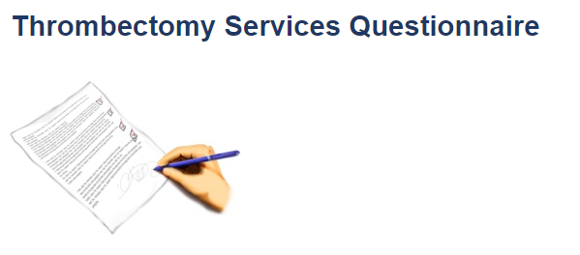
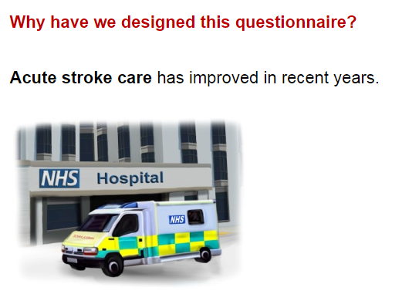

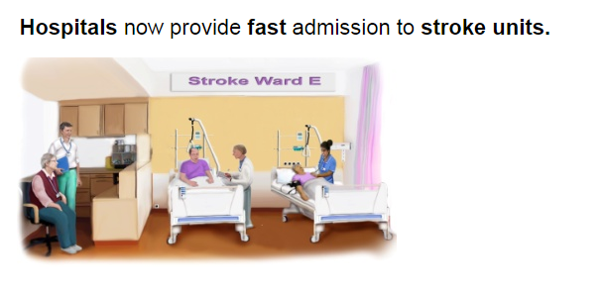

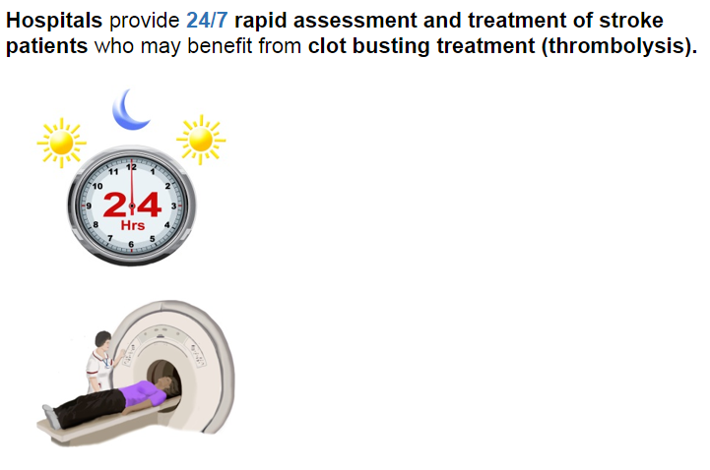

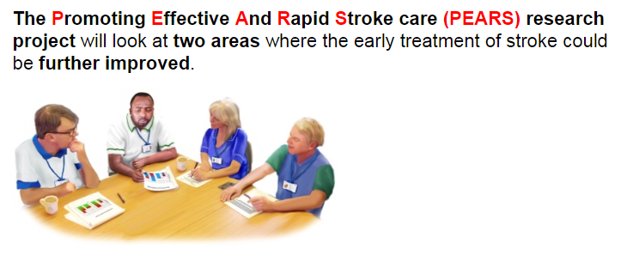

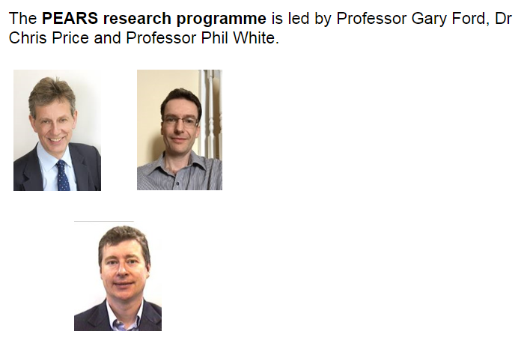

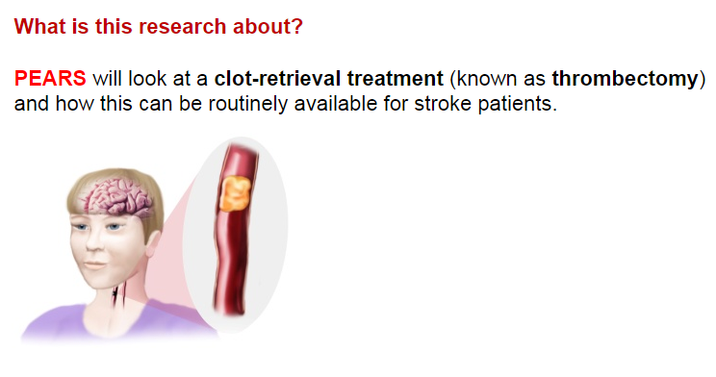
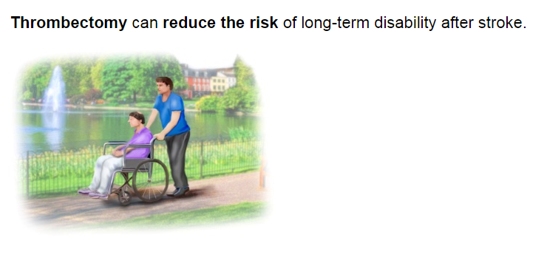

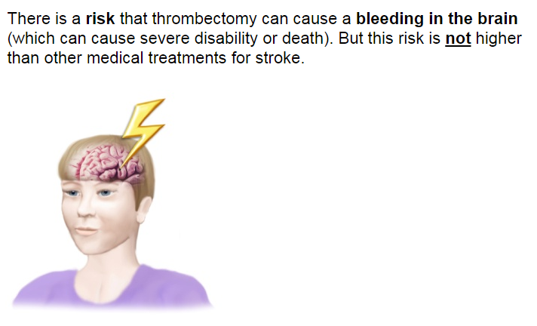
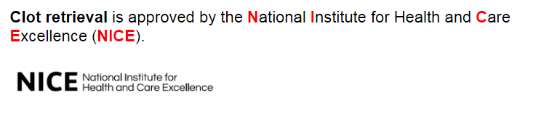

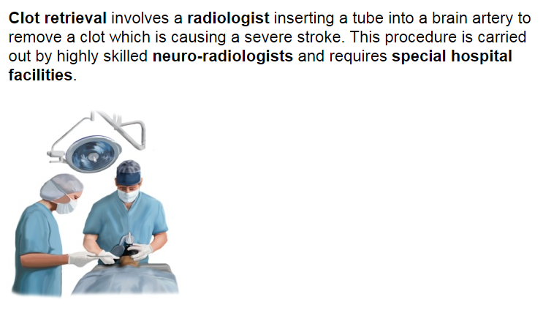

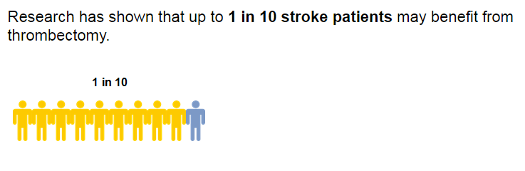

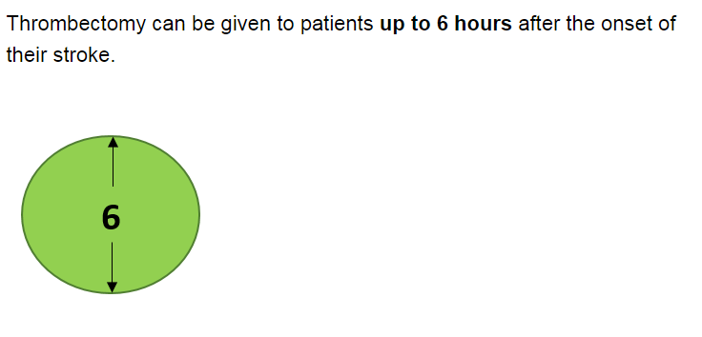

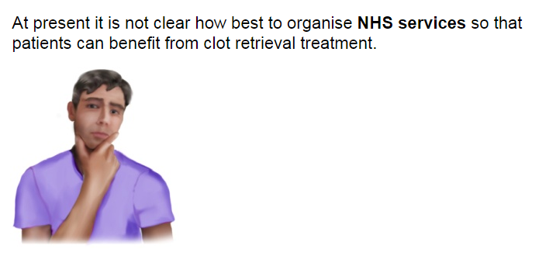

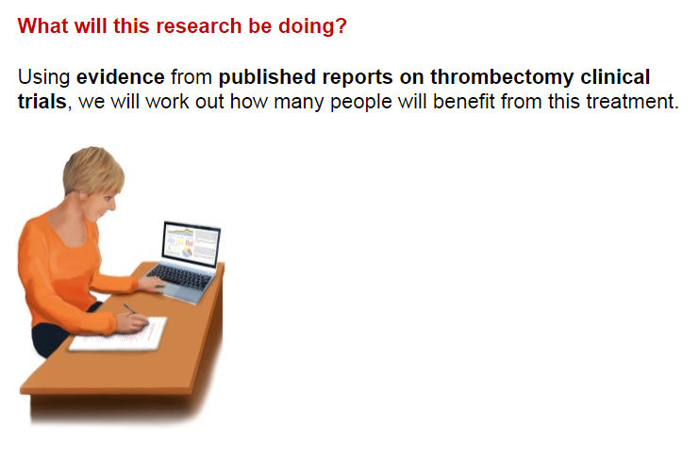

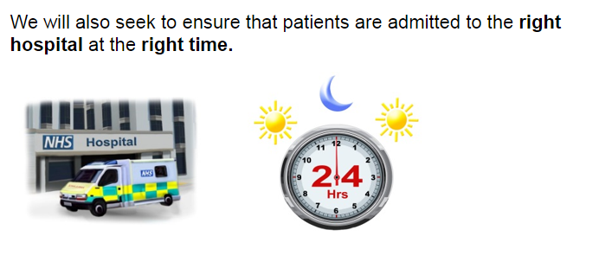

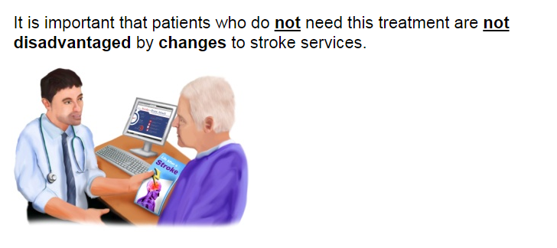

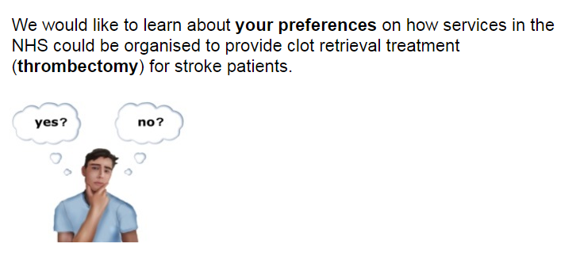

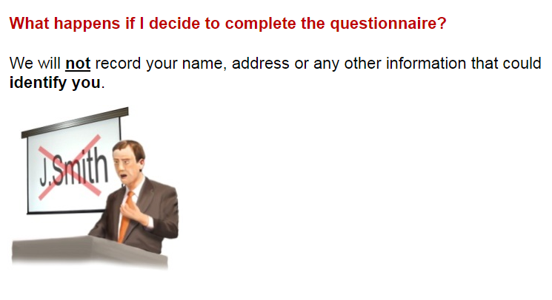

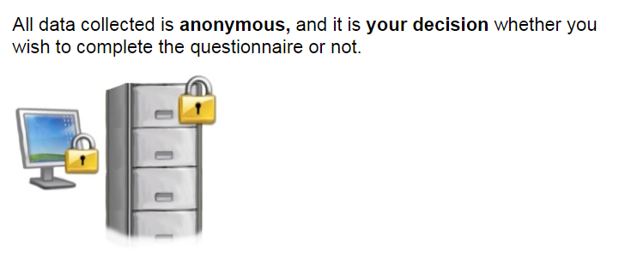

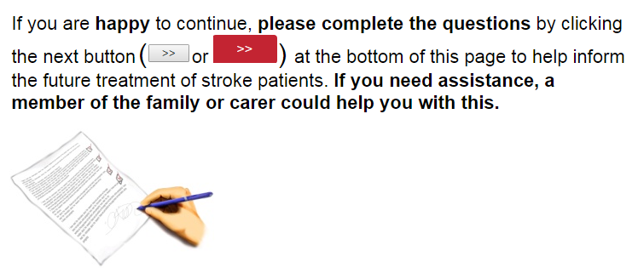

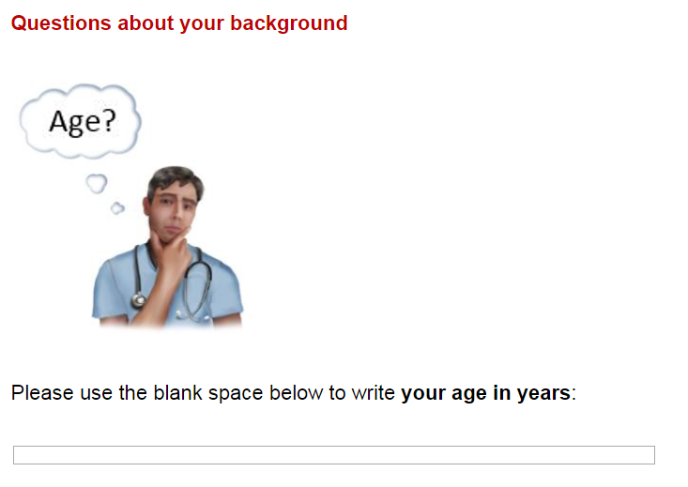

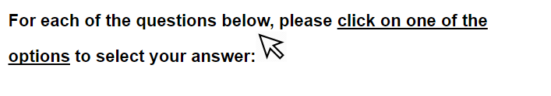
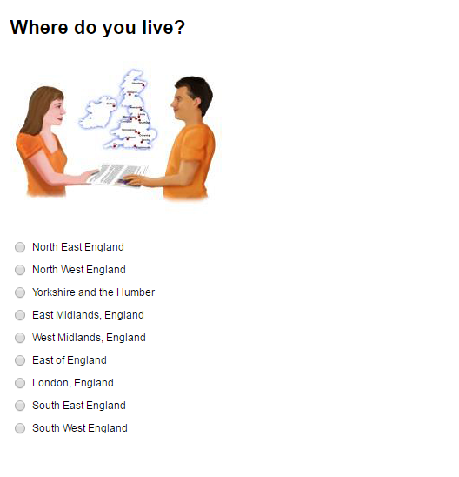
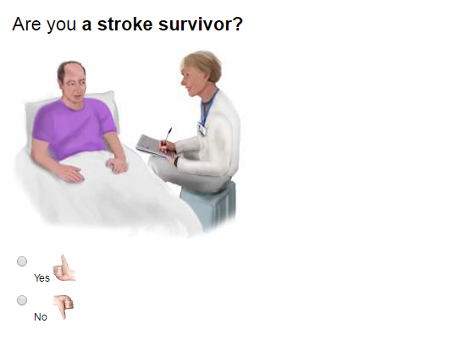

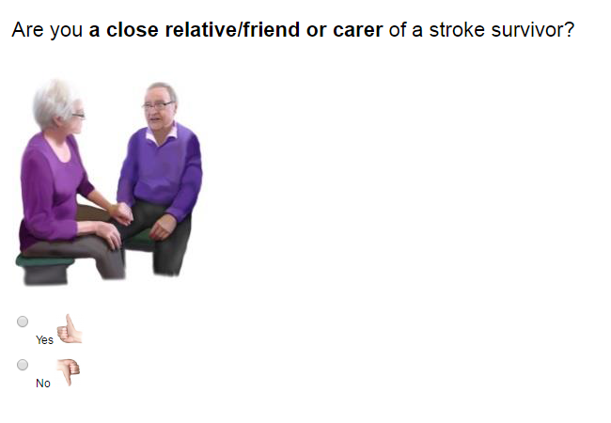

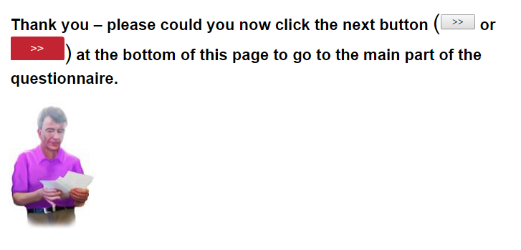
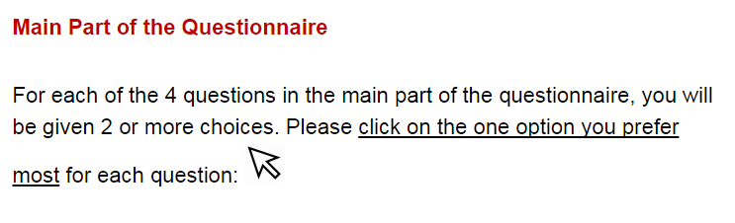

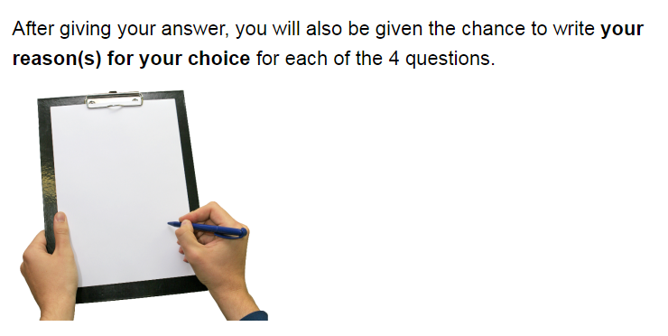

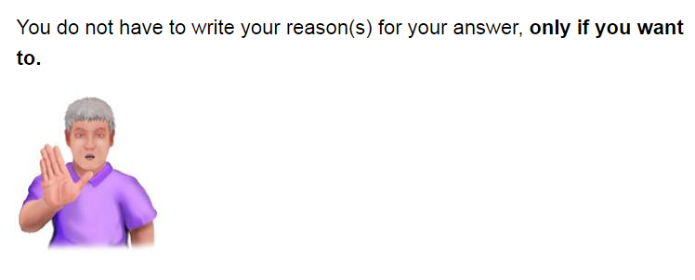
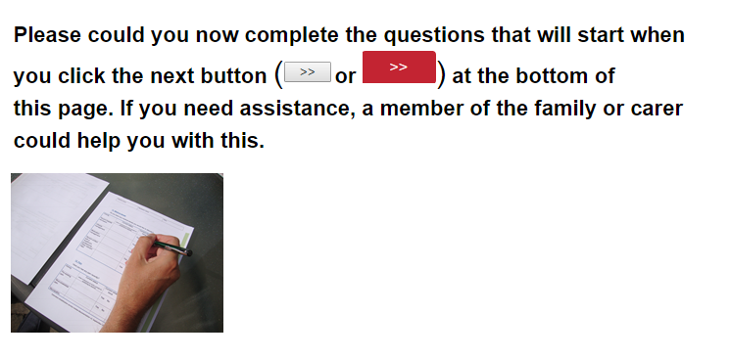

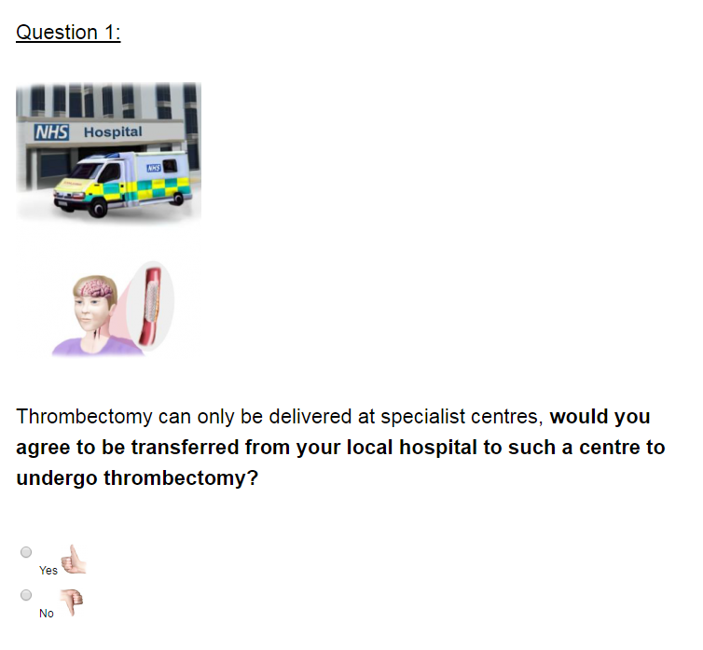
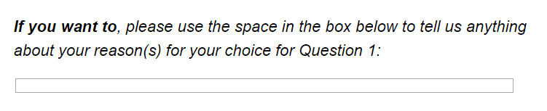

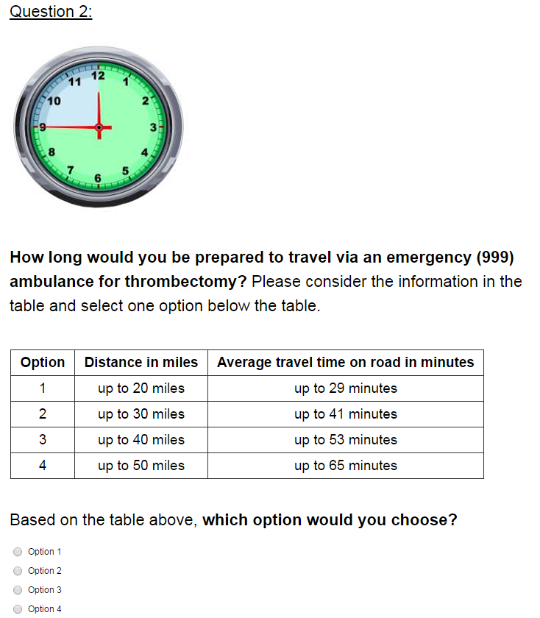
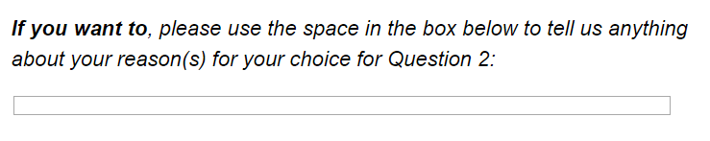

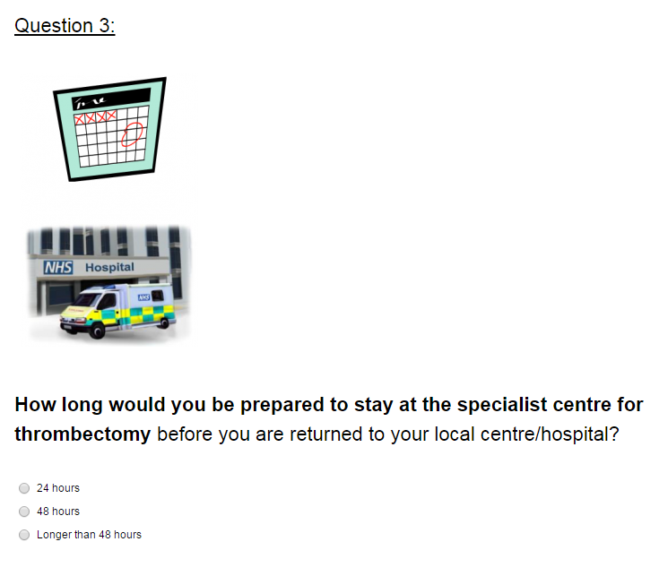
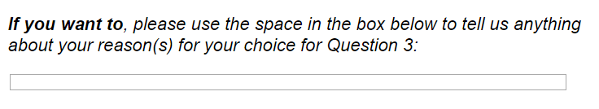

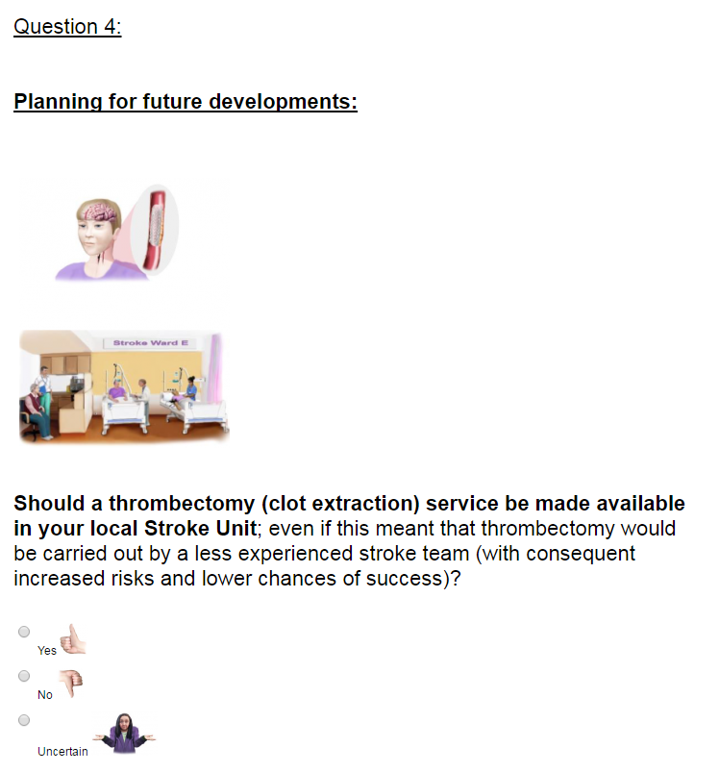
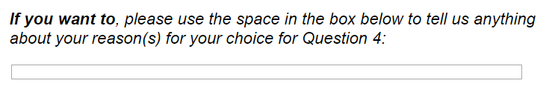

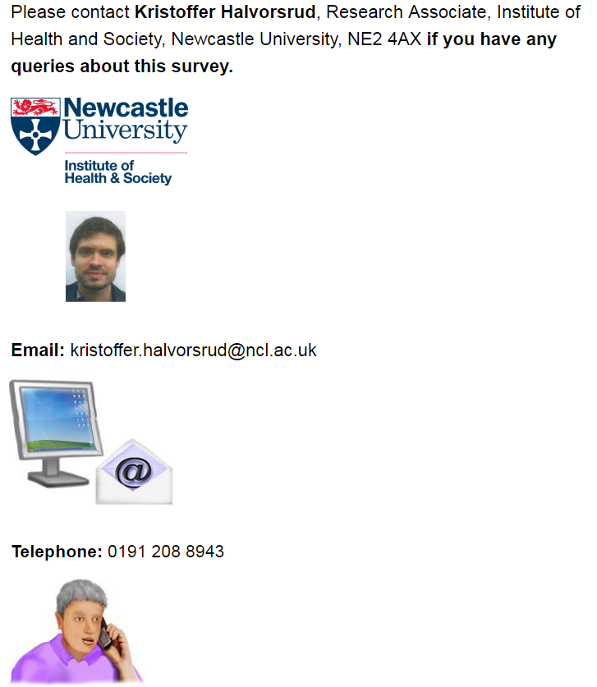

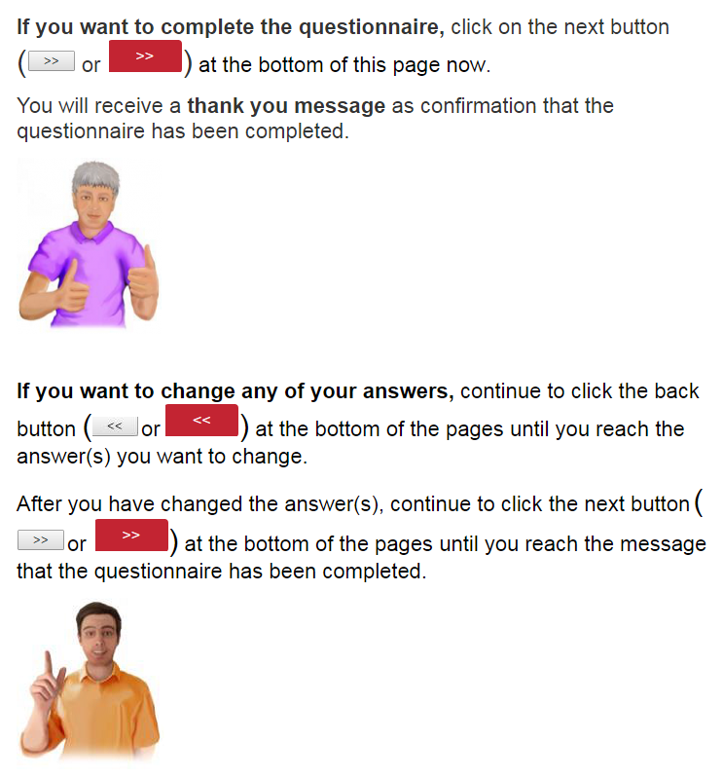

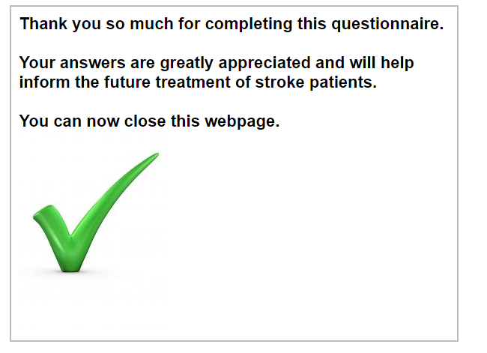
Appendix 2. BWS Survey Instrument

Start of Block: Survey Introduction Block
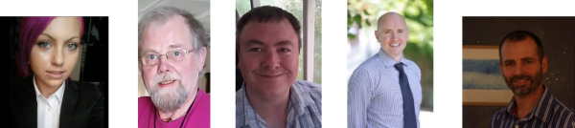
Researchers at Newcastle University would like to learn about
your preferences on how services in the NHS could be organised to provide clot removal treatment (thrombectomy) to stroke patients who may benefit.
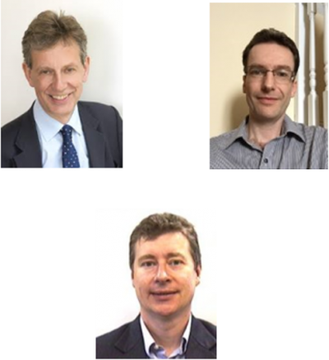
Promoting Effective And Rapid Stroke care (PEARS) is a 5 year research project led by Professor Gary Ford, Dr Chris Price and Professor Phil White and funded by the National Institute for Health Research.
PEARS is looking at ways to improve early treatment of stroke.
Please note that this survey has been designed to be completed on a desktop PC or laptop.

If you use a mobile phone, you may need to scroll up/down or left/right to see all of the information in the questionnaire. If you must use a mobile phone, we recommend rotating your device to landscape orientation.

Page Break
Why have we designed this questionnaire?

In England, approximately 80,000 people per year suffer a stroke.
Approximately 70,000 of these are caused by a blood clot.
Clot removal is the most effective treatment for a particular group of patients where stroke is caused by a large clot.
Clot removal can only be performed when the clot blocks a large blood vessel.
If the clot blocks a small blood vessel, the only medical treatment option is to provide drugs to break down the clot.
Clot removal is suitable for approximately one in ten (8,000) stroke patients (those with a large clot).

However, not all of these patients have access to clot removal treatment because the treatment is fairly new and there are not many clot removal centres in England.

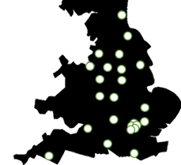
Also, these centres only exist in major urban areas and so access to them is more limited for rural patients.

Page Break

The brain needs a good blood supply to work.
If a brain artery is blocked by a clot, the brain area supplied by that artery can't work.
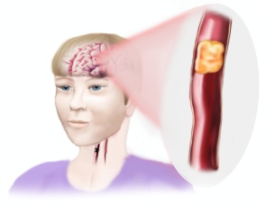
If the blood continues to be cut off, the area of the brain without blood will begin to die.
When brain areas die, we lose our ability to do certain things and may become severely disabled.
If brain areas continue to die, this may even lead to death.
Clot removal treatment (thrombectomy) involves a neuro-radiologist (a highly skilled, specialist Doctor) inserting a device into a brain artery to remove the clot which is causing a severe stroke.
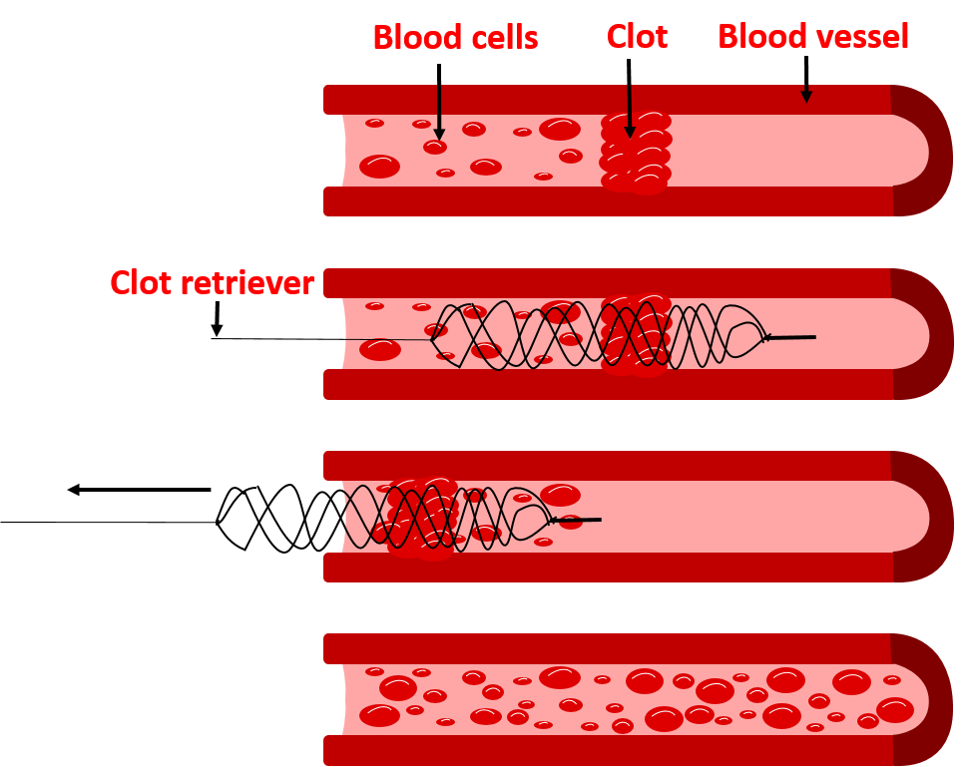
This procedure requires special hospital equipment and facilities.

Clot removal is approved by the National Institute for Health and Care Excellence (NICE).
For further information about clot removal (how it is done, risks associated with the treatment and cost) please view the short film at the following website: http://www.bbc.co.uk/programmes/p016v0hb

Clot removal is the only treatment which can fully remove the stroke-causing clot.

Other treatments try to break down the clot by using drugs but this does not always get rid of the whole clot or restore blood flow.

This means that clot removal is more likely to prevent disability than other treatments.
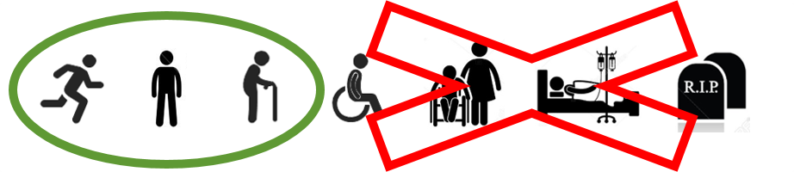

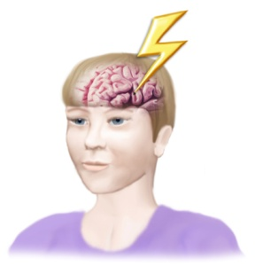
There is a risk that clot removal can cause bleeding in the brain
(which can cause severe disability or death).
But, this risk is not higher than it is for other medical stroke treatments (including drugs to break down clots).
Like the current routine treatment for stroke (drugs to break down clots), clot removal works best when treatment is given earlier.
But, for some patients, treatment can still work well after delays.

Stroke treatments are not given after the approved time windows because the risk of causing more harm outweighs the potential benefit of treatment:
Clot removal needs to be given within 7 hours after stroke onset (or possibly longer in a small minority).
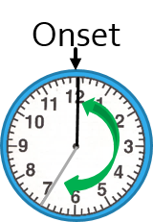
This time window is greater than the 4.5 hour time window for blood thinning drugs to break down clots.

This means that some people can be treated using clot removal at a time point when medical treatment (drugs to break down clots) is no longer an option.
However, currently, many suitable patients are unable to receive clot removal at an early time point or even within the treatment time window.

Stroke services will need to be changed to provide clot removal treatment to everyone that needs it.

It will be expensive to increase the number of patients that receive clot removal treatment but the cost is likely to be worth it in preventing disability.
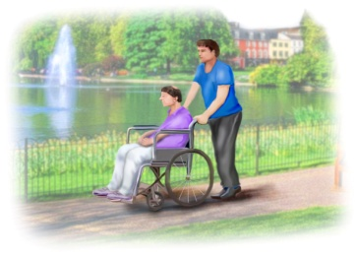
We are developing a service model to make clot removal routinely available to stroke patients but we need your help to do this because there are different options.
The main issues with changing stroke services to provide clot removal routinely are:
1. The cost.
2. Ensuring effectiveness of the treatment.
3. Providing equal access to the service.

The changes that will be made to stroke services will depend on which of these issues is prioritised most.

We would like to know which aspects of stroke services you prioritise most by asking you to choose between elements from alternative service designs.
This will allow us to understand how to best plan a new model for treatment provision by telling us what is important to consider and include.

It is important that the 90% of stroke patients that do not need this treatment are not disadvantaged by changes to stroke services.

Page Break
We are using an unusual survey design that you may not have seen before.
Please watch this video to understand why we are using this design and what we would like from you as a respondent.

Hello, my name is Darren Flynn and I'm a member of the research team, from Newcastle University, that has designed this study.
Thank you very much for taking the time to read the background information about why we have designed this questionnaire.
The questionnaire uses what is called a 'Best-Worst Scaling' design. We have used Best-Worst Scaling to identify peoples' preferences around the design of health services for clot removal treatment for acute stroke.
There will be two tasks presented to you: The first task will ask you to identify your preferences around service design for stroke clot removal treatment. Whereas the second task will ask you about your preferences around access, outcomes and cost of clot removal services.
For each of the two tasks in the questionnaire, you will be presented with a series of statements. The difference statements are not related in any way. Please treat each individual statement as standalone pieces of information.
For each set of statements, we would like you to identify one of them as your least preferred and one which is your most preferred. The series of statements will be presented in a continuous fashion. They may look very similar, with only slight changes to the statements, and may seem a little repetitive. But, the questionnaire has been designed this way on purpose so that we can identify peoples' preferences more accurately and in a less demanding way.
This will help us to understand what to prioritise when making recommendations to the NHS about how to best design clot removal services for acute stroke.
Thank you very much for agreeing to help us with designing stroke clot removal services. Your participation is most appreciated.
We are interested in your preferences on how services in the NHS could be organised to provide clot removal treatment (thrombectomy).
If you would like to help improve the future treatment of stroke patients, please complete the brief questionnaire.

This questionnaire has been designed to be inclusive of individuals with and without communication difficulties.
The graphics have been included to aid your understanding of the text in case you need help.

What happens if I complete the questionnaire?

All data collected is anonymous. We will not record your name or any other information that could identify you.

As well as this, your data will be stored securely.

You can stop answering the survey at any time but, by completing the survey, you're giving your consent for your data to be used in the PEARS research project.

It is your decision whether you wish to complete the survey or not.
However, you must be aged 18 years or older to provide your consent to complete the survey.

Please confirm your age:
- I confirm that I am aged 18 years or older.

Page Break

Please indicate whether:
1. You understand the purpose of the project.
2. You understand why we will collect your data and how we will use it.
3. You consent to taking part in the questionnaire.

If you need to go back to the start to understand the purpose of the project and how your data will be used so you can provide your informed consent, please use the back arrow button at the bottom of this page.

- I understand the purpose of this project (1)
- I understand what will happen to my data (4)
- I consent to take part in the survey (3)

Q191 Alternatively:
- I do not want to take part in the survey (4)
Display This Question:
If Alternatively: = I do not want to take part in the survey

We respect your decision not to take part in the survey.

If you have changed your decision, you can still go back to take part using the back button at the bottom of the page.

Otherwise, thank you for your time.

You can now exit the page

Skip To: End of Survey If We respect your decision not to take part in the survey. If you have changed your decision, you...() Is Displayed

Page Break
The questionnaire:
In the following questions, you will be asked to select your preferences on elements of service provision.
Here is a simple example of this type of question:

Q229 Please choose your most and least preferred options when choosing a meal at a restaurant:
Most preferred |  | Least preferred
 | The meal will taste good.
 | The meal is healthy.
 | The meal looks good.

Page Break
Please press the forward arrow button at the bottom of the page to continue to the questions.

After you progress, if you find that you need to go back to the start or change your answers to questions, please press the back button .

If you need assistance, a carer or family member could help you with this.
You do not need to complete the survey in one sitting: Your progress will be saved after each page so you can return to the same position, even after closing your browser.

Page Break

End of Block: Survey Introduction Block

Start of Block: Best Worst Scaling Part 1 Block 1 (randomised blocks and questions within blocks: complete 1 of 2 blocks)
Page Break
Part 1 of 2
For each of the following questions, we would like you to select what you believe to be the most and least preferable elements from different stroke service designs.

+
For each question, the set of service elements come from different service designs. Parts of each design have been mixed up into different questions.

The difference between these service designs is the number of clot removal centres.
This has a different effect on different aspects of these designs.
To make it easier for you to answer the questions, we have not stated all of the differences between the designs.
We just need you to decide which of the aspects you prefer from the set of design elements as these are what could affect you.

Each of these eight questions will look very similar to each other but they are all slightly different.
Remember, there are no right or wrong answers to these questions.

Page Break

Most Preferred | Please select one element from a service design for the 'most preferable' column and one element from another service design for the 'least preferable' column.  Please remember that each question will look very similar to the previous but will have at least one small difference.  The parts of the questions that could change have enlarged, blue text. | Least Preferred
o | A transfer from the  first hospital you visit to  a clot removal centre  may be needed  to get clot removal treatment. | o
o | Treatment is provided by medical  teams less experienced with clot removal  in a less specialised facility  so that you can have  a local service. | o
o | The length of stay at  a clot removal centre  is more than 48 hours. | o
o | To get access to clot removal treatment,  you will have to travel  in an ambulance  for 45 minutes or less. | o
Question 1
7 questions left for part 1
Most Preferred | Please select one element from a service design for the 'most preferable' column and one element from another service design for the 'least preferable' column.  Please remember that each question will look very similar to the previous but will have at least one small difference.  The parts of the questions that could change have enlarged, blue text. | Least Preferred
o | A transfer from the  first hospital you visit to  a clot removal centre  is not needed to get  clot removal treatment. | o
o | Treatment is provided by  experienced expert medical  teams using specialised  equipment rather than  at a local service. | o
o | The length of stay at  a clot removal centre is  less than 48 hours. | o
o | To get access to clot removal treatment,  you will have to travel  in an ambulance for  45 minutes or longer. | o
Question 2

6 questions left for part 1

Question 3
Question 4
We apologise for the repetitive nature of the survey.
We realise that the repetitive nature of the questions can cause some confusion and lead you to feel that you aren't answering correctly.

We also realise that it is challenging to choose your preferences between these design elements.

Please don't be discouraged.
We have used this method to find out the most information about your preferences in a way that takes you the least possible effort.

We very much appreciate the effort you have put in so far. We would appreciate this even more if you could persist in answering the remaining questions.
4 questions remaining for part 1
8 questions remaining for part 2
Question 5
Question 6
Question 7
Question 8
If you have any comments to make on the part of the survey you just completed, please type them in the box below:________________________________________________________________
________________________________________________________________
________________________________________________________________
End of Part 1!

Thank you so much for persisting with the questions so far!
If you would like to change any of your answers for Part 1, please use the back button to navigate to the question(s) you would like to change. This is your last opportunity to change answers from Part 1.
If you are finished answering Part 1, please continue to the final part which contains 8 questions.

Part 2 of 2
Just like in Part 1 of the survey:
For each of the following questions, we would like you to select what you believe to be the most and least preferable elements from different stroke service designs.

+

For each question, the set of service elements come from different service designs. Parts of each design have been mixed up into different questions.
The difference between the service designs is the number of clot removal centres.
This has a different effect on different aspects of these designs.
To make it easier for you to answer the questions, we have not stated all of the differences between the designs.
We just need you to decide which of the outcomes you prefer from the set of design elements as these are what could affect you.

Each of these eight questions will look very similar to each other but they are all slightly different.
Remember, there are no right or wrong answers to these questions.

Page Break

Most Preferred | Please select one element from a service design for the 'most preferable' column and one element from another service design for the 'least preferable' column.  Please remember that each question will look very similar to the previous but will have at least one small difference.  The parts of the questions that could change have enlarged text. | Least Preferred
o | Out of 100 people who receive clot removal treatment,  52 (52%) will recover with no or mild disability.  41 (41%) will recover with moderate to severe disability.  7 (7%) will be dead. | o
o | In England, the cost of providing clot removal treatment  over 2 years is as much as setting-up and funding  70 MRI scanners* for 2 years (~£154,000,000).  * Magnetic Resonance Imaging (MRI) is a complex medical imaging technology which uses strong magnetic fields and radio waves to produce detailed images of the inside of the body.  MRI can assist with diagnosing medical conditions. | o
o | Out of 100 patients eligible for clot removal treatment,  71 (71%) will have access to it  within the treatment time window.  29 (29%) will not have access.  [This means: out of the 8,000 eligible patients per year:  5,680 will have access.  2,320 will not have access.] | o
Question 1

7 Questions left for Part 2
Most Preferred | Please select one element from a service design for the 'most preferable' column and one element from another service design for the 'least preferable' column.  Please remember that each question will look very similar to the previous but will have at least one small difference.  The parts of the questions that could change have enlarged text. | Least Preferred
o | Out of 100 people who receive clot removal treatment,  41 (41%) will recover with no or mild disability.  49 (49%) will recover with moderate to severe disability.  10 (10%) will be dead. | o
o | In England, the cost of providing clot removal treatment  over 2 years is as much as setting-up and funding  88 MRI scanners* for 2 years (~£193,000,000).  * Magnetic Resonance Imaging (MRI) is a complex medical imaging technology which uses strong magnetic fields and radio waves to produce detailed images of the inside of the body.  MRI can assist with diagnosing medical conditions. | o
o | Out of 100 patients eligible for clot removal treatment,  72 (72%) will have access to it  within the treatment time window.  28 (28%) will not have access.  [This means: out of the 8,000 eligible patients per year:  5,760 will have access.  2,240 will not have access.] | o
Question 2
6 questions left for part 2
Question 3
Question 4

Nearly finished!
Well done and thank you very much for persisting.

Only 4 questions remaining! Please don't give up now! Answers to every question are valuable.

Question 5
Question 6
Question 7
Question 8

If you have any comments to make on the part of the survey you just completed, please type them in the box below:
____________________________________________________________________________________________________
Thank you for completing the main part of the survey!
In order to further understand your preferences, we have a few questions about you:

What is your age?

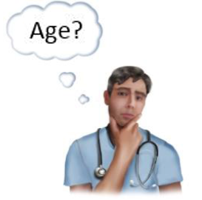

Please use the box below to type your age in years (e.g. 45)

________________

For the next few questions, please select the option that applies to you:

What is your gender?

Male
Female
Other

Which region do you live in?
North East England
North West England
Yorkshire and the Humber, England
East Midlands, England
West Midlands, England
East of England
London, England
South East England
South West England
Other
Which of the following environments do you live in?
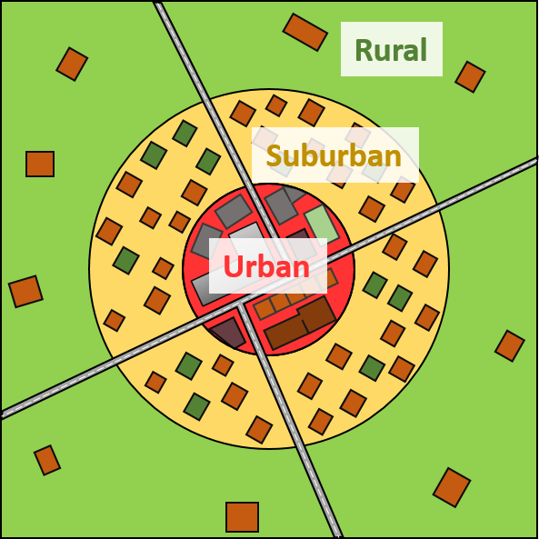
o | Urban  (i.e. in a city)

o | Suburban  (i.e. just outside of a city)

o | Rural  (i.e. the countryside)

Are you a stroke survivor?
- Yes
- No

Are you a close relative/friend or carer of a stroke survivor?

- Yes
- No

Do you have aphasia?

(Aphasia is a language problem where the production and/or comprehension of speech is more difficult)
- Yes
- No

Thank you very much for taking part in our research!
All responses contribute to our understanding of how to improve stroke services.
If you would like to, please share the survey on social media:
Share on Facebook
Tweet

If you have any questions, or would like to withdraw your data, please contact:
Hannah Lumley, Stroke Research Group, Institute of Neuroscience, Newcastle University, 3-4 Claremont Terrace, Newcastle upon Tyne, NE2 4AE.
Email:
hannah.lumley@newcastle.ac.uk

Telephone:

(0191) 20 85847

If you would like to go back to change your answers to Part 2, you can still do this by pressing the back button at the bottom of the page until you reach the question(s) you want to change.

After you have changed your answers, please press the forward button until you reach the end of the survey so we can record your response.

If you are finished answering the survey, please press the forward button to submit your response to the survey.

