Supplementary Tables and Figures
Comprehensive Characterization of the Coding and Non-coding Single Nucleotide Polymorphisms in the Tumor Protein p63 (TP63) Gene Using In silico Tools
Shamima Akter¹, Shafaat Hossain², Md. Ismail Hosen², Hossain Uddin Shekhar^{2*}
¹ Department of Bioinformatics and Computational Biology, George Mason University, Fairfax, Virginia- 22030
² Department of Biochemistry and Molecular Biology, University of Dhaka, Dhaka-1000, Bangladesh.

*Correspondence to: Dr. Hossain Uddin Shekhar, Professor, Department of Biochemistry and Molecular Biology, University of Dhaka, Dhaka-1000, Bangladesh, Email: hossainshekhar@du.ac.bd

Table S1. Functional nsSNPs Prediction in TP63 in SIFT, PolyPhen2, CADD
Variant ID |  |  | SNP | Source | Conseq.Type  (SNP type) | SIFT_class | PolyPhen2 class | CADD_class
rs1266601767 |  |  | D178Y | dbSNP | missense variant | deleterious | probably damaging | likely deleterious
rs866938979 |  |  | S189L | dbSNP | missense variant | deleterious | probably damaging | likely deleterious
rs1057517984 |  |  | Y202C | dbSNP | missense variant | deleterious | probably damaging | likely deleterious
rs121908849 |  |  | R266Q | dbSNP | missense variant | deleterious | probably damaging | likely deleterious
rs121908840 |  |  | R318H | dbSNP | missense variant | deleterious | probably damaging | likely deleterious
rs886039442 |  |  | R319H | dbSNP | missense variant | deleterious | probably damaging | likely deleterious
rs1320920860 |  |  | V325D | dbSNP | missense variant | deleterious | probably damaging | likely deleterious
rs753404887 |  |  | D331V | dbSNP | missense variant | deleterious | probably damaging | likely deleterious
rs1040062725 |  |  | G332R | dbSNP | missense variant | deleterious | probably damaging | likely deleterious
rs113993967 |  |  | R337Q | dbSNP | missense variant | deleterious | probably damaging | likely deleterious
rs1029852196 |  |  | R338H | dbSNP | missense variant | deleterious | probably damaging | likely deleterious
rs121908841 |  |  | R343Q | dbSNP | missense variant | deleterious | probably damaging | likely deleterious
rs1064793282 |  |  | C347F | dbSNP | missense variant | deleterious | probably damaging | likely deleterious
rs866267914 |  |  | G349E | dbSNP | missense variant | deleterious | probably damaging | likely deleterious
rs121908844 |  |  | D351G | dbSNP | missense variant | deleterious | probably damaging | likely deleterious
rs1553857889 |  |  | D355N | dbSNP | missense variant | deleterious | probably damaging | likely deleterious
rs757536818 |  |  | R376C | dbSNP | missense variant | deleterious | probably damaging | likely deleterious
rs761885185 |  |  | R379C | dbSNP | missense variant | deleterious | probably damaging | likely deleterious
rs765502786 |  |  | R379H | dbSNP | missense variant | deleterious | probably damaging | likely deleterious
rs1173679499 |  |  | R393Q | dbSNP | missense variant | deleterious | probably damaging | likely deleterious
rs1282887680 |  |  | R408C | dbSNP | missense variant | deleterious | probably damaging | likely deleterious
rs751698974 |  |  | R408H | dbSNP | missense variant | deleterious | probably damaging | likely deleterious
rs886039443 |  |  | F552C | dbSNP | missense variant | deleterious | probably damaging | likely deleterious
rs121908843 |  |  | C561G | dbSNP | missense variant | deleterious | probably damaging | likely deleterious
rs774221257 |  |  | L562R | dbSNP | missense variant | deleterious | probably damaging | likely deleterious
rs1172845743 |  |  | Y574C | dbSNP | missense variant | deleterious | probably damaging | likely deleterious
rs774550896 |  |  | R647H | dbSNP | missense variant | deleterious | probably damaging | likely deleterious
rs764601563 |  |  | R655Q | dbSNP | missense variant | deleterious | probably damaging | likely deleterious

Table S2. Analysis of nsSNPs using PROVEAN and ClinVar
Variant ID |  |  | SNP | Source | PROVEAN score | PROVEAN impact | ClinVar result
rs1266601767 |  |  | D178Y | dbSNP | -3.381 | Deleterious | not found
rs866938979 |  |  | S189L | dbSNP | -5.556 | Deleterious | not found
rs1057517984 |  |  | Y202C | dbSNP | -7.964 | Deleterious | Likely pathogenic
rs121908849 |  |  | R266Q | dbSNP | -3.612 | Deleterious | Pathogenic
rs121908840 |  |  | R318H | dbSNP | -4.645 | Deleterious | Pathogenic
rs886039442 |  |  | R319H | dbSNP | -4.627 | Deleterious | Pathogenic
rs1320920860 |  |  | V325D | dbSNP | -4.628 | Deleterious | not found
rs753404887 |  |  | D331V | dbSNP | -6.694 | Deleterious | not found
rs1040062725 |  |  | G332R | dbSNP | -5.704 | Deleterious | not found
rs113993967 |  |  | R337Q | dbSNP | -3.618 | Deleterious | Pathogenic
rs1029852196 |  |  | R338H | dbSNP | -4.523 | Deleterious | Uncertain significance
rs121908841 |  |  | R343Q | dbSNP | -3.663 | Deleterious | Pathogenic
rs1064793282 |  |  | C347F | dbSNP | -10.073 | Deleterious | Pathogenic
rs866267914 |  |  | G349E | dbSNP | -7.342 | Deleterious | Pathogenic
rs121908844 |  |  | D351G | dbSNP | -6.41 | Deleterious | Pathogenic
rs1553857889 |  |  | D355N | dbSNP | -3.512 | Deleterious | Pathogenic
rs757536818 |  |  | R376C | dbSNP | -3.65 | Deleterious | not found
rs761885185 |  |  | R379C | dbSNP | -2.648 | Deleterious | Uncertain significance
rs765502786 |  |  | R379H | dbSNP | -1.476 | Neutral | Uncertain significance
rs1173679499 |  |  | R393Q | dbSNP | -2.402 | Neutral | not found
rs1282887680 |  |  | R408C | dbSNP | -7.064 | Deleterious | not found
rs751698974 |  |  | R408H | dbSNP | -4.461 | Deleterious | not found
rs886039443 |  |  | F552C | dbSNP | -2.7 | Deleterious | Likely pathogenic
rs121908843 |  |  | C561G | dbSNP | -3.819 | Deleterious | Likely pathogenic
rs774221257 |  |  | L562R | dbSNP | -2.328 | Neutral | not found
rs1172845743 |  |  | Y574C | dbSNP | -2.828 | Deleterious | not found
rs774550896 |  |  | R647H | dbSNP | -2.062 | Neutral | not found
rs764601563 |  |  | R655Q | dbSNP | -1.246 | Neutral | not found

Table S3. Regulome DB results of non-coding SNPs
dbSNP IDs | Regulome DB Rank | Regulome DB Score | Type | Position in  respect to TP63
rs62290004 | 2a | 0.67948 | Intron Variant | Intron 1-2
rs6774934 | 2a | 1 | Intron Variant | Intron 1-2
rs11708278 | 2b | 0.68277 | Intron Variant | Intron 3-4
rs1913721 | 2b | 0.43292 | Intron Variant | Intron 4-5
rs1913722, rs57898901 | 2b | 0.62301 | Intron Variant | Intron 4-5
rs4488809 | 2b | 0.57802 | Intron Variant | Intron 1-2
rs4687090 | 2b | 0.43292 | Intron Variant | Intron 1-2
rs55803942 | 2b | 0.46415 | Intron Variant | Intron 3-4
rs56104635 | 2b | 0.70883 | Intron Variant | Intron 4-5
rs6444404 | 2b | 0.50526 | Intron Variant | Intron 4-5
rs6794898 | 2b | 0.67017 | Intron Variant | Intron 1-2
rs6797174 | 2b | 0.93104 | Intron Variant | Intron 1-2
rs79155799 | 2b | 0.55744 | Intron Variant | Intron 1-2
rs79659066 | 2b | 0.69579 | Intron Variant | Intron 3-4
rs9830137 | 2b | 0.70883 | Intron Variant | Intron 3-4
rs9847745 | 2b | 0.63796 | Intron Variant | Intron 1-2
rs10049472 | 2c | 0.49417 | Intron Variant | Intron 1-2
rs4687085 | 2c | 0.42417 | Intron Variant | Intron 1-2
rs6777728 | 2c | 0.9 | Intron Variant | Intron 4-5
rs28673064 | 3a | 0.97433 | 5 prime UTR variant | 5 prime UTR
rs78233713 | 7 | 0.18412 | 3 prime UTR variant | 3 prime UTR
rs73199799 | 7 | 0.18412 | 3 prime UTR variant | 3 prime UTR

Table S4. miRNA binding site prediction of noncoding SNPs in TP63 protein through PolymiRTS
Location | dbSNP ID | Variant | Wobble | Ancestral | Allele | miR ID | Conservation | miRSite | Function | Exp | context+
189612062 | rs142981128 | SNP | Y | G | G | hsa-miR-22-3p | 16 | accaccGGCAGCT | D | N | -0.161
 |  |  |  |  |  | hsa-miR-138-5p | 14 | acCACCAGCAgct | C | N | -0.35
 |  |  |  |  |  | hsa-miR-3692-5p | 14 | accaCCAGCAGct | C | N | -0.186
 |  |  |  |  |  | hsa-miR-4456 | 13 | aCCACCAGcagct | C | N | -0.192
 |  |  |  |  |  | hsa-miR-4722-5p | 14 | tctcatCTCCTGC | O | N | -0.168
189612196 | rs140149400 | SNP | Y | A | A | hsa-miR-1273f | 19 | cagaCCATCTCtt | D | N | -0.149
 |  |  |  |  |  | hsa-miR-4527 | 19 | CAGACCAtctctt | D | N | -0.131
 |  |  |  |  |  | hsa-miR-6503-5p | 19 | CAGACCAtctctt | D | N | -0.131
 |  |  |  |  |  | hsa-miR-6753-3p | 19 | CAGACCAtctctt | D | N | -0.119
 |  |  |  |  |  | hsa-miR-7107-3p | 19 | CAGACCAtctctt | D | N | -0.116
 |  |  |  |  | G | hsa-miR-409-5p | 12 | catatcGGTAACC | C | N | -0.073
189613717 | rs36099321 | SNP | N | C | C | hsa-miR-184 | 10 | gtttcCCGTCCAt | D | N | -0.135
 |  |  |  |  |  | hsa-miR-4804-5p | 10 | gtttcCCGTCCAt | D | N | -0.122
 |  |  |  |  |  | hsa-miR-4520a-3p | 10 | gtttcCTGTCCAt | C | N | -0.011
 |  |  |  |  | C | hsa-miR-636 | 13 | tggtaaCAAGCAC | C | N | -0.166
189614414 | rs36064124 | SNP | N | C | C | hsa-miR-6892-5p | 13 | ctgctTCCCTTAc | D | N | -0.119
189614507 | rs35861864 | SNP | Y | G | G | hsa-miR-101-3p | 10 | tGTACTGTgtctc | D | N | -0.086

Table S5. PolymiRTS Results of noncoding SNPs for disease association
Disease/Trait | PubMedID | MarkerID | P_Value
Brain imaging | 20100581 | rs7610017 | NS
Lung cancer | 23143601 | rs4488809 | 0.000000004
Lung cancer | 21725308 | rs4488809 | 7E-26
Lung adenocarcinoma | 22797724 | rs10937405 | 7E-17
Lung adenocarcinoma | 20871597 | rs10937405 | 7E-12
Acute lymphoblastic leukemia (childhood) | 22076464 | rs17505102 | 0.000000009
Acute lymphoblastic leukemia (childhood) | 22076464 | rs17505102 | 0.00000002
Bladder cancer | 20972438 | rs710521 | 2E-10
Urinary bladder cancer | 20348956 | rs710521 | 0.00000006
Urinary bladder cancer | 18794855 | rs710521 | 0.0000001

Figure S1. SNP types and number of TP63

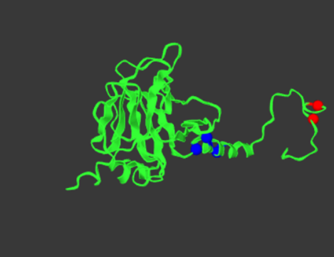
Figure S2. Mutations in protein structure. The positions of the SNPs are C347F, D355N, G349E, R376C, R408C, R408H, R379C, R379H

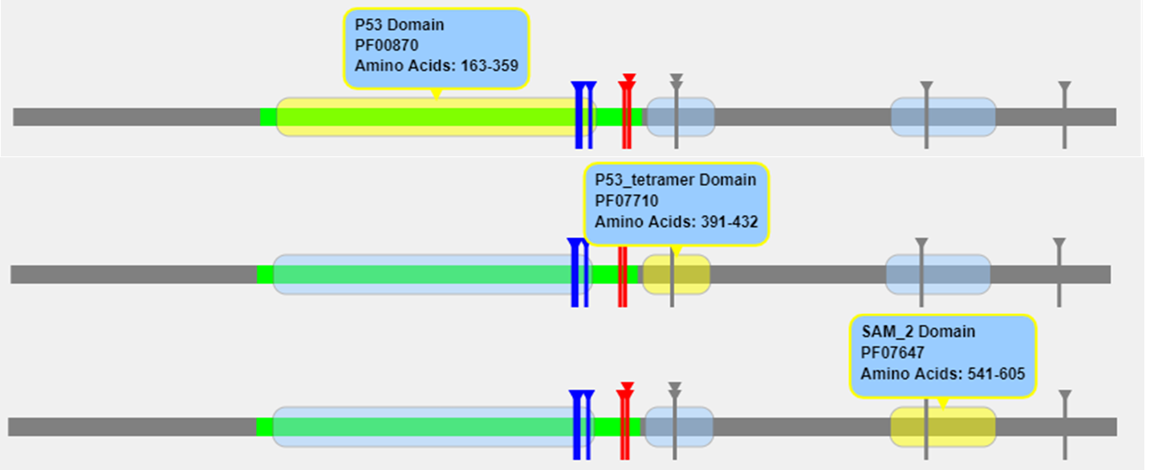
Figure S3. Three domains are shown in yellow color with blue box labelling after structural analysis with Mutation 3D. Vertical sticks shows the mutation in different domains. P53 domain is the DNA binding domain of TP63. R266Q,R318H,R319H,R337Q,R343Q,C347F, D351G,G349E,D355N, are present in p53 domain or DNA binding domain, R376C, R408C, R408H, R379C, R379H are in p53_tetramer domain and L562R in Sam domain.

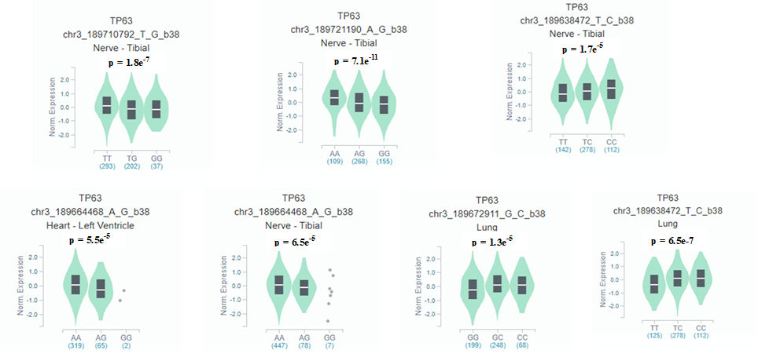
Figure S4. Violin plots of noncoding SNPs for single tissue eQTLs through analyzing with GTEx portal. The plots show the normalized TP63 gene expressions with mutations in different tissues along with significant p values.
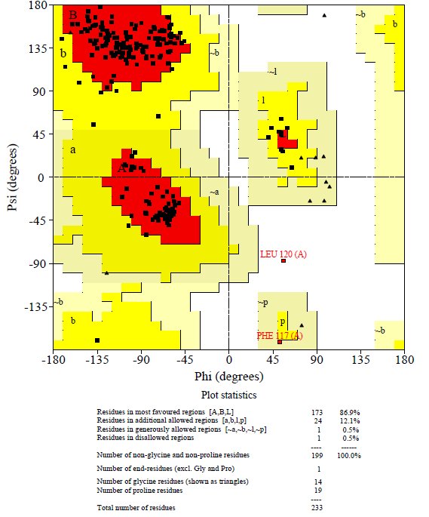
Figure S5: Ramachandran plot statistics of Precheck analysis in PDB sum server for 3D structure of TP63 protein :2RMN.A,B,L denote the alpha, beta, and loop structures in protein.

