Supplementary Material

Nodes with the highest control power play an important role at the final level of cooperation in directed networks

Ali Ebrahimi¹, Marzieh Yousefi², Farhad Shahbazi², Ali Masoudi-Nejad^{1*}

- Laboratory of Systems Biology and Bioinformatics (LBB), Institute of Biochemistry and Biophysics, University of Tehran, Tehran, Iran
- Department of physics, Isfahan University of Technology (IUT), Isfahan, Iran

*Corresponding Author
Ali Masoudi-Nejad, Ph.D,
Laboratory of Systems Biology and Bioinformatics (LBB)
Institute of Biochemistry and Biophysics
University of Tehran, Tehran, Iran.
E-mail: amasoudin@ut.ac.ir
WWW: http://LBB.ut.ac.ir

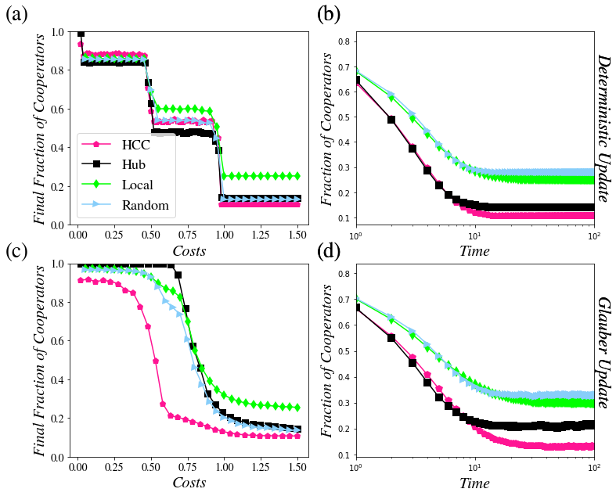
Fig S1. Results regarding the s208 network. a) Analysis of cooperation level based on the deterministic update rule. b) Network dynamics in achieving steady state relevant to the deterministic update law (c=1). c) Analysis of cooperation level based on the Glauber update rule. d) Network dynamics in achieving steady state related to the Glauber update rule (c=1)

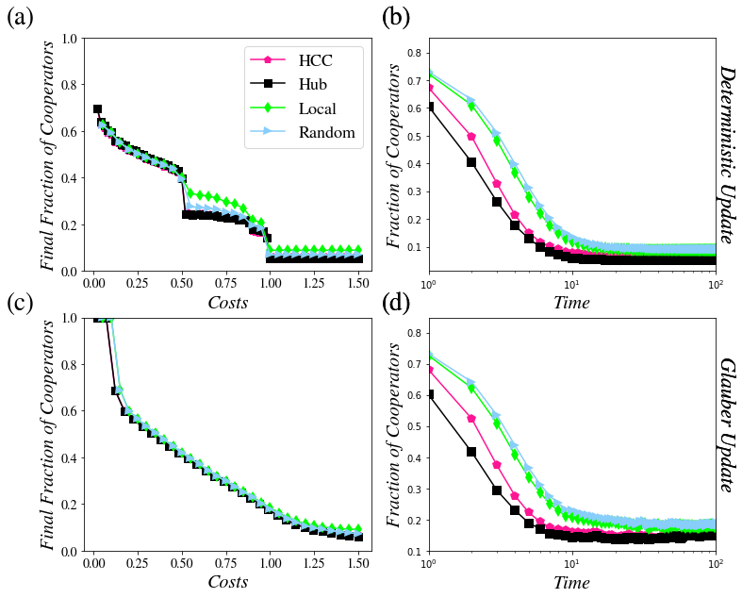
Fig S2. Results regarding the Mangrove network. Designations are as Fig S1.

