Article Title: Targeted alpha immunotherapy of CD20-positive B-cell lymphoma model: Dosimetry estimate of ²²⁵Ac-DOTA-rituximab using ⁶⁴Cu-DOTA-rituximab
Journal Name: EJNMMI Physics
Author names: Chul-Hee Lee, Ilhan Lim, Sang-Keun Woo, Wook Kim, Kwang Il Kim, Kyo Chul Lee, Kanghyon Song, Sang Moo Lim

Affiliation and e-mail address of the corresponding author:

a
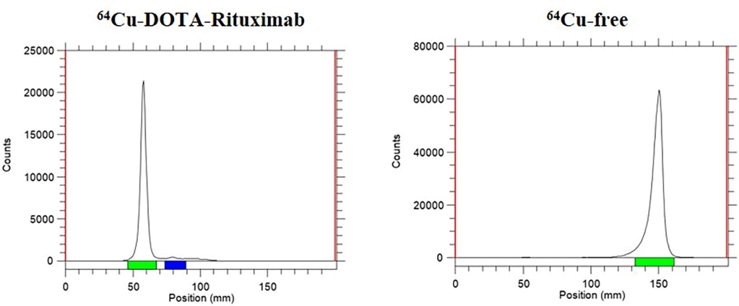
b
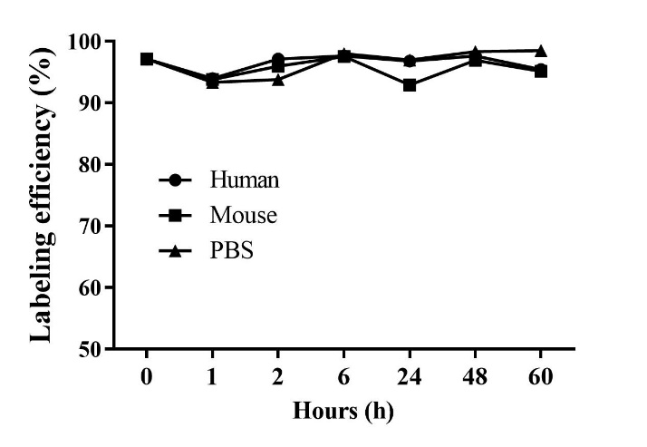
Supplementary fig.1 Radiolabeling of ⁶⁴Cu-DOTA-rituximab and their serum stability. a Radiolabeling efficiency was observed to be more than 95% compared to free ⁶⁴Cu. b Serum stability in humans and mice, and saline was shown to be at least 90% stable

