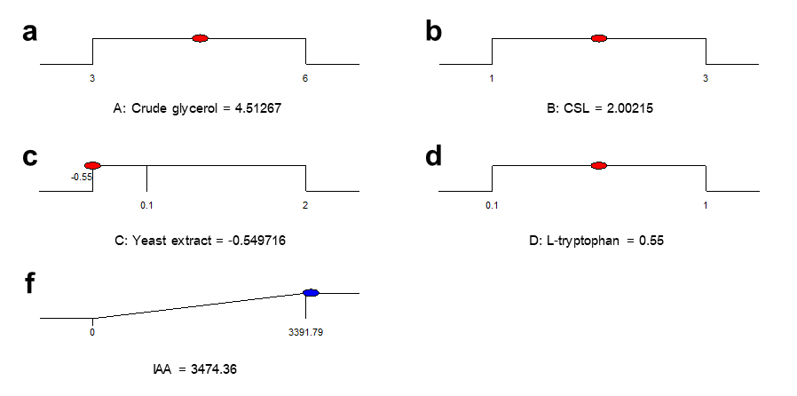
Figure S1 Summary of the criteria set for the optimization run. The ramps show the predicted levels, and the numbers represent the percentages (%w/v) of (a) crude glycerol, (b) CSL, (c) technical-grade yeast extract, and (d) L-tryptophan.
Table S1 The variables and their levels for the CCD.
Factor | Symbol | Coded levels
 |  | – α | – 1 | 0 | + 1 | + α
Crude glycerol (%w/v) | A | 1.98 | 3 | 4.5 | 6 | 7.02
CSL (%w/v) | B | 0.32 | 1 | 2 | 3 | 3.68
Technical-grade yeast extract (%w/v) | C | – 0.55 | 0.1 | 1.05 | 2 | 2.65
Feed-grade L-tryptophan (%w/v) | D | – 0.21 | 0.1 | 0.55 | 1 | 1.31

