Pubmed 91
Search: (((((((((((((((((((((((((((((((((((((((((((Stem Cell, Mesenchymal[Title/Abstract]) OR (Stem Cells, Mesenchymal[Title/Abstract])) OR (Mesenchymal Stem Cell[Title/Abstract])) OR (Bone Marrow Mesenchymal Stem Cells[Title/Abstract])) OR (Bone Marrow Mesenchymal Stem Cell[Title/Abstract])) OR (Bone Marrow Stromal Cells[Title/Abstract])) OR (Bone Marrow Stromal Cell[Title/Abstract])) OR (Bone Marrow Stromal Cells, Multipotent[Title/Abstract])) OR (Multipotent Bone Marrow Stromal Cell[Title/Abstract])) OR (Multipotent Bone Marrow Stromal Cells[Title/Abstract])) OR (Adipose-Derived Mesenchymal Stem Cells[Title/Abstract])) OR (Adipose Derived Mesenchymal Stem Cells[Title/Abstract])) OR (Adipose Derived Mesenchymal Stem Cells[Title/Abstract])) OR (Adipose Tissue-Derived Mesenchymal Stem Cell[Title/Abstract])) OR (Adipose Tissue Derived Mesenchymal Stem Cell[Title/Abstract])) OR (Adipose Tissue-Derived Mesenchymal Stem Cells[Title/Abstract])) OR (Adipose Tissue Derived Mesenchymal Stem Cells[Title/Abstract])) OR (Mesenchymal Stem Cells, Adipose-Derived[Title/Abstract])) OR (Mesenchymal Stem Cells, Adipose Derived[Title/Abstract])) OR (Adipose Tissue-Derived Mesenchymal Stromal Cells[Title/Abstract])) OR (Adipose Tissue Derived Mesenchymal Stromal Cells[Title/Abstract])) OR (Adipose-Derived Mesenchymal Stromal Cells[Title/Abstract])) OR (Adipose Derived Mesenchymal Stromal Cells[Title/Abstract])) OR (Adipose-Derived Mesenchymal Stem Cell[Title/Abstract])) OR (Adipose Derived Mesenchymal Stem Cell[Title/Abstract])) OR (Mesenchymal Stromal Cells[Title/Abstract])) OR (Stromal Cell, Mesenchymal[Title/Abstract])) OR (Stromal Cells, Mesenchymal[Title/Abstract])) OR (Mesenchymal Stromal Cell[Title/Abstract])) OR (Multipotent Mesenchymal Stromal Cells[Title/Abstract])) OR (Mesenchymal Stromal Cells, Multipotent[Title/Abstract])) OR (Multipotent Mesenchymal Stromal Cell[Title/Abstract])) OR (Mesenchymal Progenitor Cell[Title/Abstract])) OR (Mesenchymal Progenitor Cells[Title/Abstract])) OR (Progenitor Cell, Mesenchymal[Title/Abstract])) OR (Progenitor Cells, Mesenchymal[Title/Abstract])) OR (Wharton Jelly Cells[Title/Abstract])) OR (Wharton's Jelly Cells[Title/Abstract])) OR (Wharton's Jelly Cell[Title/Abstract])) OR (Whartons Jelly Cells[Title/Abstract])) OR (Bone Marrow Stromal Stem Cells[Title/Abstract])) OR ("Mesenchymal Stem Cells"[Mesh])) AND ((((((((((((((Infarction, Myocardial[Title/Abstract]) OR (Infarctions, Myocardial[Title/Abstract])) OR (Myocardial Infarctions[Title/Abstract])) OR (Cardiovascular Stroke[Title/Abstract])) OR (Cardiovascular Strokes[Title/Abstract])) OR (Stroke, Cardiovascular[Title/Abstract])) OR (Strokes, Cardiovascular[Title/Abstract])) OR (Myocardial Infarct[Title/Abstract])) OR (Infarct, Myocardial[Title/Abstract])) OR (Infarcts, Myocardial[Title/Abstract])) OR (Myocardial Infarcts[Title/Abstract])) OR (Heart Attack[Title/Abstract])) OR (Heart Attacks[Title/Abstract])) OR ("Myocardial Infarction"[Mesh]))) AND (randomized controlled trial[Publication Type] OR randomized[Title/Abstract] OR placebo[Title/Abstract]) Filters: from 2000/1/1 - 2021/1/23.
Embase database 263
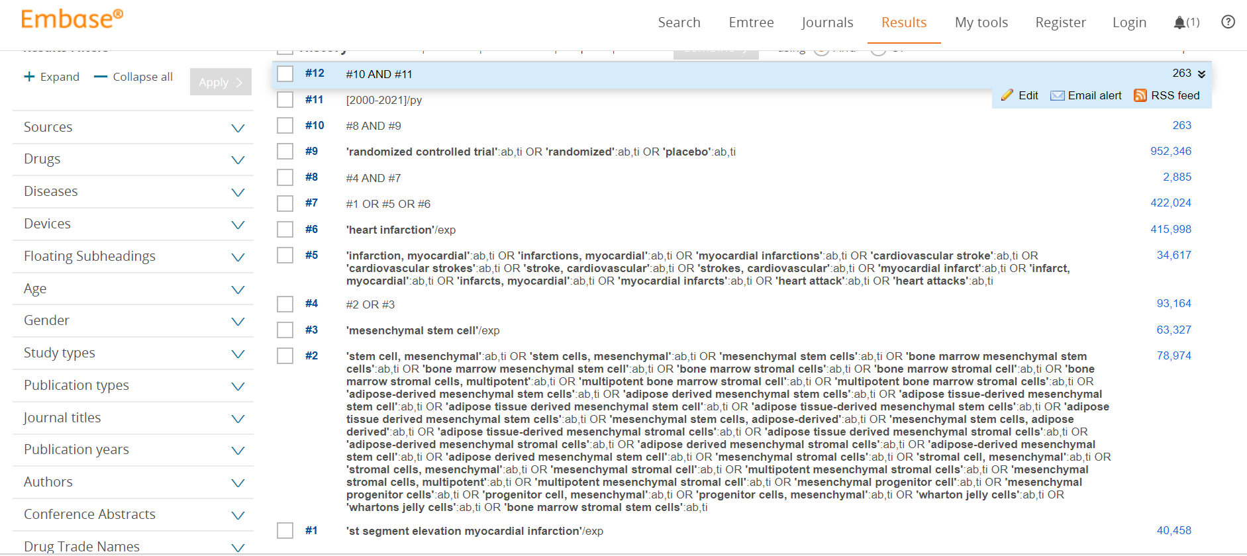
Cohrance library 127
