Genetic ancestry inferred from autosomal and Y chromosome markers and HLA genotypes in Type 1 Diabetes from an admixed Brazilian population.

Rossana Santiago de Sousa Azulay^{1,2}*, Luís Cristóvão Porto³, Dayse Aparecida Silva⁴, Maria da Gloria Tavares^{1,2}, Roberta Dualibe², Gilvan Cortês Nascimento^{1,2}, Sabrina Da Silva Pereira Damianse^{1,2}, Viviane Chaves de Carvalho Rocha^{1,2}, Marcelo Magalhães^{2,5}, Vandilson Rodrigues², Paulo Ricardo Vilas Boas Carvalho³ Manuel dos Santos Faria^{1,2,5}, Marília Brito Gomes⁶

¹Endocrinology Unit, University Hospital of the Federal University of Maranhão (HUUFMA), São Luís, Brazil
²Research Group in Clinical and Molecular Endocrinology and Metabology (ENDOCLIM), São Luís, Brazil
³Histocompatibility and Cryopreservation Laboratory (HLA), Rio de Janeiro State University (UERJ), Rio de Janeiro, Rio de Janeiro, Brazil
⁴DNA Diagnostic Laboratory (LDD), Rio de Janeiro State University (UERJ), Rio de Janeiro, Rio de Janeiro, Brazil
⁵Clinical Research Center of the University Hospital of the Federal University of Maranhão (CEPEC – HUUFMA), São Luís, Brazil
⁶Diabetes Unit, State University of Rio de Janeiro (UERJ), Rio de Janeiro, Brazil

* Corresponding author at: Service of Endocrinology, University Hospital, Federal University of Maranhão (HUUFMA), Rua Barão de Itapary, 227, Centro, 65020-070, São Luís, Maranhão, Brazil. E-mail address: rossanaendocrino@gmail.com

Table 1S. Color/race of family members informed of the Maranhão state T1D and control participants.
Variable | T1D  (n=152) | Control  (n=286) | P value
 | n (%) | n (%)
Reported color-race
Father |  |  | 0.086
White | 42 (27.6) | 84 (29.4)
Black | 18 (11.8) | 57 (19.9)
Brown* | 85 (55.9) | 135 (47.2)
Asian* | 0 (0.0) | 1 (0.3)
Indigenous | 1 (0.7) | 5 (1.8)
Unknown | 6 (3.9) | 4 (1.4)
Mother |  |  | 0.010
White | 44 (28.9) | 98 (34.3)
Black | 13 (8.6) | 45 (15.7)
Brown* | 94 (61.8) | 131 (45.8)
Asian* | 0 (0.0) | 4 (1.4)
Indigenous | 0 (0.0) | 6 (2.1)
Unknown | 1 (0.7) | 2 (0.7)
Maternal grandfather |  |  | 0.183
White | 45 (29.6) | 77 (27.0)
Black | 19 (12.5) | 60 (21.1)
Brown* | 70 (46.1) | 105 (36.8)
Asian* | 0 (0.0) | 1 (0.3)
Indigenous | 1 (0.7) | 3 (1.1)
Unknown | 17 (11.2) | 39 (13.7)
Maternal grandmother |  |  | 0.609
White | 61 (40.1) | 108 (37.8)
Black | 15 (9.9) | 37 (12.9)
Brown* | 60 (39.5) | 107 (37.4)
Asian* | 0 (0.0) | 2 (0.7)
Indigenous | 2 (1.3) | 9 (3.2)
Unknown | 14 (9.2) | 23 (8.0)
Paternal grandfather |  |  | 0.824
White | 43 (28.3) | 80 (28.0)
Black | 21 (13.8) | 51 (17.8)
Brown* | 48 (31.6) | 87 (30.4)
Asian* | 0 (0.0) | 1 (0.3)
Indigenous | 1 (0.7) | 3 (1.1)
Unknown | 39 (25.7) | 64 (22.4)
Paternal grandmother |  |  | 0.192
White | 55 (36.2) | 94 (32.9)
Black | 13 (8.6) | 44 (15.4)
Brown* | 54 (35.5) | 91 (31.8)
Asian* | 0 (0.0) | 2 (0.7)
Indigenous | 1 (0.7) | 7 (2.4)
Unknown | 29 (19.1) | 48 (16.8)
Data are presented as number (percentage). T1D = type 1 diabetes. Bold indicates statistical significance (P < .05).

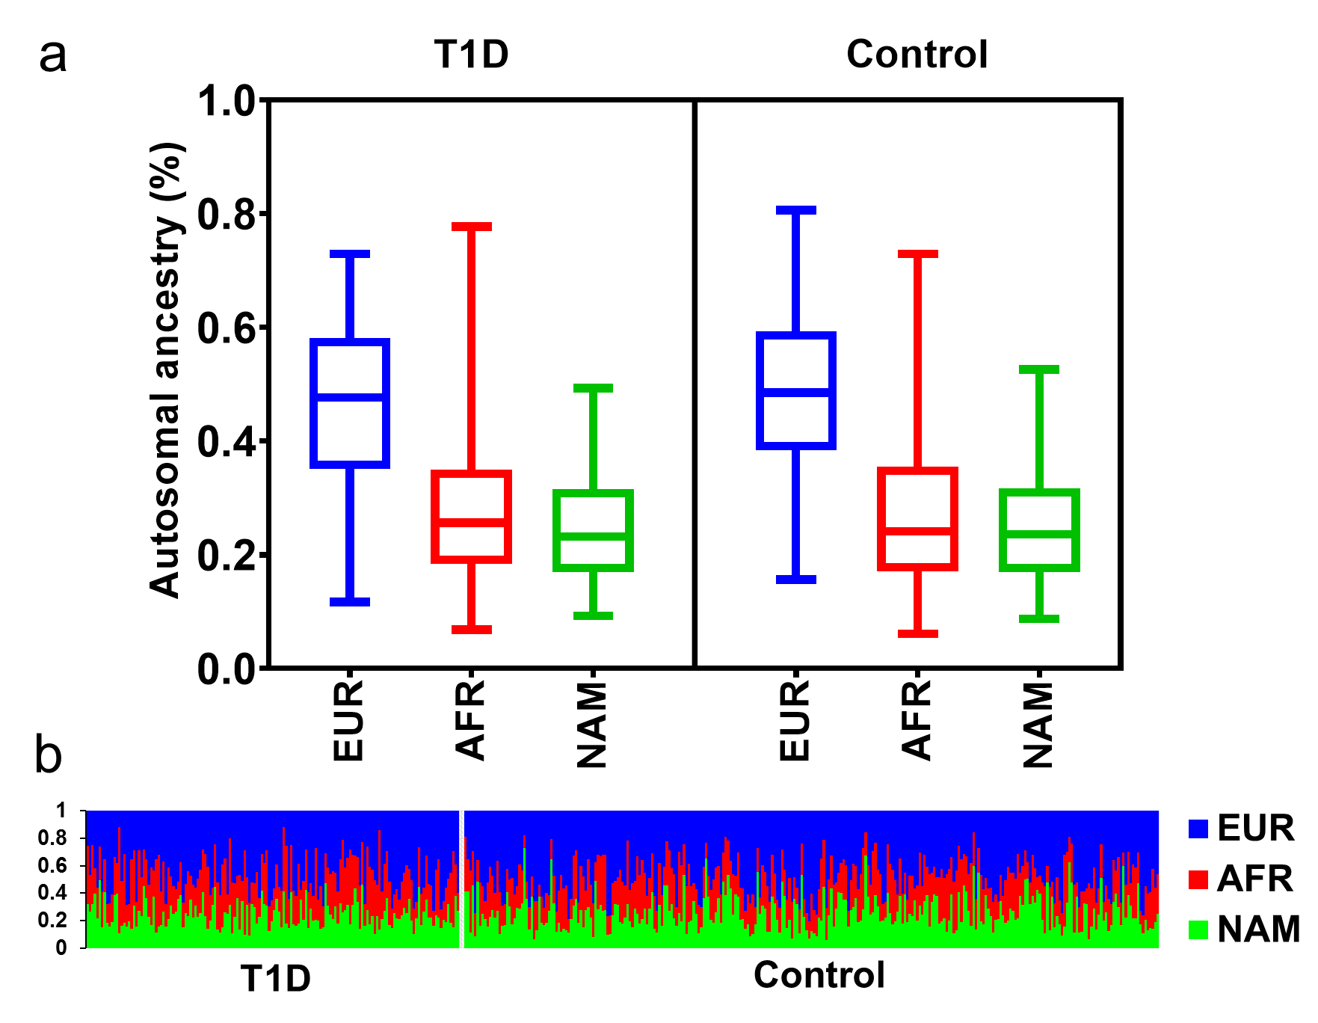
Figure 1S. Box plot (a) and individual (b) proportions of the ancestry estimates for the patients with T1D and control group, using 46 AIM-Indel. EUR = European. AFR =- African. NAM = Native American. Ancestry estimates were obtained using STRUCTURE, for the following options: k = 3; 50 000 burning steps, followed by 50 000 Markov Chain Monte Carlo iterations; Admixture model (Use population Information to test for migrants); and allele frequencies were correlated and updated using only individuals with POPFLAG = 1.

Figure 2S. Box-plot representing autosomal ancestry within self-reported color-race groups in patients with T1D (a) and control group (b). EUR = European. AFR = African. NAM = Native American.

Table 2S. Most frequent (> 5% of frequency) HLA-DRB1, -DQA1 and -DQB1alleles in patients with T1D in the São Luís, Maranhão State, Brazil.
HLA allele | n | %
DRB1*
01 | 22 | 7.24%
03 | 91 | 29.93%
03:01 | 90 | 29.61%
04 | 92 | 30.26%
04:01 | 21 | 6.91%
04:04 | 18 | 5.92%
04:05 | 28 | 9.21%
07:01 | 31 | 10.20%
DQA1*
01:01 | 27 | 8.94%
01:02 | 19 | 6.29%
03:01 | 81 | 26.82%
03:02 | 21 | 6.95%
05:01 | 88 | 29.14%
05:05 | 18 | 5.96%
DQB1*
02:01 | 80 | 26.32%
02:02 | 36 | 11.84%
03:01 | 19 | 6.25%
03:02 | 99 | 32.57%
05:01 | 29 | 9.54%
Bold indicates the most prevalent HLA alleles. T1D = type 1 diabetes.

Table 3S. HLA-DRB1/DRB1 genotypes distribution in patients with T1D in the São Luís, Maranhão State, Brazil (> 1% of frequency).
HLA-DRB1/DRB1 genotype | n | %
DRB1*01/DRB1*10 | 2 | 1.32%
DRB1*01/DRB1*13 | 2 | 1.32%
DRB1*01/DRB1*03 | 5 | 3.29%
DRB1*01/DRB1*04 | 6 | 3.95%
DRB1*03/DRB1*03 | 13 | 8.55%
DRB1*03/DRB1*04 | 40 | 26.32%
DRB1*03/DRB1*07 | 8 | 5.27%
DRB1*03/DRB1*09 | 2 | 1.32%
DRB1*03/DRB1*11 | 2 | 1.32%
DRB1*03/DRB1*13 | 4 | 2.63%
DRB1*03/DRB1*16 | 2 | 1.32%
DRB1*04/DRB1*04 | 9 | 5.92%
DRB1*04/DRB1*07 | 9 | 5.92%
DRB1*04/DRB1*08 | 7 | 4.61%
DRB1*04/DRB1*09 | 3 | 1.97%
DRB1*04/DRB1*10 | 2 | 1.32%
DRB1*04/DRB1*11 | 2 | 1.32%
DRB1*04/DRB1*13 | 4 | 2.63%
DRB1*07/DRB1*07 | 2 | 1.32%
DRB1*07/DRB1*13 | 2 | 1.32%
DRB1*07/DRB1*15 | 2 | 1.32%
Bold indicates the most prevalent HLA-DRB1 genotypes. T1D = type 1 diabetes.

Table 4S. Frequencies of HLA genotypes in patients with T1D in the São Luís, Maranhão State, Brazil (> 1% of frequency).
Genotype  DRB1~DQA1~DQB1 DRB1~DQA1~DQB1 | n | %
01:01~01:01~02:01 03:01~05:01~05:01 | 2 | 1.32%
01:01~01:01~03:02 04:05~03:01~05:01 | 3 | 1.97%
01:02~01:01~02:01 03:01~05:01~05:01 | 3 | 1.97%
01:02~01:01~05:01 10:01~01:01~05:01 | 2 | 1.32%
03:01~02:01~02:01 07:01~05:01~02:02 | 8 | 5.26%
03:01~03:01~02:01 04:01~05:01~03:02 | 6 | 3.95%
03:01~03:01~02:01 04:02~05:01~03:02 | 7 | 4.61%
03:01~03:01~02:01 04:04~05:01~03:02 | 7 | 4.61%
03:01~03:01~03:02 04:04~05:01~03:02 | 3 | 1.97%
03:01~03:02~02:01 04:05~05:01~03:02 | 9 | 5.92%
03:01~03:02~03:02 04:05~05:01~03:02 | 2 | 1.32%
03:01~05:01~02:01 03:01~05:01~02:01 | 11 | 7.24%
04:01~03:01~03:02 04:05~03:01~03:02 | 3 | 1.97%
04:01~03:01~03:02 08:07~04:01~04:02 | 3 | 1.97%
04:04~02:01~02:02 07:01~03:01~03:02 | 2 | 1.32%
04:05~02:01~02:02 07:01~03:01~03:02 | 3 | 1.97%
04:07~01:01~03:02 10:01~03:01~05:01 | 2 | 1.32%
07:01~01:02~02:02 15:03~02:01~06:02 | 2 | 1.32%
07:01~02:01~02:02 09:01~03:01~02:02 | 2 | 1.32%
Bold indicates the most prevalent categories.

Figure 3S. Distribution of the HLA-DRB1 (a) and HLA-DQA1 (b)alleles in patients with T1D in the São Luís, Maranhão State according to self-reported color/race.

Table 5S. Allelic frequency distribution of the HLA-DRB1 in individuals with type 1 diabetes and control/BMD.
HLA alleles | T1D | Control/REDOME | OR [95% CI] | P value
 | n (%) | n (%)
DRB1*
01 | 22 (7.24) | 117 (9.44) | 0.74 [0.46–1.20] | 0.230
03 | 91 (29.93) | 94 (7.58) | 5.20 [3.77–7.19] | <0.001*
04 | 92 (30.26) | 165 (13.31) | 2.82 [2.10–3.79] | <0.001*
07 | 31 (10.2) | 167 (13.47) | 0.72 [0.48–1.09] | 0.126
08 | 13 (4.28) | 98 (7.90) | 0.52 [0.28–0.94] | 0.028*
09 | 8 (2.63) | 32 (2.58) | 1.02 [0.46–2.23] | 1.000
10 | 4 (1.32) | 27 (2.18) | 0.59 [0.20–1.72] | 0.337
11 | 9 (2.96) | 132 (10.65) | 0.25 [0.12–0.50] | <0.001*
12 | 1 (0.33) | 8 (0.65) | 0.50 [0.06–4.07] | 1.000
13 | 14 (4.61) | 173 (13.95) | 0.29 [0.17–0.52] | <0.001*
14 | 2 (0.66) | 56 (4.52) | 0.14 [0.03–0.57] | 0.001*
15 | 5 (1.64) | 101 (8.15) | 0.18 [0.07–0.46] | <0.001*
16 | 12 (3.95) | 70 (5.65) | 0.68 [0.36–1.28] | 0.236
DQA1*
01:01 | 27 (8.94) | 169 (13.63) | 0.61 [0.40-0.94] | 0.024*
01:02 | 19 (6.29) | 188 (15.16) | 0.37 [0.22-0.60] | <0.001*
01:03 | 5 (1.66) | 82 (6.61) | 0.23 [0.09-0.58] | <0.001*
02:01 | 30 (9.93) | 169 (13.63) | 0.69 [0.46-1.04] | 0.079
03:01 | 81 (26.82) | 209 (16.85) | 1.79 [1.33-2.40] | <0.001*
03:02 | 21 (6.95) | 0 (0) | - | <0.001*
04:01 | 10 (3.31) | 98 (7.90) | 0.39 [0.20-0.76] | 0.004*
04:02 | 0 (0) | 1 (0.08) | - | 1.000
05:01 | 88 (29.14) | 322 (25.97) | 1.16 [0.87-1.53] | 0.292
05:03 | 2 (0.66) | 0 (0) | - | 0.038*
05:05 | 18 (5.96) | 0 (0) | - | <0.001*
05:10 | 0 (0) | 1 (0.8) | - | 1.000
06:01 | 1 (0.33) | 1 (0.8) | 4.08 [0.25-65.65] | 0.355
DQB1*
02:01 | 80 (26.32) | 83 (6.69) | 4.97 [3.54-6.98] | <0.001*
02:02 | 36 (11.84) | 157 (12.66) | 0.92 [0.62-1.36] | 0.698
03:01 | 19 (6.25) | 255 (20.56) | 0.25 [0.15-0.41] | <0.001*
03:02 | 99 (32.57) | 134 (10.81) | 3.98 [2.95-5.37] | <0.001*
03:03 | 5 (1.64) | 57 (4.60) | 0.34 [0.13-0.87] | 0.018*
03:04 | 0 (0) | 2 (0.16) | - | 1.000
03:19 | 3 (0.99) | 0 (0) | - | 0.007*
04:01 | 0 (0) | 1 (0.08) | - | 1.000
04:02 | 12 (3.95) | 112 (9.03) | 0.41 [0.22-0.76] | 0.003*
05:01 | 29 (9.54) | 161 (12.98) | 0.70 [0.46-1.07] | 0.001*
05:02 | 3 (0.99) | 17 (1.37) | 0.71 [0.20-2.46] | 0.780
05:03 | 0 (0) | 21 (1.69) | - | 0.022*
06:01 | 0 (0) | 4 (0.32) | - | 1.000
06:02 | 6 (1.97) | 109 (8.79) | 0.20 [0.09-0.47] | <0.001*
06:03 | 5 (1.64) | 78 (6.29) | 0.24 [0.10-0.62] | 0.001*
06:04 | 6 (1.97) | 29 (2.34) | 0.84 [0.34-2.04] | 0.698
06:09 | 1 (0.33) | 17 (1.37) | 0.23 [0.03-1.79] | 0.227
06:11 | 0 (0) | 2 (0.16) | - | 1.000
06:38 | 0 (0) | 1 (0.08) | - | 1.000
OR = Odds ratio. 95% CI = 95% confidence interval. * Statistically significant difference (P < .05). Control/REDOME = Samples from REDOME database.

Table 6S. Allelic frequency distribution of the HLA-DRB1, -DQA1 and -DQB1 in individuals with T1D according to Y chromosome ancestry.
HLA Alleles | Y chromosome ancestry |  |  | P value
 | EUR  (n = 134) | AFR  (n = 14) | NAM  (n = 10) | EUR versus AFR | EUR versus NAM | AFR versus NAM
 | n (%) | n (%) | n (%)
DRB1* |  |  |  | 0.785 | <0.001* | 0.525
01 | 6 (4.5) | 2 (14.4) | 3 (30.0)
03 | 36 (26.9) | 4 (28.6) | 2 (20.0)
04 | 47 (35.1) | 4 (28.6) | 1 (10.0)
07 | 14 (10.4) | 1 (7.1) | 0 (0)
08 | 9 (6.7) | 0 (0) | 0 (0)
13 | 7 (5.2) | 1 (7.1) | 0 (0)
16 | 5 (3.7) | 1 (7.1) | 3 (30.0)
Other | 10 (7.5) | 1 (7.1) | 1 (10.0)
DQA1* |  |  |  | 0.277 | 0.108 | 0.499
01:01 | 8 (6.1) | 2 (14.3) | 3 (30.0)
01:02 | 10 (7.6) | 1 (7.1) | 2 (20.0)
01:03 | 3 (2.3) | 0 (0) | 0 (0)
02:01 | 12 (9.1) | 1 (7.1) | 0 (0)
03:01 | 42 (31.8) | 2 (14.3) | 1 (10.0)
03:02 | 5 (3.8) | 3 (21.4) | 0 (0)
04:01 | 6 (4.5) | 0 (0) | 0 (0)
05:01 | 35 (26.5) | 4 (28.6) | 2 (20.0)
05:03 | 2 (1.5) | 0 (0) | 0 (0.0)
05:05 | 9 (6.8) | 1 (7.1) | 2 (20.0)
DQB1* |  |  |  | 0.963 | 0.086 | 0.374
02:01 | 31 (23.1) | 4 (28.6) | 2 (20.0)
02:02 | 12 (9.0) | 2 (14.3) | 0 (0)
03:01 | 12 (9.0) | 1 (7.1) | 2 (20.0)
03:02 | 49 (36.6) | 4 (28.6) | 1 (10.0)
03:03 | 1 (0.7) | 0 (0) | 0 (0)
03:19 | 2 (1.5) | 0 (0) | 0 (0)
04:02 | 7 (5.2) | 0 (0) | 0 (0)
05:01 | 9 (6.7) | 2 (14.3) | 3 (30.0)
05:02 | 2 (1.5) | 0 (0) | 1 (10.0)
06:02 | 3 (2.2) | 0 (0) | 0 (0)
06:03 | 2 (1.5) | 0 (0) | 1 (10.0)
06:04 | 4 (3.0) | 1 (7.1) | 0 (0)
EUR = European Y chromosome. AFR = African Y chromosome. NAM = Native American Y chromosome. Other = DRB1* 09, 10, 11, 14, 15. * Statistically significant difference (P < 0.05).

Table 7S. Distribution of the DRB1* alleles in individuals with T1D according to Y chromosome haplogroup.
HLA | Y chromosome haplogroup
 | E1b1a |  | E1b1b |  | G2a |  | I2a |  | Q |  | R1b |  | Other
 | n | % | n | % | n | % | n | % | n | % | n | % | n | %
DRB1*01 | 2 | 18.2 | 0 | 0 | 0 | 0 | 1 | 9.1 | 3 | 27.3 | 2 | 18.2 | 3 | 27.3
DRB1*03 | 4 | 9.5 | 10 | 23.8 | 4 | 9.5 | 6 | 14.3 | 2 | 4.8 | 10 | 23.8 | 6 | 14.3
DRB1*04 | 3 | 5.8 | 9 | 17.3 | 3 | 5.8 | 1 | 1.9 | 1 | 1.9 | 26 | 50.0 | 9 | 17.3
DRB1*07 | 1 | 6.7 | 2 | 13.3 | 1 | 6.7 | 1 | 6.7 | 0 | 0 | 9 | 60.0 | 1 | 6.7
DRB1*08 | 0 | 0 | 1 | 11.1 | 1 | 11.1 | 1 | 11.1 | 0 | 0 | 3 | 33.3 | 3 | 33.3
DRB1*09 | 0 | 0 | 0 | 0 | 0 | 0 | 0 | 0 | 0 | 0 | 0 | 0 | 1 | 100
DRB1*10 | 0 | 0 | 1 | 100 | 0 | 0 | 0 | 0 | 0 | 0 | 0 | 0 | 0 | 0
DRB1*11 | 0 | 0 | 1 | 16.7 | 1 | 16.7 | 0 | 0 | 1 | 16.7 | 1 | 16.7 | 2 | 33.2
DRB1*13 | 1 | 12.5 | 2 | 25.0 | 0 | 0 | 0 | 0 | 0 | 0 | 4 | 50.0 | 1 | 12.5
DRB1*14 | 0 | 0 | 0 | 0 | 0 | 0 | 0 | 0 | 0 | 0 | 2 | 100 | 0 | 0
DRB1*15 | 0 | 0 | 1 | 50.0 | 0 | 0 | 0 | 0 | 0 | 0 | 1 | 50.0 | 0 | 0
DRB1*16 | 1 | 11.1 | 1 | 11.1 | 0 | 0 | 0 | 0 | 3 | 33.3 | 4 | 44.4 | 0 | 0
Other = Frequency less than 5 (T, E1a, I1, I2b, J1, J2a, J2b, N, R1a). Bold indicates Y haplogroup most frequent according to HLA-DRB1. Chi-square test (P=0.326)

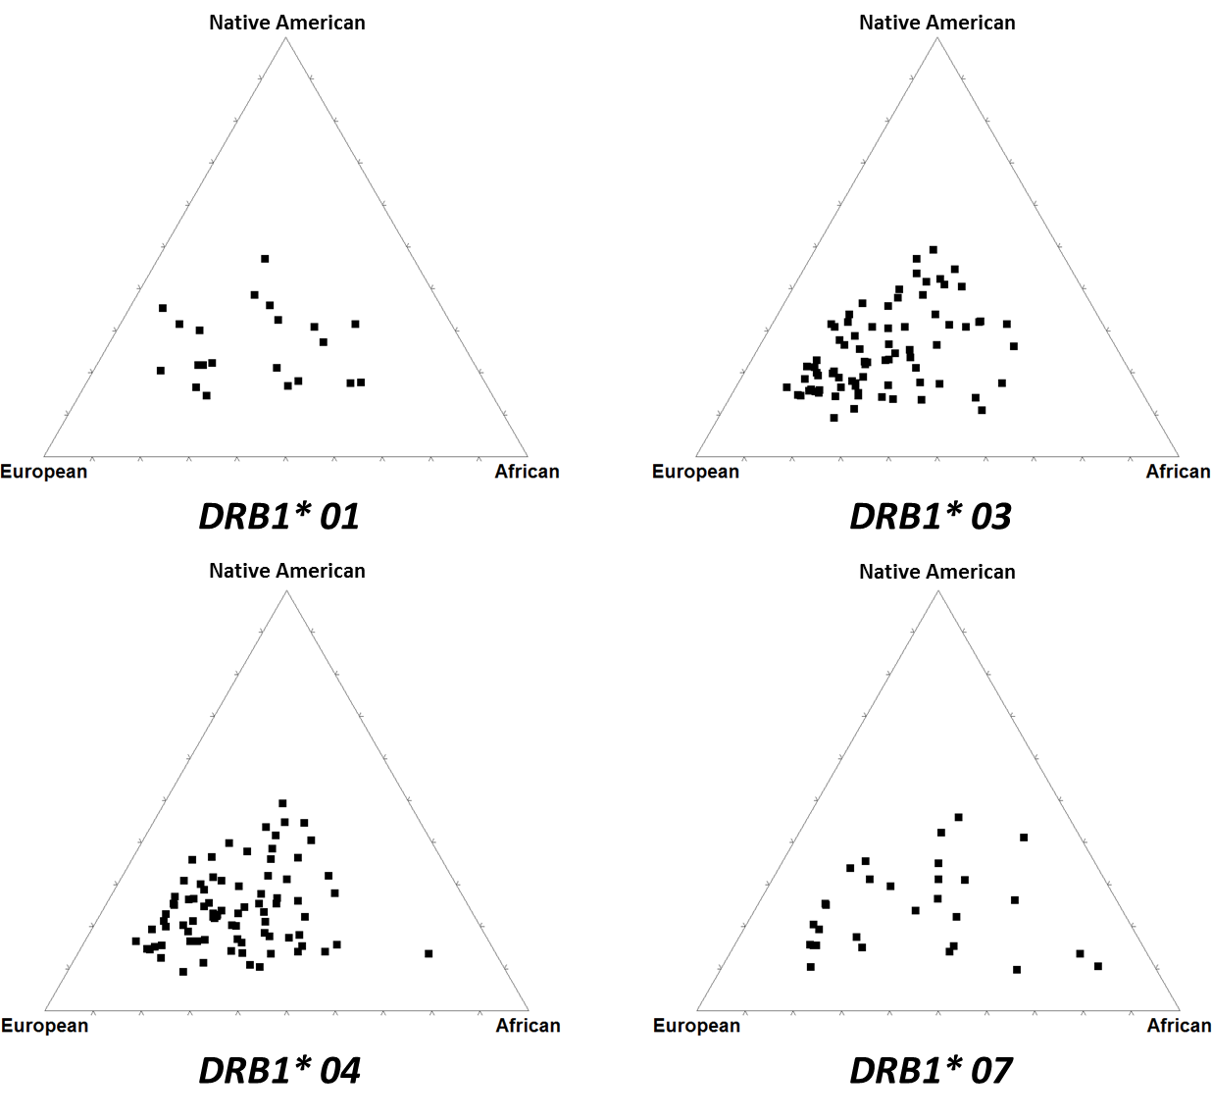
Figure 4aS. Triangle plot of autosomal ancestry according to DRB1 alelles.
African (p = 0.078), Native American (p = 0.692), European (p = 0.215)

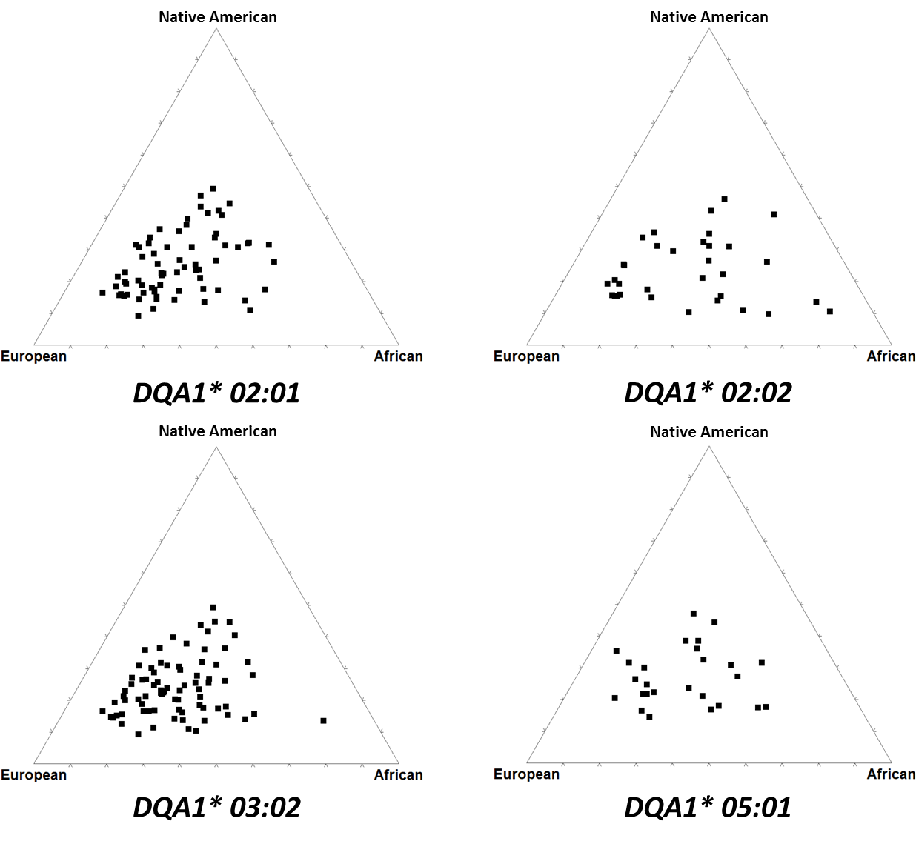
Figure 4bS. Triangle plot of autosomal ancestry according to DQA1 group.
African (p = 0.025), Native American (p = 0.286), European (p = 0.062)

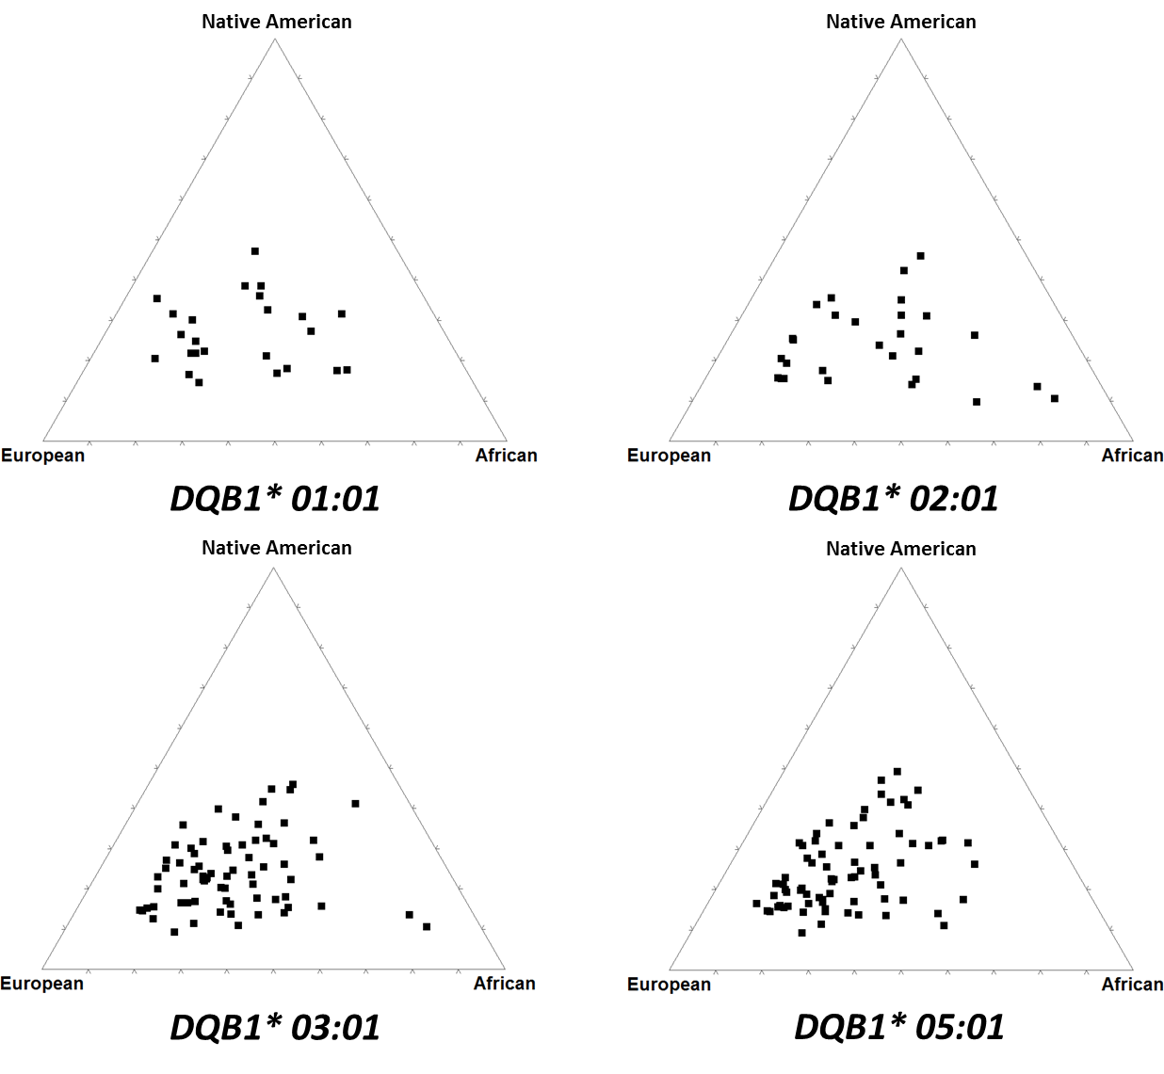
Figure 4cS. Triangle plot of autosomal ancestry according to DQB1 group.
African (p= 0.066), Native American (p = 0.617), European (p = 0.149)

