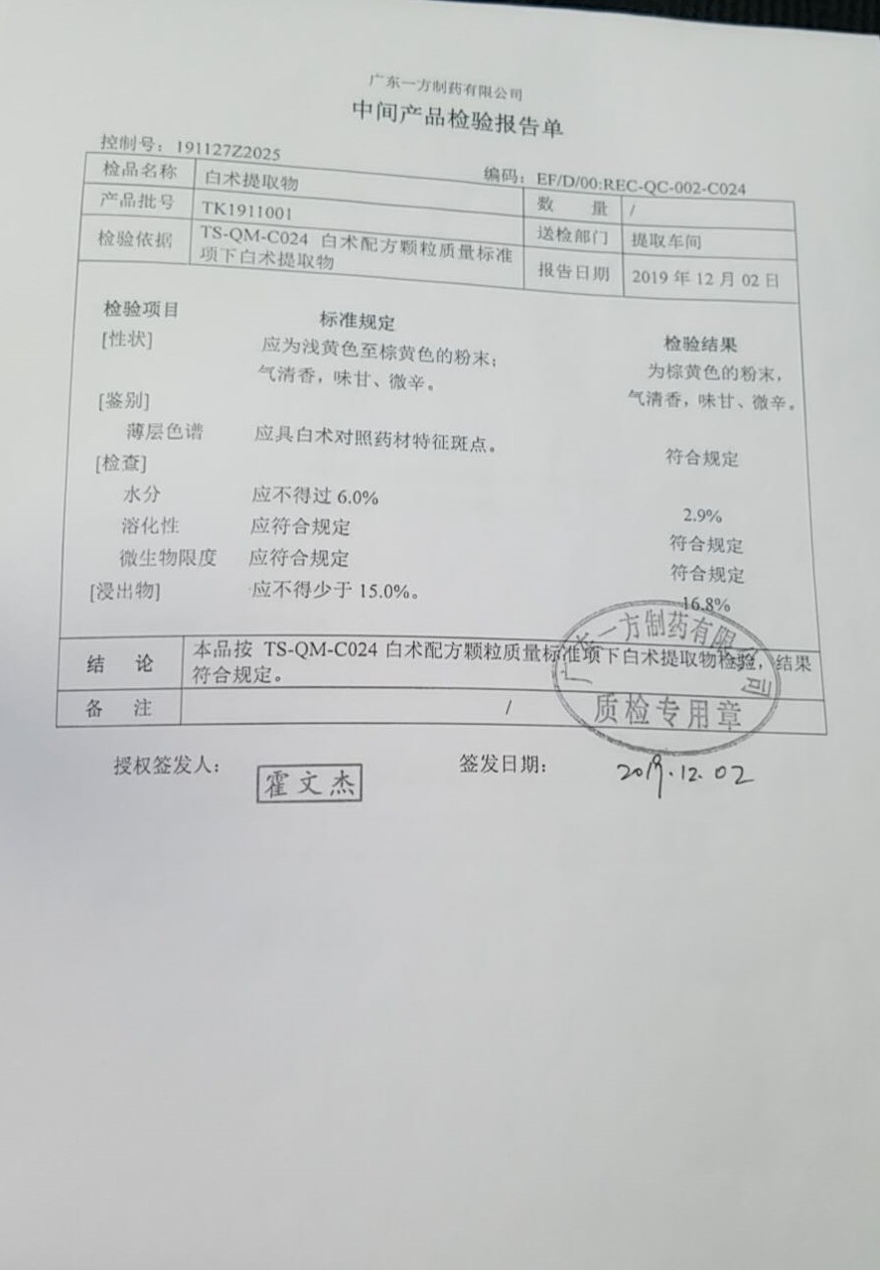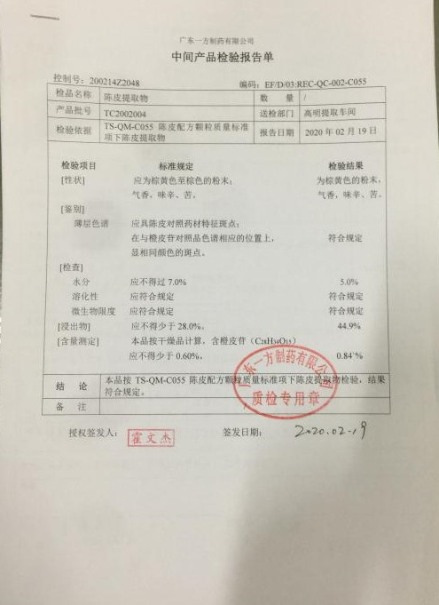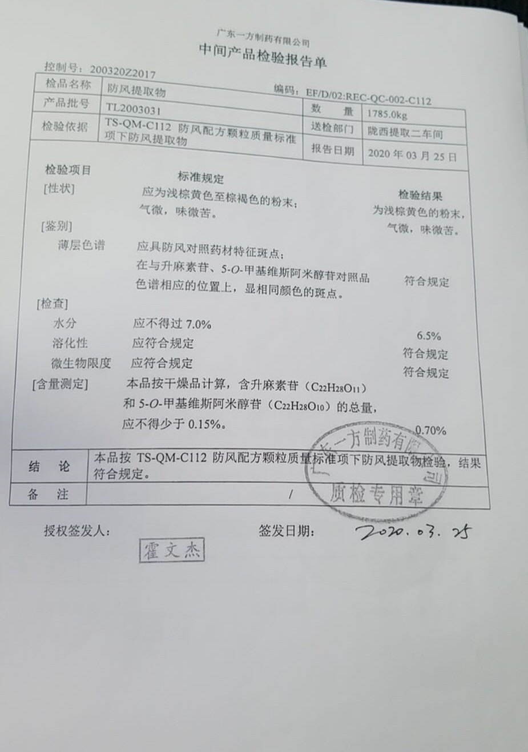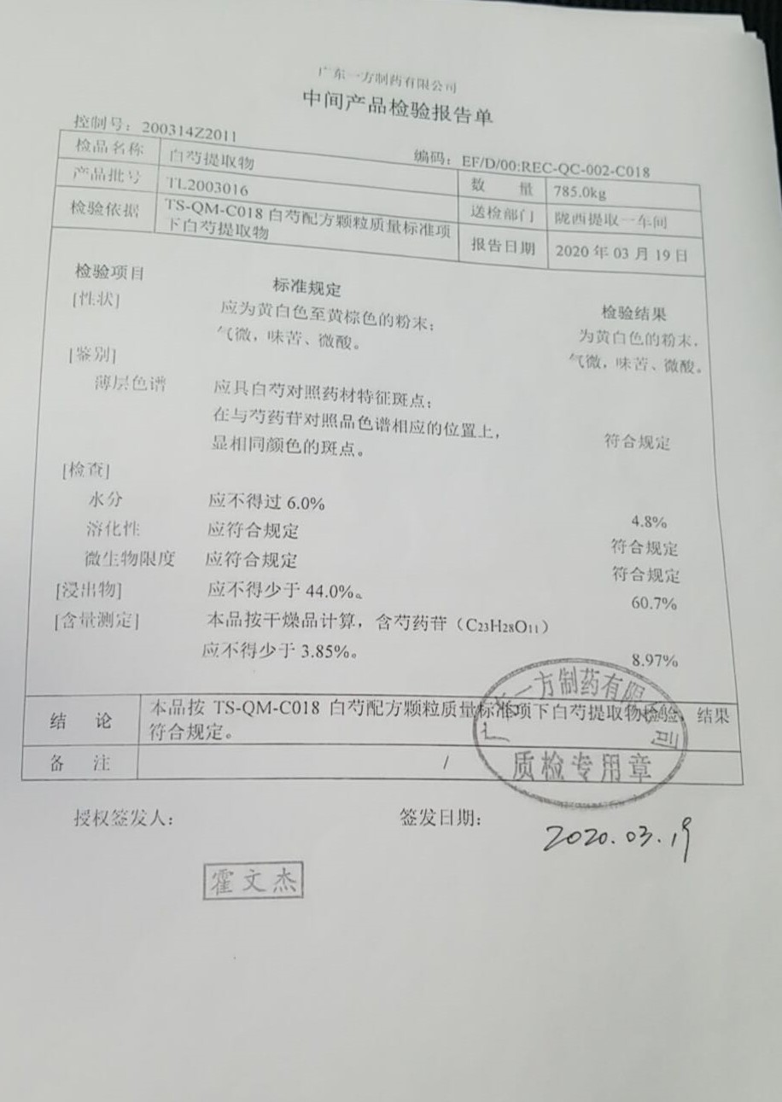

**Rhizoma Atractylodis Macrocephalae extract**

**Citri Reticulatae Pericarpium extract**

**Saposhnikoviae Radix extract**

**Paeoniae Radix Alba etract**