Supporting Information

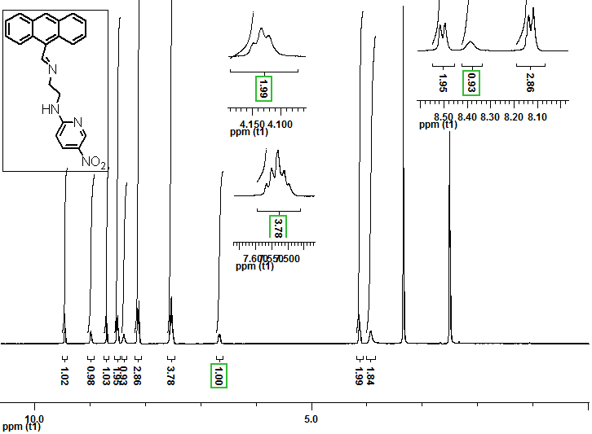

Figure S1. ¹H-NMR spectrum of 9-[(5-nitropyridin-2-aminoethyl)iminiomethyl]-anthracene.

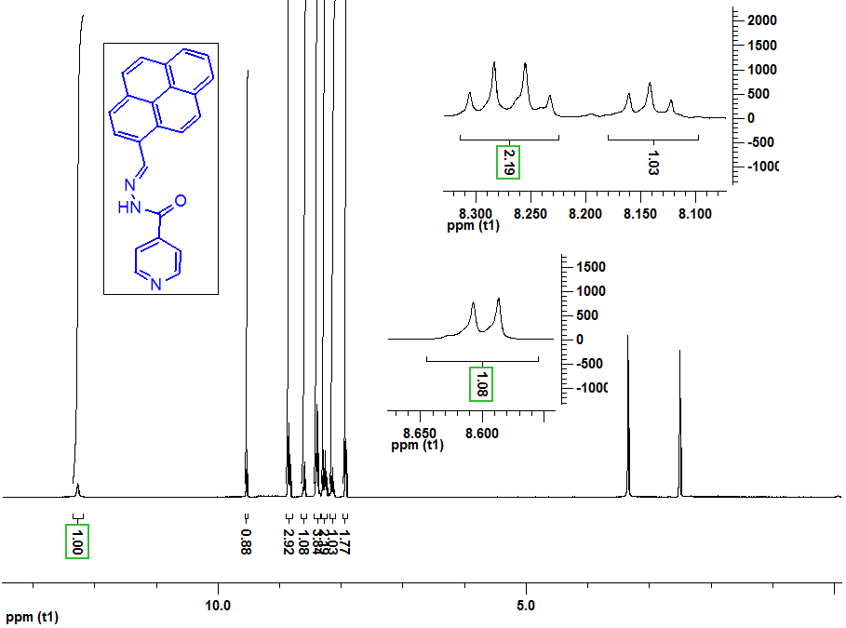
Figure S2. ¹H-NMR spectrum of 9-[(5-nitropyridin-2-aminoethyl)iminiomethyl]-anthracene

