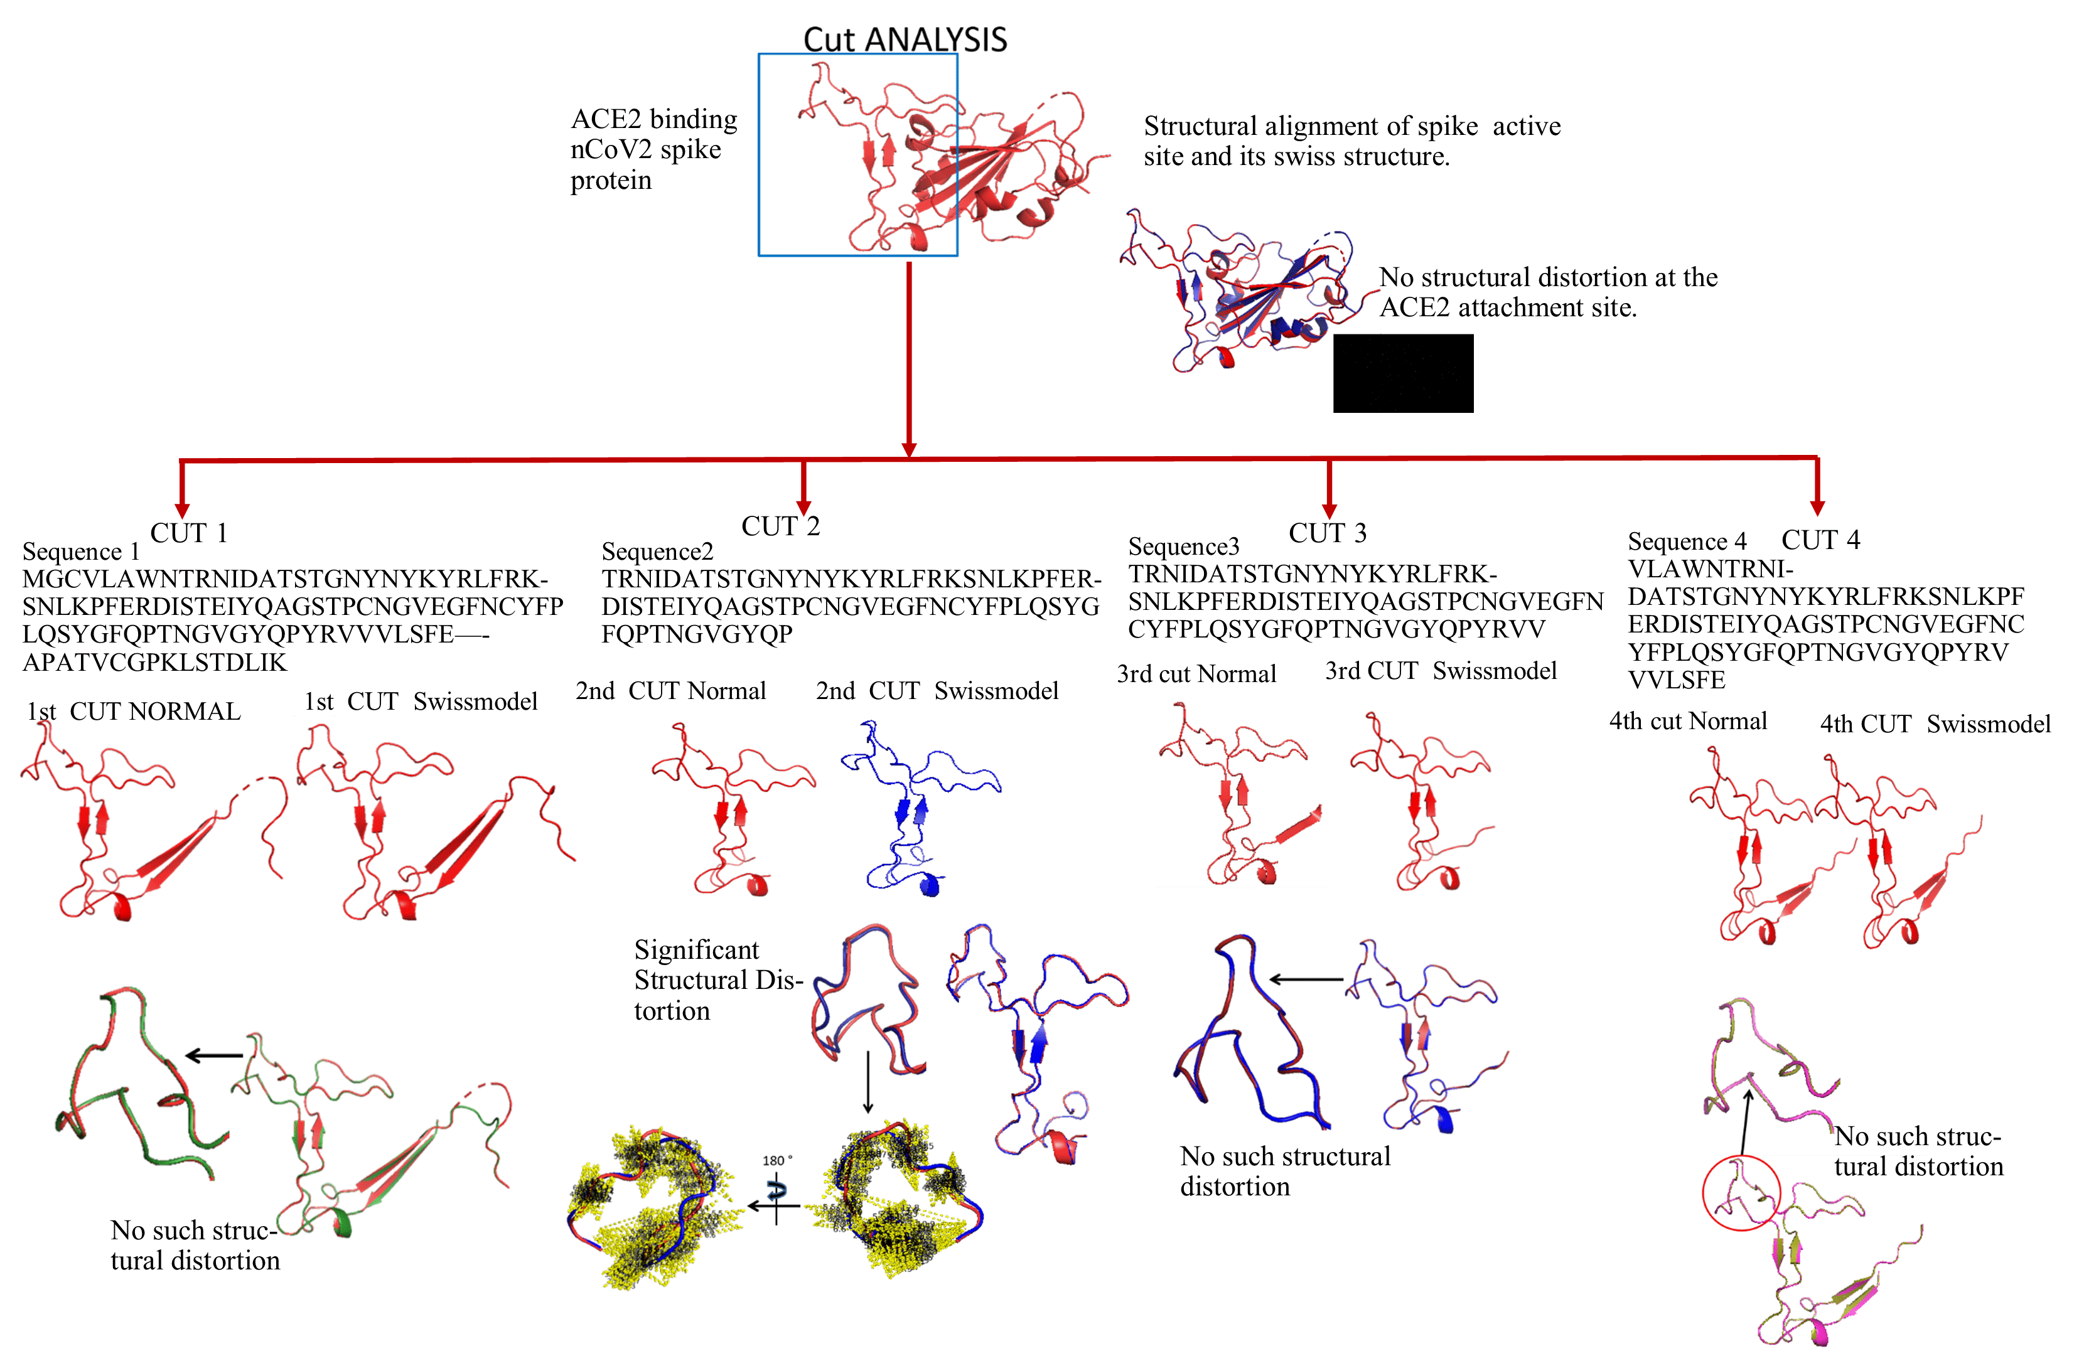
S Figure 1: Different Cut site analysis of SARS COV-2 spike glycoprotein
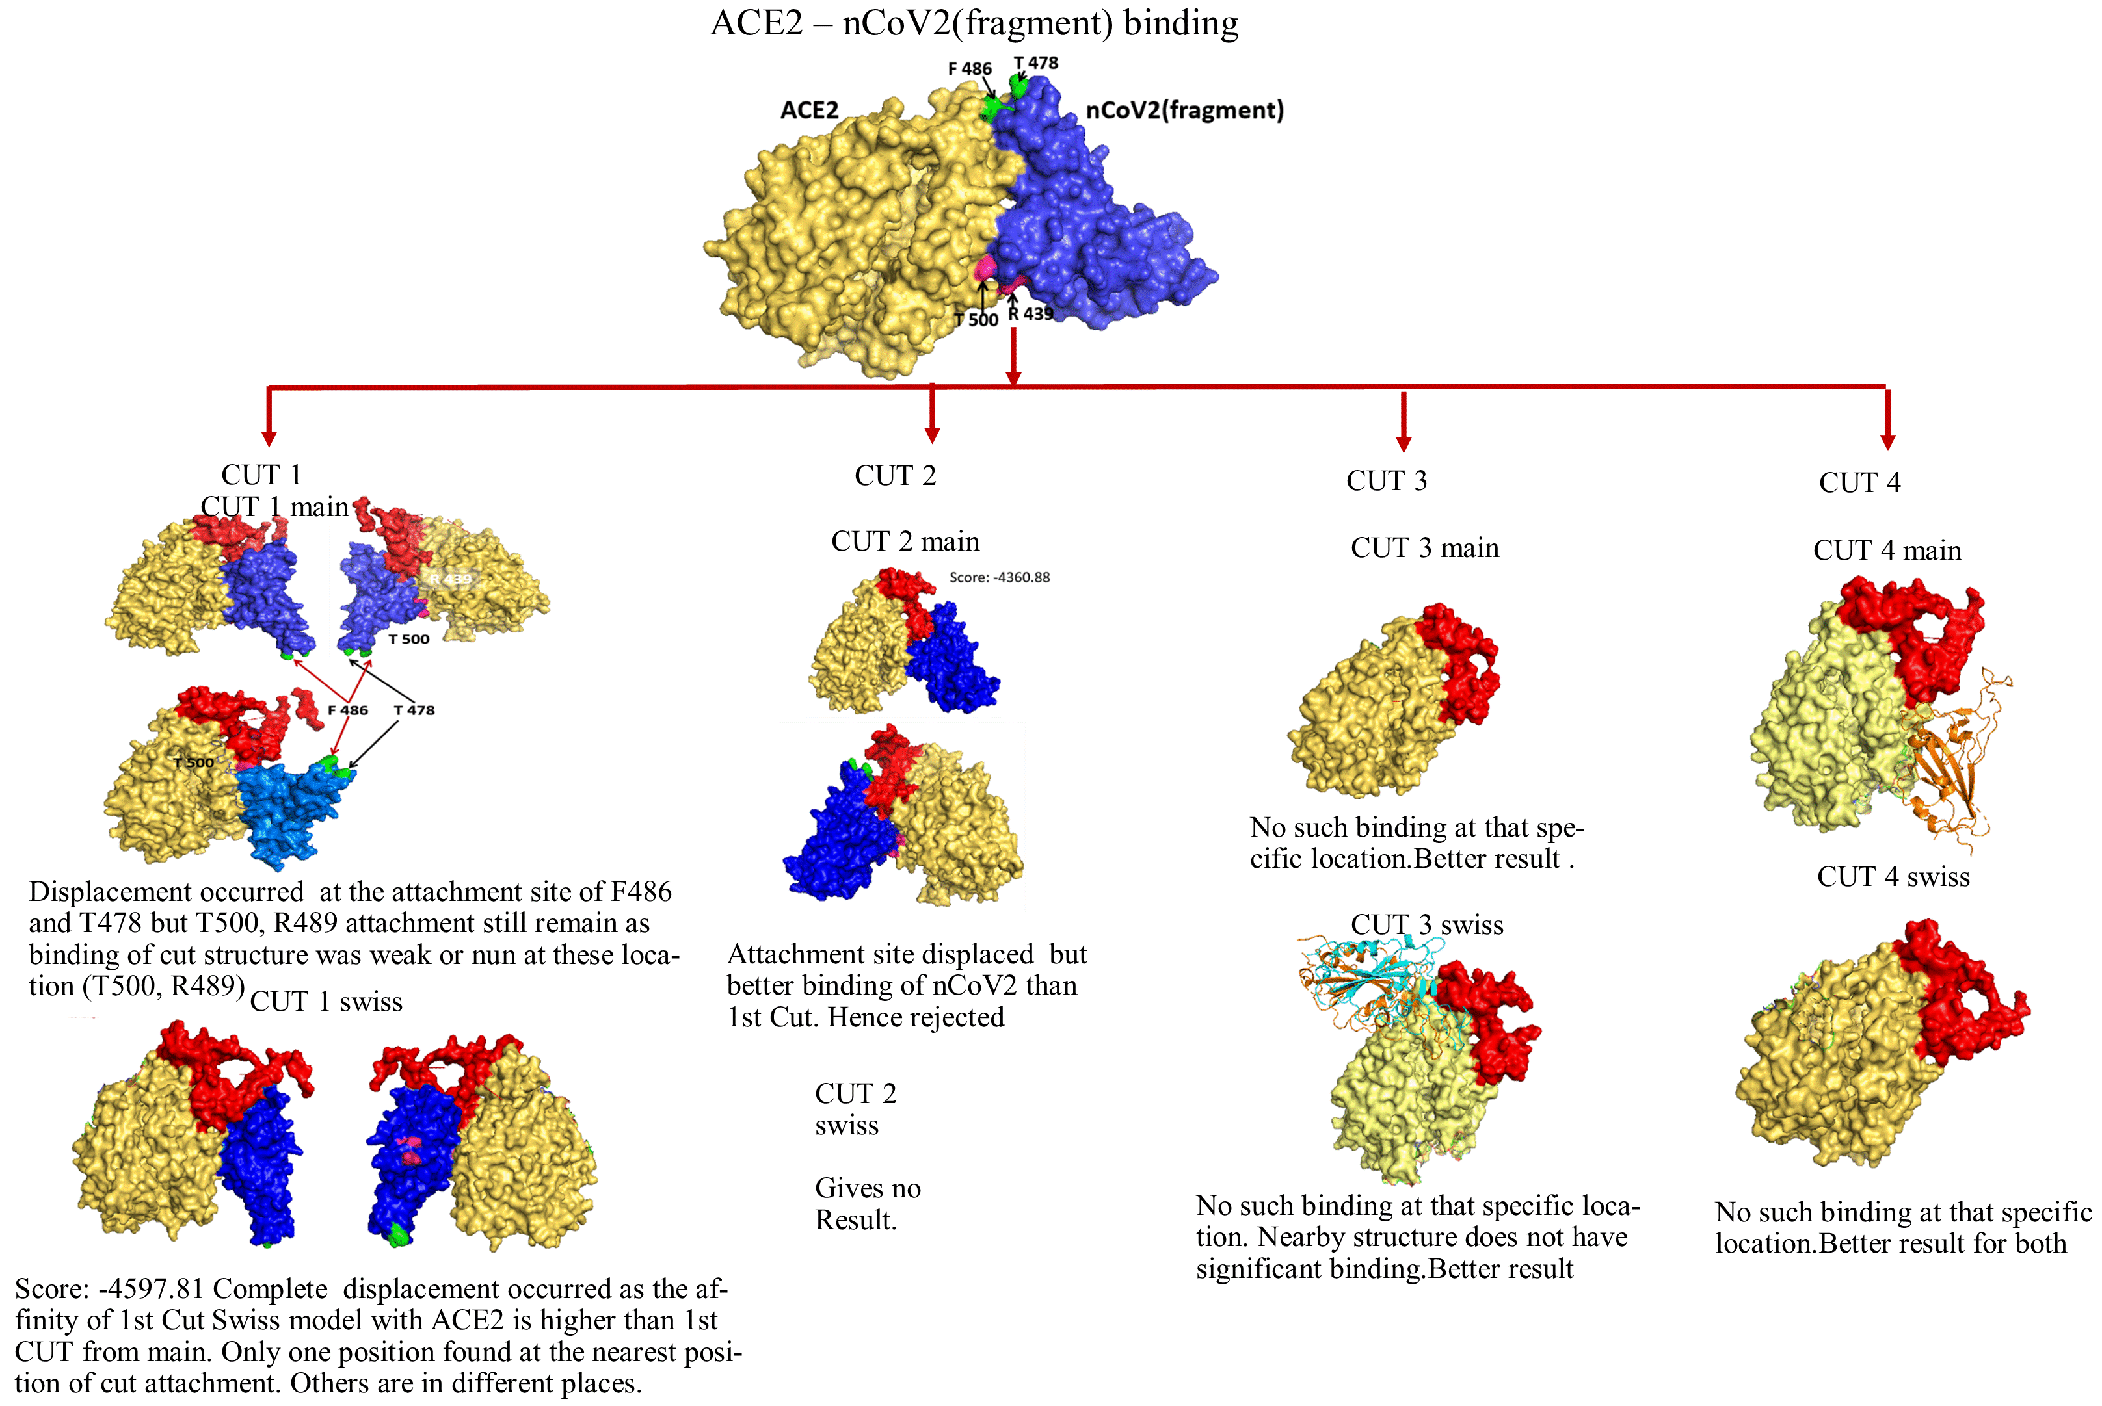
Figure 2: Binding interaction site analysis between Cut 1,2,3,4 and ACE Receptor .
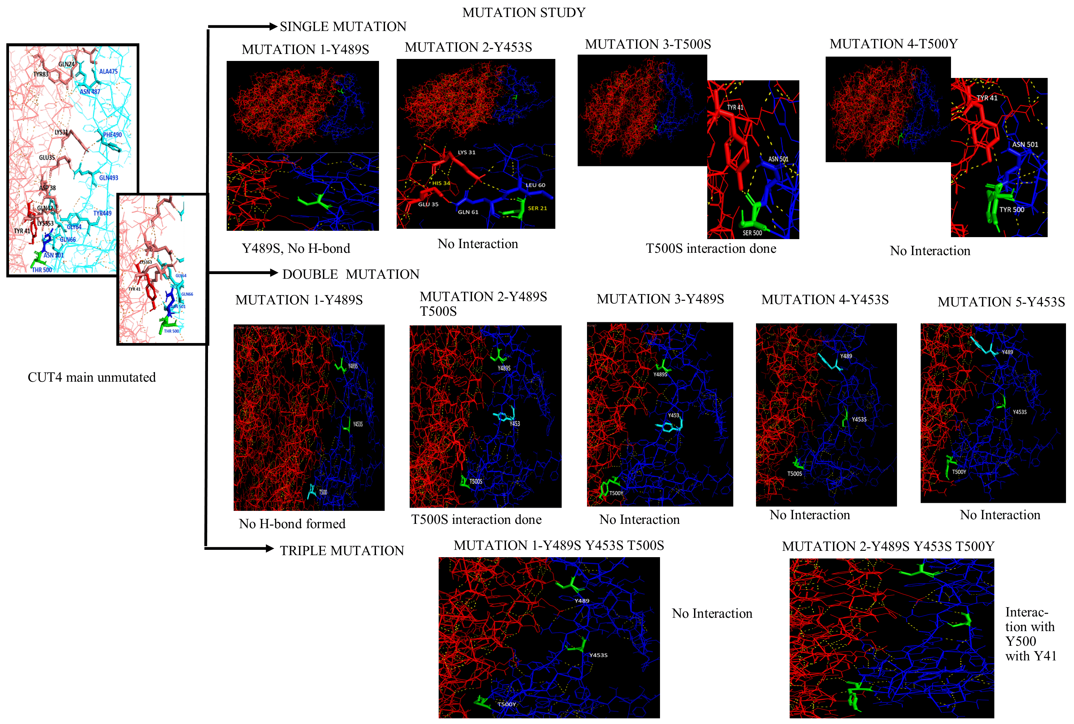
S Figure 3: Depicts the binding sites for Cut 4 Main unmutated with ACE 2 receptor and the resultant interaction in the case of Single Mutation, Double Mutation and Triple mutation induced in Cut 4 with the same.

