Sheet1: TaClpS1 lacking the chloroplast transit peptide in the system of N. benthamiana and P.parasitica.
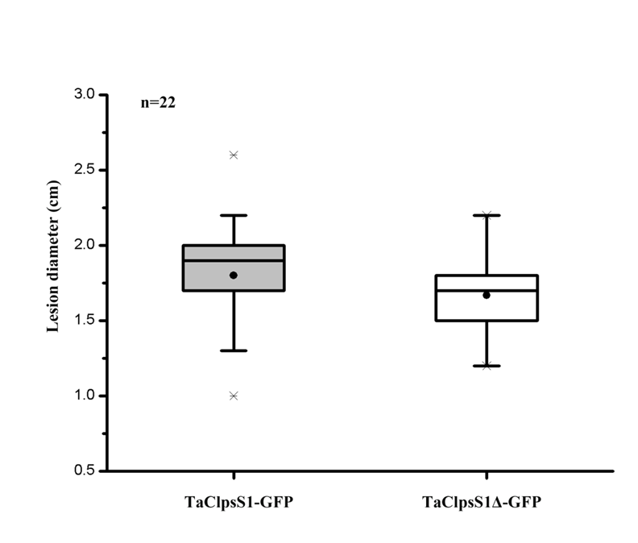
Sheet 2: The expression of TaClpS1H in TaClpS1 silenced plants under 0h (control treatment) and at Pst infection 24 hpi.

Sheet 3: qRT-PCR raw data of PR1 and PR2 at 24hpi.
sampel | ct data | ct data
 | EF | Pr1
r-24h | 20.41333333 | 27.66
r-24h | 20.33 | 27.87333
r-24 | 20.73666667 | 27.50333
1as-24h | 20.14666667 | 26.16
1as-24h | 20.21666667 | 26.59667
1as-24 | 20.69 | 26.11333
2as-24h | 19.76 | 24.84
2as-24h | 19.73 | 25.27667
2as-24 | 20.01666667 | 24.82333
sampel | ct data | ct data
 | EF | Pr2
r-24 | 20.50333 | 25.00333
r-24 | 20.39667 | 24.85
r-24 | 20.24333 | 24.86
1as-24 | 20.58667 | 22.57
1as-24 | 20.5 | 22.55
1as-24 | 20.52667 | 22.49333
2as-24 | 19.89667 | 21.85
2as-24 | 19.81667 | 21.82333
2as-24 | 19.82667 | 21.83333
the p-value between Pr1 and Pr2: 0.088097156.

