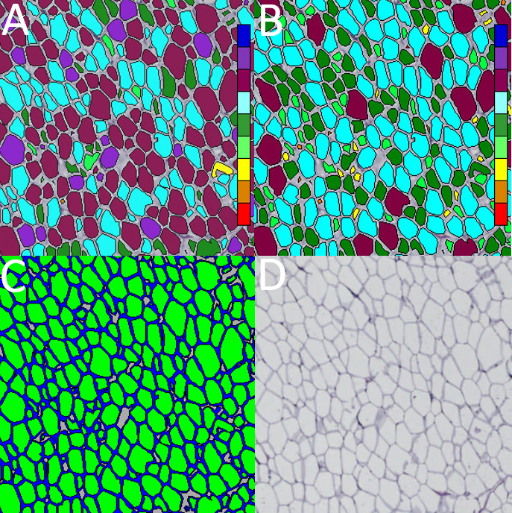

Figure S1 Iron hematoxylin, Adipose Tissue App (Visiopharm® software with application (APP) name; Iron Haematoxylin, Adipose Tissue (APP ID 10113), version 1.0. (A) Adipose cells classified based on Form Factor (Classes range from a Form Factor value of 0 (red) to 1 (dark blue), as indicated by the color bar, (B) Adipose cells classified based on Area (Classes range from an Area of 60 um² (red) to 36000 um² (dark blue), as indicated by the color bar, (C) Membrane and cell detected by the APP “02 Quantify Fat Cell Membranes”and (D) Adipose tissue staining.

All three protocols consist of a threshold segmentation of membrane, extracellular matrix (ECM), and adipose cell area. The cell area is divided into reasonable sized cells based on the segmented membrane. Cell areas larger than 36000 µm² are excluded. The three protocols utilize the resulting cells and membranes to calculate different outputs. The first protocol calculates the membrane-to-cell ratio. The other two protocols classify the adipose cells into nine classes based on size and shape, respectively. The size-measure is area and the shape-measure is Form Factor. Form factor is a measure of the circularity of the object, ranging from 0, being a line, to 1, being a perfect circle (see VIS Help Manual for more information). The adipose cells are quantified by size and shape individually. The three protocols must be run separately.
The output variables obtained from these protocols are:
Protocol 1 (overall tissue composition): Percentages of a) Cell area, b) Membrane area, c) Undefined area
Protocol 2 (adipocyte size): Percentages of adipocytes within size ranges: a) smaller than 200 µm², b) from 200 µm² and smaller than 400 µm², c) from 400 µm² and smaller than 800 µm², d) from 800 µm² and smaller than 1600 µm², e) from 1600 µm² and smaller than 3200 µm², f) from 3200 µm² and smaller than 6400 µm², g) from 6400 µm² and smaller than 12800 µm², h) from 12800 µm² and smaller than 25600 µm² and i) from 25600 µm² and smaller than 36000 µm²
Protocol 3 (adipocyte shape): Percentage of adipocytes with a Form Factor a) smaller than 0.2, b) larger than 0.2 and smaller than 0.3, c) larger than 0.3 and smaller than 0.4, d) larger than 0.4 and smaller than 0.5, e) larger than 0.5 and smaller than 0.6, f) larger than 0.6 and smaller than 0.7, g) larger than 0.7 and smaller than 0.8, g) larger than 0.8 and smaller than 0.9, and h) larger than 0.9 and up to 1.0 (perfect circle).

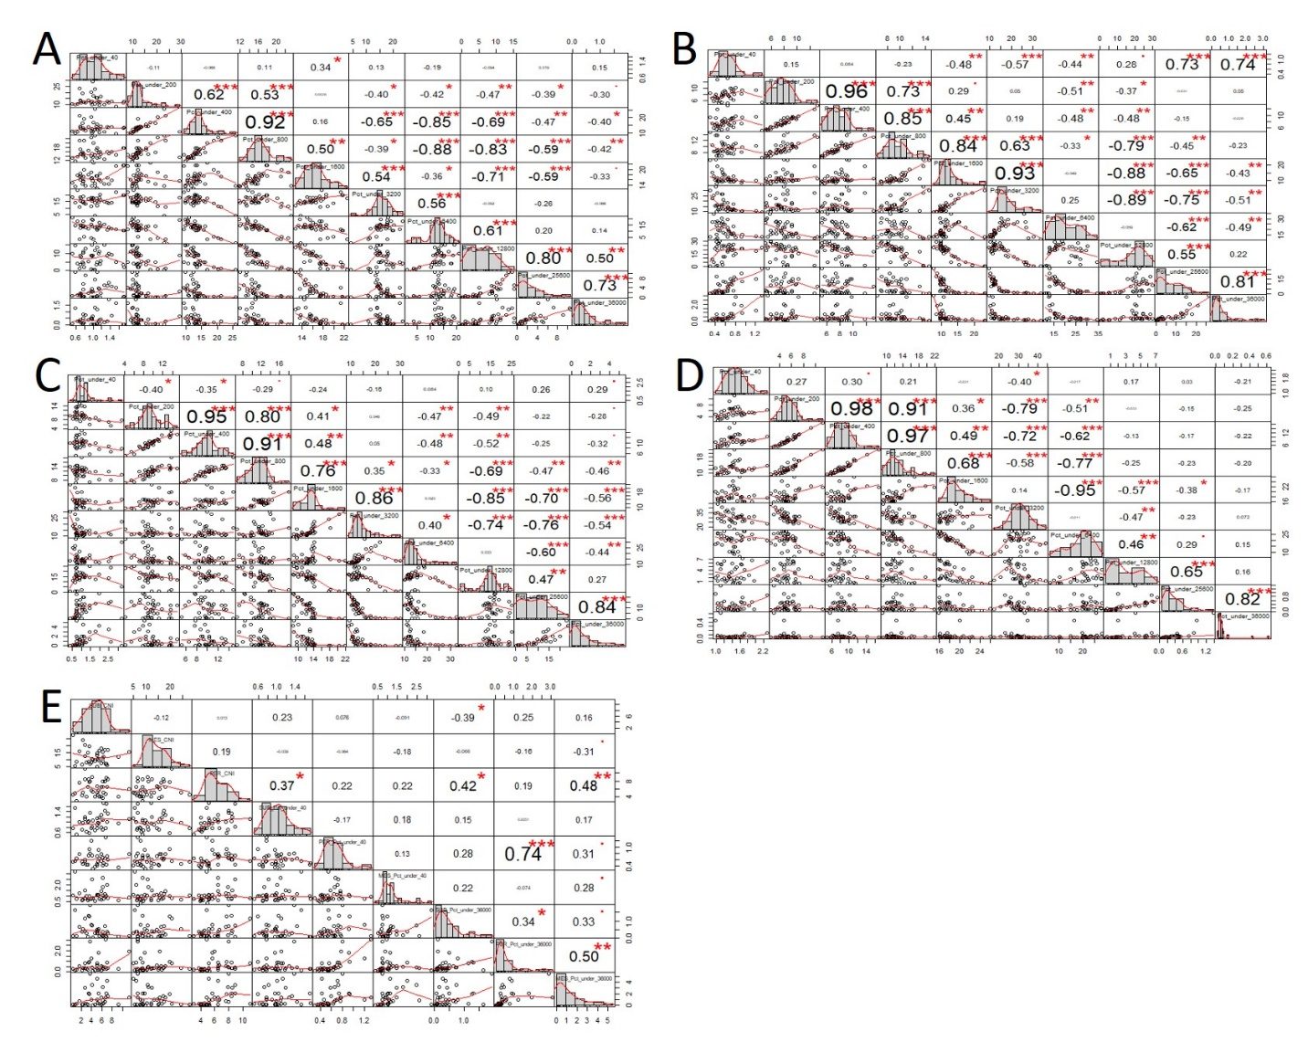

Figure S2 Overview of correlations (r) between proportions of adipocytes in different cell size classes within (A) subcutaneous, (B) perirenal, (C) mesenteric, and (D) epicardial adipose tissues from 2½ year old adult sheep with different early nutrition histories. Panel (E) in addition shows correlations between very small and large adipocytes and cell number indices (CNI) across adipose tissues (e). All sheep were born as twins from mothers, which during the last 6 weeks of gestation (term~147 days) had been exposed to NORM (fulfilling 100% of daily energy and protein requirements); HIGH (fulfilling 150% of energy and 110% of protein requirements, respectively); or LOW (50% of NORM) levels of nutrition. From 3-days of age until 6 months of age (post-puberty), one twin was fed a CONV diet (milk replacer during the first 8 weeks of life and exclusively hay thereafter, and adjusted in amounts to achieve moderate constant growth rates of approx. 225 g/day) and the other twin a HCHF diet (high carbohydrate (starch)-high-fat diet (37% fat dairy cream mixed with milk replacer in a 1:1 ratio (max. 2½ l/day) supplemented with rolled maize (max. 2 kg/d)). From 6 months until 2½ years of age, all sheep were fed with the same CONV (low-fat hay-based diet). Tissue slides were obtained at autopsy from the 2½ years old adult sheep and adipose tissues were stained with Iron-Hematoxylin except EPI, which was stained with Hematoxylin and Eosin for optimal staining of cell membranes. Average cross-sectional area (CSA) of adipocytes and distribution of adipocytes in cell size classes were determined in whole tissue scans using the Iron Haematoxylin Adipose Tissue software (APP ID 10113; Visiopharm®, Hoersholm, Denmark). A cell number index (CNI) was calculated as adipocyte mass (total fat mass (kg) multiplied by the % of adipocyte coverage on tissue slides) divided by the volume of a spherical adipocyte with a radius equivalent to a circle with same area as the average measured CSA. The adipocytes were automatically by the software categorized into size classes according to their CSA, with classes ranging from 0-40 (Pct_under_40), 40-200 (Pct_under_200), 200-400 (Pct_under_400), 400-800 (Pct_under_800), 800-1600 (Pct_under_1600), 1600-3200 (Pct_under_3200), 3200-6400 (Pct_under_6400), 6400-12800 (Pct_under_12800), 12800-26500 (Pct_under_25600), 26500-36000 (Pct_under_36000) µm². The values r denote the degree of correlation and asterisk (*) denote significant differences between cell size classes and CNI as revealed by pairwise comparison (*P<0.05, **P<0.01, ***P<0.001).

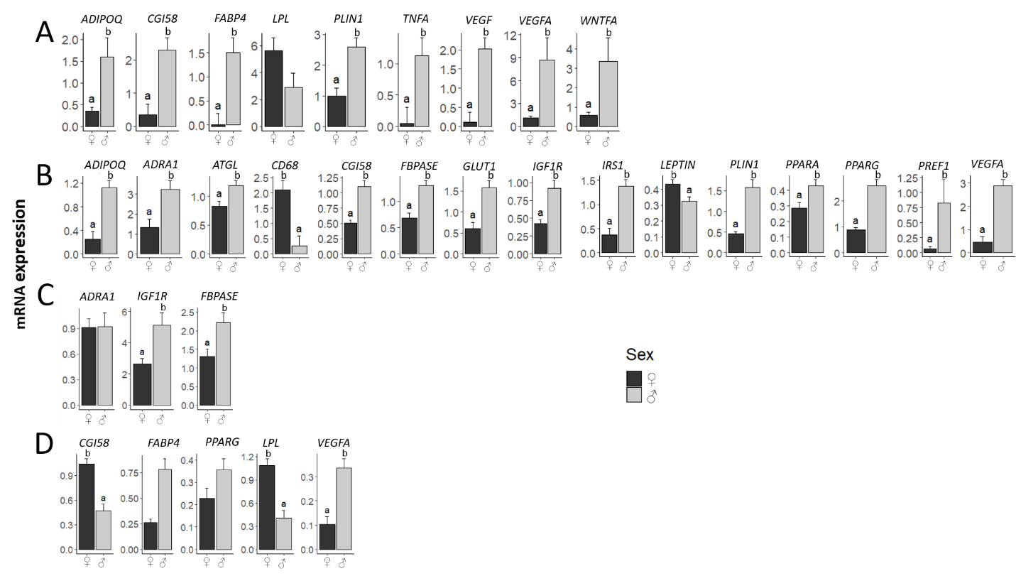

Figure S3 Sex effects (independently of the early nutrition history) on mRNA expression (relative to that of the reference gene, beta-actin) of (A) subcutaneous, (B) perirenal, (C) mesenteric, and (D) epicardial adipose tissues in 2½ years old male (♂) and female (♀) adult sheep. All sheep were born as twins from mothers, which during the last 6 weeks of gestation (term~147 days) had been exposed to NORM (fulfilling 100% of daily energy and protein requirements); HIGH (fulfilling 150% of energy and 110% of protein requirements, respectively); or LOW (50% of NORM) levels of nutrition. From 3-days of age until 6 months of age (post-puberty), one twin was fed a CONV diet (milk replacer during the first 8 weeks of life and exclusively hay thereafter, and adjusted in amounts to achieve moderate constant growth rates of approx. 225 g/day) and the other twin a HCHF diet (high carbohydrate (starch)-high-fat diet (37% fat dairy cream mixed with milk replacer in a 1:1 ratio (max. 2½ l/day) supplemented with rolled maize (max. 2 kg/d)). From 6 months until 2½ years of age, all sheep were fed with the same CONV (low-fat hay-based diet). ^{ab} Significant differences between groups are denoted by different superscript letters. The number of animals in the groups are: (a) Subcutaneous: N=31 (14♂:17♀), (b) Perirenal: N=36 (17♂:19♀), (c) Mesenteric: N=31 (13♂:18♀) and, (d) Epicardial: N=27 (17♂: 20♀).

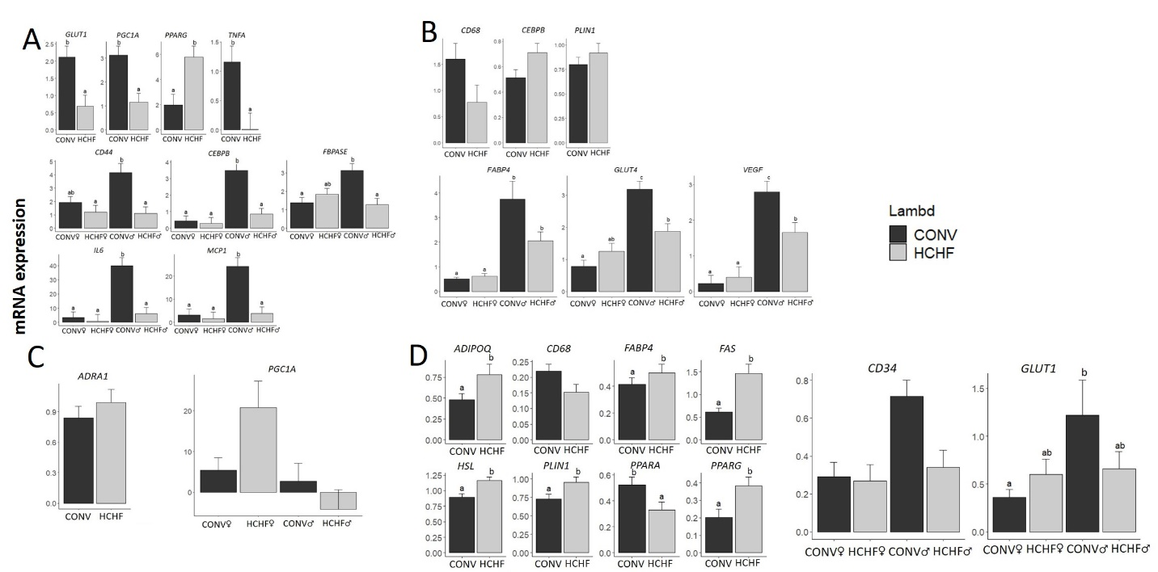

Figure S4 Sex independent and sex-dependent effects of postnatal nutrition on mRNA expressions (relative to that of the reference gene, beta-actin) in (A) subcutaneous, (B) perirenal, (C) mesenteric, and (D) epicardial adipose tissues from 2½ years old male (♂) and female (♀) adult sheep. All sheep were born as twins from mothers, which during the last 6 weeks of gestation (term~147 days) had been exposed to NORM (fulfilling 100% of daily energy and protein requirements); HIGH (fulfilling 150% of energy and 110% of protein requirements, respectively); or LOW (50% of NORM) levels of nutrition. From 3-days of age until 6 months of age (post-puberty), one twin was fed a CONV diet (milk replacer during the first 8 weeks of life and exclusively hay thereafter, and adjusted in amounts to achieve moderate constant growth rates of approx. 225 g/day) and the other twin a HCHF diet (high carbohydrate (starch)-high-fat diet (37% fat dairy cream mixed with milk replacer in a 1:1 ratio (max. 2½ l/day) supplemented with rolled maize (max. 2 kg/d)). From 6 months until 2½ years of age, all sheep were fed with the same CONV (low-fat hay-based diet). Values are expressed as emmean ± SEM. ^{abc} Significant differences between groups are denoted by different superscript letters. The numbers of animals in postnatal nutrition groups were: (a) Subcutaneous: CONV (N= 18, 6♂:12♀); HCHF (N=17, 9♂:8♀), (b) Perirenal: CONV (N=20, 8♂:12♀); HCHF (N=17, 9♂:8♀), (c) Mesenteric: CONV (N=20, 8♂:12F♀); HCHF (N=17, 9♂:8♀) and, (d) Epicardial: CONV (N=20, 8♂:20♀); HCHF (N=17, 9♂:8♀).

