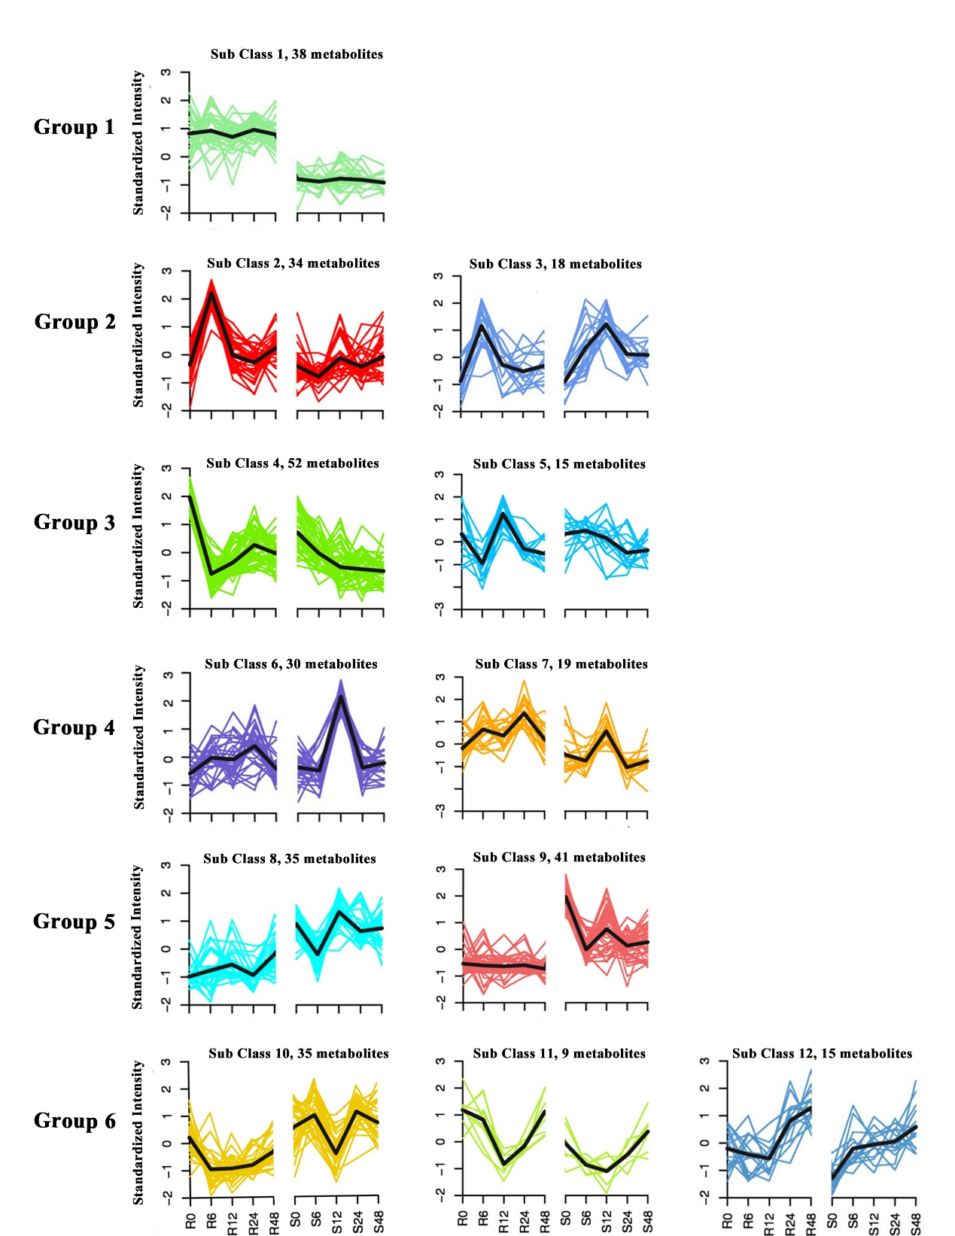
Supplemental Material
Supplementary Figure 1. Overview of metabolites expression clusters measured by K-means cluster using Pearson correlation distances. A total of 341 differentially accumulated metabolites (DAMs) with significant differential expression at least one-time point after GPA infestation are classified into 12 subclasses. The standardized intensity of each metabolite is shown in different colors. Average expression responses for each cluster are shown in black. R0 and S0 represent the control non-infected samples for R-32 and S-27, respectively. R6, R12, R24, R48, S6, S12, S24 and S48 refer to 6-, 12-, 24- and 48-hpi for R-32 and S-27.

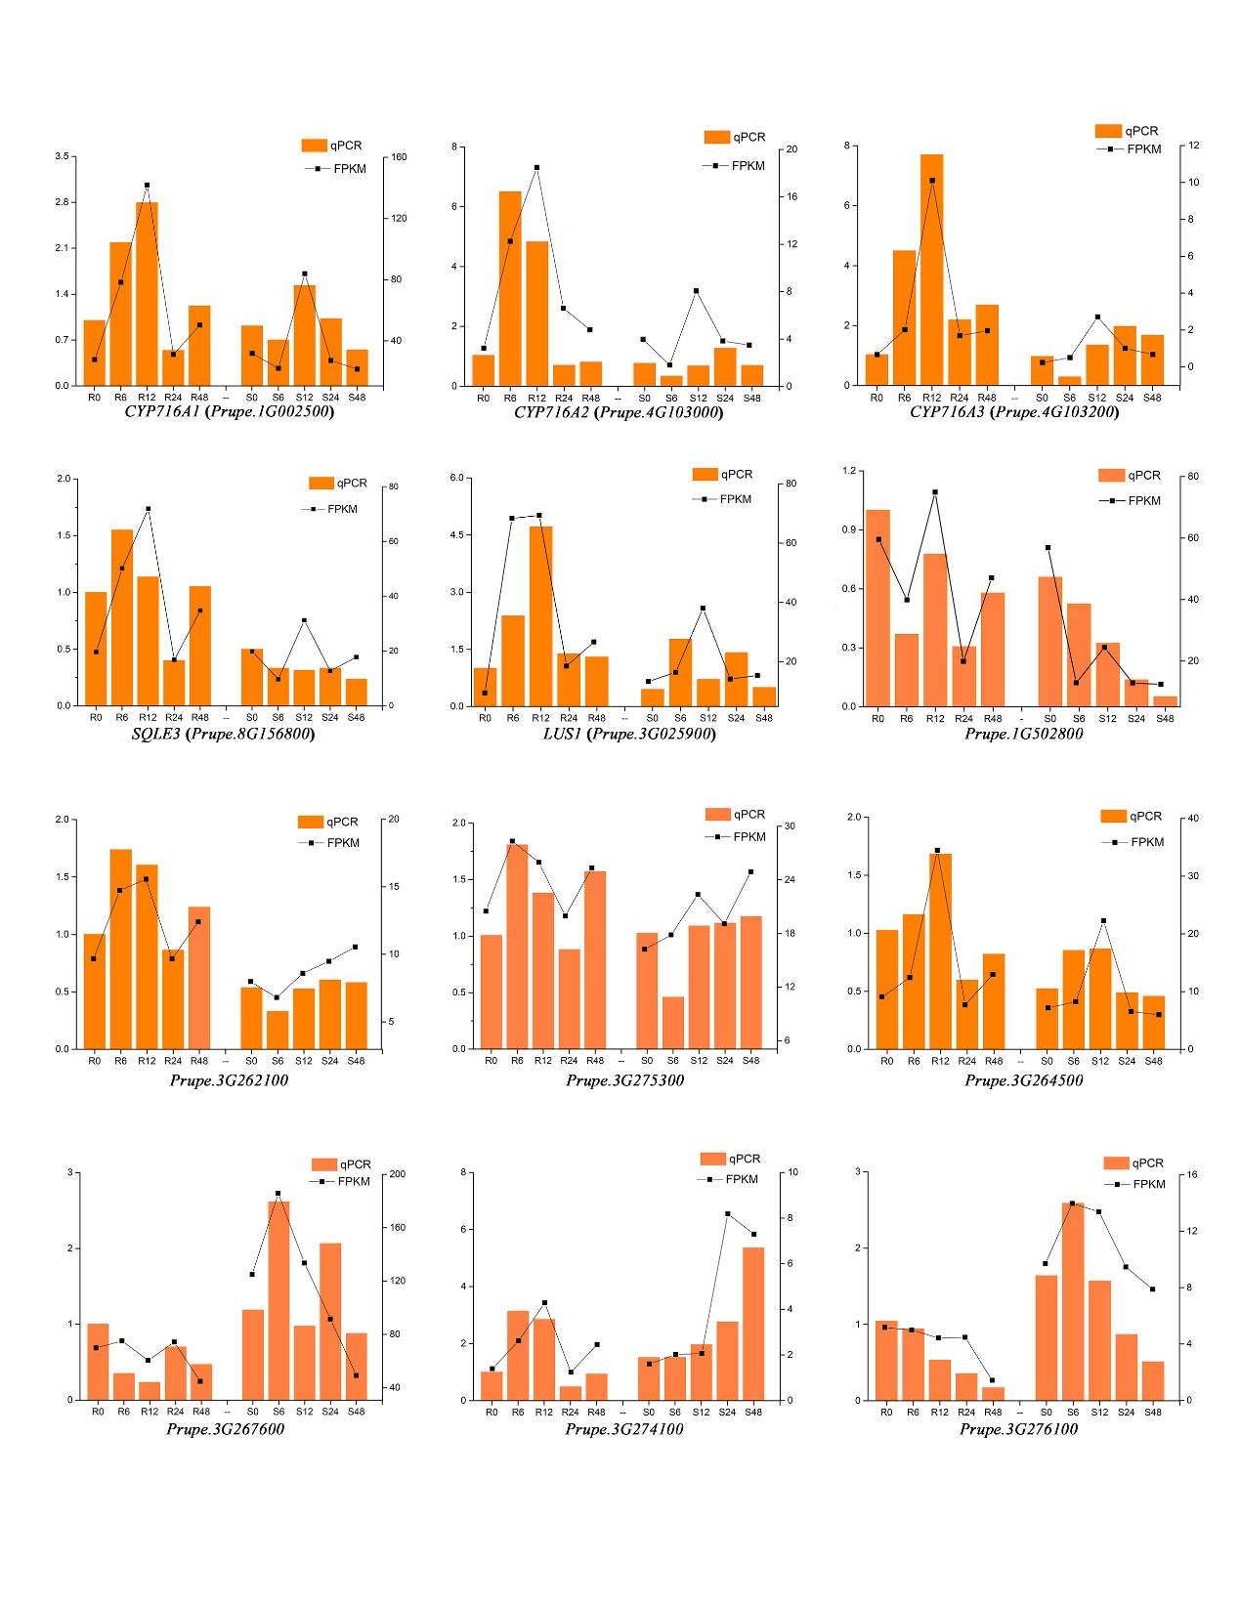
Supplementary Figure 2. RT-PCR validation of expression levels of 12 DEGs identified by RNA-seq. The left vertical axis stands for the quantitative real-time polymerase chain reaction (qRT-PCR) and the right vertical axis stands for fragments per kilo-base per million mapped reads (FPKM).

