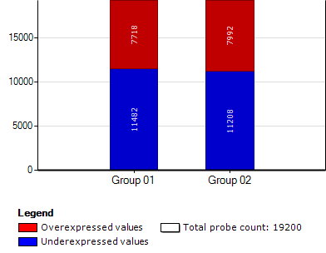
Supplementary Fig. 5 Differentially expressed genes by SARS-CoV virus.

