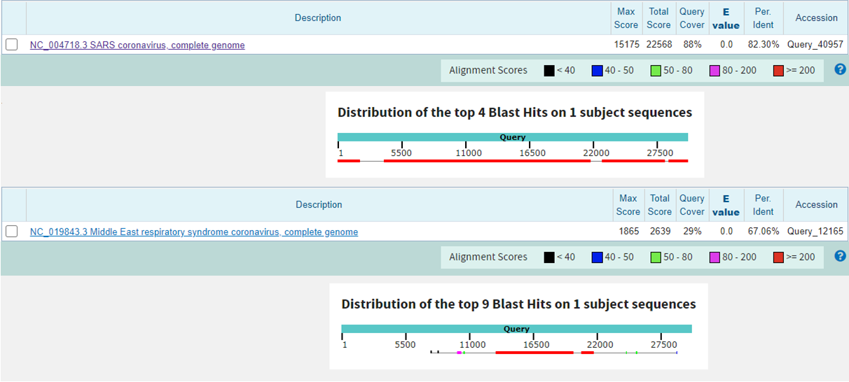
Supplementary Fig. 4 Whole Genome comparison among MERS-CoV, SARS-CoV and SARS-CoV-2.

