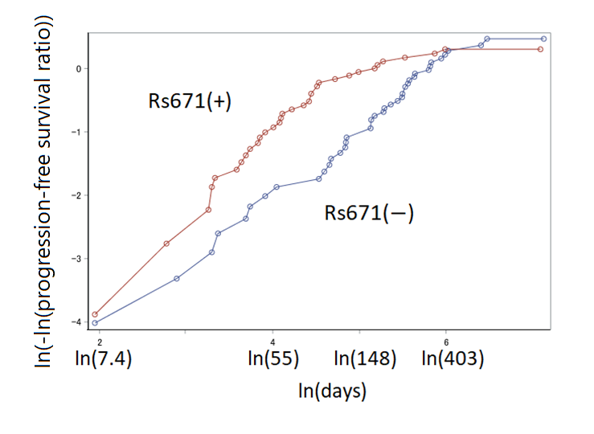
Figure S1. Plot of log (-log (progression-free survival ratio)) versus log (days of progression-free survival).
Hazard proportionality was tested by the parallelism between the curve of rs671(−) (cases with ALDH2*1/*1) and rs671(+) (cases with ALDH22*1/*2 and ALDH2*2/*2) to examine the suitability for the Cox proportional hazard model.

Table S1. Immune-related adverse events (IrAEs) and second or subsequent ICI doses.
 | Total |  | Rs671(−) |  | Rs671(+) |  | p
Diagnosis of IrAEs before disease progression*
Within 6 months
No | 77 | (73%) | 39 | (70%) | 38 | (78%) | 0.361
Yes | 28 | (27%) | 17 | (30%) | 11 | (22%)
―Days from ICI, median (IQR) | 77 | (50–118) | 77 | (55–123) | 65 | (16–91) | 0.359
Within a year
No | 72 | (69%) | 36 | (64%) | 36 | (73%) | 0.312
Yes | 33 | (31%) | 20 | (36%) | 13 | (27%)
―Days from ICI, median (IQR) | 80 | (55–150) | 89 | (56–159) | 80 | (46–135) | 0.461
Number of ICI doses during the entire observation period
1–5 | 50 | (48%) | 19 | (34%) | 31 | (63%) | 0.003
6–68 | 55 | (52%) | 37 | (66%) | 18 | (37%)
Rs671(−); ALDH2*1/*1, rs671(+); ALDH2*1/*2 or ALDH2*2/*2, ICI; immune checkpoint inhibitor, IQR; interquartile range. *Prednisolone treatment for adverse events of ICIs or discontinuation of the ICI due to its adverse events. p; probability value for the Chi-squared test, Fisher’s exact test, or Wilcoxon rank-sum test. The hazard ratio (HR) of irAEs estimated by the Cox proportional hazard model also showed no difference between ALDH2 genotypes. The HR of irAEs within 6 months for the rs671(+) group was 1.5 with a 95% confidence interval of 0.6–3.8. Similarly, the HR of irAEs within a year was 1.5 (0.6–3.6) (covariates: sex, age (continuous), Brinkman index (<100, <1000, ≥1000) (ordinal), type of first ICI, tumor histotype, TNM classification (categorical), number of lines (first, second, third, and later) (categorical), chemistry with ICI, PD-L1 positivity ratio (<1%, <50%, -100%, unassessed) (categorical), and EGFR mutation ((+), (-), unassessed) (categorical)).

SAS code for the Cox proportional hazards model using time-dependent explanatory variables

proc phreg;
class sex ici path stagec line chemo pdl1 egfr;
model pfsday*pfs_cens(1) = star2 sex age bi ici path stage line chemo pdl1 egfr aeStatus ae_t;
if (aed = . or pfsday < aed) then do;
aeStatus = 0;
ae_t = 0;
end;
else do;
aeStatus = 1;
ae_t = aed;
end;
run;

star2; carrier of ALDH2*2 allele
bi; Brinkman Index
ici; type of immune checkpoint inhibitor (ICI)
path; tumor histotype
stage; TNM classification
line; Treatment line
chemo; chemotherapy with first ICI
pdl1; PD-L1 positive ratio in cancer tissue
egfr; EGFR mutation in cancer tissue
pfsday; period of progression-free survival
pfs_cens; censored (1) or not censored (disease progressed, 0)
aeStatus; adverse effect of ICI (0 or 1) (time-dependent variable)
aed; days from starting ICI therapy to the diagnosis of adverse effects

