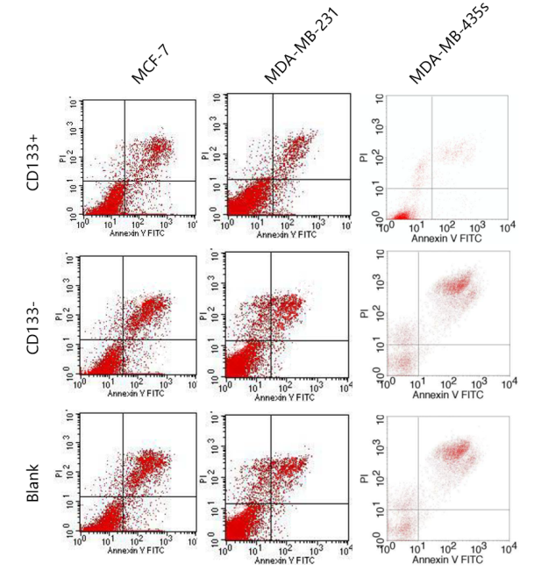
Revision Figure 1: CD133+ HPCs enhances breast cancer cell proliferation and attenuates apoptosis in vitro

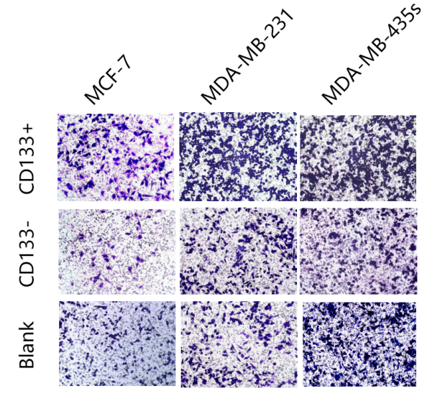
Revision Figure 2: CD133+ HPCs enhance breast cancer cell invasion in vitro.
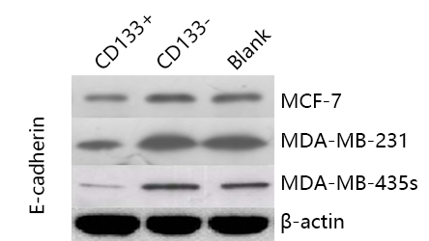
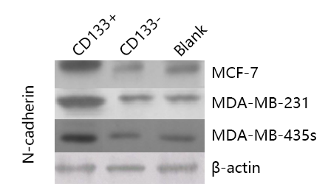
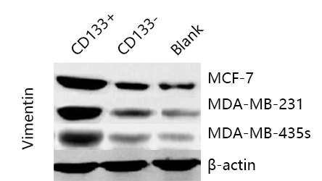
Revision Figure 3: CD133+ HPCs promote the EMT process in breast cancer cells.

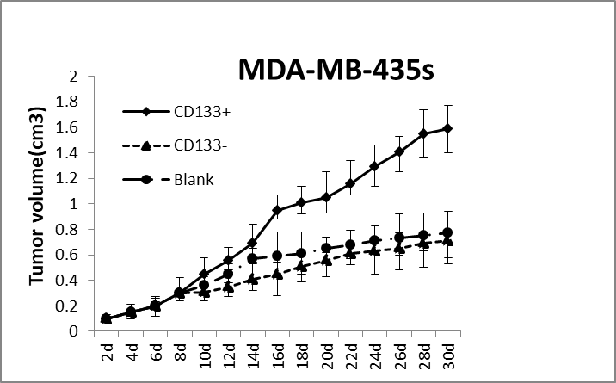
Revision Figure 4: CD133+ HPCs promote breast cancer growth in vivo

