Supplementary Information of

Stokes dual-soliton spectroscopy in a graphene functionalized over-modal microresonator for individual molecule gas tracing
Zhongye Yuan^{1#}, Teng Tan^{1,2#}, Guofeng Yan², Siyu Zhou³, Ning An¹, Hao Zhang¹, Bo Peng³, Giancarlo Soavi^{4,5}*, Yunjiang Rao^{1,2}*, Baicheng Yao¹*
¹Key Laboratory of Optical Fiber Sensing and Communications (Education Ministry of China), University of Electronic Science and Technology of China, Chengdu 611731, China.
²Research Centre of Optical Fiber Sensing, Zhejiang Laboratory, Hangzhou 310000, China.
³State Key Laboratory of Electronic Thin Film and Integrated Devices, University of Electronic Science and Technology of China, Chengdu 611731, China.
⁴Institute of Solid State Physics, Friedrich Schiller University Jena, Jena 07743, Germany.
⁵Abbe Center of Photonics, Friedrich Schiller University Jena, Jena 07745, Germany.
#These authors contributed equally.
*Corresponding authors: yaobaicheng@uestc.edu.cn; yjrao@uestc.edu.cn; giancarlo.soavi@uni-jena.de.
1. Supplementary notes
S1. Co-generation and interaction of the Kerr and Stokes combs
We study the interaction of the external pump laser, the Kerr comb and the Raman process in our microsphere resonator using the nonlinear method of silica optical fibers ¹. For simplicity, here we only consider one mode. The total intracavity oscillating electrical field is E(t,φ) = {E_{p} + E_{k} + E_{s}}, and includes the slowly varying envelope of the external pump laser, the Kerr comb and the Stokes comb. Here t and φ refer to time and detuning respectively. The pump provides energy for both the four wave mixing and the stimulated Raman scattering processes². Starting from the Lugiato-Lefever-equation (LLE), a pair of coupled equations in frequency domain describing the intracavity slowly-varying field can be extended by adding the Raman term³:
$ωE_{k}\left(φ\right)=\frac{D_{2k}}{2}\frac{∂^{2}E_{k}}{∂φ^{2}}+\left(1-r\right)\left(\frac{n_{2}ω_{k}D_{1k}}{2nπA_{kk}}{E_{k}}^{2}+\frac{n_{2}ω_{k}D_{1k}}{nπA_{ks}}{E_{s}}^{2}\right)E_{k}+\frac{rE_{k}}{D_{1k}}\int{h_{R}\left(\frac{φ-φ^{'}}{D_{1k}}\right)}\left[\frac{n_{2}ω_{k}D_{1k}}{2nπA_{kk}}{\left|E_{k}\left(φ^{'}\right)\right|}^{2}+\frac{n_{2}ω_{k}D_{1k}}{2nπA_{ks}}{\left|E_{s}\left(φ^{'}\right)\right|}^{2}\right]dφ^{'}+\frac{RE_{s}}{D_{1k}}\int{h_{R}\left(\frac{φ-φ^{'}}{D_{1k}}\right)\frac{n_{2}ω_{k}D_{1k}}{2nπA_{ks}}E_{k}\left(φ^{'}\right){E_{s}}^{*}\left(φ^{'}\right)\exp\left(iΩ\frac{φ-φ^{'}}{D_{1k}}\right)dφ^{'}}-j\left(\frac{κ_{k}}{2}+jΔω_{k}\right)E_{k}+j{(κ_{e}P_{k})}^{\frac{1}{2}}$ (S1)
$ωE_{s}\left(φ\right)=j\left({D_{1k}-D}_{1s}\right)\frac{∂E_{s}}{∂φ}+\frac{D_{2s}}{2}\frac{∂^{2}E_{s}}{∂φ^{2}}+\left(1-r\right)\left(\frac{n_{2}ω_{s}D_{1s}}{2nπA_{ss}}{E_{s}}^{2}+\frac{n_{2}ω_{s}D_{1s}}{nπA_{ks}}{E_{s}}^{2}\right)E_{s}+\frac{rE_{s}}{D_{1k}}\int{h_{R}\left(\frac{φ-φ^{'}}{D_{1k}}\right)}\left[\frac{n_{2}ω_{s}D_{1s}}{2nπA_{ss}}{\left|E_{s}\left(φ^{'}\right)\right|}^{2}+\frac{n_{2}ω_{s}D_{1s}}{2nπA_{ks}}{\left|E_{k}\left(φ^{'}\right)\right|}^{2}\right]dφ^{'}+\frac{RE_{k}}{D_{1k}}\int{h_{R}\left(\frac{φ-φ^{'}}{D_{1k}}\right)\frac{n_{2}ω_{s}D_{1s}}{2nπA_{ss}}E_{s}(φ^{'}){E_{k}}^{*}(φ^{'})exp⁡(-iΩ\frac{φ-φ^{'}}{D_{1k}})dφ^{'}}-j\left(\frac{κ_{s}}{2}+jΔω_{s}\right)E_{s}+j{g_{R}P}_{s}$ (S2)
In contrast to Ref [3], in this model we consider strong Raman scattering, which can be excited directly by the pump laser. Here E_{k} and E_{s} are the normalized field energies of the Kerr and Stokes comb, with discrete ω_{k,s}, which could be written via Taylor expansion ω_{u} = ω₀ + D₁u + (1/2)D₂u²......Here u is the mode number. D_{1,ks} and D_{2,ks} refer to the FSR and the second order dispersion at u = 0. Ω = ω_{0,k} - ω_{0,s} is the central frequency difference. Moreover, κ_{k,s} is the cavity loss and Δω_{k,s} is the detuning of the mode zero of the comb and the cold cavity resonance. κ_{e} is the cavity-bus coupling rate of the pump, P_{p} = P_{k} + P_{s} is the total intracavity pump power. A_{mn} is the nonlinear mode area, defined as
$A_{mn}=\frac{\iint{{|A_{m}|}^{2}dxdy\iint{{|A_{n}|}^{2}dxdy}}}{\iint{{|A_{m}|}^{2}{|A_{n}|}^{2}dxdy}}$ (S3)
Here A_{m} and A_{n} are transverse distribution of the interacting modes. h_{R}(ω) is the stimulated Raman response, whose real part reflects the index modulation, while the imaginary part determines the Raman gain¹,
$\begin{matrix}δ_{R}=rRe\left[h_{R}\right] \\ g_{R}=2γrIm[h_{R}]\end{matrix}$ (S4)
Here r = 0.18, and γ = n₂ω/(cA_{sk}). In the case of lossless quasi-continuous approximation (e.g. in silica, the pulse durations, hundreds fs to ps, are much longer than the Raman response time, < 10 fs), we can simplify the coupled equations to:
$ωE_{k}\left(φ\right)=\frac{D_{2k}}{2}\frac{∂^{2}E_{k}}{∂φ^{2}}+\left(\frac{n_{2}ω_{k}D_{1k}}{2nπA_{kk}}{E_{k}}^{2}+\frac{n_{2}ω_{k}D_{1k}}{nπA_{ks}}{E_{s}}^{2}\right)E_{k}-{2D}_{1k}E_{k}\frac{∂\left\{\frac{n_{2}ω_{k}D_{1k}}{2nπA_{kk}}{E_{k}}^{2}+\frac{n_{2}ω_{k}D_{1k}}{nπA_{ks}}{E_{s}}^{2}\right\}}{∂φ}-jR\frac{ω_{k}}{ω_{s}}{E_{s}}^{2}E_{k}+j{(κ_{e}P_{k})}^{\frac{1}{2}}$ (S5)
$ωE_{s}\left(φ\right)=j\left({D_{1k}-D}_{1s}\right)\frac{∂E_{s}}{∂φ}+\frac{D_{2s}}{2}\frac{∂^{2}E_{s}}{∂φ^{2}}+\left(\frac{n_{2}ω_{s}D_{1s}}{2nπA_{ss}}{E_{s}}^{2}+\frac{n_{2}ω_{s}D_{1s}}{nπA_{ks}}{E_{s}}^{2}\right)E_{s}-{2D}_{1k}E_{k}\frac{∂\left\{\frac{n_{2}ω_{s}D_{1s}}{2nπA_{ss}}{E_{s}}^{2}+\frac{n_{2}ω_{s}D_{1s}}{nπA_{ks}}{E_{k}}^{2}\right\}}{∂φ}+jR{E_{k}}^{2}E_{s}-j\left(\frac{κ_{s}}{2}+jΔω_{s}\right)E_{s}+j{g_{R}P}_{s}$ (S6)
Here R = cD_{1k}g_{R}/4nπA_{ks}. To analytically solve the equations, we use the approximation that the Kerr soliton and the Stokes soliton are formed independently in the same mode family (D_{1k}-D_{1s}) = 0, the pump laser power is high and the nonlinear conversion efficiency is low (< 10⁻²). First we use the sech² DKS model to calculate the Kerr comb evolution⁴. From this we obtain the E_{s}(t,φ), assuming the mode Q factor 3×10⁸, D₁ = 100 GHz, D₂ = -10 fs²/mm. The calculated result is shown in Fig. S1. During the evolution, when the Kerr soliton has just formed, the phase-locked four-wave-mixing would suppress the Raman scattering⁵, because g_{R} is proportional to 1/Δk (Δk is the phase mismatching, when it approaches 0, g_{R} becomes very small). Hence the threshold of Stokes comb increases dramatically⁶.

S2. Principles of spectroscopy based on multiple Stokes combs
In a multimode microresonator, multiple Stokes lines at different mode families can be generated since the SRS process doesn’t require strict phase matching. By using the finite element method (FEM), we simulate the mode field distribution of several typical modes in our microsphere, as shown in Fig. S2a. In this simulation, we use the following parameters: microsphere diameter 600 μm, silica material index 1.446, central wavelength 1550 nm. It is clear that a higher order mode has a larger mode volume. When we deposit a layer of graphene a bit far away from the equator, the graphene can only interacts with light in higher order modes. Based on the FEM simulation, we also include the effective index n_{eff} of these modes, as Fig. S2b shows. n_{eff} (ω) determines the FSR (or the D₁)
$FSR=\frac{c}{n_{eff}L}$ (S7)
Here L is the cavity perimeter, and dFSR/dω determines the chromatic dispersion (D₂). Specifically, n_{eff} from TE₀₁ to TE₀₅ mode, TM₀₁ to TM₀₅ mode decreases with the increasing mode order. In practice, there are much more transverse mode families, which can enable rich mode-to-mode interactions and beating. According to Ref [3], a condition for Stokes soliton and Kerr soliton co-locking is that the Stokes lines feature an FSR that is close in value to that of the Kerr soliton. Hence the locked Stokes soliton mode should be lower in order than the Kerr soliton mode. For instance, Fig. S2c plots the n_{eff} dispersion curves of TE₀₁ to TE₀₅ mode, and TM₀₁ to TM₀₅ mode. For example, when the pump mode of a Kerr soliton is TM₀₅, the possible Stokes soliton could belong to TM₀₄ (at 1597 nm), TE₀₄ (at 1629 nm), TM₀₃ (at 1642 nm), TE₀₃ (at 1677 nm), and TM₀₂ (at 1692 nm). Besides, when the pump mode of a Kerr soliton is TM₀₁, only the TE₀₁ mode at 1586 nm shares the same n_{eff} (or D₁). This indicates that multiple Stokes solitons with different FSR could co-exist. Specifically, in the case of pumping the TM₀₅ mode at 1550 nm (locking FSR 108 GHz), we illustrate a calculated multi-Stokes soliton spectrum in Fig. S2d. The Stokes lines generated in different mode families clearly overlap and thus one can measure their beating (Fig. S2e).

S3. Device and gas sensing preparation
Fig. S3a sketches the fabrication process of our graphene covered microsphere device. We prepare the whisper-gallery-mode microresonator samples from standard silica fiber by using the arc-discharge fusing method. First, we put a silica fiber in a programmable fiber fusion splicer (FITEL S184). By controlling the arc discharge power, discharge duration and discharge position, we fabricate microspheres with the diameter of the ≈ 620 μm, whose scale error is less than 2 microns. For soliton comb formation, these samples can produce repetition rate ≈ 100 GHz. Fig. S3b shows the optical microscope image and scanning electron microscopic image of a fabricated microsphere sample, verifying that its surface is smooth, enabling ultrahigh Q factors. On the other hand, we prepare the high-quality crystalline graphene via PDMS based mechanical exfoliation⁷. Then, by using the dry-transfer technique, we deposit the graphene layer on the surface of the microsphere. In this process, we carefully control the graphene position, making sure that intracavity transmitted light can interact with it although far from the equator. This also avoids risk of burning.
Fig. S3c plots the Raman spectrum of our graphene deposited on a silica microsphere. This spectrum is measured using a Renishaw InVia spectrometer, with excitation wavelength at 514 nm. The on-sample power is less than 0.5 mW, to avoid heating damage. In the Raman spectrum, there is almost no D peak and intensity ratio of the G/2D peak is ≈ 60%. The position of the G peak and the 2D peak are 1584 nm (linewidth 18 cm⁻¹) and 2688 nm (linewidth 25 cm⁻¹), respectively. These data indicate that the exfoliated graphene is almost defect-free. The D+D’’ peak at 2450 cm⁻¹ mainly reflects the fact that graphene is lying on a silica substrate rather than suspended⁸. According to the Raman spectroscopy, we confirm that the initial Fermi level of the graphene is ≈ 0.1 eV (p-doping).
The gas sample preparation process is shown in Fig. 3d. We prepare pure NH₃ gas (molecular weight 17 g/mol, density 0.76 g/L) at room temperature (≈ 300 K) with standard atmospheric pressure (101 kPa). The typical gas mole density is 0.045 mol/L under this condition. Then we dilute the NH₃ in dry air, by using a 1 mL chamber and a 1 rheodyne with resolution 1 μL (NH₃ is 4.5×10⁻⁸ mol per μL). After this process, we extract 1 μL of the diluted gas sample, in which the NH₃ concentration is 4.5×10⁻¹¹ mol. Then we inject the diluted NH₃/Air hybrid into the sensing chamber (with the graphene microresonator inside, volume 8 L, gas number 0.357 mol). The minimum NH₃ concentration in the sensing chamber can reach 1.26×10⁻¹⁰, or 0.126 ppb.

S4. Linear transmission of the microresonators
We characterize our microresonator samples by using a tunable laser (Santec TSL-710). The launched-in laser power is 0.2 mW, much lower than any nonlinear threshold. Fig. S4a sketches the setup for measuring the linear transmission. Here the laser scanning speed is 100 GHz/s, and the maximum sampling rate of the oscilloscope is 10⁹ per second. Hence the maximum point-to-point spectral resolution is 100 Hz, enough for the resonance characterization. In Fig. S4b, we plot the measured cavity transmission over one FSR (1550 ~ 1551 nm). By carefully tuning the distance of the tapered fiber and the microresonators, we can enable the microresonators to work at the critical coupling point (intracavity loss = coupling loss)⁹ of the fundamental mode (TM₀₁). In this case, most of other high order modes are in the over coupling region (intracavity loss < coupling loss). Due to its large mode volume, a > 600 μm microsphere supports many transverse mode families. As a result, we can see many resonant dips in one fundamental FSR. Moreover, after graphene deposition, due to the breaking of geometric symmetry, more high order modes are enhanced. The top panel in Fig. S4c counts the numbers of longitudinal mode families in one FSR, before and after graphene deposition. In a typical silica microsphere sample, we find 496 resonances, while we find 523 resonances after graphene deposition. This result also depends on the polarization. In the bottom panel, we show the coupling curves of two modes (TM₀₁ and a high order mode H).
$T=\frac{{(ρ-|t|)}^{2}}{{(1-ρ|t|)}^{2}}$ (S8)
Here ρ = 1-α is the intracavity transmission, t = 1-κ is the bus transmission. When ρ = t, a mode is at the critical coupling point. Calculated Q factors of this two modes are 3×10⁸ (TM₀₁) and 6.1×10⁷ (H). This H mode could be affected by the graphene (graphene introduces additional loss), but the light field of the fundamental mode doesn’t interact with the graphene. This is also the reason why the resonant dips of high order modes demonstrate larger depth in graphene microsphere. Fig. S4d plots the single resonance of two specific resonances (a fundamental mode and a higher order mode). The blue curves show the case before graphene deposition, and the red curves show the case after graphene deposition. The linewidth of the fundamental mode remains ≈ 0.65 MHz, suggesting an intrinsic Q factor 3×10⁸. Due to the graphene deposition, the linewidth of the H mode increases from ≈ 1 MHz to ≈ 1.4 MHz, suggesting that its intrinsic Q factor decreases from 2×10⁸ to 1.3×10⁸.

S5. Co-formation of multiple soliton combs and the selected dual-comb beat note.
Fig. S5a shows the experimental setup for comb generation. For the excitation we used a tunable ECDL (external cavity diode laser, Santec TSL-710, typical linewidth 200 kHz, tunable range 1480 ~ 1640 nm). After amplification by a high power EDFA (erbium doped fiber amplifier), the pump power can reach > 3 W (in practice, 200 mW after the EDFA is enough for Kerr and Raman soliton generation). Then we use a FPC (fiber polarization controller) to tune the light polarization and to optimize the fiber-to-cavity coupling. Such coupling is achieved by using a tapered fiber with diameter ≈ 1 μm. The microsphere device is carefully fixed in a chamber, and we use a TEC (thermal electrical cooler, Thorlabs) to accurately control the temperature. The generated combs could be separated by using a C/L band fiber based WDM (wavelength division multiplexer, 1625 nm) and measured in OSA (optical spectrum analyzer, Yokogawa 6370D), power meter (PM, data tracing) and ESA (electrical spectrum analyzer, R&S 0 ~ 43 GHz).
Fig. S5b plots three spectral frames during the comb evolution. All the nonlinear effects (including Kerr and Raman) are driven by the tunable ECDL pump. In the detuning process, we control the pump laser blue-to-red tuning manually. By increasing the red-detuning, we can obtain the ‘unlocked Kerr + Stokes’ state, then the ‘Kerr soliton + suppressed Stokes’ state, and finally the ‘Kerr soliton + Stokes solitons’ state. This result agrees well with the theoretical analysis. We note that the excited Stokes lines could belong to different mode families, as the stimulated Raman scattering does not require strict phase matching like FWM. When the Stokes solitons are locked on the Kerr soliton, they share a quasi-equal line-to-line space (≈ 100 GHz) but have different central frequency of the envelope. This enables detectable inter-comb beating down conversion. For sensing spectroscopy, we select a pair of overlapping Stokes solitons with ΔFSR 7MHz. According to the calculated result, such a 7 MHz spectral difference could come from TE_{0,A+1} and TM_{0,A} couples (RI difference 0.001). To satisfy the Kerr-Stokes co-locking, the pumping mode around 1550 nm should be in higher order (> A). To verify this assumption, we measured the 7 MHz beat note by using a polarization controller (Fig. S5c). When the input polarization is either TE or TM only, we cannot obtain the 7 MHz beat note.

S6. Optoelectronic property of graphene
The carrier density of graphene determines its conductivity. In particular, the intra-band conductivity and the inter-band conductivity can be written as ¹⁰
$σ_{g,intra}=\frac{ie^{2}E_{F}}{πℏ(2πf+\frac{i}{τ})}$ (S8)
$σ_{g,inter}=\frac{ie^{2}E_{F}}{4πℏ}ln\left[\frac{2\left|E_{F}\right|-ℏ(2πf+\frac{i}{τ})}{2\left|E_{F}\right|+ℏ(2πf+\frac{i}{τ})}\right]$ (S9)
Here E_{F} is the quasi-Fermi level, directly determined by the external bias. f is the optical frequency, τ ≈ 10⁻¹³ s is the carrier relaxation lifetime, ħ = 1.05×10⁻³⁴ J·s is the reduced Planck constant, and e = -1.6×10⁻¹⁹ C is the unit charge. External electric tuning (such as gas adsorption) mainly influences the σ_{g,inter}, which is also directly related to the saturable absorption. Considering graphene as an atomically thick planar waveguide with such complex sheet conductivity, we can write its effective optical permittivity as¹¹
$ϵ_{g}=\frac{-Im(σ_{g,i})+i{Re(σ}_{g})}{2πf∆}$ (S10)
Here Re(σ_{g}) and Im(σ_{g}) are the real and imaginary parts of the σ_{g} respectively. By considering a thickness Δ = 0.33 nm, the refractive index of the graphene layer can be derived from
${\left\{Re(n_{g})+i{Im(n}_{g})\right\}}^{2}=Re(ϵ_{g})+iIm(ϵ_{g})$ (S11)
For media modes with real permittivity, we can calculate
$\left\{\begin{aligned}Re(n_{g})=\frac{2Re(ϵ_{g}){\left(\frac{Re(ϵ_{g})}{2}+\frac{\sqrt{{Re(ϵ_{g})}^{2}-{Im(ϵ_{g})}^{2}}}{2}\right)}^{1/2}-2{\left(\frac{Re(ϵ_{g})}{2}+\frac{\sqrt{{Re(ϵ_{g})}^{2}-{Im(ϵ_{g})}^{2}}}{2}\right)}^{3/2}}{ϵ_{g,i}} \\ Im(n_{g})={\left(\frac{\sqrt{{Re(ϵ_{g})}^{2}+{Im(ϵ_{g})}^{2}}}{2}-\frac{Re(ϵ_{g})}{2}\right)}^{1/2}\end{aligned}\right.$ (S12)
Fig. S6 maps the calculated spectra of the complex ϵ_{g} and n_{g}, for different Fermi levels. This shows that both the real and the imaginary parts of the graphene’s refractive index can oscillate dramatically during the gate tuning. For a specific optical wavelength at 1550 nm (our Kerr comb region), the maximum tuning range of the Re(n_{g}) is from 0.20 to 3.23, while the Im(n_{g}) is from 0.25 to 1.42.

S7. Optoelectronic implementation for gas tracing
Fig. S7a shows the experimental setup for gas sensing measurement. The device is put in a gas chamber equipped with optical fiber coupling and a temperature controller. The generated Stokes solitons are checked with an OSA, ensuring that they are in locked state. Then the optical signal is detected by using an amplified photodetector (Thorlabs APD 103C), that we use to monitor their beat notes. The beat notes are detected in an ESA (R&S, 0 ~ 43 GHz). For further amplification of the electrical signals and to match the bandwidth of our lock-in amplifier (Stanford Research, SR 810, 125 kHz), we use a RF signal generator (Tektronix TSG4100A, 0 ~ 200 MHz) to create a reference signal for further down-conversion in a frequency mixer. Fig. S7b plots the two RF signals. The frequency difference between the reference and our selected comb beat note is tunable (we commonly use the number 50 kHz). Mixing of the two lines (with frequency f_{A} = 7.5 MHz, and f_{B} = 7.55 MHz) generates more frequency components: f_{B} - f_{A}, f_{B} + f_{A}, and their harmonics such as 2f_{A} – f_{B}, 2f_{B} - f_{A}, 3f_{A} – 2f_{B}, 3f_{B} – 2f_{A}, etc. Specifically, we only amplify and trace the down conversion signal with f_{d} = 50 kHz (Fig. S7c). Thanks to the stable nature of the soliton and the amplification during the electrical mixing, SNR of this 50 kHz signal is > 70 dB, with 3dB linewidth < 2 Hz, as shown in the zoomed-in panel (band: 49.9 kHz to 50.1 kHz). In the lock-in implementation, we tune the lock-in filter band to 3 Hz (integration time 300 ms) at 50 kHz, to obtain enough amplification rate and enhance the sensitivity. When the electrical signal is stable, the output of the lock-in amplifier is a CW wave, which is monitored in an oscilloscope. Once gas molecules are adsorbed on the graphene-microsphere device, the 50 kHz signal will shift and we will detect a large change in intensity. Fig. S7d compares the sensitivity of the microsphere Stokes comb device, before and after graphene deposition. The Stokes solitons generated in a pure silica microresonator show no sensitivity to gas molecules, as the NH3 molecules cannot be adsorbed on silica.

2. Supplementary Figures

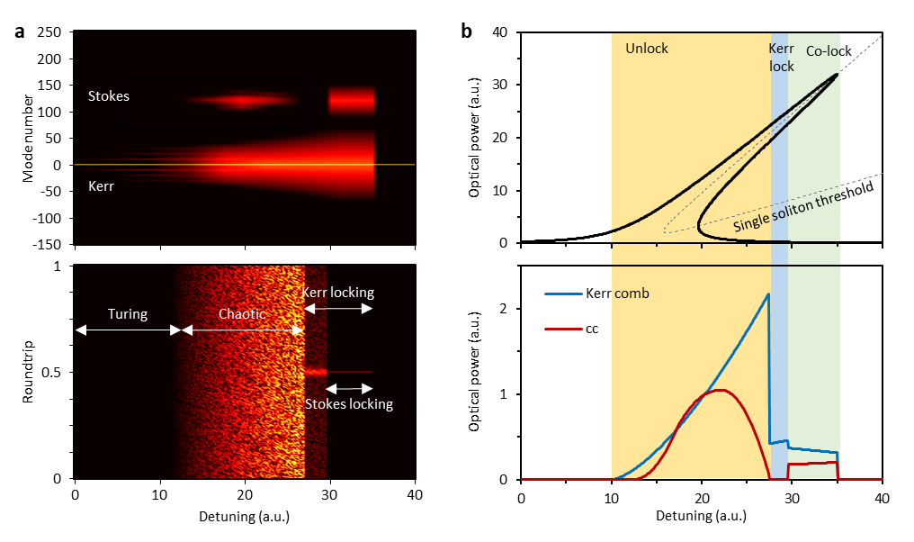
Fig. S1. Calculated results: Kerr and Stokes soliton evolution in a microresonator. a, Simulation of the intracavity field in frequency (upper panel) and time (bottom panel) domain. Here the detuning is normalized to the resonance. The Kerr single soliton appears after Turing state and chaotic state. The Stokes comb appears first, driven by the pumping laser. Then it is suppressed in the Kerr soliton region. Once the Kerr soliton power reaches the injected-locking threshold, the Stokes soliton is formed. b, Calculated curves. Upper panel: The Kerr triangle (black solid) and the first-order FWM bi-stable threshold (grey dashed). Bottom panel: Correlation of the detuning and the optical power, for the Kerr comb (blue) and Stoke comb (red). In the above simulations, we only calculated one Stokes mode (TM₀₁).

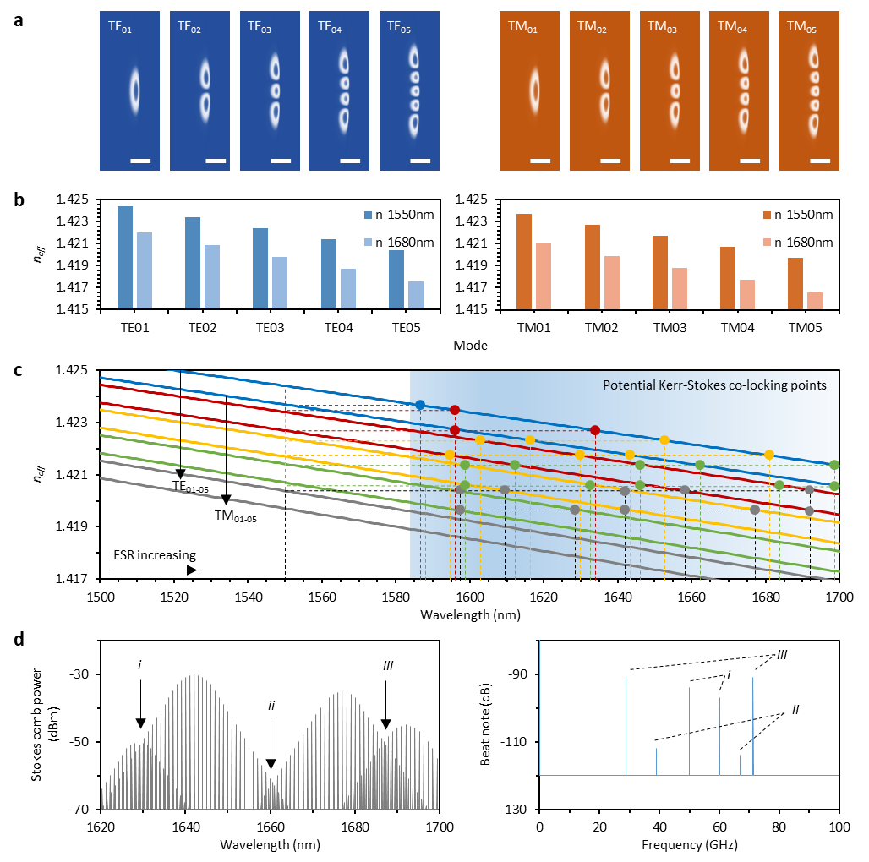
Fig. S2. The mode families of a multimode microresonator. a, Simulated electric field distributions. Left panels: Transverse electrical modes, order 01 to 05. Right panels: Transverse magnetic modes, order 01 to 05. b, Calculated n_{eff} of the ten modes. c, n_{eff} offset varies with wavelength. The n_{eff} of TE₀₁/TM₀₁, TE₀₂/TM₀₂ TE₀₃/TM₀₃, TE₀₄/TM₀₄, TE₀₅/TM₀₅ are shown in blue, red, yellow, green and grey respectively. d, Spectrum of multiple Stokes solitons, in different modes (from left to right: TE₀₄, TM₀₃, TE₀₃, TM₀₂). e, Overlapping of the multiple combs enables beat notes with frequencies smaller than the resonator FSR.

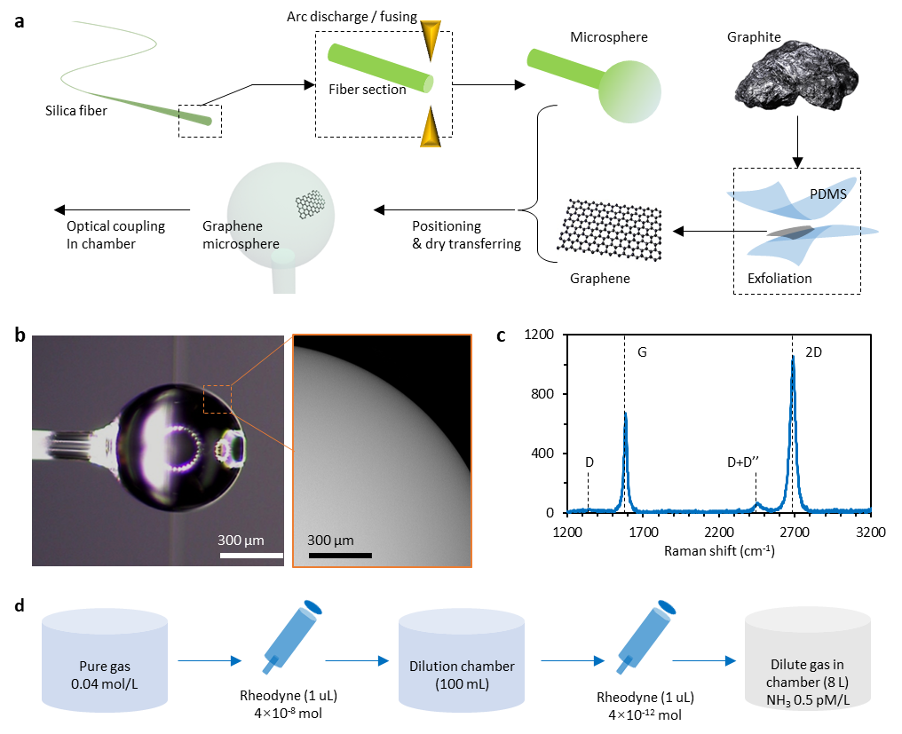
Fig. S3. Device fabrication and characterization. a, Fabrication process. i) we fabricate the silica microsphere via arc-discharging/fusing. ii) We prepare 2D graphene from graphite via mechanical exfoliation. iii) The graphene is assembled on the microsphere via dry transfer. b, Microscopic images of the microsphere sample, scale bars are marked. c, Raman spectrum of the mechanically exfoliated graphene deposited on the device. d, NH₃ gas preparation.

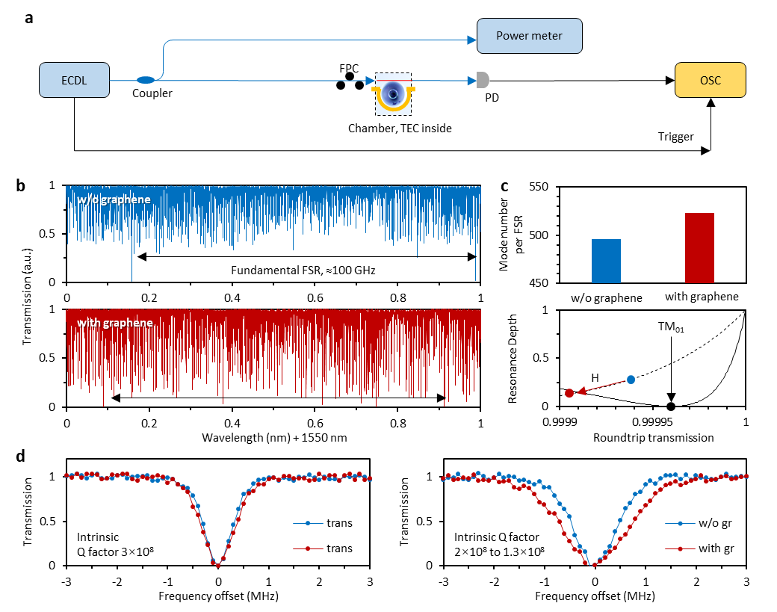
Fig. S4. Measured linear transmissions. a, Experimental setup for linear transmission measurement. ECDL: external cavity diode laser. PD: photodetector, OSC: oscilloscope. b, Linear transmission spectra in 1 nm span. Blue curve: before graphene deposition. Red curve: after graphene deposition. c, Top panel: Statistics of the resonance number in one FSR. Bottom panel: coupling curve of two modes. Solid curve: the graphene doesn’t influence the fundamental mode. Dashed curve: graphene affects some higher order modes. d, Single resonance characterization. Left: the fundamental mode. Right: a higher order mode.

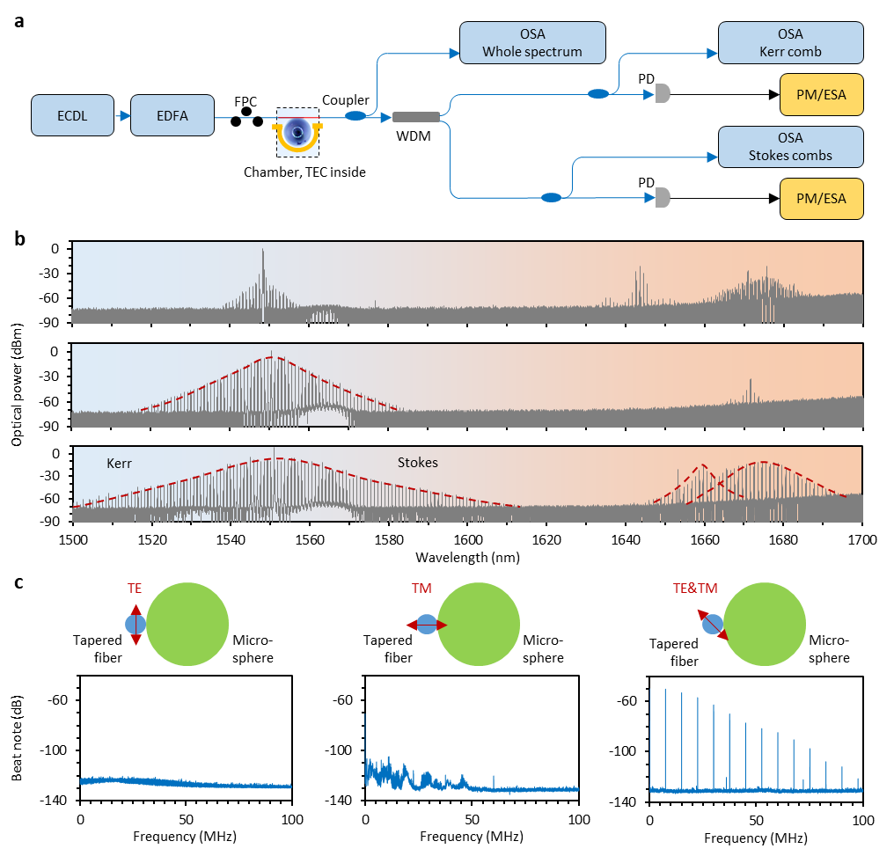
Fig. S5. Generation of the Kerr and Stokes solitons and inter mode comb beating. a, Experimental setup. b, Measured spectra during the comb generation, when increasing the pump red-detuning. c, The multiple Stokes solitons enable a beat note at 7 MHz (and its harmonics), which comes from two Stokes solitons with ΔRI 0.001. These two solitons have orthogonal polarizations.

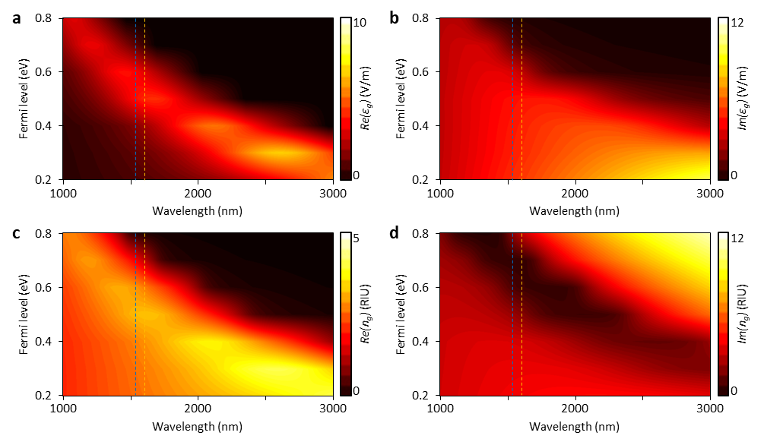
Figure S6 | Tunable optical refractive index of graphene. a and b, Real part and imaginary part of the graphene permittivity for E_{F} from 0.2 eV to 0.8 eV. c and d, Real part and imaginary part of the refractive index. Here the blue and yellow dashed lines mark the central wavelengths of the Kerr and Stokes comb.

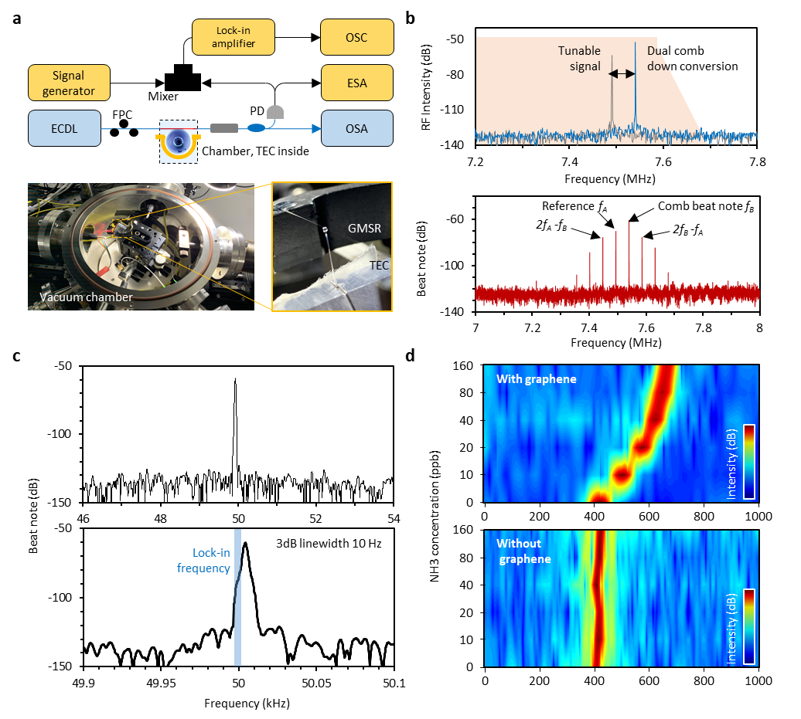
Fig. S7. Opto-electrical implementation for tracing individual gas molecule. a, Experimental setup. b, Top panel: Measured comb down conversion beat note (blue curve, @7.55 MHz) and a tunable electrical reference (grey curve, from a signal generator). Bottom panel: spectrum of the mixed two signals in the band 7 ~ 8 MHz, here we can see many harmonics. c, The mixing induced down conversion, which is used to detect the gas molecules. This signal is filtered and amplified in a lock-in amplifier. d, Comparison: graphene based Stokes solitons show higher sensitivity to gas molecules, comparing with solitons generated in pristine silica microsphere.

Supplementary references
1. Agrawal, G. Nonlinear Fiber Optics. Nonlinear Fiber Optics (2012). doi:10.1016/C2011-0-00045-5
2. Liang, W. et al. Passively Mode-Locked Raman Laser. Phys. Rev. Lett. 105, 143903 (2010).
3. Yang, Q.-F., Yi, X., Yang, K. Y. & Vahala, K. Stokes solitons in optical microcavities. Nat. Phys. 13, 53–57 (2017).
4. Herr, T. et al. Temporal solitons in optical microresonators. Nat. Photonics 8, 145–152 (2013).
5. Golovchenko, E. A., Mamyshev, P. V., Pilipetskii, A. N. & Dianov, E. M. Mutual influence of the parametric effects and stimulated Raman scattering in optical fibers. IEEE J. Quantum Electron. 26, 1815–1820 (1990).
6. Kato, T. et al. Transverse mode interaction via stimulated Raman scattering comb in a silica microcavity. Opt. Express 25, 857 (2017).
7. Novoselov, K. S. et al. A roadmap for graphene. Nature 490, 192–200 (2012).
8. Ferrari, A. C. Raman spectroscopy of graphene and graphite: Disorder, electron–phonon coupling, doping and nonadiabatic effects. Solid State Commun. 143, 47–57 (2007).
9. Yariv, A. Critical coupling and its control in optical waveguide-ring resonator systems. IEEE Photonics Technol. Lett. 14, 483–485 (2002).
10. Mikhailov, S. A. & Ziegler, K. New electromagnetic mode in graphene. Phys. Rev. Lett. 99, 016803 (2007).
11. Vakil, A. & Engheta, N. Transformation optics using graphene. Science 332, 1291–1294 (2011).

