Supplementary Information

Positive selection affects the expression of systemic lupus erythematosus associated loci in human populations

Victoria Oberreiter¹, Tobias Goellner¹, David L. Morris², Helmut Schaschl^{1,*}

Affiliations
¹Department of Evolutionary Anthropology, University of Vienna, Althanstrasse 14, 1090 Vienna, Austria
Department of Medical and Molecular Genetics, Faculty of Life Sciences & Medicine, King's College London School of Medicine, Great Maze Pond, London SE1 9RT, United Kingdom

Supplementary Table 1. SNP allele frequencies (1000 Genomes) and genomic position of the allele under positive selection at the different SLE risk loci.
Beneficial allele/ alternate allele | Position | Locus | Allele frequencies
 |  |  | AFR | EUR | SAS | EAS
rs4655706-G/A | 67855152 | IL12RB2 | 0.20 | 0.58 | 0.56 | 0.34
rs10176621-T/C | 192035043 | STAT4 | 0.13 | 0.74 | 0.76 | 0.58
rs4681674-G/A;  rs4681834-T/G | 58273815  58263151 | ABHD6  ABHD6 | 0.08  0.11 | 0.30  0.58 | 0.16  0.65 | 0.01  0.78
rs583911-G/A | 159710390 | IL12A | 0.16 | 0.47 | 0.43 | 0.70
rs4479588-G/T;  rs9682946-A/G | 188899235  188792843 | TPRG1  TPRG1 | 0.05  0.14 | 0.43  0.93 | 0.29  0.86 | 0.40  0.91
rs9307257-G/A | 102396292 | BANK1 | 0.87 | 0.54 | 0.56 | 0.76
rs7708392-G/C | 150457485 | TNIP1 | 0.15 | 0.74 | 0.60 | 0.27
rs11755393-A/G | 74099826 | UHRF1BP1 | 0.23 | 0.65 | 0.71 | 0.54
rs2428793-C/G;  rs6460087-A/G | 74099826  74065589 | GTF2I  GTF2I | 0.47  0.20 | 0.07  0.67 | 0.02  0.68 | 0.04  0.88
rs1015877-C/G | 75296212 | HIP1 | 0.20 | 0.34 | 0.29 | 0.32
rs10086521-T/C | 10783769 | XKR6 | 0.03 | 0.35 | 0.37 | 0.77
rs4841563-T/G | 11425081 | BLK | 0.05 | 0.32 | 0.47 | 0.92
rs75346988-G/A | 5097324 | JAK2 | 0.82 | 1.0 | 1.0 | 1.0
rs2732552-T/C | 35084592 | CD44 | 0.69 | 0.45 | 0.28 | 0.25
rs6539014-A/G | 102277782 | DRAM1 | 0.02 | 0.43 | 0.33 | 0.09
rs10774625-A/G | 111910215 | ATXN2 | 0.02 | 0.48 | 0.07 | 0.0
rs1274641-G/A | 68668994 | RAD51B | 0.68 | 0.82 | 0.83 | 0.97
rs7197422-C/G | 11121071 | CLEC16A | 0.30 | 0.59 | 0.57 | 0.66
rs140490-G/T | 21921686 | UBE2L3 | 0.50 | 0.81 | 0.57 | 0.49
rs61616683-T/C | 39755773 | SYNGR1 | 0.04 | 0.23 | 0.35 | 0.78

Supplementary Table 2. Pairwise F_{ST}–values of SNPs under positive selection at SLE risk loci for different human populations (Pop): AFR – African population (LWK), EUR – European population (GBR), SAS – South Asian population (BEB), EAS – East Asian population (CHB).

 |  |  | Pairwise F_{ST}
Risk region | Risk gene_locus | Positively selected SNP | Pop | AFR | EUR | SAS | EAS
1p31.3 | IL12RB2 | rs4655706 | AFR | -
 |  |  | EUR | 0.273 | -
 |  |  | SAS | 0.211 | 0.002 | -
 |  |  | EAS | 0.071 | 0.081 | 0.040 | -
2q32.3 | STAT4 | rs10176621 | AFR | -
 |  |  | EUR | 0.572 | -
 |  |  | SAS | 0.577 | 0 | -
 |  |  | EAS | 0.426 | 0.03 | 0.03 | -
3p14.3 | ABHD6 | rs4681674  rs4681834 | AFR | -
 |  |  | EUR | 0.195 | -
 |  |  | SAS | 0 | 0.152 | -
 |  |  | EAS | 0.087 | 0.380 | 0.121 | -
 |  |  | AFR | -
 |  |  | EUR | 0.354 | -
 |  |  | SAS | 0.478 | 0.0172 | -
 |  |  | EAS | 0.593 | 0.089 | 0.020 | -
3q25.33 | IL12A | rs583911 | AFR | -
 |  |  | EUR | 0.189 | -
 |  |  | SAS | 0.166 | 0 | -
 |  |  | EAS | 0.459 | 0.110 | 0.131 | -
3q28 | TPRG1 | rs4479588  rs9682946 | AFR | -
 |  |  | EUR | 0.320 | -
 |  |  | SAS | 0.138 | 0.064 | -
 |  |  | EAS | 0.313 | 0 | 0.065 | -
 |  |  | AFR | -
 |  |  | EUR | 0.865 | -
 |  |  | SAS | 0.799 | 0.015 | -
 |  |  | EAS | 0.879 | 0 | 0.028 | -
4q24 | BANK1 | rs9307257 | AFR | -
 |  |  | EUR | 0.235 | -
 |  |  | SAS | 0.219 | 0 | -
 |  |  | EAS | 0.041 | 0.093 | 0.08 | -
5q33.1 | TNIP1 | rs7708392 | AFR | -
 |  |  | EUR | 0.451 | -
 |  |  | SAS | 0.232 | 0.070 | -
 |  |  | EAS | 0.026 | 0.312 | 0.111 | -
6p21.31 | UHRF1BP1 | rs11755393 | AFR | -
 |  |  | EUR | 0.419 | -
 |  |  | SAS | 0.461 | 0 | -
 |  |  | EAS | 0.252 | 0.037 | 0.059 | -
7q11.23 | GTF2I | rs2428793  rs6460087 | AFR | -
 |  |  | EUR | 0.242 | -
 |  |  | SAS | 0.393 | 0.071 | -
 |  |  | EAS | 0.385 | 0.047 | 0.002 | -
 |  |  | AFR | -
 |  |  | EUR | 0.227 | -
 |  |  | SAS | 0.317 | 0.008 | -
 |  |  | EAS | 0.595 | 0.203 | 0.126 | -
 | HIP1 | rs1015877 | AFR | -
 |  |  | EUR | 0 | -
 |  |  | SAS | 0.041 | 0 | -
 |  |  | EAS | 0.119 | 0.003 | 0.020 | -
8p23.1 | XKR6 | rs10086521 | AFR | -
 |  |  | EUR | 0.322 | -
 |  |  | SAS | 0.455 | 0.023 | -
 |  |  | EAS | 0.743 | 0.296 | 0.168 | -
 | BLK | rs4841563 | AFR | -
 |  |  | EUR | 0.164 | -
 |  |  | SAS | 0.387 | 0.077 | -
 |  |  | EAS | 0.851 | 0.591 | 0.373 | -
9p24 | JAK2 | rs75346988 | AFR | -
 |  |  | EUR | 0.226 | -
 |  |  | SAS | 0.221 | nan | -
 |  |  | EAS | 0.237 | nan | nan | -
11p13 | CD44 | rs2732552 | AFR | -
 |  |  | EUR | 0.164 | -
 |  |  | SAS | 0.274 | 0.016 | -
 |  |  | EAS | 0.365 | 0.062 | 0.008 | -
12q23.2 | DRAM1 | rs7137913  rs6539014 | AFR | -
 |  |  | EUR | 0.537 | -
 |  |  | SAS | 0.277 | 0.106 | -
 |  |  | EAS | 0.156 | 0.216 | 0.020 | -
 |  |  | AFR | -
 |  |  | EUR | 0.453 | -
 |  |  | SAS | 0.276 | 0.058 | -
 |  |  | EAS | 0.057 | 0.308 | 0.126 | -
12q24.12 | SH2B3_ATXN2 | rs10774625 | AFR | -
 |  |  | EUR | 0.519 | -
 |  |  | SAS | 0.070 | 0.375 | -
 |  |  | EAS | 0.005 | 0.504 | 0.045 | -
14q24.1 | RAD51B | rs1274641 | AFR | -
 |  |  | EUR | 0.062 | -
 |  |  | SAS | 0.040 | 0 | -
 |  |  | EAS | 0.253 | 0.100 | 0.127 | -
16p13 | CLEC16A | rs8049882 | AFR | -
 |  |  | EUR | 0.164 | -
 |  |  | SAS | 0.174 | 0 | -
 |  |  | EAS | 0.281 | 0.020 | 0.015 | -
22q11.21 | UBE2L3 | rs140490 | AFR | -
 |  |  | EUR | 0.225 | -
 |  |  | SAS | 0.003 | 0.163 | -
 |  |  | EAS | 0.013 | 0.133 | 0 | -
22q13.1 | SYNGR1 | rs61616683 | AFR | -
 |  |  | EUR | 0.179 | -
 |  |  | SAS | 0.382 | 0.073 | -
 |  |  | EAS | 0.738 | 0.457 | 0.234 | -

nan = not a number
Supplementary Table 3. The locations of SLR risk loci under positive selection in the Reactome Pathway Browser (https://reactome.org/); timing of selection (in kya) and potential target gene of positive selection are also given. N.d. = no data.
SNP under positive selection | GTEx functions | Timing of selection | Potential target of positive selection | Reactome - locations in the  PathwayBrowser
rs4655706 | eQTL | 9 - 11 | IL12RB2 | immune system
rs10176621 | eQTL | 19 - 21 | STAT4 | immune system
rs4681674; rs4681834 | eQTL;  eQTL | 7 - 10  9 - 13 | ABHD6 | hemostasis, signal transduction
rs583911 | eQTL | 13 - 19 | IL12A | immune system
rs4479588; rs9682946 | -  - | 10 - 16  14 - 19 | - | n.d
rs9307257 | eQTL | 5 - 9 | FLJ20021 | n.d
rs7708392 | eQTL | 15 - 20 | TNIP1 | metabolism of proteins
rs11755393 | eQTL | 12 - 15 | UHRF1BP1 | n.d
rs2428793; rs6460087 | -  eQTL | 15 - 21  14 - 19 | GTF2I | n.d
rs1015877 | eQTL | 20 - 25 | HIP1 | vesicle-mediated transport
rs10086521 | eQTL | 24 - 31 | BLK | n.d
rs4841563 | eQTL | 28 - 35 | BLK | gene expression
rs75346988 |  | 8 - 9 | - | immune system
rs2732552 | eQTL | 10 - 14 | CD44 | extracellular matrix organization, hemostasis, immune system, metabolism
rs6539014 | eQTL | 7 - 11 | DRAM1 | n.d
rs10774625 | eQTL | 2 - 3 | ALDH2 | metabolism
rs1274641 | eQTL | 30 - 35 | RDH12 | DNA repair, hemostasis
rs7197422 | eQTL | 35 - 45 | CLEC16A | n.d
rs140490 | eQTL | 23 - 28 | UBE2L3 | immune system; metabolism of proteins
rs61616683 | eQTL | 23 - 33 | SYNGR1 | immune system

Supplementary Figure 1. Scatter plots with (A) |iHS| and (B) F_{ST} values across the genomic region SH2B3–ATXN2 (chr12q24.12). (A) y-axis of the plot shows the normalized iHS values for each SNP; the x-axis shows the genomic region on chr12. The black line indicates statistical significance (p < 0.05) level for |iHS| > 2.0. (B) y-axis of the plot shows the pairwise F_{ST} values for each SNP (GBR vs LWK); the y-axis shows the genomic region; the black line indicates statistical significance level (p < 0.05) for F_{ST} values ≥ 0.32; red line indicates the mean F_{ST} across the locus.
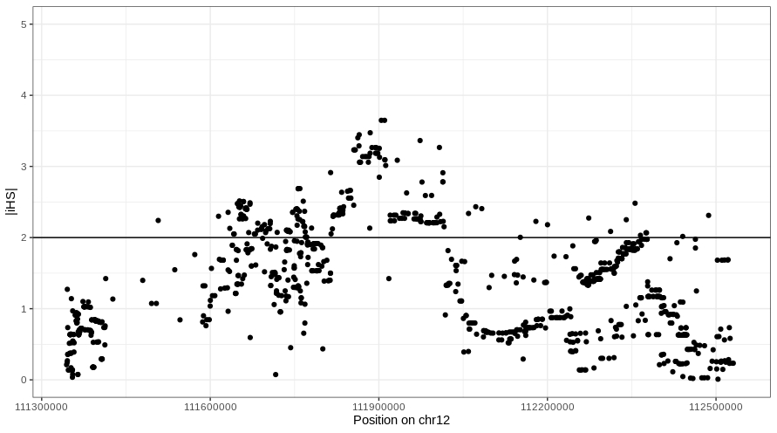
(A)

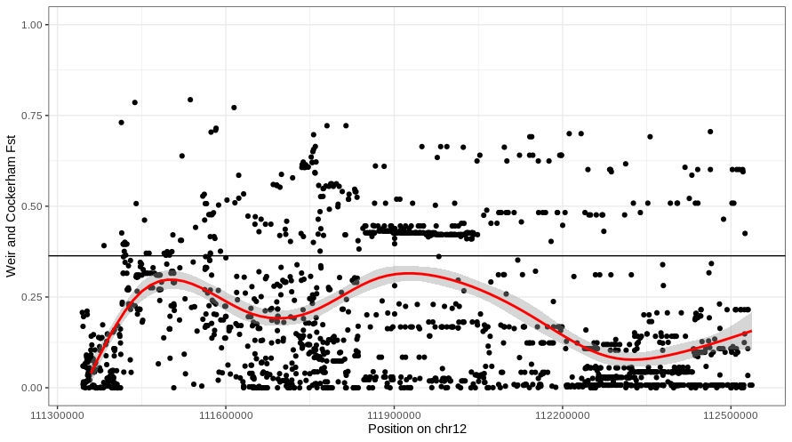
(B)
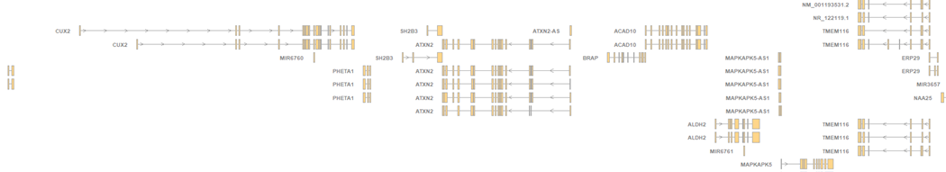

Supplementary Figure 2. Linkage disequilibrium (LD) plot of the SLE risk region SH2B3-ATXN2 at the chromosome region 12q24.12 for the populations GBR and CHB (for population details see Materials and Methods).
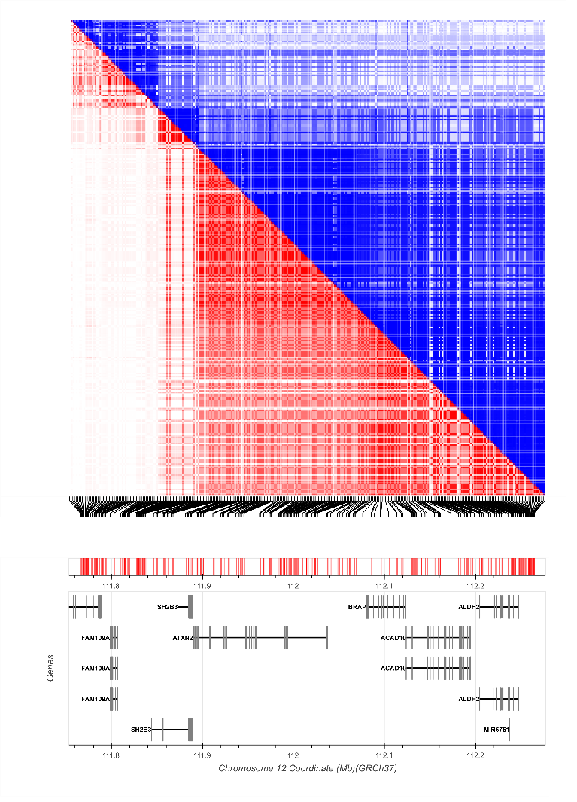
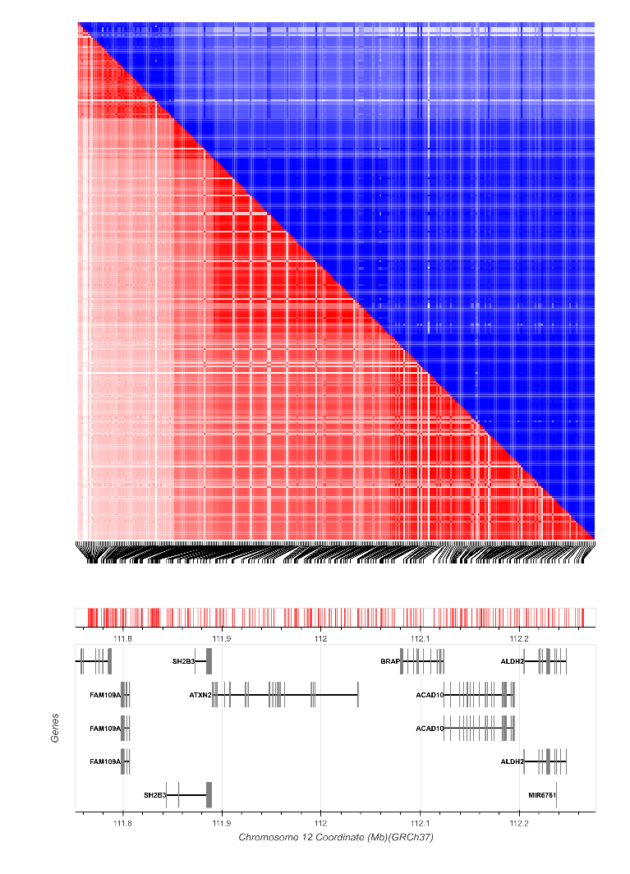
CHB
GBR

Supplementary Table 4. Genome wide association studies (GWASs) with reported susceptibility loci to SLE. Studies were retrieved using NHGRI–EBI GWAS catalog (https://www.ebi.ac.uk/gwas/).

PUBMEDID | STUDY | Studied population | REPORTED GENE(S)
18204098 | Association of systemic lupus erythematosus with C8orf13-BLK and ITGAM-ITGAX. | European | HLA-DQA1, STAT4, TNPO3, IRF5, ITGAM, ITGAX, C8orf13, BLK
18204446 | Genome-wide association scan in women with systemic lupus erythematosus identifies susceptibility variants in ITGAM, PXK, KIAA1542 and other loci. | European | HLA region, ITGAM, TNPO3, IRF5, KIAA1542, PXK
18204447 | Functional variants in the B-cell gene BANK1 are associated with systemic lupus erythematosus. | European | BANK1, TNFAIP3, STAT4, BLK
19165918 | Genetic variants near TNFAIP3 on 6q23 are associated with systemic lupus erythematosus. | European | TNFAIP3, STAT4, BLK
19357697 | Association of BANK1 and TNFSF4 with systemic lupus erythematosus in Hong Kong Chinese | Hong Kong Chinese | BANK1, TNFSF4
19838193 | Genome-wide association study in a Chinese Han population identifies nine new susceptibility loci for systemic lupus erythematosus. | Han Chinese | STAT4, TNFSF4, ETS1, BLK, IKZF1, IRF5, TNFAIP3, NR, UBE2L3, HIC2, RASGRP3, HLA-DRB1, PRDM1, ATG5, LRRC18, WDFY4, SLC15A4, TNIP1, HIP1, ZNF689, PRR14
19838195 | A large-scale replication study identifies TNIP1, PRDM1, JAZF1, UHRF1BP1 and IL10 as risk loci for systemic lupus erythematosus. | European | HLA-DRB1, STAT4, IRF5, ITGAM, BLK, TNIP1, TNFAIP3, PTPN22, PRDM1, JAZF1, PHRF1, TNFSF4, UHRF1BP1, IL10
20169177 | Genome-wide association study in Asian populations identifies variants in ETS1 and WDFY4 associated with systemic lupus erythematosus. | Han Chinese | WDFY4, ETS1
20662065 | Identification of candidate loci at 6p21 and 21q22 in a genome-wide association study of cardiac manifestations of neonatal lupus. | European | NFKBIL1, LTA, AIF1, TNF, LTB
21044949 | ELF1 is associated with systemic lupus erythematosus in Asian populations. | Han Chinese | ELF1
21408207 | Differential genetic associations for systemic lupus erythematosus based on anti-dsDNA autoantibody production. | European | TNXB, HLA-DRB3, STAT4, IRF5, ITGAM, HLA-DQA2, IRF5
22291604 | A genome-wide association study identified AFF1 as a susceptibility locus for systemic lupus erythematosus in Japanese. | Japanese | AFF1
23053960 | Genome-wide pathway analysis of genome-wide association studies on systemic lupus erythematosus and rheumatoid arthritis. | European | HLA-DQA2, TNPO3, STAT4, STAT4, BLK, IRF5
23273568 | Meta-analysis followed by replication identifies loci in or near CDKN1B, TET3, CD80, DRAM1, and ARID5B as associated with systemic lupus erythematosus in Asians. | Han Chinese | HLA-DRB1, STAT4, GPR19, DGUOK, TET3, CD80, TNFAIP3, BLK, UHRF1BP1, TNFSF4, CDKN1B, DRAM1, ARID5B, RTKN2, IRF5, WDFY4, CREBL2, ETS1
23740937 | A systemic sclerosis and systemic lupus erythematosus pan-meta-GWAS reveals new shared susceptibility loci. |  | TNPO3, IRF5, STAT4, PXK, KIAA0319L, ITGAM, IRF8, TNFAIP3, BLK, JAZF1, TNIP1, CSK
24163247 | Allelic heterogeneity in NCF2 associated with systemic lupus erythematosus (SLE) susceptibility across four ethnic populations | European, African-American, Hispanic, Korean | NCF2
24871463 | GWAS identifies novel SLE susceptibility genes and explains the association of the HLA region. | European | C2, HLA-DQA2, FAM98B, TYRO3, EDEM3, TNPO3, RNF114, ITGAM, IRF5, HLA-DQA1, STAT4, ZNF184, SPATA8
25338677 | Genetic analysis of the pathogenic molecular sub-phenotype interferon-alpha identifies multiple novel loci involved in systemic lupus erythematosus. | European | PRKG1, A1CF, CSTF2T
25620976 | Lupus risk variants in the PXK locus alter B-cell receptor internalization | European, African American, Asian, Hispanic | PXK
25862617 | Genome-wide search followed by replication reveals genetic interaction of CD80 and ALOX5AP associated with systemic lupus erythematosus in Asian populations. | Han Chinese | CD80
26301688 | Meta-analysis of shared genetic architecture across ten pediatric autoimmune diseases. | European | LPHN2, TNM3, ANKRD30A, IL23R, PTPN22, ATG16L1, DAG1, PTGER4, ZNF365, INS, SMAD3, NOD2, NKX2-3, ANKRD55, IL12B, LRRK2, IL5, SUOX, SBK1, ADCY7, IL2RA, CD40LG, TNFSF15, ZMIZ1, IL21, CARD9, FUT2, PSMG1
26316170 | Identification of a New Susceptibility Locus for Systemic Lupus Erythematosus on Chromosome 12 in Individuals of European Ancestry. | European | HLA-DQA1, HLA-DQB1, TNXB
26502338 | Genetic association analyses implicate aberrant regulation of innate and adaptive immunity genes in the pathogenesis of systemic lupus erythematosus. | European | MHC class III, STAT4, IRF5, TNPO3, TNXB, HLA-DQB1, DPCR, MUC21, SMG7, NCF2, ITGAM, IRF5, TNIP1, TNFAIP3, PTPN22, MIR146A, CD44, BLK, UBE2L3, YDJC, DHCR7, NADSYN1, TNFSF4, IRF8, BANK1, CIITA, SOCS1, CLEC16A, TCF7, SKP1, IRAK1, MECP2, ARHGAP4, NAA10, RENBP, HCFC1, TMEM187, MIR718, CSK, SCAMP5, PPCDC, ABHD6, PXK, PDHB, PRDM1, ATG5, IKZF1, TYK2, IKZF2, SLC15A4, UBE2L3, IRF7, HLA-DQ1, FCGR2A, SLC44A4, FCGR2A, FCGR2B, FCGR3B, TNFSF4, LOC100506023, WDFY4, IFIH1, IL12A, JAZF1, SPRED2, ARID5B, ETS1, FLI1, CXorf21, CSK, RAD51B, IRF7, LRRC56, LMNTD2, RASSF7, MIR210HG, PHRF1, CDHR5, LYST, PLD2, SH2B3, ATXN2, IL10, IKZF3, UHRF1BP1, HER-2, C17orf37, GRB7, ZNFN1A3, ZBPB2, GSDMB, IKZF3, ERBB2, CIITA, SOCS1
26606652 | Genome-Wide Association Study in an Amerindian Ancestry Population Reveals Novel Systemic Lupus Erythematosus Risk Loci and the Role of European Admixture. | Native American | TNPO3, IRF5, IRF5, ITGAM, IRAK1, HLA-DQA1, STAT4, HLA-DQB1, HLA-DRB1, TNIP1, LOC100506023, USMG5, BC040734, HLA-B, NCF2
26663301 | Identification of a Systemic Lupus Erythematosus Risk Locus Spanning ATG16L2, FCHSD2, and P2RY2 in Koreans. | Korean | STAT4, IKZF1, C7orf72, PERP, TNFAIP3, PRDX6, TNFSF4, HIP1, LOC392787, IRF5, ETS1, FCHSD2, P2RY2, ATG16L2, BLK, TMEM187, MECP2, IRAK1, WDFY4, TNFSF4, PRDX6
26980576 | Response to Intravenous Cyclophosphamide Treatment for Lupus Nephritis Associated with Polymorphisms in the FCGR2B-FCRLA Locus. | Korean | FCGR2B, FCRLA, FCGR3B, RPL31P11
27193031 | A combined large-scale meta-analysis identifies COG6 as a novel shared risk locus for rheumatoid arthritis and systemic lupus erythematosus. | European | PTPN22, TNPO3, IRF5, TNFAIP3, COG6, BLK, UBE2L3, ICAM3, TYK2
27399966 | Genome-wide association meta-analysis in Chinese and European individuals identifies ten new loci associated with systemic lupus erythematosus. | Han Chinese | MHC class III, STAT4, SMG7, NCF2, ITGAM, IRF5, TNIP1, BLK, JAK2, IRF8, TNFAIP3, LBH, TNFSF4, MIR146A, LPP, TPRG1-AS1, GTF2IRD1-GTF2I, UBE2L3, PTPN22, TYK2, PTPRC, CD45, ATXN1, PRDM1, ATG5, BACH2, IKBKE, CD44, FCGR2A, WDFY4, IRF7, UHRF1BP1, TCF7, SKP1, BANK1, RNASEH2C, CSK, IKZF2, ZFP90, TET3
29494758 | Genome-wide association study identifies three novel susceptibility loci for systemic lupus erythematosus in Han Chinese. | Han Chinese | KIT, TRAPPC11, GPR78
29848360 | Genome-wide association study meta-analysis identifies five new loci for systemic lupus erythematosus. | European | GRB2, SMYD3, LAT2, ARHGAP27, ST8SIA4
29967481 | Genetic variants in systemic lupus erythematosus susceptibility loci, XKR6 and GLT1D1 are associated with childhood-onset SLE in a Korean cohort. | Korean | XKR6, GLT1D1

Supplementary Table 5. 1000 Genomes populations and genetic ancestries included in the study (ftp://ftp-trace.ncbi.nih.gov/1000genomes/ftp/release/20130502/).

Number of individuals | Population code | Population  description | Super population | Super population code
99 | LWK | Luhya in Webuye, Kenya | Africa | AFR
113 | GWD | Gambians from The Gambia | Africa | AFR
99 | ESN | Esan in Nigeria | Africa | AFR
91 | GBR | British in England and Scotland | Europe | EUR
99 | FIN | Finnish in Finland | Europe | EUR
107 | TSI | Toscani in Italia | Europe | EUR
86 | BEB | Bengali from Bangladesh | South Asian | SAS
102 | ITU | Indian Telugu from the UK | South Asian | SAS
96 | PJL | Punjabi from Lahore, Pakistan | South Asian | SAS
103 | CHB | Han Chinese in Beijing, China | East Asian | EAS
104 | JPT | Japanese in Tokyo, Japan | East Asian | EAS
99 | KHV | Kinhin Ho Chi Minh City, Vietnam | East Asian | EAS

