Supplementary Figures and Figure Legends
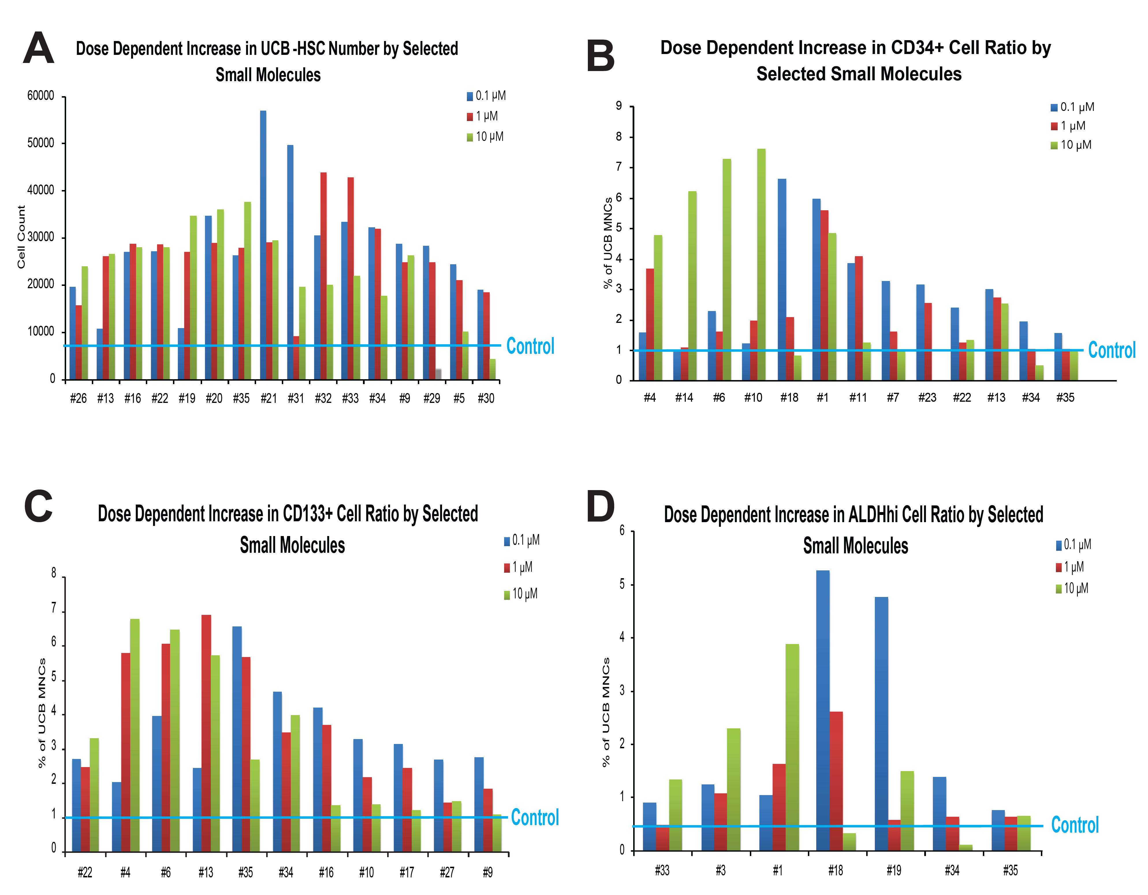
Supplementary Figure 1. Dose dependent effects of the prominent HSMs on UCB-HSPCs were shown for (a) total cell count, (b) CD34+, (c) CD133+ and (d) ALDH^{Br} cell ratio compared to DMSO control.

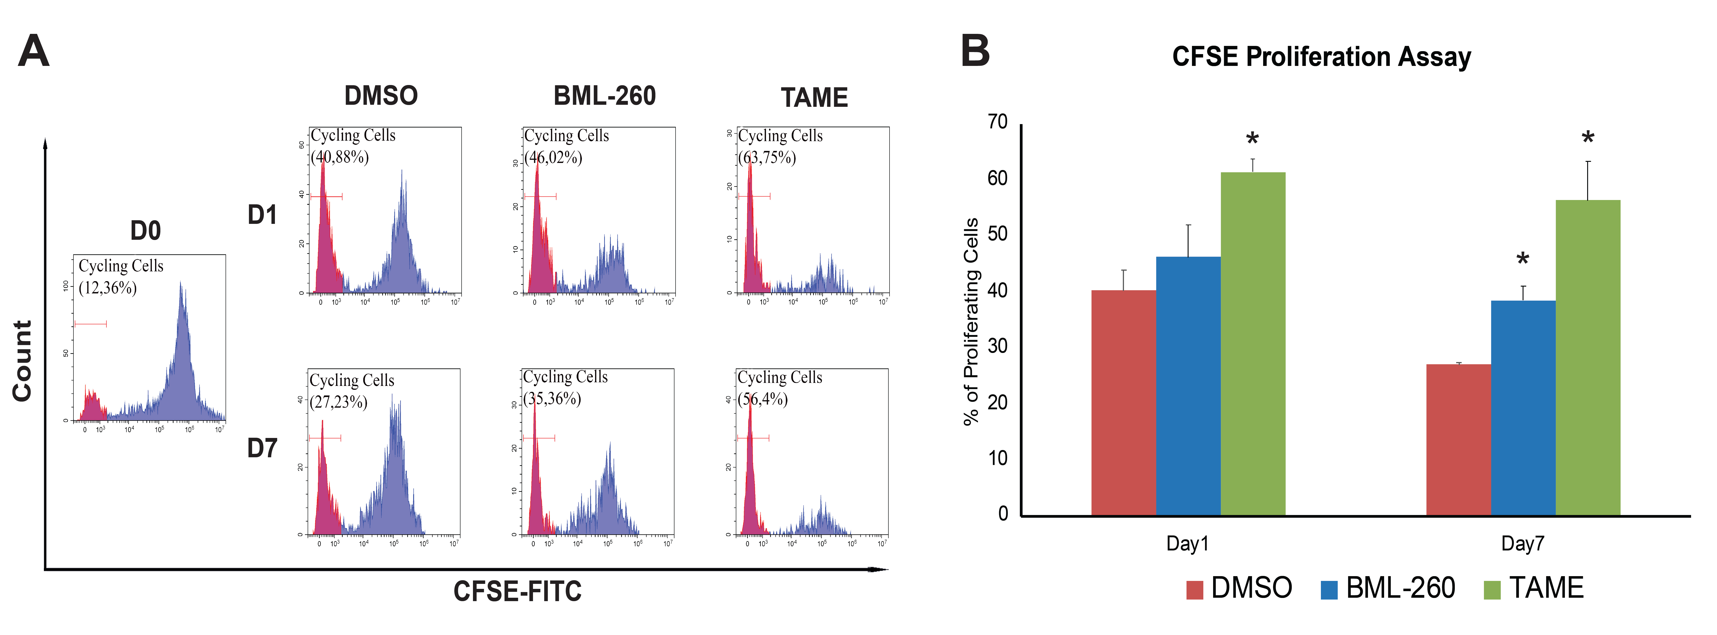
Supplementary Figure 2. Analysis of cell proliferation ability of HSM expanded-mPB-CD34+ cells by CFSE staining. (a) The representative histogram plots and (b) quantification of CFSE assays post 1 and 7 days of BML-260 and TAME treatments (n=3).

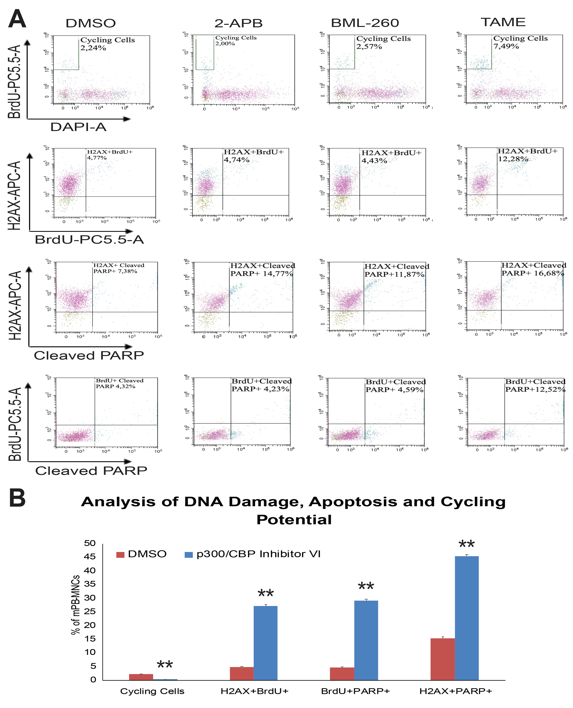Supplementary Figure 3. The genotoxicity assessment of HSM treated mPB-HSPCs. (a) The representative flow plots of genotoxicity assays for 2-APB, BML-260 and TAME treatments. (b) The quantification of cycling cell ratio, apoptosis (BrdU+PARP+) and DNA damage (H2AX+BrdU+) in cycling cells and the relation of DNA damage and apoptosis on the expanded cells (H2AX+PARP+) post p300/CBP inhibitor-VI compared to DMSO control (n=3, **p<0,01).

