Supplemental Figure legends

Fig. S1 GC-MS spectra of PHAs extracted from *Methylobacterium* sp. XJLW, A is the GC spectra while B shows the MS spectra of the 7.59 min peak in A.

Fig. S2 Comparison of 1H- spectra (A) and 13C-NMR spectra (B) between PHB standards and PHAs extracted from *Methylobacterium* sp. XJLW.

Fig. S3 Comparison of IR spectra between PHB standards and PHAs extracted from *Methylobacterium* sp. XJLW.

Fig. S4 LC-MS spectra of CoQ10 standards (A) and CoQ10 sampleextracted from *Methylobacterium* sp. XJLW (B).

 

**B**

**A**

**Fig. S1**

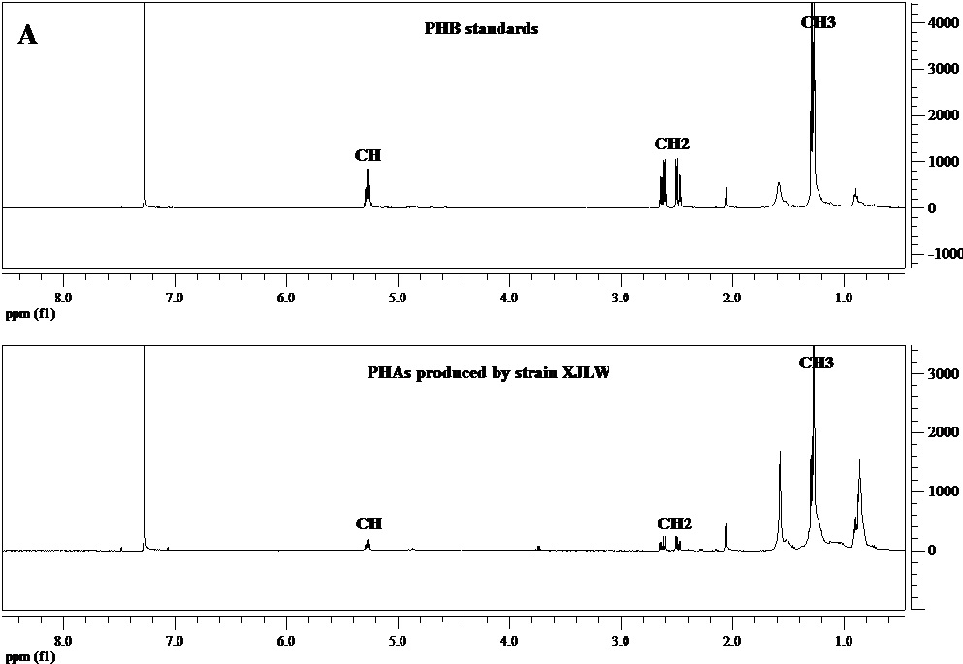 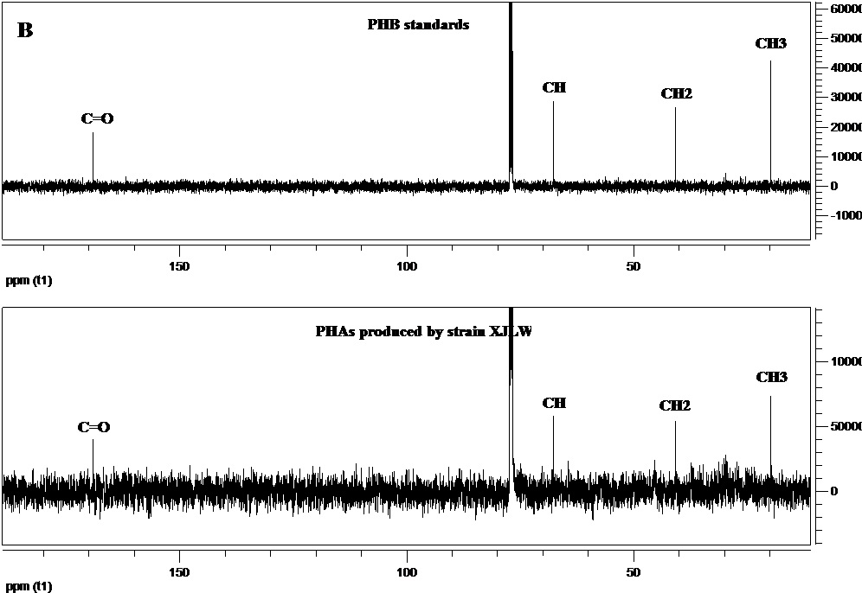

**Fig.S2**



**Fig.S3**

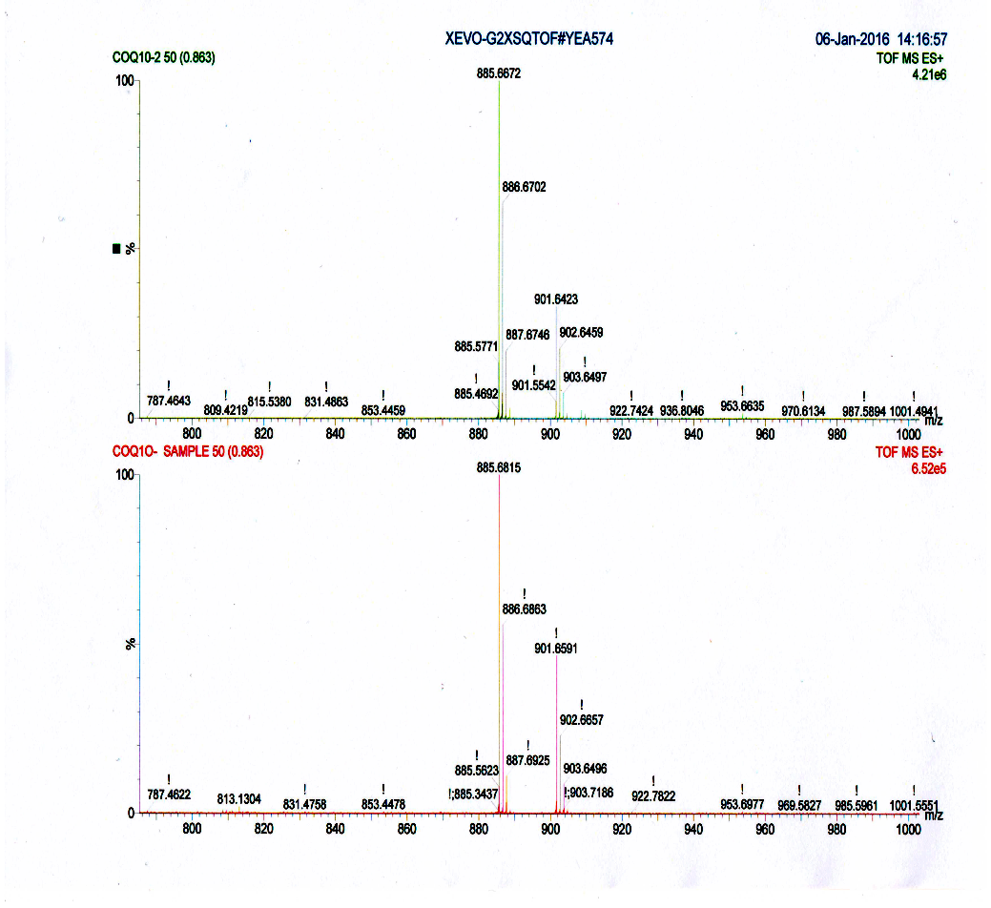

**B**

**A**

**CoQ10 from *M*.XJLW**

**CoQ10 standard**

**CoQ10 from *M*.XJLW**

**CoQ10 standard**

**[CoQ10+Na]+**

**[CoQ10+Na]+**

**Fig.S4**