Supplementary Data
Figure S1. Collection sites of seven Australian Ptr isolates from the field
Each collection site is depicted as a grain pictogram with the different colours representing isolates from different states. The exception is Western Australia, where the three blue Ptr strains were isolated from wheat whilst the yellow site represents a Ptr strain isolated from barley. All other Ptr strains were isolated from wheat. This figure was created using Map Data © 2021 Google.
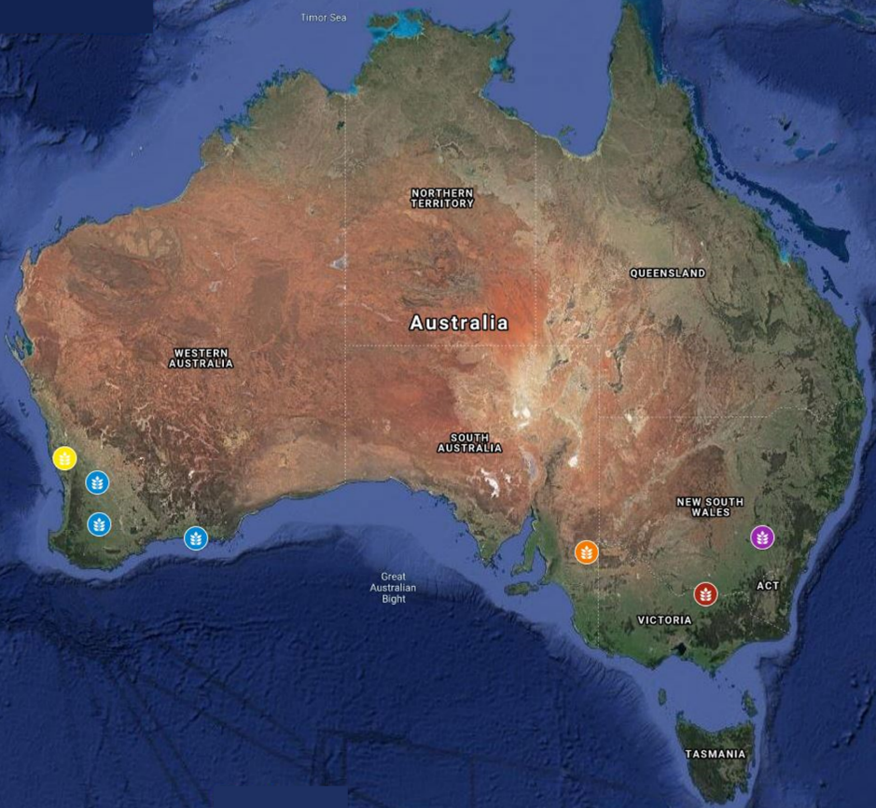

Table S1. Growth conditions tested for conidia production in Ptr
Parameters | Vegetative | Conidiophore | Conidia
Duration | 3, 5, 7, 10, 12, 14 days | 6, 12, 18, 24, 48 h | 6, 12, 18, 24, 48 h
Light Source | White, N-UV, UV-B, BLB, Darkness | White, N-UV, UV-B, BLB, Darkness | White, N-UV, Darkness
Light Cycle | 12h Light/Dark, Continuous | 12h Light/Dark, Continuous | 12h Light/Dark, Continuous
Temperature | 22-26C | 22-26C | 15-24C
Plate Lid | Sealed, Removed, Loose | Sealed, Removed, Loose | Sealed, Removed, Loose
Growth Media | V8-PDA, ½ PDA, TWA | V8-PDA, ½ PDA, TWA | -
Plug Location | Growing Edge, Total | - | -
Wounding | 200ul Tip End, 1ml Tip End, Cork Borers | - | -

Table S2. All harvesting parameters tested for purity and concentration in Ptr
Optimal values are underlined.

Stages | Tested parameters
Preparation | None, Remove Excess Agar
Solution | Gelatin at 5 %, 0.5 %, 0.05 %, Tween 20 at 2 %, 0. 2%, 0.02 %, H₂O
Release | None, Tip Scraping, Scalpel Scraping, Vortexing, Shaker Rack, Centrifuge, Large Brush, Small Brush
Extraction | Regular Pipetting, Pouring, Pipetting with a cut tip, direct pour followed by washing with a cut tip
Purification | None, Gauze, cheesecloth, sorbitol gradient, 4000 rpm spin, 1000 rpm spin,
Concentration | None, 4000 rpm spin, 1000 rpm spin

