An interdisciplinary exploration of responsible algorithm design in the era of distributed energy resources – Supplementary Materials

Social science research activity

Participant demographics

The citizens FDG cohort were evenly split along gender lines but overall participants tended to be on the older side (only 11% were in the 18-34 age bracket). 31% had Secondary and Vocational school education, two participants held a diploma while the remainder had a university qualification. 60% of participants owned their own renewable technology and 70% of participants were owner-occupiers. 16% lived in apartments or townhouses. As such, even while we did have representation from participants who were not living in detached houses, our cohort tended to underrepresent apartment dwellers, young people and renters, which presents a limitation to the scope of work and analysis. For future research, modes of recruitment should pay particular attention to these groups.

Focus group discussion questions

For researchers interested in conducting a similar research design, we provide the questions that we drew on for the FGD, noting that the discussions were semi-structured and so the facilitator also asked follow up questions in response to participants input that are not included here.

The FGD questions for energy professionals were:
- What do you see as the benefits of having storage at the 100kW - 1MW scale?
- Who could own these assets?
- Who could operate them?
- What are the regulations that would need to be reviewed if storage were to be rolled out at the neighbourhood scale?
- What are some practical issues we would need to consider? Here you might like to think of what new rules we would need, and whether there would be some stakeholders that may be inhibited. (Prompts: maintenance, location of the asset, end of life)
- 6: How could energy customers/users be involved? (prompt: as investors, direct users, not at all?)

The FGD script and questions for citizens were:
- What does energy mean to you? (Designed as an icebreaker question.)

- We are interested to hear your thoughts about the potential for us to have battery storage at the community level. At the moment, people can buy batteries for their homes to store their excess solar they don’t use during the day. But a lot of people are excluded from this because they don’t own their homes, they can’t afford it, they live in an apartment or their rooflines don’t work for solar panels. It is also possible that, having bigger batteries on the street might be cheaper overall for reducing everyone’s bills. Batteries at the 5MW and smaller scale can also help in places where the network is struggling or where there is a lot of solar which is creating challenges for a grid where energy was only expected to flow in one direction. Currently there are some rules that make this a more expensive solution, so there are some barriers to making it work. But given, some of this brief information, what are your initial thoughts about the idea of having a shared battery in our neighbourhoods?

- There are at least two options for how community might be involved in a shared battery. We’ll explore them one by one to hear your thoughts.
  - Firstly: The shared battery could be linked to your energy bill. For instance, if you had excess solar, you could store this in the battery for later use. If you didn’t own solar, you could still use the battery, for instance by having the battery charge from off peak power over night and supply energy to you during peak times. The energy supplied from the battery would be cheaper than what you currently pay.
    - What might be some advantages and disadvantages of this model?
    - Do you think it would be fair for solar owners to get a generous feed in tariff to be in this scheme? Or could this further entrench the divide between the solar haves/have nots?
    - Under this scenario, who would you like to be delivering this bill to you?

  - Secondly, another option is that the shared battery is not linked to your energy bill, but individual community members or community organisations invest and own it. The battery would then buy and sell power to the various electricity markets.
    - What would be the criteria for getting the opportunity to invest in the battery?
    - Would you like to see a portion of the profits be invested into community facilities?
    - Who would manage the battery on behalf of the investors?
    - Another option is that your local network might own a significant part of the battery. This would help them save on network upgrades etc, which then brings down the price for everyone. The network savings should happen regardless of whether the network owns it. But the network could be a good option for the ongoing maintenance and safety checks required, because this is similar to the work they already do in maintaining poles, wires, pipelines, substations etc.

- If you were part of a shared battery scheme and there was a power outage, would you be comfortable with the battery providing power to everyone? The small capacity of the battery means it wouldn’t be able to service everyone for a long time. Or, perhaps you could elect for it to power critical, vulnerable or community spaces such as a nursing home, or local library?

- Are there any practical concerns that you have about the idea of having a shipping container sized battery in your neighbourhood?

Techno-economic modelling method
To demonstrate the generality of our techno-economic modelling findings we present results for the months of April and July 2018.

Figures S1, S2 show the financial outcomes of the different algorithms for customers (left) and the owner of the NSB (right) for one month of operation. As in the main article, the profit maximising algorithm (blue striped bars) generates the greatest revenue for the NSB owner with the smallest benefit for customers, while the self-sufficiency algorithm leads to a net cost for the NSB owner (yellow diagonal hatches) while saving customers the greatest amount, and the cost minimising algorithm producing the best collective outcome for all customers and the NSB owner.

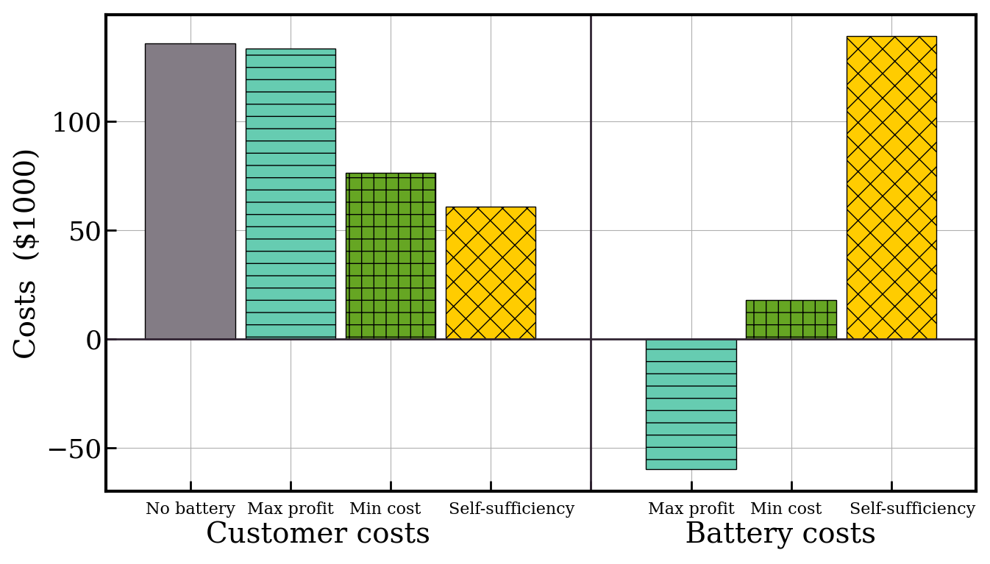
Fig. S1. The total cost of electricity to customers (left) and to the NSB (right) for operation in April. Values are simply electricity price multiplied by electricity consumption/generation, with negative costs indicating revenues. Results show four scenarios: without a NSB, and with a NSB operated by algorithms pursuing three different objectives.

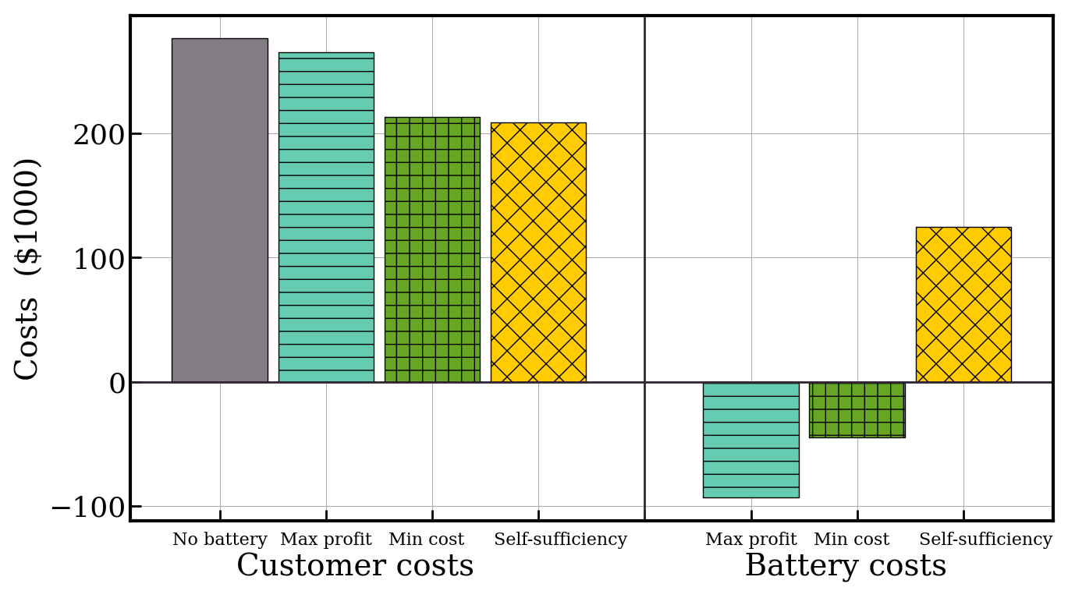
Fig. S2. The total cost of electricity to customers (left) and to the NSB (right) for operation in July. Values are simply electricity price multiplied by electricity consumption/generation, with negative costs indicating revenues. Results show four scenarios: without a NSB, and with a NSB operated by algorithms pursuing three different objectives.

Lastly, Figs. S3, S4 quantify the impact of the different algorithms on the grid. The boxplots show the power imports and exports during each interval of the months. As in January, the self-sufficiency algorithm maximally reduces the stress on the grid, reducing the average and peak amounts of excess solar power leaving the local area and the power imported from outside. The figures underscore the susceptibility of the financially oriented algorithms to create extreme peak power strains on the grid, which are particularly pronounced in the profit maximising algorithm. In all cases the self-sufficiency algorithm has the best impact on the grid.

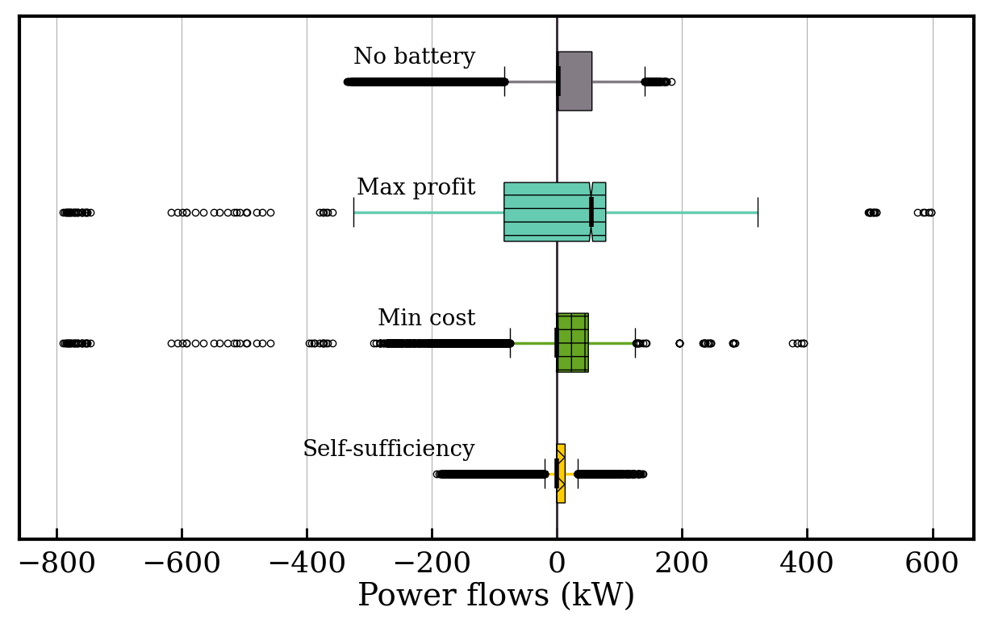
Fig. S3. Statistical spread of the net load on the local community (customers and NSB) across April, considering three NSB operation algorithms or the absence of the NSB. Positive (negative) values indicate flows into (out of) the local community.

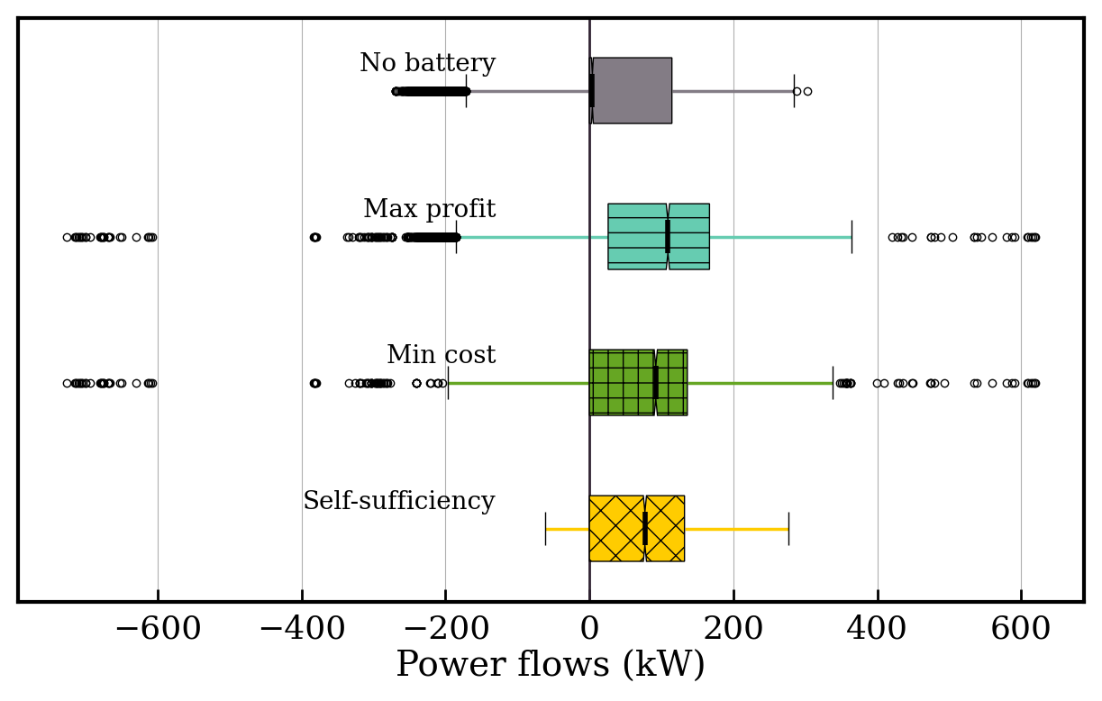
Fig. S4. Statistical spread of the net load on the local community (customers and NSB) across July, considering three NSB operation algorithms or the absence of the NSB. Positive (negative) values indicate flows into (out of) the local community.

