Supplementary Information
Altered microRNA expression in COVID-19 patients enables identification of SARS-CoV-2 infection
Ryan J. Farr¹, Christina L. Rootes¹, Louise C. Rowntree², Thi H.O. Nguyen², Luca Hensen², Lukasz Kedzierski^{2,5}, Allen C. Cheng^{3,4}, Katherine Kedzierska^{2,6}, Gough G. Au¹, Glenn A. Marsh¹, Seshadri S. Vasan¹, Chwan Hong Foo⁷, Christopher Cowled¹, Cameron R. Stewart^{1#}
- CSIRO Health & Biosecurity, Australian Centre for Disease Preparedness, Private bag 24, Geelong 3220, Victoria, Australia
- Department of Microbiology and Immunology, University of Melbourne, at the Peter Doherty Institute for Infection and Immunity, Melbourne 3000, Victoria, Australia.
- School of Public Health and Preventive Medicine, Monash University, Melbourne, Victoria, Australia.
- Infection Prevention and Healthcare Epidemiology Unit, Alfred Health, Melbourne, Victoria, Australia.
- Faculty of Veterinary and Agricultural Sciences, University of Melbourne, Melbourne, Victoria, Australia.
- Global Station for Zoonosis Control, Global Institution for Collaborative Research and Education (GI-CoRE), Hokkaido University, Sapporo, Japan
- Exios Bio LLC, Conshohocken, PA, USA.
#Correspondence to Cameron R. Stewart, CSIRO Health & Biosecurity, Australian Centre for Disease Preparedness, Private Bag 24, Geelong 3220, Victoria, Australia. cameron.stewart@csiro.au.

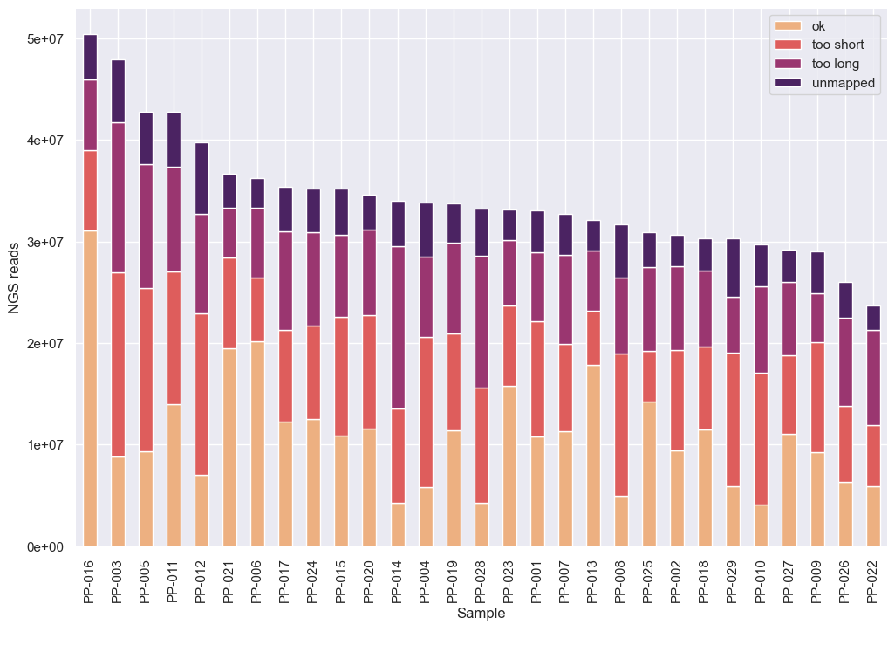
Supplementary Figure 1: After adaptor trimming, reads that fell outside the expected size range for miRNAs (18-26 nt) were filtered out, as were reads that failed to map to a miRNA precursor.

Supplementary Table 1. Differentially expressed miRNAs in V1 COVID-19 patients
MicroRNA | Log2 Fold Change | P-value | Adjusted P-value
hsa-miR-766-3p | -3.21286 | 6.44E-10 | 2.95E-07
hsa-miR-651-5p | -4.21545 | 2.75E-06 | 0.000631
hsa-miR-1275 | -5.48443 | 8.11E-06 | 0.001241
hsa-let-7e-5p | 1.377425 | 2.34E-05 | 0.002687
hsa-miR-3198 | -3.78907 | 3.12E-05 | 0.002869
hsa-miR-195-5p | 2.358879 | 4.38E-05 | 0.003354
hsa-miR-627-5p | -4.48848 | 6.23E-05 | 0.003576
hsa-miR-4662a-5p | -2.50778 | 5.95E-05 | 0.003576
hsa-miR-3684 | -4.76149 | 0.000173 | 0.007946
hsa-let-7a-5p | 1.0124 | 0.000169 | 0.007946
hsa-miR-483-5p | 2.550091 | 0.000205 | 0.008575
hsa-miR-3125 | 6.252678 | 0.000229 | 0.00876
hsa-miR-3617-5p | -5.45059 | 0.00035 | 0.010311
hsa-miR-500b-3p | -4.96428 | 0.000494 | 0.010311
hsa-miR-664b-3p | -4.05027 | 0.000298 | 0.010311
hsa-miR-5189-3p | -3.84697 | 0.000485 | 0.010311
hsa-miR-6772-3p | -3.63046 | 0.000421 | 0.010311
hsa-miR-145-3p | -3.58149 | 0.000462 | 0.010311
hsa-miR-30a-5p | 1.134764 | 0.00039 | 0.010311
hsa-miR-27a-5p | 4.318811 | 0.000442 | 0.010311
hsa-miR-2116-3p | 4.390754 | 0.000432 | 0.010311
hsa-miR-31-5p | 6.509967 | 0.000316 | 0.010311
hsa-miR-4772-3p | -3.69055 | 0.000521 | 0.010403
hsa-miR-1290 | 2.351267 | 0.00059 | 0.011278
hsa-miR-1226-3p | -3.93577 | 0.000726 | 0.013326
hsa-miR-589-3p | -4.13788 | 0.000789 | 0.013412
hsa-miR-210-3p | -3.42172 | 0.000776 | 0.013412
hsa-miR-103a-3p | 0.759379 | 0.00082 | 0.013436
hsa-miR-3115 | -4.1628 | 0.000968 | 0.015325
hsa-miR-769-3p | -3.94101 | 0.001136 | 0.015806
hsa-miR-320b | 1.367456 | 0.001052 | 0.015806
hsa-miR-193a-5p | 2.618751 | 0.00112 | 0.015806
hsa-miR-206 | 3.499758 | 0.001136 | 0.015806
hsa-miR-873-5p | -3.89657 | 0.001308 | 0.017152
hsa-miR-148a-3p | 1.076395 | 0.001274 | 0.017152
hsa-miR-3913-5p | -3.46608 | 0.00142 | 0.017672
hsa-miR-320a-3p | 0.881589 | 0.001425 | 0.017672
hsa-miR-576-5p | 1.606005 | 0.00148 | 0.017882
hsa-miR-197-3p | 1.427729 | 0.001568 | 0.018452
hsa-miR-4742-3p | 5.005176 | 0.001674 | 0.019211
hsa-miR-423-5p | 0.869915 | 0.00177 | 0.019812
hsa-miR-28-5p | -2.90744 | 0.001873 | 0.020377
hsa-miR-320c | 1.316571 | 0.001909 | 0.020377
hsa-miR-551b-3p | -2.99277 | 0.002173 | 0.022674
hsa-miR-142-3p | 1.127168 | 0.00223 | 0.022748
hsa-let-7i-3p | -2.711 | 0.00251 | 0.025046
hsa-miR-92a-3p | 0.995885 | 0.002748 | 0.026838
hsa-miR-548k | -4.01054 | 0.002948 | 0.02819
hsa-miR-18a-3p | -4.18347 | 0.00305 | 0.028575
hsa-miR-491-5p | -2.72341 | 0.003523 | 0.032344
hsa-miR-6721-5p | 2.649822 | 0.003784 | 0.034055
hsa-miR-6503-3p | -3.44108 | 0.004569 | 0.040326
hsa-miR-3065-3p | -3.16935 | 0.005048 | 0.043718
hsa-miR-150-5p | -1.06201 | 0.005553 | 0.046345
hsa-let-7f-5p | 0.824654 | 0.005516 | 0.046345

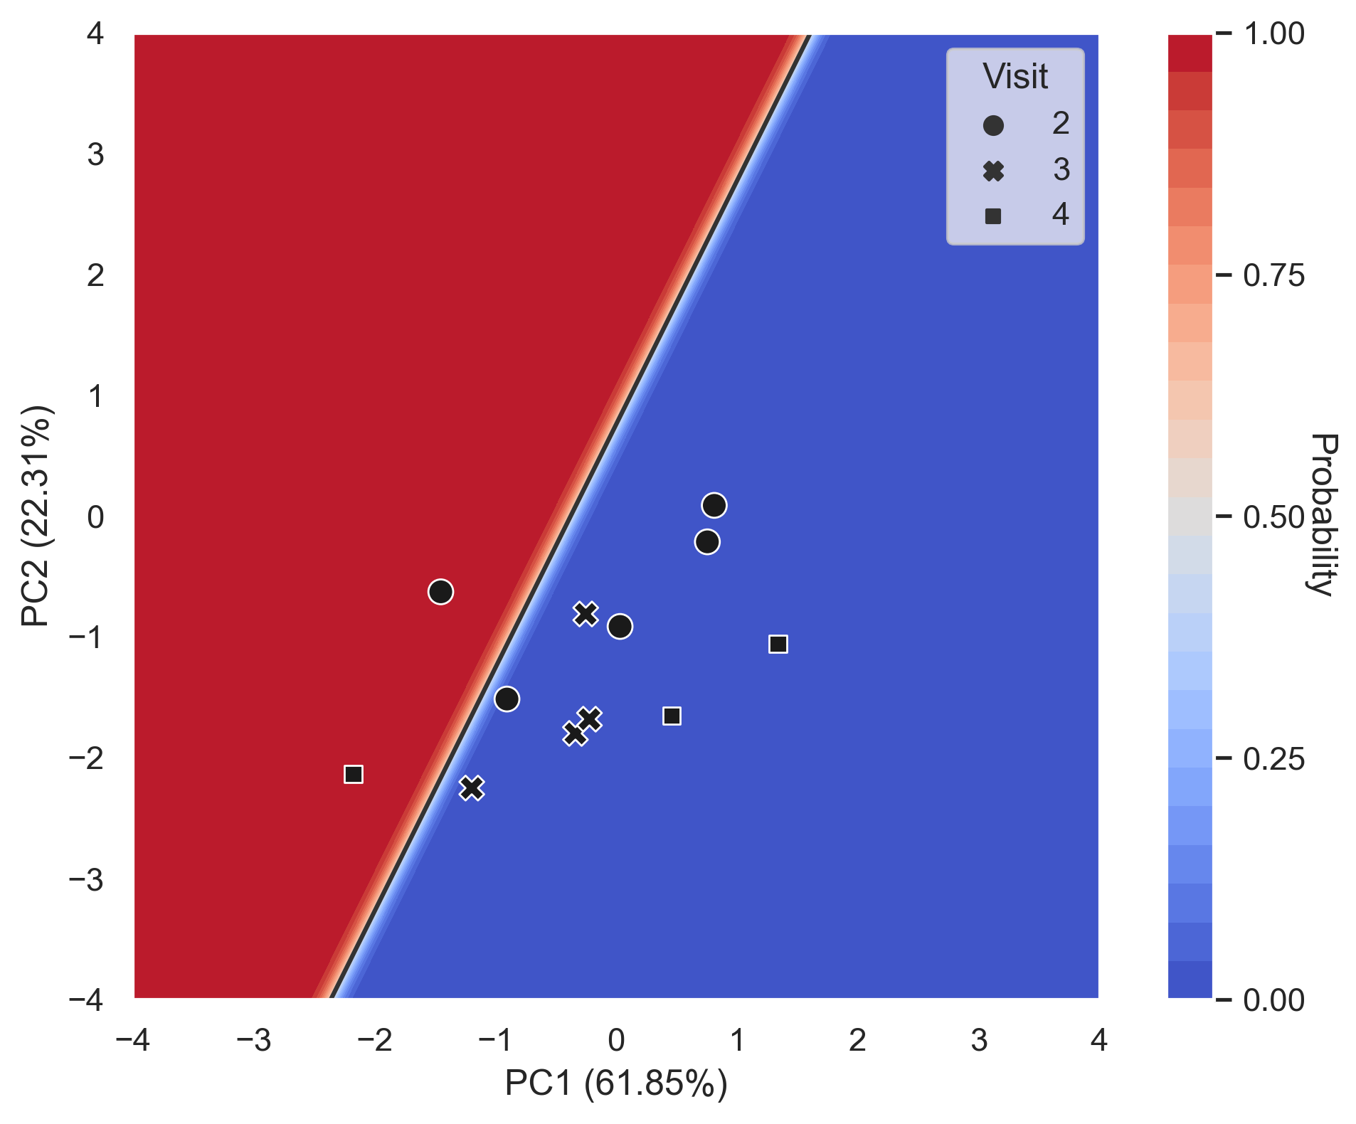
Supplementary Figure 2. Application of the V1 COVID-19 miRNA signature to subsequent time points. Decision boundary graph showing the logistic regression decision point (solid black line) and the probability a person is infected with SARS-CoV-2 (blue to red shading). Datapoints are COVID-19 patients at V2 (circles, n=5), V3 (crosses, n=4), and V4 (squares, n=3).

Supplementary Table 2: Human cytokine data
Sample ID | Condition | Visit | IL-1β | IFNα2 | IFNγ | TNFα | MCP1 | IL-6 | IL-8 | IL-10 | IL-12 | IL-17a | IL-18 | IL-23 | IL-33
PP-001 | COVID | 2 | 15.46 | 14.94 | 119.9 | 13.09 | 571.2 | 1.62 | 14.06 | 1.14 | 1.56 | <1.98 | 355.65 | 132.43 | <6.57
PP-002 | COVID | 2 | 2.14 | <1.46 | 5.21 | <2.25 | 1185 | 10.98 | 18.36 | 337.96 | 1.6 | 3.32 | 262.69 | 6.16 | <6.57
PP-003 | HEALTHY | 1 | 1.9 | 5.84 | 6.6 | 3.03 | 1559 | 5.97 | 8.41 | 1.17 | 2.02 | 15.99 | 186.72 | 3.68 | 964.37
PP-004 | COVID | 1 | 5.09 | 17.01 | 29.48 | 42.68 | 730.19 | 35.52 | 13.81 | 8.44 | 6.02 | 24.87 | 183.12 | 9.17 | 89.38
PP-005 | COVID | 3 | <1.21 | <1.46 | <1.11 | <2.25 | 459.94 | <1.24 | 39.84 | 1.17 | <1.44 | 2.13 | 8.17 | 6.16 | <6.57
PP-006 | HEALTHY | 1 | <3.22 | <3.04 | <3.01 | 4.08 | 269.44 | 10.32 | 14.32 | 4.93 | 4.26 | 3.46 | 97.31 | <5.32 | <68.00
PP-007 | COVID | 1 | 7.79 | 10.17 | 2.89 | 3.7 | 363.32 | <1.24 | 14.81 | <1.12 | 2.53 | 7.79 | 106.51 | 5.7 | <6.57
PP-008 | COVID | 1 | <1.21 | 20.8 | 74.34 | 15.82 | 3493 | 32.54 | 14.56 | 7.56 | 2.1 | <1.98 | 718.84 | 4.43 | <6.57
PP-009 | COVID | 3 | <3.75 | <4.55 | 39.97 | 6.81 | 1198 | 59.51 | 26.15 | 9.54 | <2.51 | 4.64 | 6967 | 20.7 | 31.29
PP-010 | COVID | 2 | 4.52 | 10.1 | 36.35 | 46.68 | 2256 | 314.71 | 72.38 | 10.76 | 6.65 | 20.36 | 287.41 | 19.69 | 70.54
PP-011 | HEALTHY | 1 | <1.21 | <1.46 | 2.7 | <2.25 | 1156 | <1.24 | 129.98 | <1.12 | <1.44 | <1.98 | 42.13 | 2.1 | <6.57
PP-012 | HEALTHY | 1 | 24.38 | 7.29 | 75.08 | 11 | 528.48 | 7.85 | 35.95 | 11.25 | 7.71 | 22.64 | 144.68 | 147.71 | 97.97
PP-013 | COVID | 4 | 4.93 | <1.46 | <1.11 | <2.25 | 1101 | 1.33 | 56.25 | <1.12 | 1.75 | 22.9 | 440.39 | 5.26 | <6.57
PP-014 | HEALTHY | 1 | 5.7 | 4.09 | 6.85 | 71.12 | 496.84 | 3.23 | 12.35 | 5.23 | 7.57 | <2.25 | 126.32 | <5.32 | <68.00
PP-015 | COVID | 1 | 20.22 | 20.67 | 140.57 | 20.73 | 223.86 | 13.53 | 23.28 | <1.12 | 4.17 | <1.98 | 920.08 | 325 | <6.57
PP-016 | COVID | 3 | 16.54 | 15.91 | 97.65 | 9.44 | 509.95 | <1.24 | 8.9 | <1.12 | <1.44 | <1.98 | 142.27 | 224.55 | <6.57
PP-017 | COVID | 3 | 4.71 | 14.55 | 20.23 | 33.33 | 733.33 | 7.62 | 13.81 | 7.7 | 6.12 | 17.09 | 76.38 | 11.5 | 56.93
PP-018 | COVID | 2 | <3.75 | <4.55 | 53.14 | <4.91 | 1276 | 22.82 | 15.81 | 19.8 | <2.51 | <3.75 | 413.19 | <6.87 | <24.64
PP-019 | HEALTHY | 1 | 9.66 | 14.93 | <3.01 | 5.28 | 328.32 | 6.57 | 10.15 | 4.35 | 5.51 | 72.63 | 148.95 | 19.75 | 70.92
PP-020 | HEALTHY | 1 | 5.28 | 11.61 | 31.48 | 8.27 | 1764 | 10.41 | 160.89 | 11.38 | 3.74 | 37.12 | 745.01 | 8.45 | 677.62
PP-021 | COVID | 4 | 1.26 | 2.96 | 4.95 | 21.54 | 290.29 | <1.24 | 3.43 | 1.32 | 1.63 | 3.44 | 32.16 | 4.05 | <6.57
PP-022 | COVID | 1 | 2.06 | 1.64 | 7.51 | <2.25 | 889.54 | 29.2 | 22.38 | 658.39 | <1.44 | <1.98 | 64.81 | 8.73 | <6.57
PP-023 | HEALTHY | 1 | 20.35 | 16.6 | 68.93 | 13.45 | 495.84 | 6.08 | 30.03 | 18.79 | 12.3 | 4.02 | 155.21 | 29.3 | 1523
PP-024 | COVID | 2 | 9.23 | 12.71 | 6.02 | 7.08 | 281.32 | 2.29 | 21.49 | 1.46 | 2.88 | 11.18 | 147.81 | 9.88 | <6.57
PP-025 | HEALTHY | 1 | 3.09 | 5.25 | 4.44 | 5.04 | 209.42 | 11.74 | 11.13 | <1.12 | 3.73 | 3.69 | 68.93 | 3.33 | <6.57
PP-026 | COVID | 1 | <3.75 | <4.55 | 8.2 | <4.91 | 1276 | 23.93 | 12.28 | 7.14 | 2.58 | <3.75 | 538.86 | 10.7 | <24.64
PP-027 | HEALTHY | 1 | 9.2 | <3.04 | <3.01 | 51.79 | 291.04 | <2.52 | 16.36 | 4.16 | 4.14 | <2.25 | 66.21 | <5.32 | <68.00
PP-028 | COVID | 1 | <1.21 | <1.46 | 1.98 | <2.25 | 507.64 | 1.33 | 81.96 | 1.6 | <1.44 | 2.64 | 35.52 | 4.05 | 13.09

All data presented as pg/ml. < indicates that the sample was below the limit of detection for the assay. Results for PP-028 were unavailable.
Supplementary Table 3. Differentially expressed miRNAs in COVID patients with and without oxygen therapy compared to healthy controls.
COVID | Log2 Fold Change | P-value | Adjusted P-value
hsa-miR-766-3p | -4.19225 | 5.21E-12 | 2.07E-09
hsa-miR-106b-5p | -5.75169 | 1.18E-08 | 2.35E-06
hsa-miR-99b-3p | -3.52661 | 1.94E-08 | 2.58E-06
hsa-miR-1273h-3p | -3.47899 | 1.88E-06 | 0.000187
hsa-let-7a-3p | -3.64017 | 7.23E-06 | 0.000575
hsa-miR-6741-5p | -4.66624 | 6.12E-05 | 0.004057
hsa-miR-21-3p | -3.44342 | 0.00011 | 0.00625
hsa-miR-301b-3p | -6.45426 | 0.000371 | 0.015198
hsa-miR-7-1-3p | -3.99909 | 0.000385 | 0.015198
hsa-miR-148b-5p | -3.87087 | 0.00042 | 0.015198
hsa-miR-576-5p | 2.354226 | 0.000358 | 0.015198
hsa-miR-3198 | -4.41744 | 0.000482 | 0.015548
hsa-miR-4662a-5p | -2.83107 | 0.000508 | 0.015548
hsa-miR-6772-3p | -4.9359 | 0.00062 | 0.017631
hsa-miR-197-3p | 2.047464 | 0.000746 | 0.019795
hsa-miR-874-3p | -3.19538 | 0.000812 | 0.020193
hsa-miR-889-3p | -2.89213 | 0.00092 | 0.02035
hsa-miR-92a-3p | 1.44452 | 0.000909 | 0.02035
hsa-miR-651-5p | -3.9583 | 0.001144 | 0.023966
hsa-miR-500b-3p | -6.2643 | 0.001854 | 0.027356
hsa-miR-769-3p | -5.6131 | 0.001856 | 0.027356
hsa-miR-1468-5p | -3.69357 | 0.001529 | 0.027356
hsa-miR-431-3p | -3.52784 | 0.001375 | 0.027356
hsa-miR-345-5p | -2.60138 | 0.001803 | 0.027356
hsa-miR-339-3p | -2.42465 | 0.001467 | 0.027356
hsa-miR-103a-3p | 1.002187 | 0.001654 | 0.027356
hsa-miR-30a-5p | 1.310467 | 0.001608 | 0.027356
hsa-miR-6503-3p | -5.32504 | 0.001956 | 0.027809
hsa-miR-4433b-5p | 1.183644 | 0.002065 | 0.028344
hsa-miR-542-5p | -4.36027 | 0.002429 | 0.03222
hsa-miR-627-5p | -4.89716 | 0.002562 | 0.032613
hsa-miR-4750-5p | -3.32802 | 0.002786 | 0.032613
hsa-miR-132-3p | -3.32335 | 0.002759 | 0.032613
hsa-miR-877-5p | -1.82536 | 0.002731 | 0.032613
hsa-miR-1255b-5p | -4.41336 | 0.003407 | 0.036653
hsa-miR-1290 | 2.61842 | 0.003234 | 0.036653
hsa-miR-450b-5p | 3.457641 | 0.003395 | 0.036653
hsa-let-7f-2-3p | -4.81708 | 0.004022 | 0.041125
hsa-let-7e-5p | 1.368144 | 0.00403 | 0.041125
hsa-miR-30a-3p | 2.784327 | 0.004248 | 0.042272
hsa-miR-23a-5p | -3.65232 | 0.005123 | 0.048547
hsa-miR-215-5p | 2.852478 | 0.005076 | 0.048547
COVID + Supplementary Oxygen | Log2 Fold Change | P-value | Adjusted P-value
hsa-miR-10a-3p | -4.14081 | 8.17E-07 | 0.000337
hsa-miR-766-3p | -2.78001 | 2.36E-06 | 0.000487
hsa-miR-651-5p | -4.34509 | 6.84E-05 | 0.008552
hsa-miR-150-5p | -1.66873 | 8.30E-05 | 0.008552
hsa-miR-4433b-5p | -1.15971 | 0.000176 | 0.012731
hsa-miR-206 | 4.319059 | 0.000185 | 0.012731
hsa-miR-195-5p | 2.532532 | 0.000281 | 0.016549
hsa-let-7e-5p | 1.403158 | 0.000423 | 0.021765
hsa-miR-320a-3p | 1.116713 | 0.000485 | 0.022202
hsa-miR-483-5p | 2.778292 | 0.000685 | 0.028224
hsa-miR-5189-3p | -4.60876 | 0.000869 | 0.032109
hsa-miR-98-5p | 1.053429 | 0.000935 | 0.032109
hsa-miR-200c-3p | 1.127342 | 0.001488 | 0.047153
hsa-miR-664b-3p | -4.41473 | 0.001729 | 0.047479
hsa-miR-96-5p | -3.88486 | 0.001725 | 0.047479

Green shading indicates DE miRNAs common to both comparisons.

Supplementary Figure 3. Detection of influenza (H1N1) genomic RNA in lung tissue (blue), nasal swab (orange), nasal wash (green) and serum (red) of infected ferrets (2-4 ferrets per time point). Data is presented as normalized CT on a reverse y-axis. Undetectable results are plotted as CT=40.

Supplementary Table 4. Differentially expressed miRNAs in ferrets infected with SARS-CoV-2 compared to uninfected ferrets.
MicroRNA | Log2 Fold Change | P-value | Adjusted P-value
hsa-miR-92a-3p | -3.40243 | 2.77E-51 | 8.32E-49
hsa-miR-486-5p | -4.56453 | 4.00E-50 | 6.00E-48
hsa-miR-30e-5p | 2.220567 | 9.42E-31 | 9.42E-29
hsa-miR-423-5p | -2.49659 | 2.47E-30 | 1.86E-28
hsa-miR-141-3p | 4.102239 | 2.60E-23 | 1.56E-21
hsa-miR-128-3p | -1.81219 | 2.07E-14 | 1.03E-12
hsa-miR-210-3p | 4.141206 | 2.84E-14 | 1.22E-12
hsa-miR-1-3p | 4.035272 | 1.15E-13 | 4.33E-12
hsa-miR-500a-3p | 2.387716 | 2.64E-11 | 8.80E-10
hsa-let-7b-5p | -1.33777 | 1.59E-10 | 4.35E-09
hsa-miR-22-3p | 2.434372 | 1.50E-10 | 4.35E-09
hsa-miR-3661 | 18.47553 | 2.10E-10 | 5.25E-09
hsa-miR-24-3p | 1.736326 | 3.73E-10 | 8.61E-09
hsa-miR-340-5p | 3.633067 | 7.96E-10 | 1.71E-08
hsa-miR-574-5p | 3.125416 | 2.53E-09 | 5.06E-08
hsa-let-7e-5p | 2.636013 | 4.96E-09 | 9.29E-08
hsa-miR-378c | 3.648634 | 5.47E-09 | 9.65E-08
hsa-miR-221-3p | 1.592029 | 7.81E-09 | 1.30E-07
hsa-miR-181c-3p | 4.132007 | 8.35E-09 | 1.32E-07
hsa-miR-30a-5p | 2.007322 | 1.96E-08 | 2.94E-07
hsa-miR-130a-3p | 4.152037 | 2.72E-08 | 3.89E-07
hsa-miR-1306-3p | -1.94074 | 5.95E-08 | 8.11E-07
hsa-miR-95-3p | 2.570983 | 7.48E-08 | 9.76E-07
hsa-miR-146a-5p | 1.378139 | 1.09E-07 | 1.36E-06
hsa-miR-195-5p | 3.626193 | 1.23E-07 | 1.48E-06
hsa-miR-27b-3p | 1.188622 | 1.82E-07 | 2.10E-06
hsa-miR-425-5p | -1.38106 | 2.67E-07 | 2.97E-06
hsa-miR-9-5p | -7.20819 | 2.97E-07 | 3.18E-06
hsa-miR-30a-3p | 4.165755 | 6.49E-07 | 6.71E-06
hsa-miR-4454 | 2.633807 | 9.61E-07 | 9.61E-06
hsa-miR-148b-3p | -1.48248 | 1.18E-06 | 1.14E-05
hsa-miR-599 | 4.236388 | 1.50E-06 | 1.40E-05
hsa-miR-379-5p | 4.442619 | 2.48E-06 | 2.25E-05
hsa-miR-142-5p | 1.209372 | 2.78E-06 | 2.45E-05
hsa-miR-451a | -1.97605 | 4.74E-06 | 3.95E-05
hsa-miR-191-3p | 2.163531 | 4.70E-06 | 3.95E-05
hsa-miR-223-5p | 2.236282 | 6.54E-06 | 5.30E-05
hsa-miR-196b-5p | 2.122202 | 1.08E-05 | 8.54E-05
hsa-miR-194-5p | 1.517522 | 1.13E-05 | 8.69E-05
hsa-let-7d-5p | 1.566595 | 2.20E-05 | 0.000165
hsa-miR-324-3p | -1.88195 | 3.07E-05 | 0.000219
hsa-miR-186-5p | -1.12431 | 3.00E-05 | 0.000219
hsa-miR-502-3p | 1.625416 | 3.37E-05 | 0.000235
hsa-miR-423-3p | -1.28775 | 6.88E-05 | 0.000463
hsa-miR-151b | 3.246396 | 6.94E-05 | 0.000463
hsa-miR-760 | 1.672519 | 8.44E-05 | 0.00055
hsa-miR-93-3p | -2.0878 | 8.93E-05 | 0.00057
hsa-miR-382-5p | 4.329109 | 0.000131 | 0.000818
hsa-miR-25-3p | -1.17445 | 0.000143 | 0.000877
hsa-miR-331-3p | 3.140441 | 0.000175 | 0.001048
hsa-miR-29c-3p | -1.31867 | 0.000212 | 0.001247
hsa-miR-320a-3p | 0.83899 | 0.00023 | 0.001328
hsa-miR-1277-5p | 3.844184 | 0.000264 | 0.001494
hsa-miR-320d | 1.458544 | 0.000344 | 0.001913
hsa-miR-769-5p | -1.67987 | 0.000359 | 0.001961
hsa-miR-320c | 1.215624 | 0.000399 | 0.002136
hsa-miR-3064-5p | 3.447122 | 0.000416 | 0.00219
hsa-miR-197-3p | -1.90611 | 0.000436 | 0.002258
hsa-miR-6529-5p | 1.035497 | 0.00052 | 0.002644
hsa-miR-146b-5p | 1.779472 | 0.000568 | 0.002841
hsa-miR-151a-3p | 0.94682 | 0.000617 | 0.003035
hsa-miR-378a-5p | 2.322497 | 0.00063 | 0.00305
hsa-miR-18a-3p | -3.53688 | 0.000659 | 0.003137
hsa-miR-27a-3p | 1.292027 | 0.000791 | 0.003709
hsa-miR-503-5p | -1.58755 | 0.000911 | 0.004206
hsa-miR-192-5p | 1.624728 | 0.000982 | 0.004465
hsa-miR-10a-3p | 3.552578 | 0.001061 | 0.00475
hsa-miR-147b-3p | 2.605864 | 0.001262 | 0.005566
hsa-miR-182-5p | 2.355723 | 0.00142 | 0.006173
hsa-miR-409-3p | 3.702095 | 0.00147 | 0.0063
hsa-miR-885-3p | 3.28422 | 0.001508 | 0.006372
hsa-miR-450b-5p | -3.14202 | 0.001579 | 0.006487
hsa-miR-106b-3p | -1.19454 | 0.001564 | 0.006487
hsa-miR-215-5p | 1.118426 | 0.001663 | 0.006744
hsa-miR-125a-3p | 3.884957 | 0.001698 | 0.006794
hsa-miR-542-3p | 2.479661 | 0.001726 | 0.006812
hsa-miR-30d-5p | 0.556115 | 0.001796 | 0.006997
hsa-miR-432-5p | 2.872645 | 0.001856 | 0.007137
hsa-miR-342-3p | -1.13623 | 0.001999 | 0.007592
hsa-let-7f-5p | 0.705477 | 0.00208 | 0.0078
hsa-miR-200a-3p | 1.697966 | 0.002144 | 0.007942
hsa-miR-30e-3p | 2.553678 | 0.002823 | 0.010328
hsa-miR-21-3p | 3.818532 | 0.003966 | 0.014335
hsa-miR-1843 | 2.786565 | 0.004319 | 0.015426
hsa-miR-150-5p | -1.59146 | 0.005053 | 0.017835
hsa-miR-320b | 0.883137 | 0.00622 | 0.021696
hsa-miR-26b-3p | 2.499836 | 0.006974 | 0.024047
hsa-miR-26b-5p | 0.892899 | 0.007316 | 0.02494
hsa-miR-499a-5p | 2.118508 | 0.007585 | 0.025566
hsa-miR-200b-5p | 3.430621 | 0.008099 | 0.026997
hsa-miR-125b-1-3p | 3.56792 | 0.008649 | 0.028515
hsa-miR-10b-5p | -1.33314 | 0.00912 | 0.029738
hsa-miR-219a-1-3p | 3.594186 | 0.010575 | 0.034112
hsa-miR-885-5p | 3.723072 | 0.011075 | 0.035346
hsa-miR-574-3p | 1.958175 | 0.011467 | 0.036212
hsa-miR-15b-3p | -1.17185 | 0.012126 | 0.037894
hsa-miR-449a | -7.85645 | 0.012722 | 0.038944
hsa-let-7b-3p | 3.199181 | 0.012693 | 0.038944
hsa-miR-32-5p | 2.424765 | 0.013387 | 0.040567
hsa-miR-339-5p | 0.562952 | 0.014345 | 0.042639
hsa-miR-130b-3p | 0.975159 | 0.014355 | 0.042639
hsa-miR-2114-5p | -4.79594 | 0.016771 | 0.048848
hsa-miR-19a-3p | 1.142888 | 0.016749 | 0.048848

Green shading indicates DE miRNAs that were also found in human patient plasma samples.

Supplementary Table 5. Other statistical comparisons
Table or Figure | Comparison | Test | Statistic | P-value
Table 1 | HEALTHY vs COVID-19 gender frequency | Chi-square | 0 | 1
Table 1 | HEALTHY vs COVID-19 age distribution | Normal distribution | 3.7193 | 0.1557
Table 1 | HEALTHY vs COVID-19 age distribution | Two-sided t-test | 0.0642 | 0.9495
Figure 1 | HEALTHY vs COVID-19 miR-4662a abundance | One-sided Mann-Whitney U | 68 | 0.0073
Figure 1 | HEALTHY vs COVID-19 miR-766-3p abundance | One-sided Mann-Whitney U | 66 | 0.0117
Figure 1 | HEALTHY vs COVID-19 IL-6 abundance | Normal distribution | 3.3598 | 0.1864
Figure 1 | HEALTHY vs COVID-19 IL-6 abundance | One-sided t-test | -3.3245 | 0.0021

