Supplemental data

Introduction of the Aspergillus fumigatus α-1,2-mannosidase MsdS into Trichoderma reesei leads to abnormal polarity and improves the ligno-cellulose degradation

Prakriti Sharma Ghimire^{#1,2,4}, Haomiao Ouyang^{#1}, Guangya Zhao^{1,2}, Mingming Xie^{1,2}, Hui Zhou¹, Jinghua Yang¹, Cheng Jin^{1,2,3}*

¹ State Key Laboratory of Mycology, Institute of Microbiology, Chinese Academy of Sciences, Beijing 100101, China; ² University of Chinese Academy of Sciences, Beijing 100101, China; ³ National Engineering Research Center for Non-food Bio-refinery, Guangxi Academy of Sciences, Nanning 530007, Guangxi, China; ⁴ Himalayan Environment Research Institute (HERI), Bouddha-6, Kathmandu, Nepal.

* To whom corresponding should be addressed: 1-3 West Beichen Road, Chaoyang District, Beijing 100101, China; Tel: +86-10-64807425; Fax: +86-10-64807429; e-mail: jinc@im.ac.cn.
# These authors made equal contributions to this work.

Author details
Prakriti SharmaGhimire: sharprakriti@gmail.com
Haomiao Ouyang: ouyanghm@im.ac.cn
Guangya Zhao: zhaoguangyazky@163.com
Mingming Xie: mingming_xie@139.com
Hui Zhou: zhouh@im.ac.cn
Jinghua Yang: yangjh@im.ac.cn

Fig.S1. LC-MS/MS results of the msdS-expressing mutant. Proteins extracted from the msdS-expressing mutant Tr-MsdS were separated by 10% SDS-PAGE and stained with Coomassie R-250. Proteins corresponding to 40~60 kDa were cut from polyacrylamide gels After in-gel digestion, peptides were subjected to an EASY-nLC 1000 interfaced via a Nanospray Flex ion source to an Orbitrap Fusion Tribrid mass spectrometer (Thermo Fisher Scientific). The peptides were loaded onto a trap column (C18, 5 μm particles, 100 μm ID, 3 cm length, Dr. Maisch GmbH) and separated using an analytical column (C18, 3 μm particles, 75 μm ID, 15 cm length, Dr. Maisch GmbH) at a flow rate of 400 nL/min with a 60 min LC gradient composed of Solvent A (0.1% formic acid (v/v)) and Solvent B (acetonitrile, 0.1% formic acid (v/v)). The gradient was 3-8% B for 5 min, 8-20% B for 40min, 20-35% B for 10 min, 35-80% B for 3 min, and finally 80% B for 2 min. A data-dependent Top20 method was used with precursor MS1 scan (m/z 350–1550) acquired in the Orbitrap at a resolution setting of 120,000, followed by Orbitrap HCD-MS/MS and ITHCD-MS/MS of the 20 most abundant multiply charged precursors in the MS1 spectrum.MS2 spectra were acquired at a resolution of 30,000. The sequences were identified by SEQUEST with FASTA database of Aspergillus fumigatus from NCBI.

Fig.S2. Confirmation of expression of MsdS in T. reesei with LC-MS/MS. Proteins extracted from the msdS-expressing strain Tr-MsdS were separated by 10% SDS-PAGE and stained with Coomassie R-250. Proteins corresponding to 40~60 kDa were cut from polyacrylamide gels and analyzed using LC-MS/MS. The sequences were identified by SEQUEST with FASTA database of Aspergillus fumigatus from NCBI.

Fig.S3. Alignment of A. fumigtus MsdS and T. reesei TRIREDRAFT_45717.
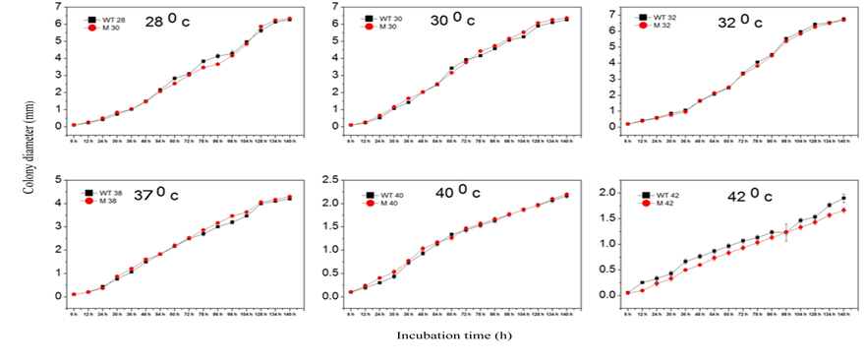
Fig.S4. Growth kinetics of the wild-type (WT) and Tr-MsdS strain. Change in colony diameter with different time when same amount of conidia were inoculated and incubated at the designated temperature.

Table S1. Thickness of the cell wall of parent and Tr-Msds cells.
Temperature | WT |  | Mutant
 | Hyphal (µm) | Conidia (µm) | Hyphal (µm) | Conidia (µm)
32⁰C | 0.06 | 0.06 | 0.14 | 0.07
 | 0.08 | 0.04 | 0.12 | 0.07
 | 0.08 | 0.07 | 0.11 | 0.09
37⁰C | 0.11 | 0.11 | 0.12 | 0.1
 | 0.12 | 0.12 | 0.19 | 0.12
 | 0.15 | 0.13 | 0.14 | 0.12

Mycelia and conidial cells were fixed as described in method section. The thickness of cell wall was measured under transmission electron microscopy (TEM) (JEM-1400).

Table S3. Primer pairs used for RT-PCR.

SN | Genes | Primer pair sequence (5’-3’)
1 | hac1 | FWD | CAGATAAGAAGCCTGCCAAGAA
 |  | REV | GACGCTGTTCCTTTTCATCTTC
2 | rho3 | FWD | ATACGGCGGGACAGGAGGAATT
 |  | REV | GTCGTAGGAAATCGTGGGCGGT
3 | sec61 | FWD | ATCCACACCGCCGTCTACATCA
 |  | REV | TTGGCAGCAATTTCAAAGTAGC
4 | rab5 | FWD | ATTGGAGCGGCTTTCCTCACCC
 |  | REV | GCTTATCGGGCTGTTCGTTGAC
5 | ftt1 | FWD | CAAACTCCTACCGTCAAAATGG
 |  | REV | GCCTCGATCTTCTGGCGGTACT
6 | ypt1 | FWD | TTCCGAACCATCACCTCGTCTT
 |  | REV | GGCGAGCCATGGTCAGGAAAGC
7 | snc1 | FWD | CGCCAGCAGGCACGCTCATTAG
 |  | REV | GGTGAGGGTTTGGGCGGTATGT

