Supplementary Information for
Peripheral members create and core members integrate: cooperation pattern of members in networks during co-creations

Authors: Kunhao Yang¹*, Itsuki Fujisaki^{1,2}, Kazuhiro Ueda¹*
¹ Graduate School of Arts and Sciences, The University of Tokyo, Tokyo, Japan (〒153-8902).
² Research Fellowship for Young Scientists (DC2), Japan Society for the Promotion of Science (JSPS), Tokyo, Japan (〒102-0083).
* Kunhao Yang, Kazuhiro Ueda
Email: yangkunhao@g.ecc.u-tokyo.ac.jp; ueda@gregorio.c.u-tokyo.ac.jp

This PDF file includes:

Supplementary text
Figures S1 to S4
Tables S1 to S2

Supplementary Information Text
S1. Statistical information about the regression models of the quality of content
Table S1 shows the statistics of all variables in the three regression models of the quality of content (in Tables 1–3 in the manuscript). The distribution of every variable and the correlations between them are provided in Figs. S1–S3.
-----Table S1 about here-----
-----Fig. S1 about here-----
-----Fig. S2 about here-----
-----Fig. S3 about here-----

S2. Statistical information about the regression model of revision behaviours in SCP-Wiki
The statistical information for every variable in the regression model of revision behaviours in SCP-Wiki (in Table 4 in the manuscript) is shown in Table S2. The distribution of every variable and the correlations between them are provided in Fig. S4.
-----Table S2 about here-----
-----Fig. S4 about here-----

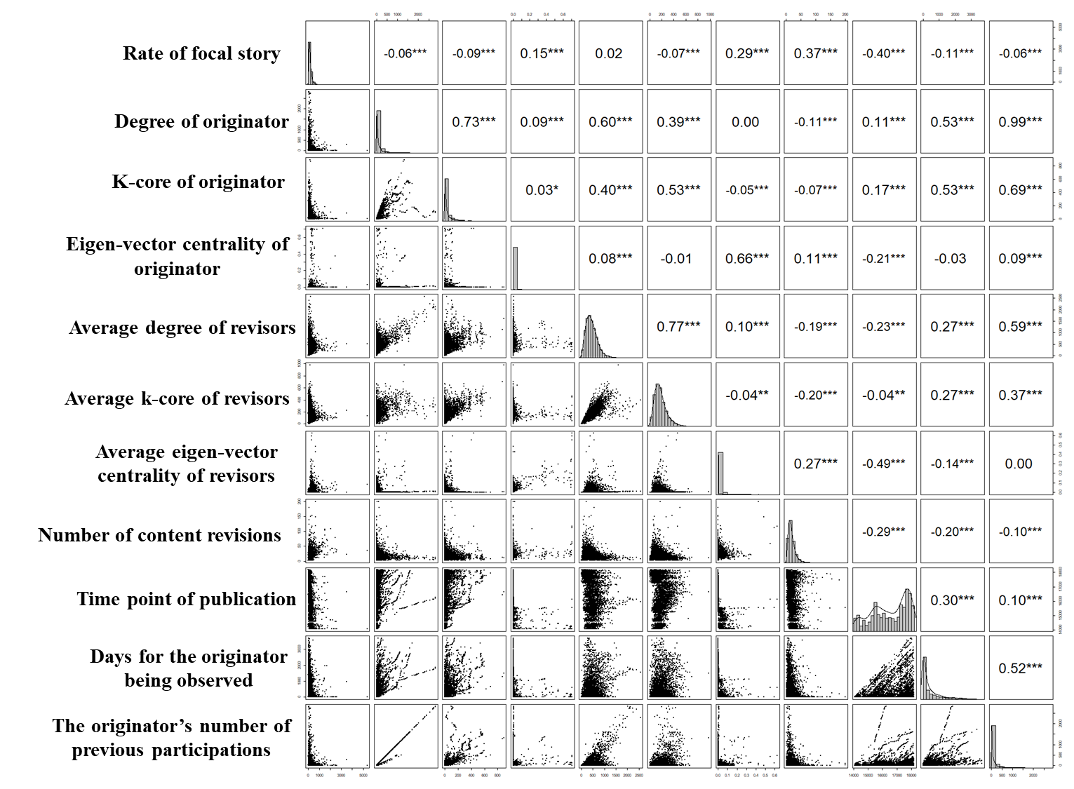

Fig. S1. Distribution, scatter plots, and correlations of variables in the regression model of SCP-Wiki content quality; the names of all variables are in the left of the figure. In this figure, the diagonal shows histograms with the density curves of every variable in the regression model of content quality in SCP-Wiki. Graphs in the lower triangle show scatter plots between each pair of variables. In the upper triangle, significant correlations between each pair of variables are shown. One asterisk refers to a p-value smaller than 0.1, two asterisks refer to a p-value smaller than 0.05, and three asterisks refer to a p-value smaller than 0.01.

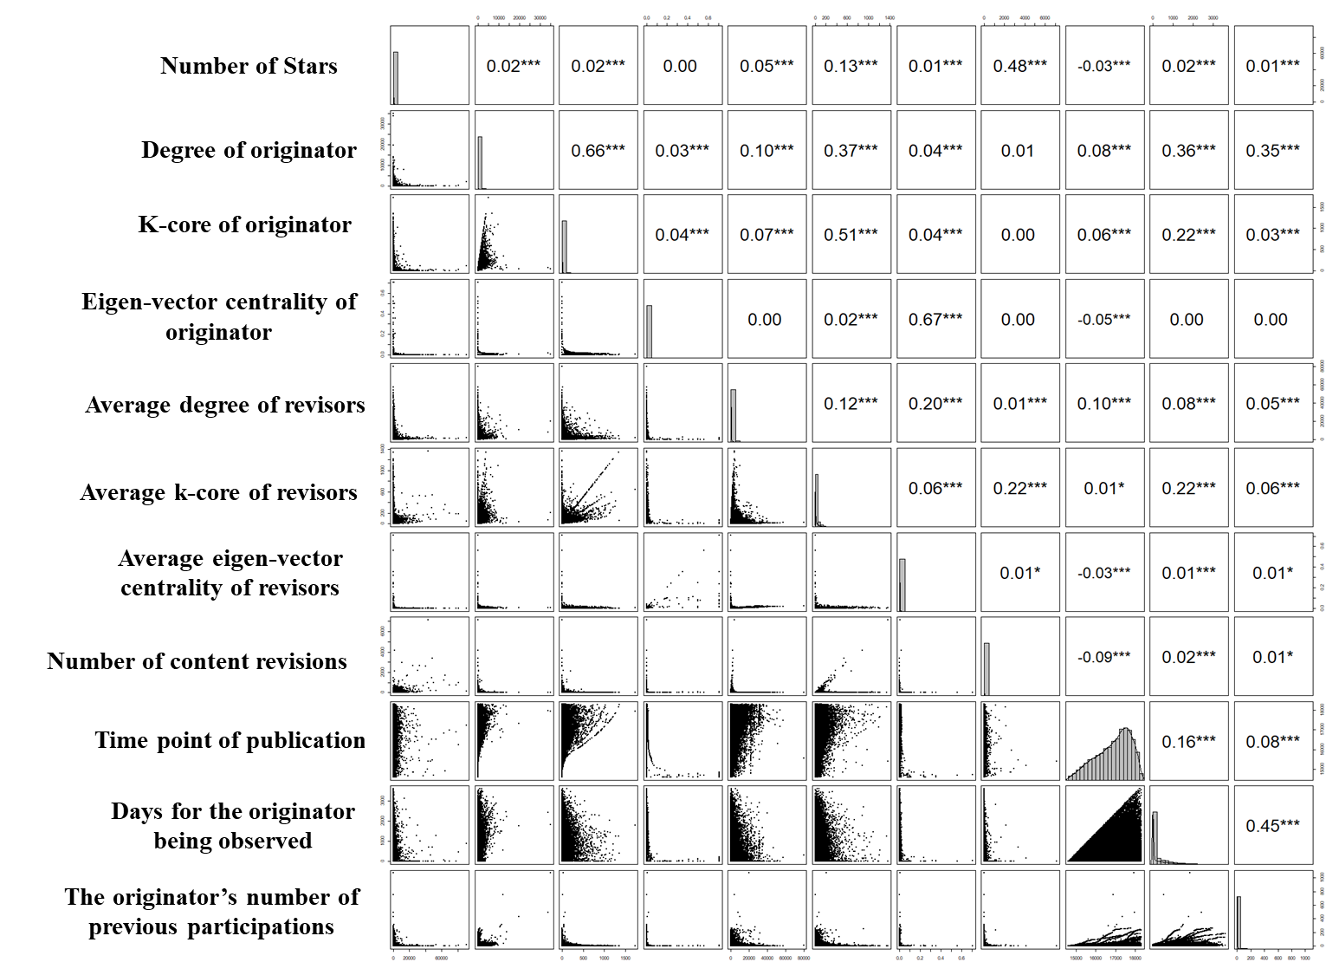

Fig. S2 Distribution, scatter plots, and correlations of variables in the regression model of Github content quality; the names of all variables are in the left of the figure. In this figure, the diagonal shows histograms with the density curves of every variable in the regression model of content quality in Github. Graphs in the lower triangle show scatter plots between each pair of variables. In the upper triangle, significant correlations between each pair of variables are shown. One asterisk refers to a p-value smaller than 0.1, two asterisks refer to a p-value smaller than 0.05, and three asterisks refer to a p-value smaller than 0.01.

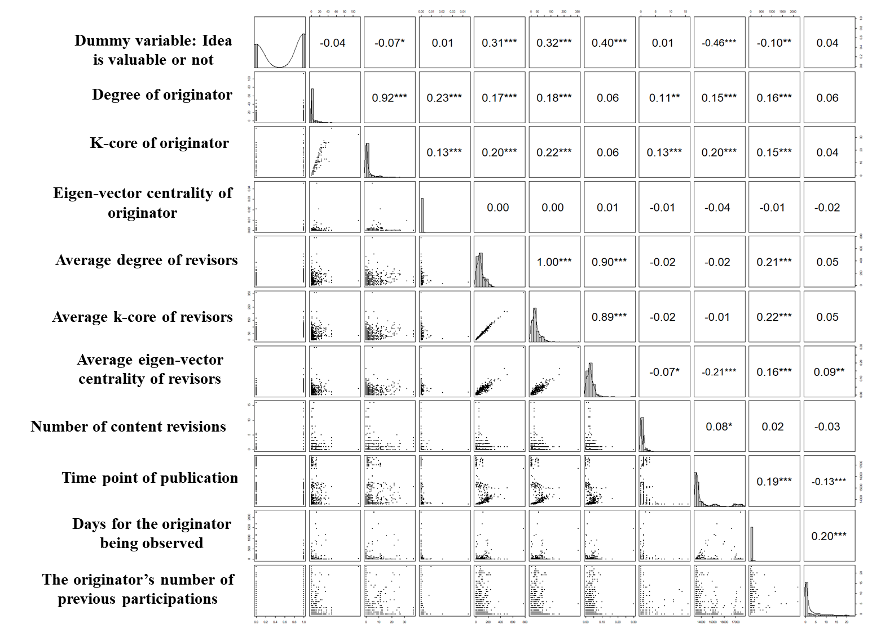

Fig. S3. Distribution, scatter plots, and correlations of all variables in the regression model of Idea Storm content quality; the names of all variables are in the left of the figure. Note that the names of the variables are abridged for display in the figure. In this figure, the diagonal shows histograms with the density curves of every variable in the regression model of content quality in Idea Storm. Graphs in the lower triangle show scatter plots between each pair of variables. In the upper triangle, significant correlations between each pair of variables are shown. One asterisk refers to a p-value smaller than 0.1, two asterisks refer to a p-value smaller than 0.05, and three asterisks refer to a p-value smaller than 0.01.

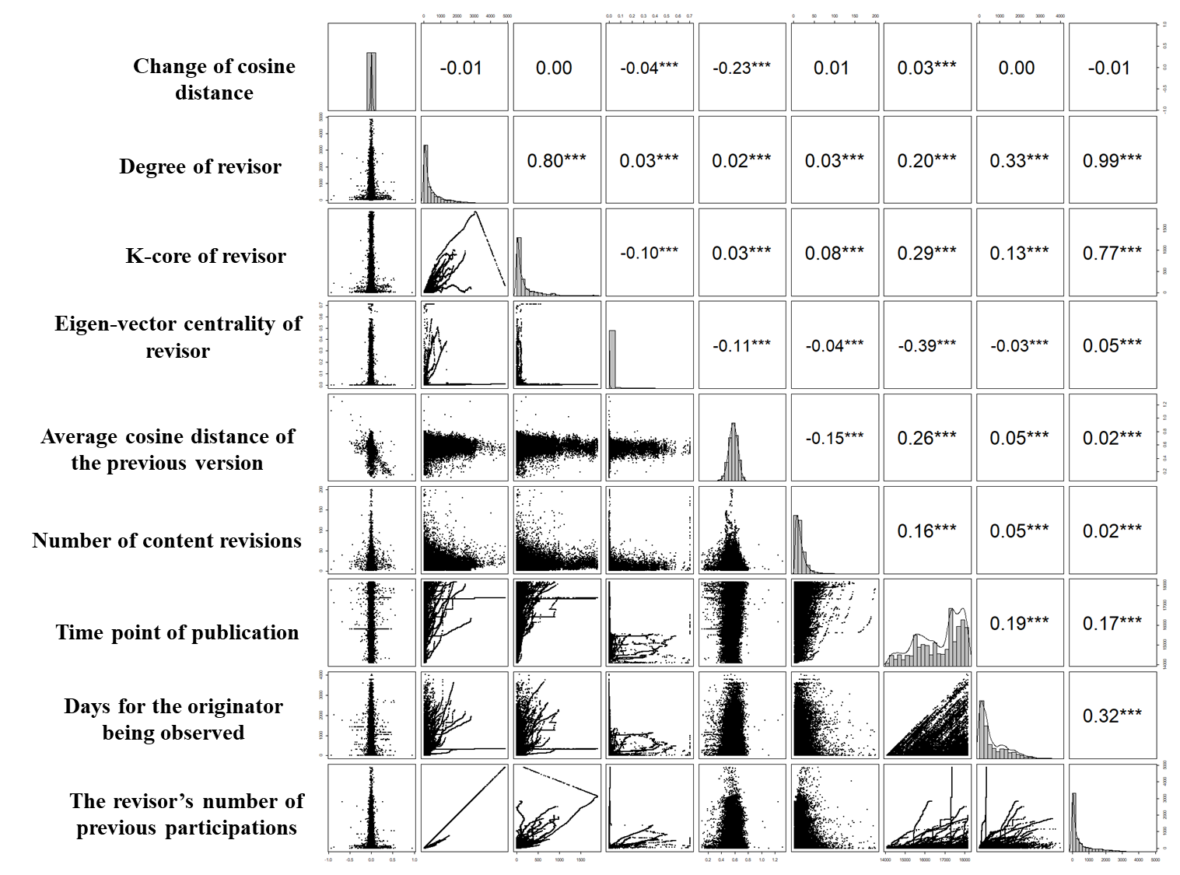

Fig. S4. Distribution, scatter plots, and correlations of variables in the regression model of originality change; the names of all variables are in the left of the figure. In this figure, the diagonal shows histograms with the density curves of every variable in the regression model of originality change. Graphs in the lower triangle show scatter plots between each pair of variables. In the upper triangle, significant correlations between each pair of variables are shown. One asterisk refers to a p-value smaller than 0.1, two asterisks refer to a p-value smaller than 0.05, and three asterisks refer to a p-value smaller than 0.01.

Table S1. Statistics of variables in regression of the quality of content
Statistic | Observations | Mean | St. Dev. | Min | Max
SCP-Wiki
Rate of focal story | 4,653 | 180.294 | 219.974 | −20 | 5,355
Degree of originator | 4,653 | 128.338 | 275.132 | 0.000 | 2,818
K-core of originator | 4,653 | 48.988 | 89.710 | 0.000 | 992
Eigenvector centrality of originator | 4,653 | 0.009 | 0.057 | 0.000 | 0.707
Average degree of revisors | 4,653 | 451.296 | 269.710 | 2.500 | 2,566
Average k-core of revisors | 4,653 | 177.704 | 100.779 | 1.000 | 979.700
Average eigenvector centrality of revisors | 4,653 | 0.012 | 0.034 | 0.000 | 0.623
Number of content revisions | 4,653 | 19.629 | 14.108 | 2 | 200
Time point of publication | 4,653 | 16,518.870 | 1,230.808 | 14,079 | 18,174
Days for the originator being observed | 4,653 | 467.432 | 694.090 | 0.000 | 3,683.698
The originator’s number of previous participations | 4,653 | 121.719 | 271.833 | 0 | 2,816
Github
Number of Stars | 99,235 | 194.324 | 1,087.2 | 5 | 90,351
Degree of originator | 99,235 | 82.322 | 435.400 | 0 | 35,145
K-core of originator | 99,235 | 9.047 | 49.415 | 0 | 1,728
Eigenvector centrality of originator | 99,235 | 0.0003 | 0.010 | 0 | 0.707
Average degree of revisors | 99,235 | 853.071 | 2,992.168 | 2 | 79,727.5
Average k-core of revisors | 99,235 | 21.346 | 50.298 | 1 | 1,368.817
Average eigenvector centrality of revisors | 99,235 | 0.0003 | 0.004 | 0.000 | 0.707
Number of content revisions | 99,235 | 7.962 | 45.371 | 1 | 7,153
Time point of publication | 99,235 | 16,894.690 | 858.192 | 14,610 | 18,300
Days for the originator being observed | 99,235 | 276.965 | 503.548 | 0.000 | 3,605
The originator’s number of previous participations | 99,235 | 3.563 | 15.698 | 0.000 | 1,069
Idea Storm
Dummy variable: Idea is valuable or not | 837 | 0.589 | / | 0 | 1
Degree of originator | 837 | 3.907 | 8.583 | 0.000 | 113
K-core of originator | 837 | 2.826 | 5.713 | 0.000 | 37
Eigenvector centrality of originator | 837 | 0.0002 | 0.002 | 0.000 | 0.045
Average degree of revisors | 837 | 76.774 | 73.930 | 0.000 | 775.000
Average k-core of revisors | 837 | 36.614 | 34.130 | 0.000 | 358.000
Average eigenvector centrality of revisors | 837 | 0.027 | 0.024 | 0.000 | 0.296
Number of content revisions | 837 | 0.742 | 1.661 | 0 | 16
Time point of publication | 837 | 14,194.400 | 1,143.889 | 13,571 | 17,660
Days for the originator being observed | 837 | 33.227 | 165.736 | 0 | 2,240
The originator’s number of previous participations | 837 | 2.804 | 4.955 | 0 | 23

Table S2. Statistic of variables in regression of the change of originality.
Statistic | Observations | Mean | St. Dev. | Min | Max
Dependent Variables
Change of cosine distance | 43,693 | 0.0002 | 0.030 | −0.935 | 0.957
Independent Variables
Degree of revisor | 43,693 | 511.160 | 676.245 | 1 | 4,868
K-core of revisor | 43,693 | 222.524 | 347.891 | 0.000 | 1,896
Eigenvector centrality of revisor | 43,693 | 0.019 | 0.072 | 0.000 | 1
Control Variables
Average cosine distance of the previous version | 43,693 | 0.573 | 0.072 | 0.107 | 1.317
Number of content revisions | 43,693 | 16.278 | 13.482 | 2 | 200
Time point of publication | 43,693 | 16,698.410 | 1,125.040 | 14,085 | 18,175
Days for the revisor being observed | 43,693 | 655.539 | 718.230 | 0.000 | 4,025.694
The revisor’s number of previous participations | 43,693 | 464.909 | 684.150 | 0 | 4,866

